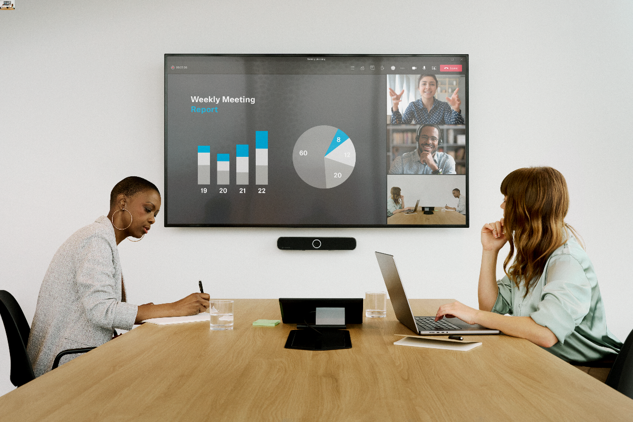

Sennheiser Announces 2025 Connect & Collaborate Roadshow

Touring Event to Offer Personal Interactions with Sennheiser Business Communications Products and Experts

Old Lyme, Connecticut — Feb 19, 2025 — Sennheiser, the first choice for advanced audio technology that makes collaboration and learning easier, is excited to announce its Connect & Collaborate Roadshow begins on Feb. 25 in Tampa, Florida. Attendees will experience Sennheiser’s newest innovations and engage with technical experts to gain deeper insights into the features and benefits of their business communications portfolio. In addition, guests can discover how solutions like SpeechLine Digital Wireless, MobileConnect and those from the TeamConnect Family, and can enhance collaboration in working and learning environments. The roadshow wraps up in Toronto, Canada on Sept. 16.
The 2025 Connect & Collaborate Roadshow will showcase Sennheiser’s business communications portfolio to end users, distributors, consultants, integrators, and resellers. It will offer hands-on training on how to design and deploy solutions for meeting spaces and/or lecture halls, with stops in the following cities:

- Feb. 25 – Tampa, Florida
- Feb. 27 – Raleigh, North Carolina
- March 4 – Scottsdale, Arizona
- March 4 – Houston, Texas
- April 1 – Costa Mesa, California
- April 3 – Salt Lake City, Utah
- April 8 – Seattle, Washington
- April 10 – Chicago Illinois
- May 6 – Cleveland, Ohio
- May 8 – Calgary, Alberta
- Sept. 9 – Washington, D.C.
- Sept. 16 – Toronto, Ontario

Hands-on demonstrations with Sennheiser TeamConnect solutions
During sessions, attendees will learn how solutions work together to simplify collaboration, enhance communication, and ensure success in conference and collaboration spaces. Attendees can earn up to 5.5 AVIXA CTS RU credits by participating in the roadshow sessions, including those from partners Q-SYS, Netgear, Planar and Lightware. In total, 12 of Sennheiser’s valued partners will be participating in various stops over the course of the roadshow.

The event is free to attend, and registration is now open here. For more information about Sennheiser and its solutions, visit www.sennheiser.com.

###

About the Sennheiser brand
We live and breathe audio. We are driven by the passion to create audio solutions that make a difference. Building the future of audio and bringing remarkable sound experiences to our customers – this is what the Sennheiser brand has represented for more than 75 years. While professional audio solutions such as microphones, meeting solutions, streaming technologies and monitoring systems are part of the business of Sennheiser electronic GmbH & Co. KG, the business with consumer devices such as headphones, soundbars and speech-enhanced hearables is operated by Sonova Holding AG under the license of Sennheiser.

www.sennheiser.com
www.sennheiser-hearing.com

Local Press Contacts
InGear
Peter Schuyler
peter@ingearpr.com
+1 917-496-8970

Global Press Contact
Jeff Horan
jeffrey.horan@sennheiser.com
+1 860-598-7539

