Neumann.Berlin Hosts Audio Community at Recording Academy®
Producers & Engineers Wing® GRAMMY® Week Event

Los Angeles, February 27, 2023 – Each year, the Recording Academy® Producers & Engineers Wing® hosts a signature GRAMMY® Week event which honors innovative and accomplished artists, engineers, and producers. The event also serves as an important hub for the audio community, fostering collaboration and the exchange of ideas. As a premier event sponsor this year, Neumann.Berlin engaged dozens of top-tier audio professionals, highlighting its latest tools for audio production including the Miniature Clip Microphone System, the newly reissued M 49 V, KH 150 monitors, NDH 30 headphones and more.
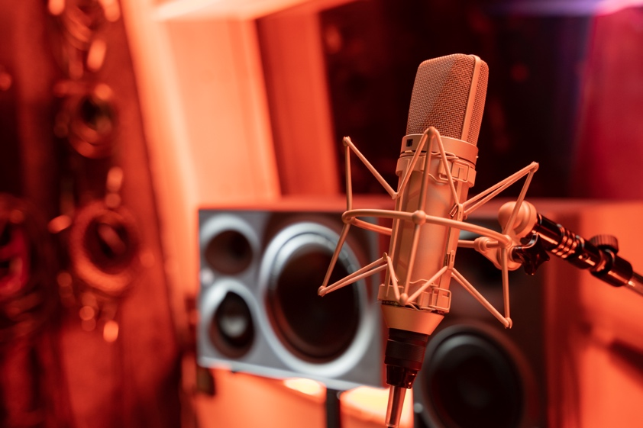
Neumann participated at the P&E Wing event, part of this year's GRAMMY Week. (Photo: Jonathan Ruest)

Inside Studio A of Los Angeles' legendary Village Studios on Wednesday, February 1st, VIP attendees were able to get up close and personal with legendary Neumann microphones, including the KU 100 Dummy Head. Also on display were Neumann's latest innovative production tools, including the reissued M 49 V condenser microphone, the NDH 30 dynamic headphones as well as the new Miniature Clip Mic (MCM) system, which has been specially developed for close miking of instruments in live applications.
“We were overwhelmed by the magnitude of positive interaction at this year’s P&E Wing event hosted by the Village Studios," commented Ralf Oehl, CEO, Neumann.Berlin. "With our relentless aim to support this community with reference recording, monitoring and live performance solutions, Neumann audio solutions have enabled artists to push the limits of recorded music since 1928, and we are enthusiastic to continue this joint path with the Producers & Engineers Wing."

Stewart Copeland and Ricky Kej, whose album won a GRAMMY® Award for Best Immersive Audio Album, were among the VIP guests to stop by the event. The album, Divine Tides, was mixed entirely on Neumann KH monitors by Eric Schilling at mediaHyperium.
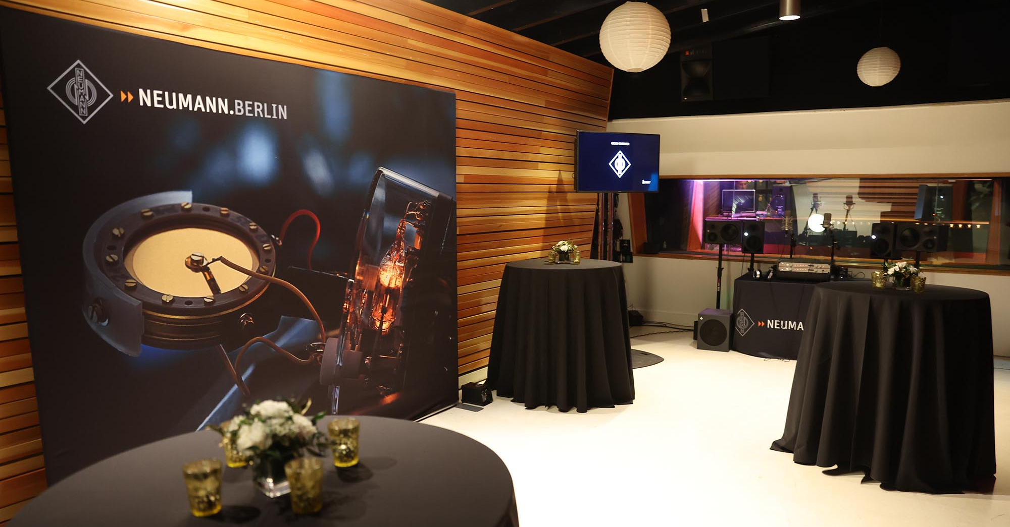
Photo: Jesse Grant/WireImage
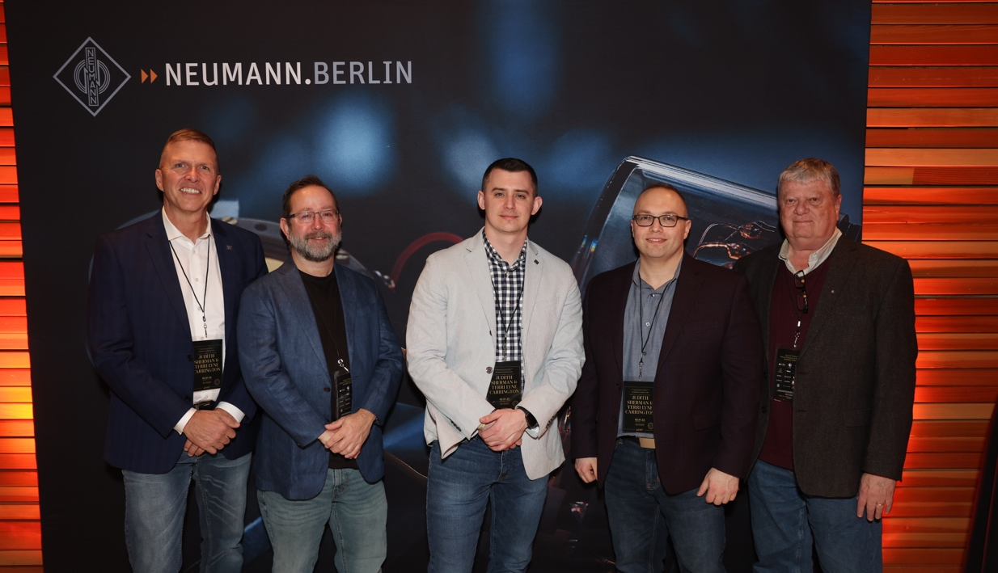
According to Jonathan Ruest of Neumann, immersive audio was a topic of great interest: "Many of our conversations during the event centered on immersive audio workflow and monitoring set ups for Dolby Atmos and other formats," he says. "We were eager to share our company's deep expertise in this regard, since our KH Series monitors have proven to be an indispensable tool for many immersive productions."
The Neumann/Sennheiser team on site, from left to right: Matt Buckner, Tim Moore, Jonathan Ruest, Greg Simon, Thom Salisbury. Photo: Jesse Grant/WireImage

Now in its 22nd year, the P&E Wing advocates for excellence and best practices in sound recording, audio technologies and education in the recording arts, along with proper crediting, recognition and rights for music creators. "We are thrilled to have had Neumann participate in this year's P&E Wing event. It is a welcome collaboration as our missions align regarding the importance of both music and sound," said Maureen Droney, Vice President, Producers & Engineers Wing. "Each year, this event serves as an important touchpoint for the music creation community, encouraging vibrant discussion among producers, engineers, artists and manufacturers, and we are grateful for Neumann's contribution."

About Neumann
Georg Neumann GmbH, known as “Neumann.Berlin”, is one of the world’s leading manufacturers of studio-grade audio equipment and the creator of recording microphone legends such as the U 47, M 49, U 67 and U 87. Founded in 1928, the company has been recognized with numerous international awards for its technological innovations. Since 2010, Neumann.Berlin has expanded its expertise in electro-acoustic transducer design to also include the studio monitor market, mainly targeting TV and radio broadcasting, recording, and audio production. The first Neumann studio headphones were introduced in 2019, and since 2022, the company has put an increased focus on reference solutions for live audio. Georg Neumann GmbH has been part of the Sennheiser Group since 1991, and is represented worldwide by the Sennheiser network of subsidiaries and long-standing trading partners. www.neumann.com.
About The Recording Academy
The Recording Academy represents the voices of performers, songwriters, producers, engineers, and all music professionals. Dedicated to ensuring the recording arts remain a thriving part of our shared cultural heritage, the Academy honors music’s history while investing in its future through the GRAMMY Museum®, advocates on behalf of music creators, supports music people in times of need through MusiCares®, and celebrates artistic excellence through the GRAMMY Awards® — music's only peer-recognized accolade and highest achievement. As the world’s leading society of music professionals, we work year-round to foster a more inspiring world for creators.
For more information about the Academy and its Producers & Engineers Wing, please visit www.recordingacademy.com or @ProdEngWing on Instagram. For breaking news and exclusive content, follow @RecordingAcad on Twitter, “like” Recording Academy on Facebook, and join the Recording Academy's social communities on Instagram, YouTube, TikTok, and LinkedIn.

Local press contacts USA:
Daniella Kohan
daniella.kohan@sennheiser.com
+1 (860) 227-2235

Jeff Touzeau
jeff@hummingbirdmedia.com
+1 (914) 602-2913

Global press contact:
Andreas Sablotny
andreas.sablotny@neumann.com
+49 (030) 417724-19

