For immediate distribution

Sonarworks and Focusrite Offer Users Free Limited-Time Reference 4 Headphone Edition License with Product Registration
New and Existing Focusrite Customers Can Register Online By May 2
Riga, Latvia, April 8, 2019 – European audio software innovator Sonarworks is offering Focusrite users a free software license of Reference 4 Headphone Edition for those who register their Focusrite hardware products with Focusrite’s Plug-In Collective before May 2, 2019. New Focusrite hardware users need only register an account on the Focusrite website, while existing users can log into their account and download the software and license before May 2. The software license is valid until October 1, 2019.
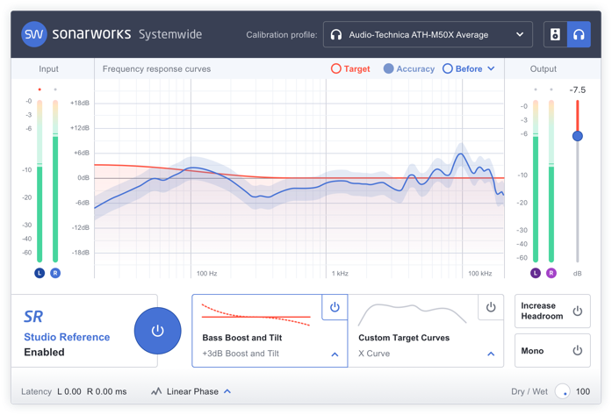
Reference 4 Headphone Edition is a more streamlined edition of Sonarworks’ flagship audio calibration software, aimed towards music creators who monitor entirely on headphones and mix wherever their work takes them. The software calibrates all supported headphone models to a neutral Studio Reference standard, providing consistent and accurate sound that allows creators to make confident mixing decisions and trust that their mixes will translate appropriately regardless of the playback device. The software consists of a DAW plug-in as well a Systemwide app, and currently supports over 200 models of headphones and counting.

“This partnering has been a great opportunity for us to deliver an accurate reference sound to even more users,” said Sonarworks’ Co-Founder and VP Martins Popelis. “We’re glad that we’re together on this mission with Focusrite.”

For more information about this promotional offer, please visit https://focusrite.com/news/plug-collective-sonarworks

For more information about Sonarworks Reference 4 Headphone Edition, please visit https://store.sonarworks.com/products/reference-4-headphone-edition

About Sonarworks
Sonarworks was founded in 2012 when two music lovers met a scientist and embarked on a mission to deliver the ultimate sound experience for anyone creating or listening to music. The company’s headquarters are based in Riga, Latvia and its customers consist of Grammy Award winning audio and music industry professionals, audiophiles and music lovers around the world. For more information on Sonarworks, please visit www.sonarworks.com.

Media Contact:
Jeff Touzeau
Hummingbird Media, Inc.
+1 (914) 602-2913
jeff@hummingbirdmedia.com

