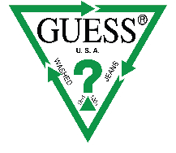

ECO IS THE SMART CHOICE FOR THE SS21 GUESS COLLECTION

The fashion-forward SMART GUESS eco collection continues to grow each season. This cool assortment of men’s, women’s and kid’s clothing is made using environmentally conscious manufacturing processes, once again renewing GUESS’ commitment to sustainable fashion. This on-trend collection features all product categories, from denim and outerwear to casualwear and more. It is created using the latest, environmentally sound materials, from recycled and organic cotton to natural hemp and recycled bottles. Each garment is recognizable thanks to a special SMART GUESS label, which can be found on approximately 50% of the season’s assortment for the GUESS JEANS line and 30% for the GUESS KIDS one.

Chief Creative Officer & Co-Founder Paul Marciano explains, “Sustainability is a catalyst for creativity, helping us to rethink the way we design our products. Our sustainability goals have challenged us to innovate, evolve and adapt. As we focus on what we do best, we know the future means, doing more with less – less water, less waste and less carbon – and meeting the aspirations of new generations”.

Chief Executive Officer and Director Carlos Alberini declares, “Inspired by the tenets of conscious capitalism my vision for GUESS is to harness our passion and use a purpose driven approach to create positive impact for our world and or brand”.

For the SS21 season, GUESS is proud to present Reborn Denim. This stand-out collection is made using second-hand, pre-loved denim that is meticulously selected and carefully processed, eliminating waste and resulting in ultra-soft denim. Orta Blu dye technology and EIM environmental impact software are used to create this innovative range, which also meets certification requirements for the Global Recycled Standard (GRS), which verifies the use of responsible social, environmental and chemical production practices. Available in four styles and finished in three unique washes designed in collaboration with top Italian laundry houses, Reborn Denim makes a strong style statement.

Celebrated for its lightweight feel, strength and eco manufacturing, Natural Hemp Fiber is produced using zero pesticides and chemicals, and 70% less water compared to cotton, making it an ideal choice for high-quality denim. Natural Hemp Fiber is used in two flattering styles and two different washes.

Eco Feather Weight is a super lightweight denim made using post-consumer cotton and recycled polyester fiber. Breathable, ultra-short, strong and flexible, it is the ideal material for GUESS premium denim and is used across both the men’s and women’s SMART GUESS capsules. This high-tech collection is GRS certified for its recycled materials and responsible production, and features four different styles and four striking washes for women, alongside two unique washes and two styles for men.

Harnessing the artisanal skills of Italian laundry masters, ‘Italian Wash’ pieces are designed globally and crafted locally, enhancing today’s style codes with Italian quality. This stunning range uses Orta Blue dye technology to create three beautiful washes and three feminine styles for women, and three men’s styles with a further three head-turning washes.

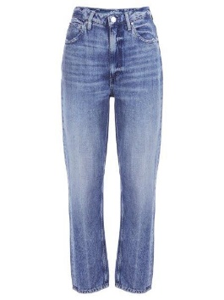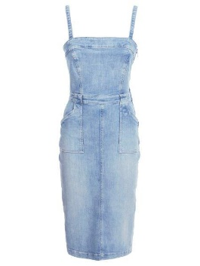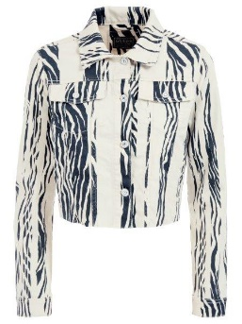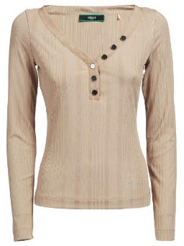

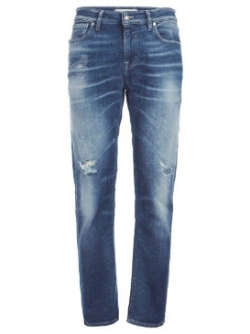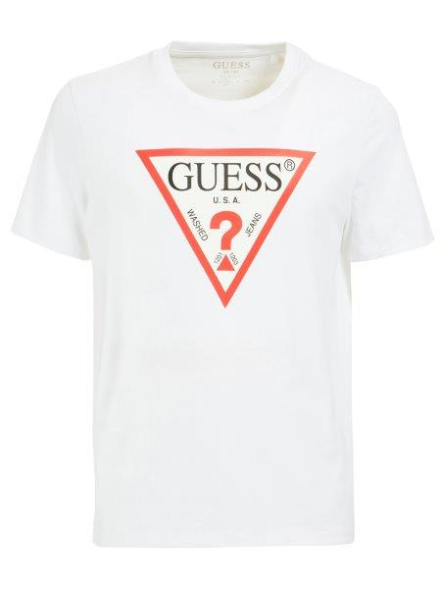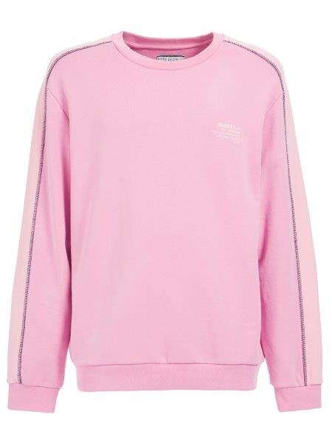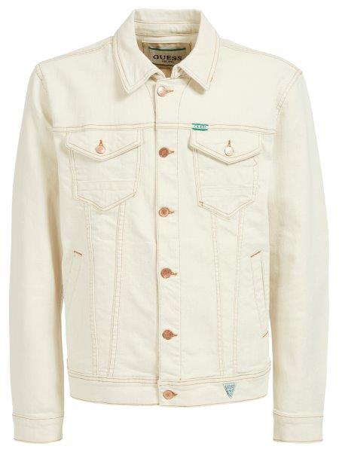

About GUESS?, Inc.
Established in 1981, GUESS began as a jeans company and has since successfully grown into a global lifestyle brand. Guess?, Inc. designs, markets, distributes and licenses a lifestyle collection of contemporary apparel, denim, handbags, watches, eyewear, footwear and other related consumer products. Guess? products are distributed through branded Guess? stores as well as better department and specialty stores around the world. As of August 1, 2020, the Company directly operated 1,084 retail stores in the Americas, Europe and Asia. The Company’s partners and distributors operated 538 additional retail stores worldwide. As of August 1, 2020, the Company and its partners and distributors operated in approximately 100 countries worldwide. For more information about the Company, please visit www.guess.com.

About GUESS Sustainability
In 2019, GUESS published its third sustainability report and updated sustainability plan. As part of that plan, the company made commitments to be good water stewards and responsibly source materials. The company is actively pursuing company-wide goals for eco materials sourcing and water saving technology adoption in denim, which is further detailed in its sustainability report, publicly available online. The GUESS Sustainability program is global, with Guess Europe launching the first eco collection in 2016, and has eco assortments available throughout the year in the U.S., Canada, Europe and select additional markets worldwide. The company is also an active industry partner on various other sustainability programs. For more information on GUESS Sustainability, visit guess.com/sustainability.

