Embargoed until October 29, 2020 / 11:59AM EDT
Hi-Res Photo Downloads

Moog’s Most Affordable Synthesizer Is Here Just in Time for the Holidays

Moog’s popular and accessible Werkstatt-01 Analog Synthesizer Kit and CV Expander return for a limited time, inviting all to get hands-on with the legendary Moog sound. Werkstatt-01 and its accompanying CV Expander are bundled together for $199, making this the most budget-friendly Moog on the market. The complete kit is now available and shipping worldwide.

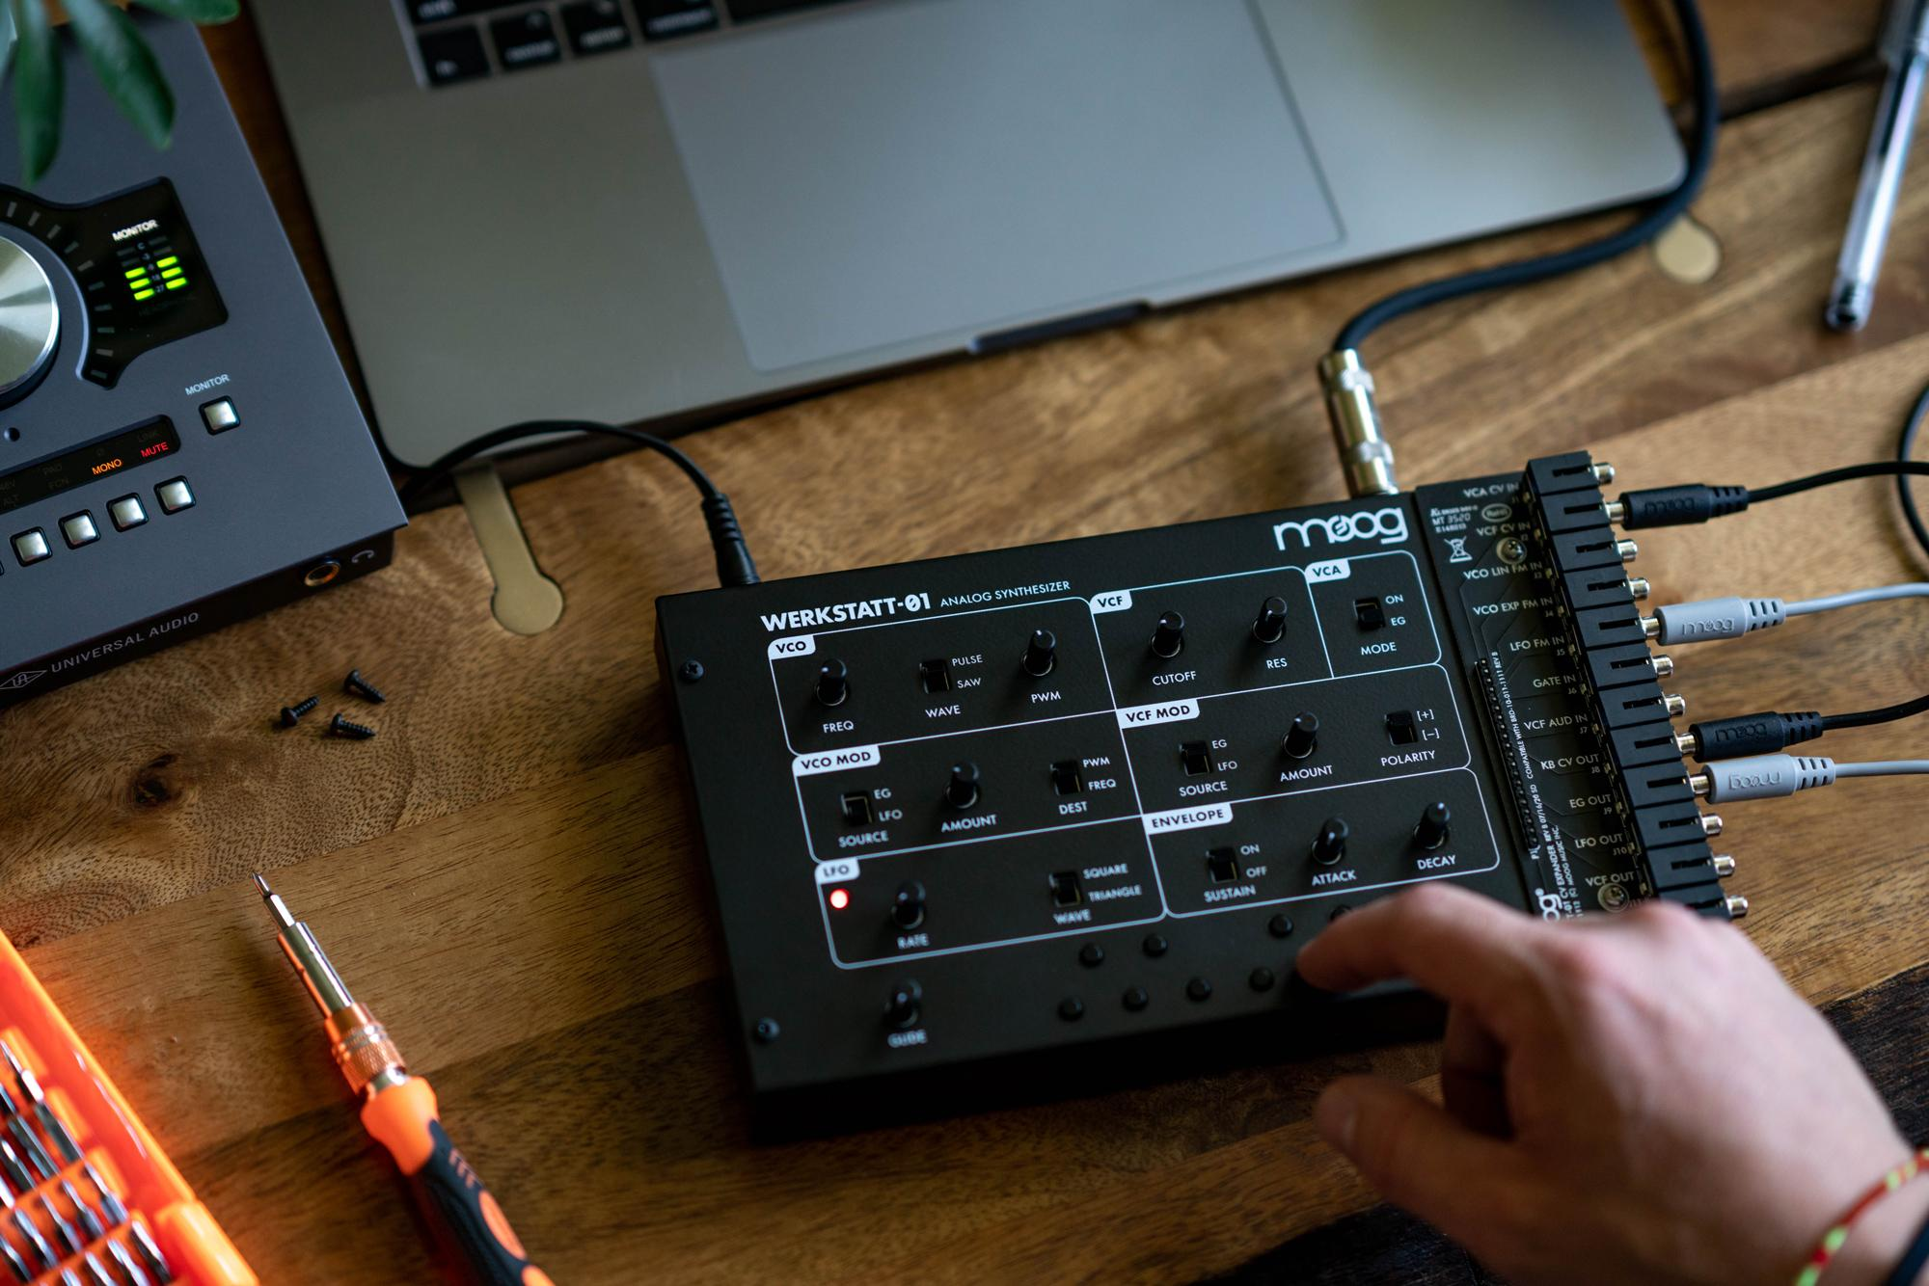

Werkstatt-01 is a patchable and compact analog synthesizer. A gateway to the expansive world of analog synthesis, the instrument is a must-have for anyone interested in exploring classic Moog sound and circuitry through the unique, hands-on experience of a DIY synthesizer project. This affordable, easy-to-assemble kit requires no prior electronics experience and is a perfect afternoon (or Christmas morning) project.

The straightforward simplicity of Werkstatt-01’s design makes it an ideal jumping-off point to discover a limitless new world of analog sound design, and the included 3.5mm CV Expander makes it a no-brainer for everyone wishing to integrate the iconic Moog sound into their music. The 9" by 6" musical machine may be small, but the raw power and spectrum of the sound it produces is immense.

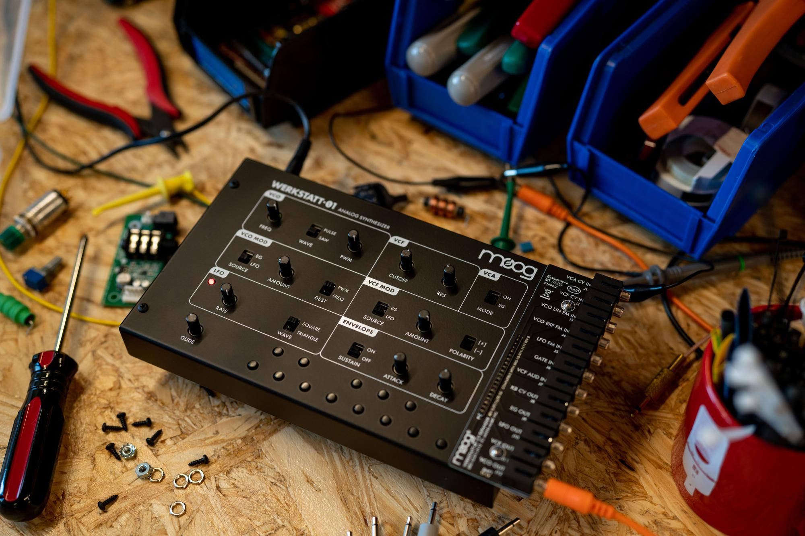

From Musical Exploration to Experimental Education
First introduced at Moogfest 2014 as part of the event’s Engineering Workshop, Moog Music’s Werkstatt-01 analog synthesizer has been admired as an essential introductory synth, a powerful standalone instrument, and an enhancement to any integrated electronic music ecosystem. Based on classic Moog circuitry, Werkstatt-01 was created to provide a hands-on understanding of how analog synthesizers work and encourage experimentation with sound through patching and interconnectivity.

Fans of Moog’s ever-expanding line of semi-modular synthesizers have Werkstatt-01 to thank—in part. The research and design that went into Werkstatt’s circuits, and the demand for more semi-modular exploratory analog instruments, ultimately led to the development of some of today’s most expressive sound design machines: Mother-32, DFAM, Grandmother, Matriarch, and Subharmonicon.

More than a musical instrument, Werkstatt-01 has also served as an interactive educational tool in STEM curricula. The compact, versatile synthesizer has been the heart of the Georgia Tech Hackathon, a weekend-long competition that takes place each February at the Atlanta university’s Center for Music Technology, for six years and counting. The 2021 Georgia Tech Hackathon will be held virtually; see details here.

The easily mod-able analog synth kit has also proven to be a perfect learning ground for DIY modifications and the science of sound. Moog’s website features a series of instructional videos that walk the viewer through how to expand their instrument through breadboarding and arduino integration. Watch them all here.

Classic Moog Sound & Circuitry
Werkstatt-01’s 100% analog circuits deliver the classic soul and futuristic sound Moog synthesizers are known for. Featuring a full-range analog oscillator with selectable waveforms for powerful sound and the legendary Moog Ladder Filter for precision harmonic sculpting, this instrument covers a vast expanse of sonic territory. Adding movement and modulation is as simple as engaging Werkstatt-01’s analog LFO circuit to simulate the motion of gently breathing waves, or crank up the LFO speed and summon cosmic laser beams. A two-stage analog envelope generator with sustain gives the user control to shape dynamics, dialing in everything from lush electronic string swells to punchy basslines and organic percussion hits—and everything in between.

The included CV Expander allows the user to enter the endless realms of modular synthesis, where new connections can be made and original sounds are unlocked. Patching inputs and outputs together from the 12 jacks of the 3.5mm patch bay will reconfigure Werkstatt-01’s circuits to create new signal paths and empower new sonic explorations. The included CV Expander also makes it easy to connect Werkstatt-01 to other Moog semi-modular synthesizers, Eurorack systems, or drum machines, enhancing any configuration with powerful analog sound.

Learn more about the instrument here.

Werkstatt-01 Videos & Audio Samples
To accompany the instrument’s release, Moog shares a new set of Moog Demo Library videos that serve as a complete guide for Werkstatt-01’s assembly process, calibration, and integration with other semi-modular instruments. Moog also presents “Hivemind,” a performance video that uses eight Werkstatt-01 synthesizers to build a complete track demonstrating the instrument's versatility and powerful sound. Watch all videos here.

Plus, sonic sorceress Lisa Bella Donna demonstrates Werkstatt-01’s raw power and wide spectrum of sound with 12 distinct sound samples, ranging from sweeping pulse width modulations to Switched-On style etudes. Listen here.

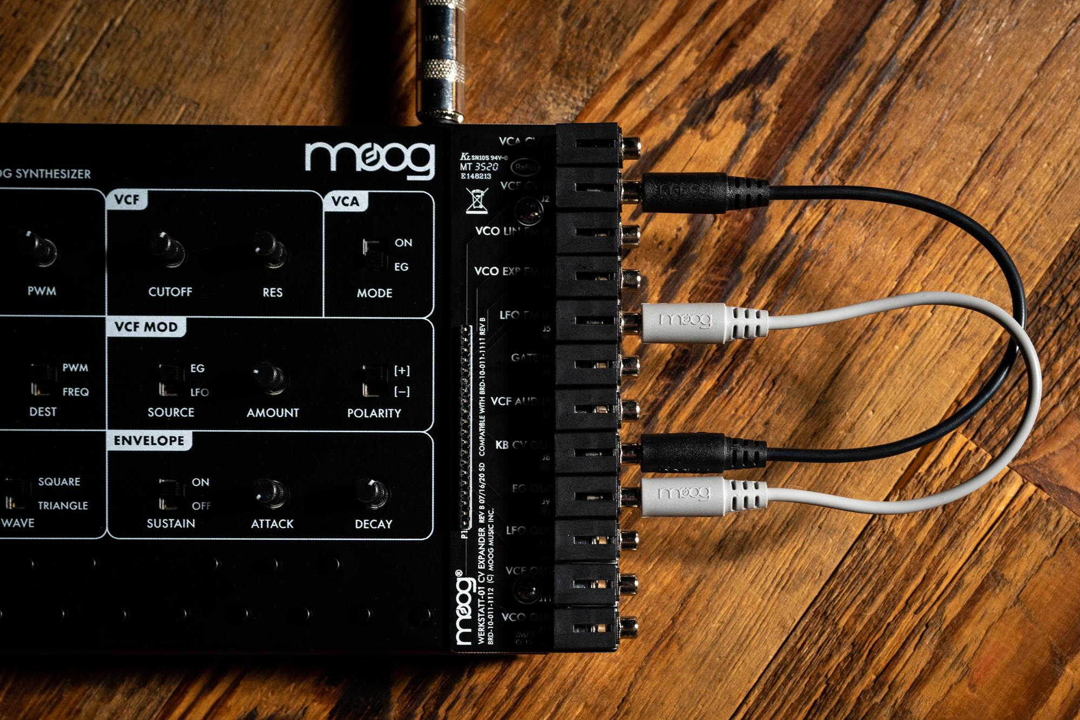

Available Now, but Not Forever
The Werkstatt-01 Analog Synthesizer Kit is shipping from the Moog factory in Asheville, North Carolina for a limited time and is available worldwide while supplies last through Moog authorized dealers. Find a dealer near you.

More about Moog Music
Moog Music is the world’s leading producer of theremins and analog synthesizers. The employee-owned company and its customers carry on the legacy of its founder, electronic musical instrument pioneer Dr. Bob Moog. All of Moog’s instruments are built with love inside its factory in downtown Asheville, North Carolina. Learn more here.

