THIS IS THE KIT
Reveal Rough Trade Session for “By My Demon Eye”

https://www.youtube.com/watch?v=cylBRiIgO_4&feature=youtu.be

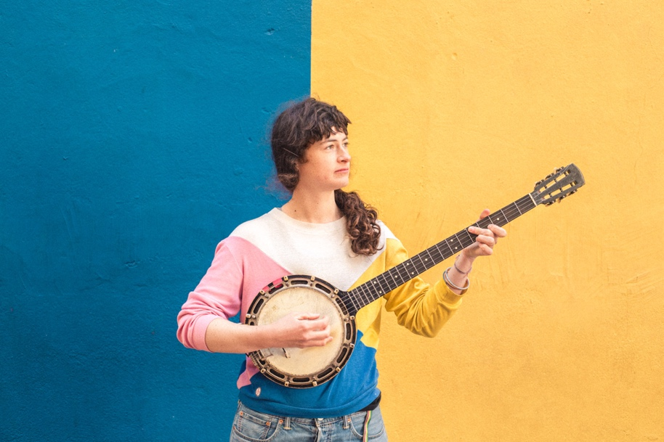

Watch the Rough Trade Session video for “By My Demon Eye” here;

https://www.youtube.com/watch?v=cylBRiIgO_4&feature=youtu.be

"The West Country wanderers fourth album may be her best yet" - 8/10 Uncut

"A joy to behold" - 9/10 Drowned in Sound

"A five-star stone cold instant classic” - 5/5 Irish Times

"This is their finest work to date" - 4/5 Record Collector

"An absorbing puzzle to pore over" - 4/5 MOJO

This Is the Kit are pleased to share their new Rough Trade Session track “By My Demon Eye”, this track is taken from the critically acclaimed 4th album “Moonshine Freeze” and first for Rough Trade Records.

Kate Stables on the track:

“This song started out as a project to make a piece of music based around the song that rabbit and tortoise sing in a Hugh Tracey story called “Rabbit and Tortoise”. I love the sound of his voice. Both when he's talking and when he's singing. And the sounds and rhythm and the meaning of the song he sings in this story just wrung so strongly in my ear and my head.

The translation of the song’s chorus is “boil boil water boil let the liar be boiled”. The song that ended up getting written is maybe misleading as people find it to be quite a “lovely sort of happy gentle song” but when they find out what the chorus means they're often a bit shocked. But for me it is an upsetting song. It's not meant to be happy. It's a heart wrenching situation between two people who have no solution for the mess they are in. but then again, I guess stories are often simply what we decide to hear”.

This Is the Kit is the musical project which holds exceptional Paris-via-Bristol songwriter Kate Stables close to its heart - have earned the adoration of peers including Guy Garvey, The National and Sharon van Etten and is they’re most compelling and accomplished to date.

Produced by John Parish (PJ Harvey, M Ward, Perfume Genius), it began in the immediate wake of its predecessor, 'Bashed Out', when days after coming off tour last November, Stables and her band (Rozi Plain, Jamie Whitby-Coles, Neil Smith and Jesse D Vernon) headed into Geoff Barrow’s Invada studios in Bristol. Aaron Dessner of The National also features on six of the album tracks.

The band have been on the road with National over the last month or so, and will be also supporting them on their upcoming US tour as well as playing their own EU shows including their biggest headline show to date at London’s Shepherds Bush Empire on 25 January.

10/05 - Cardiff, UK @ The Globe
10/06 - Leicester, UK @ The Soundhouse
10/07 – Bristol, UK @ Colston Hall
10/10 - Seattle, WA @ Tractor Tavern
10/11 - Vancouver, BC @ Cobalt
10/12 - Portland, OR @ The Old Church
10/14 - San Francisco, CA @ Swedish American Hall
10/17 - Los Angeles, CA @ Echo
10/19 - Minneapolis, MN @ Turf Club
10/20 - Chicago, IL @ Constellation
10/22 - Toronto, ON @ The Drake
10/24 - Boston, MA @ Great Scott
10/25 - New York, NY @ Mercury Lounge
10/26 - Philadelphia, PA @ Johnny Brenda’s
10/27 - Washington, DC @ DC9
11/02 - Paris, France @ Pitchfork Music Festival Paris
11/03 - Brussels, Belgium @ Botanique - Rotonde
11/04 - Luxembourg, Luxembourg @ De Gudde Wellen
11/05 - Amsterdam, Netherlands @ Melkweg
11/07 - Berlin, Germany @ Kantine am Berghain
11/08 - Prague, Czech Republic @ Cafe V Lese
11/09 - Vienna, Austria @ B72
11/11 - Lausanne, Switzerland @ Le Bourg
11/12 - Dudingen, Switzerland @ Bad Bonn
11/14 - Tourcoing, France @ Le Grand Mix
11/15 - Reims, France @ La Cartonnerie
11/16 - Lyon, France @ Groom
11/27 - Portland, OR @ Arlene Schnitzer Concert Hall*
11/28 - Seattle, WA @ Paramount Theatre*
11/29 - Seattle, WA @ Paramount Theatre*
12/01 - Vancouver, BC @ Queen Elizabeth Theatre*
12/02 - Vancouver, BC @ Queen Elizabeth Theatre*
12/05 - Philadelphia, PA @ Verizon Hall, Kimmel Center for the Performing Arts*
12/06 - Washington, DC @ Anthem*
12/07 - Montréal, QC @ Métropolis*
12/08 - Montréal, QC @ Métropolis*
12/09 - Toronto, ON @ Sony Centre for the Performing Arts*
12/10 - Hamilton, ON @ Hamilton Place Theatre*
12/12 - Chicago, IL @ Civic Opera House*
12/13 - Chicago, IL @ Civic Opera House*
01/13 – Stroud, UK @Brunel Goods Shed
01/14 – Liverpool, UK @ Leaf
01/16 – Cork, Ireland @ Cyprus Avenue
01/17 – Dublin, Ireland @ Whelans
01/18 – Leeds, UK @ Brudenell Social Club
01/19 – Glasgow, UK @ Celtic Connections / ABC
01/20 – Edinburgh, UK @ Pleasance Theatre
01/21 – Lancaster, UK @ Get Loud in Libraries
01/23 – Newcastle, UK @ Sage 2
01/24 – Birmingham, UK @ Glee Club
01/25 – London, UK @ Shepherds Bush Empire
01/26 – Cambridge, UK @ Junction

* with the National

Website http://thisisthekit.co.uk/

For more information please contact Ben Ayres (benayres@roughtraderecords.com) or Jamie Woolgar (jamiewoolgar@roughtraderecords.com) at Rough Trade Records (02088709912)

