### Via Antwerp. The Road to Ellis Island

**This summer, the Ellis Island National Immigration Museum will host the exhibition *Via Antwerp, The Road to Ellis Island*, which was created by the internationally acclaimed Red Star Line Museum in Antwerp, Belgium. The exhibition tells the story of the two million men, women and children from all over Europe, who left their homes to travel to the port of Antwerp where they embarked on the Red Star Line ships on a journey to a new future in America. *Via Antwerp* will run from 27 May until 5 September in the temporary exhibition space on the first floor next to the Great Hall of Ellis Island, where steerage passengers queued for immigration inspection.**

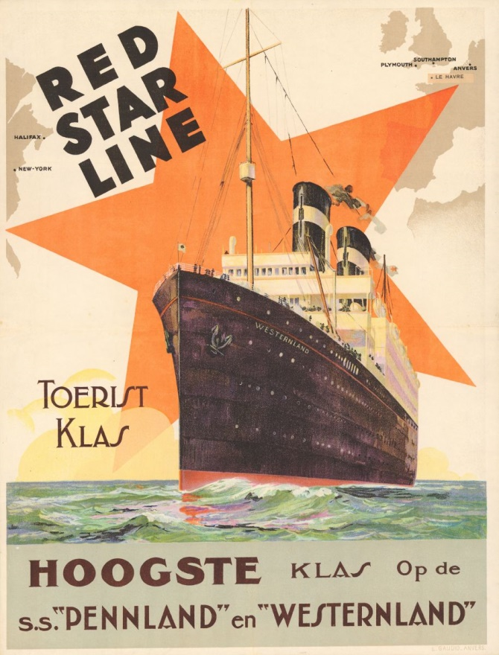

*Red Star Line poster, 1930, collection of the Friends of the Red Star Line, Antwerp*

1. **About the exhibition – Via Antwerp. The Road to Ellis Island**

From 1815 until 1940, around 60 million emigrants from all over Europe left their homeland for America in hopes of a better life. From 1873 to 1934, the Red Star Line shipping company ferried nearly two million of these emigrants from Antwerp in Belgium to the United States. Most of them arrived in New York.

In this tiny yet compelling exhibition, the Red Star Line Museum brings their story back to the U.S., and Ellis Island in particular. The narrative elaborates on a typical journey to New York around 1900 and starts in a travel agency of the Red Star Line in Russia. Migrants would then illegally cross the border from Russia into the West, travelling by train to Antwerp, where they would walk through the city and to the port and board a Red Star Line ship for the long ocean voyage before arriving at Ellis Island. *Via Antwerp* features a selection of interactive story booths, personal objects, artwork, a large ship model and publicity for the shipping company.

★ **The Red Star Line shipping company**

The Red Star Line’s official name was *Société Anonyme de Navigation Belgo-Américaine* or SANBA. It was established in 1872 by Peter Wright & Sons, a company of Philadelphia-based shipbrokers, with the aim of operating a transatlantic shipping line with steamships under a foreign flag. As ships and crews were expensive in the United States, the company decided to work with two Antwerp-based partners, Julius Von der Becke and Eduard Marsily.

The company received financial backing from the Pennsylvania Railroad Company, which considered the transatlantic passenger liner service an extension of its railway network. *SS* *Vaderland* departed on her maiden voyage to Philadelphia on 19 January, 1873. The exhibition includes a large scale model of *SS Friesland*.

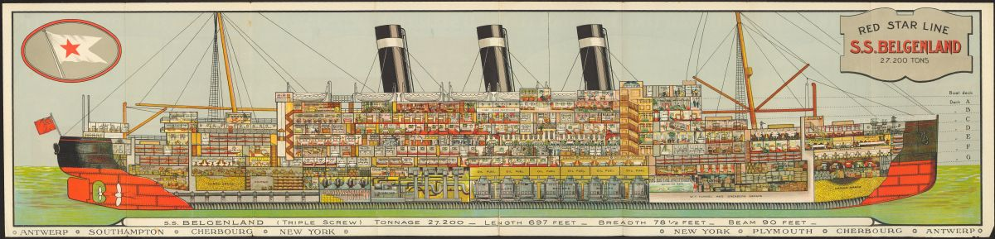

*S.S Belgenland, pamphlet, circa 1925, Red Star Line Museum, Antwerp*

★ **Departure**

Most of the migrants left to escape poverty. In some countries, war, famine, natural disasters, discrimination and persecution further complicated life. On the other side of the ocean, the United States were thriving. Friends and family who had already moved there wrote promising letters home about their life in this new country. Many of them even sent pre-paid tickets. The shipping lines had agents throughout Europe, often local shop owners who sold tickets on the side. They made the journey as easy as possible, giving information on how to get to Antwerp and even offering package deals including train tickets and hotels. The exhibition features several of the colorful brochures and posters designed by Henri Cassiers that praise the fast, safe and comfortable crossings.

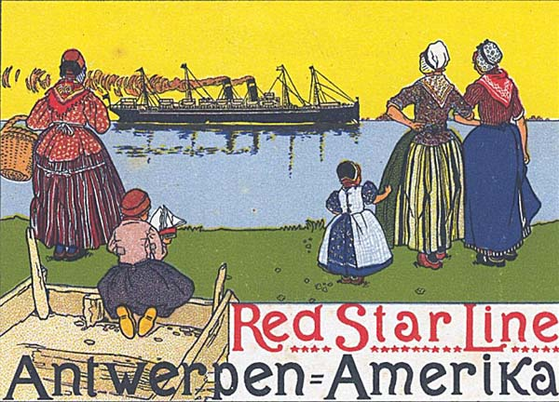

*Poster of the Red Star Line, Henri Cassiers, 1899, Letterenhuis, Antwerp*

Most migrants had to make an exhausting, uncomfortable train journey just to get to Antwerp. Seated on wooden benches in the unheated fourth class cars, they were kept separate from the other passengers. There were no washing facilities and the migrants were regularly checked for lice and disease. At the German border, they were required to present their ticket for the ocean voyage to prove that they were just “passing through”. Their luggage was also disinfected in the station. In this part of the exhibit, visitors will sympathize with young Basia Cohen, whose father already lived in the U.S., with Reinhold Libau who dreamt about a farm and with Abram Spiwak who was looking forward to embracing his sweetheart in New York again.

★ **The wait in Antwerp**

Most migrants only spent a brief time in Antwerp, but some stayed longer than planned. Travelers who were turned back by the local inspectors could turn to local aid organizations or the local hospitals for assistance. It was impossible to ignore the migrants’ presence in the city. The local citizens tended to view them with a mix of curiosity and pity. Around the turn of the century, the artists Eugeen Van Mieghem and Victor Hageman started to portray the many migrants in Antwerp’s port. Their art work mirrors the tragedy and the compassion in the literature of this period.

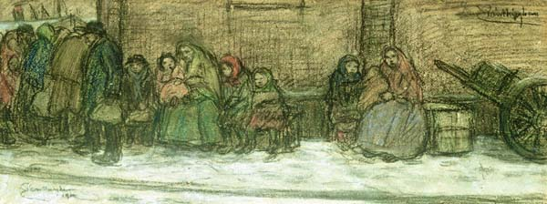

*Before embarking, steerage passengers had to undergo a medical examination and a series of hygienic procedures in the Red Star Line’s facilities near the quays.   
Eugeen van Mieghem, Migrants in Montevideostraat 1902, Eugeen Van Mieghem Foundation*

★ **Eugeen Van Mieghem – biography**

The Antwerp painter Eugeen Van Mieghem grew up in the heart of the old port. His parents had a pub opposite the first Red Star Line warehouse. The thousands of migrants who walked past the pub inspired the artist to create hundreds of drawings and paintings. A large part of Van Mieghem’s works are kept and exhibited in the Eugeen Van Mieghem Museum in Antwerp. Another Antwerp museum, Museum Plantin-Moretus has an impressive collection of 567 drawings and 47 prints by Van Mieghem. The Red Star Line Museum showcases a selection of works from this impressive collection in constantly changing temporary exhibitions.

★ **Travelling in steerage**

The voyage to the United States was anything but a pleasure cruise. Steerage passengers were kept separate from the other passengers. They stayed below deck, packed together and slept in large dormitories well into the 19th century. Everyone suffered from seasickness.

*Migrants on deck, circa 1925, collection of the MAS, Antwerp*

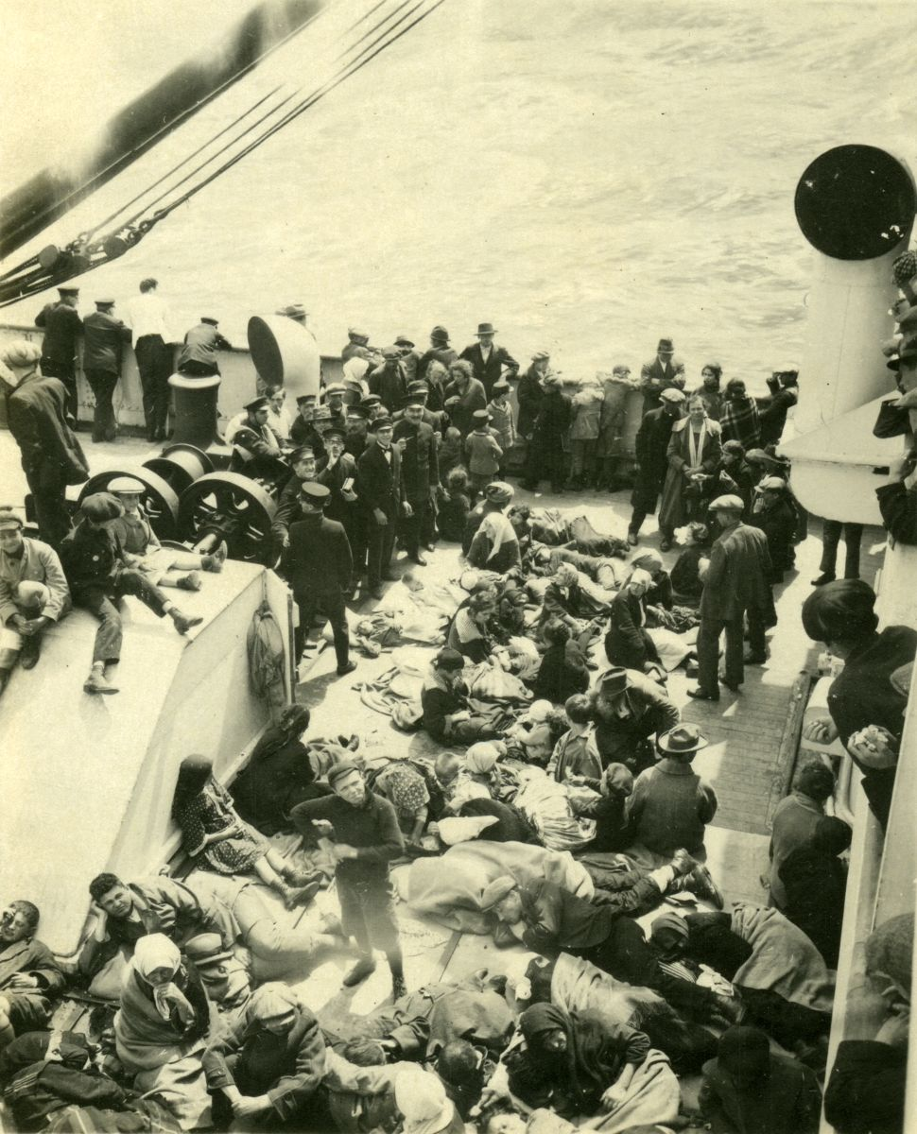

The journey in steerage was quite rough, but travel was already much more comfortable in the steamship era compared with fifty years earlier when a sailing ship would take an average of six weeks to complete the voyage. A steamer could sail from Antwerp to New York in just 10 days. The departure and arrival times were also more reliable.

Over the years the Red Star Line acquired 23 steam-powered ships, the biggest being *SS* *Belgenland*. Built in Belfast in the same shipyard as *Titanic*, the steamship arrived in Antwerp for the first time in 1923. The early 20th century marked the heyday of ocean steamers. Shipping lines touted their vessels as miracles of technology and progress. During the Roaring Twenties, the Red Star Line’s flagship was *SS* *Belgenland*, which was 204 meters in length and could carry 2,700 passengers.

★ **Arriving in America**

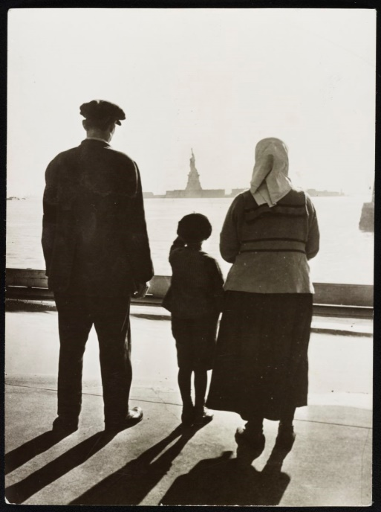

*Ellis Island, New York, 1930, Library of Congress, no. LC-USZ62-50904*

The largest gateway to America was the Ellis Island immigration processing center in New York’s harbor. Most of the immigrants would only spend a few hours on the island but some were detained for further inspection or treatment. Several organizations were on hand to help them: Belgians on Ellis Island turned to the Belgian Bureau, a Catholic missionary society with headquarters in New York City. The Red Star Line also had representatives there.

Immigrants had a chance to get ahead in the United States but this was far from easy. Most of them spent years living in uncertainty toiling hard before they gradually built up new and better lives. Unfortunately, there were also many migrants who returned home bitterly disappointed after a few years. But for some, the American Dream became a reality. **Arriving from Russia in 1893 on the Red Star Line’s *Rhynland*, young, penniless Israel Beilin, who spoke no English whatsoever, went on to reinvent himself as Irving Berlin, one of America's most prolific songwriters. Berlin's early works capture the sounds of the neighborhood in which he was raised, namely the Lower East Side, one of New York's immigrant ghettos.**

In 1930, the press stormed the ship when *Belgenland* arrived in port in New York with Albert Einstein on board, who was on his way to California. Three years later, the celebrated German scientist would sail to the United States again with the Red Star Line, only this time he was fleeing the Nazis. He remained in the United States until his death, working at the Institute for Advanced Study in Princeton, New Jersey.

1. **About the Red Star Line Museum – Millions of people, one dream**

The Red Star Line Museum opened in 2013 in the old port of Antwerp, and is located in the former building which was used for the inspection of the Red Star Line’s steerage passengers. It was their last stop on the European mainland before sailing to the United States.

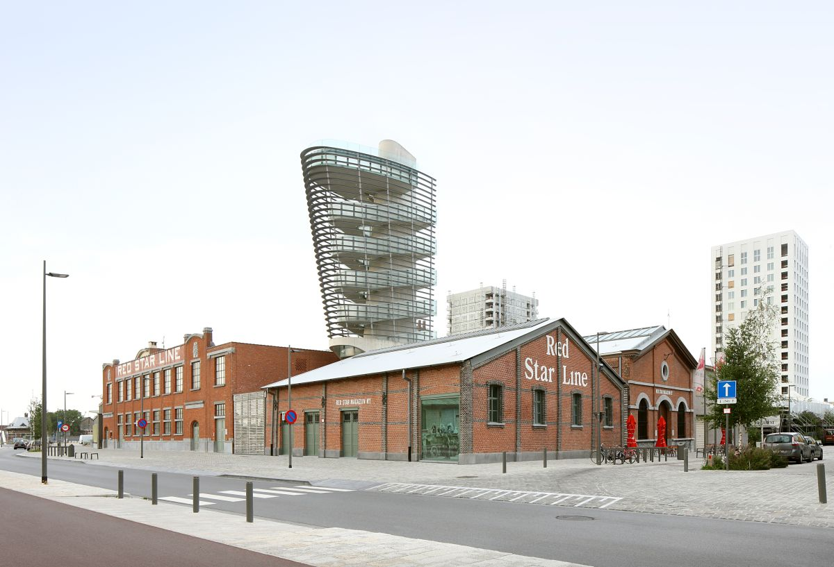

*Red Star Line Museum © Filip Dujardin*

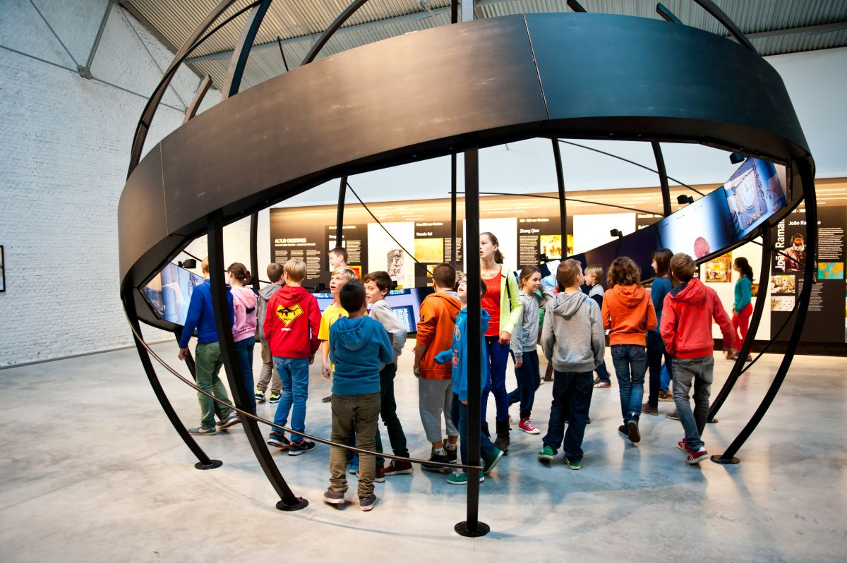  
*Red Star Line Museum © Noortje Palmers*

★ **The Red Star Line Museum: where history was written**

The Red Star Line Museum is one of only a few European migration museums and is located in the shipping company’s original departure warehouses. The Government of Flanders has listed the three Red Star Line warehouses as monuments. They are the most valuable objects in the Red Star Line Museum collection due to their immaterial value, bearing witness to a long-forgotten or ignored history. They remind us of the many human lives that changed within their walls. Steerage passengers underwent all kinds of medical examinations and administrative checks in these buildings. Their fate was decided here. The shipping company’s old buildings are still redolent with history. Hope, disappointment and sleepless nights - all the migrants’ emotions and stories are tangible, palpable and visible in the museum.

★ **The Red Star Line Museum tells a universal human story**

The museum brings the forgotten history of the Red Star Line back to life exactly where it was written. The Red Star Line Museum, that is located in the restored departure warehouses for steerage passengers, tells a universal story of migration based on the stories of passengers who made the voyage on board of its ships. It is a tale of joy and sorrow, of farewells and new beginnings; a tale of migration in the past and present. In essence, the Red Star Line story is very simple: it is about people who seek their happiness elsewhere. The Red Star Line Museum highlights the history of the Red Star Line as an example of a universal and timeless phenomenon. Migration and human mobility has always existed: millions of people all over the world left (and continue to leave) the familiar behind, looking for a new future elsewhere. The personal stories and memories of the Red Star Line’s passengers transcend the strictly historical narrative and speak of courage, loss, anxiety, fear, dreams and expectations - and in a way mirror what is happening across Europe today.

★ **The Red Star Line Museum brings a nearly forgotten history back to life**

Before the opening of the museum, the story of the Red Star Line was largely forgotten in Antwerp. The company’s archives were lost, its buildings were torn down or rundown, and there were fewer and fewer people who could share this history. But many Americans still remembered the tales their parents or grandparents told them about their journey. Precious artifacts and personal items in their homes were a poignant reminder of their family’s European origins. The National Museum of Immigration at Ellis Island has a treasure trove of oral history interviews with immigrants and personnel who worked in the immigration processing center. The oral history program and collections at Ellis Island thus became a source of inspiration and a point of departure for the research team in Antwerp, which was working on the new Red Star Line Museum. With the help of specialists in “reverse genealogy” and many American and European families, hundreds of descendants of Red Star Line passengers have been identified over the last ten years. A handful of surviving passengers can still recount their experiences firsthand. Since its opening in September 2013, the permanent exhibition of the Red Star Line Museum has prominently featured these personal stories and memories.

★ **The Red Star Line Museum tells the story from the migrant’s perspective**

Visitors retrace the footsteps of Red Star Line emigrants in the Red Star Line Museum. The museum exhibition follows the different stages of their journey. Eight thematic areas are arranged over two floors: a travel agency in Warsaw, a train compartment, the city of Antwerp, the Red Star Line building, the deck of an ocean steamer, life on board the ship, the arrival at Ellis Island and a new future in the America. The personal testimonies of Red Star Line passengers are a leitmotiv throughout the museum display.

★ **The Red Star Line Museum works together with the public**

At the start of the museum project, the collection consisted almost exclusively of posters, ship models, utensils, works of art and historic images. In recent years, the Red Star Line Museum team has actively collected and researched stories, personal objects, letters and passenger testimonies. The team has frequently approached private individuals, including collectors or families who still cherish a story about an ancestor. The museum also launched several public appeals in Belgium and abroad.

The museum expressly invites all its visitors and interested parties to share their migration stories. The interactive tours in the museum deviate from the traditional guided tours while supplementary teaching materials link the historic stories with the migration background of school children today. Since the museum’s opening people are increasingly and spontaneously sharing their stories with the public. To date, the museum has collected more than 500 stories, including a number of new, first-hand accounts. Museum visitors can look up these stories in “Het Magazijn” (The Warehouse) at the end of the exhibition.

★ **The Red Star Line Museum tells a contemporary story**

The Red Star Line Museum looks beyond history. At the beginning of the exhibition it confronts visitors with a question: How are the stories of Red Star Line passengers and their passage through the buildings relevant to us today? At the end of the historic museum display, the museum looks back on what happened in the buildings 100 years ago, albeit from a contemporary perspective. Thirteen Antwerp residents with a migration story talk about the impact that this experience has had on their lives. It is up to visitors to decide whether there are fundamental differences between the historic accounts of Red Star Line passengers elsewhere in the exhibition and these contemporary stories.

The Red Star Line Museum emphasizes the universal character of migration in various temporary exhibitions in the museum. This summer, against the backdrop of the current refugee situation in Europe, the Iraqi-Dutch artist Sadik Kwaish Alfraji is presenting his work ‘Ali’s Boat’ in the Red Star Line Museum. The main movie of this multi-media installation is also included in the ‘Via Antwerp’-exhibition at Ellis Island.

“Ali’s Boat” is a highly personal and contemporary interpretation of the museum’s central theme, namely the universal dream, shared by millions of people, to start a new life elsewhere.

1. **Transatlantic cooperation**

★ **The Ellis Island National Immigration Museum and the Ellis Island Family Research Center**

The Ellis Island National Immigration Museum set up an “oral history” project in Eighties and Nineties, recording thousands of interviews with Americans who entered the United States at Ellis Island. The Ellis Island Museum shared 60 audio files and transcripts from witnesses that discuss their journey from Antwerp with the Red Star Line Museum.

The collaboration with Ellis Island also provided the museum with unprecedented access to the collection of Augustus Sherman, the Head Clerk at Ellis Island. Sherman photographed more than 250 people who were waiting for a decision in the detention center between 1905 and 1925. They often wore traditional attire from their homeland, sometimes because Sherman asked them to. Today the photographs, which were taken by an amateur photographer, seem somewhat voyeuristic. Sherman seems to focus on the characteristics that many Americans associated with immigrants at that time such as exotic attire, large families, physical deformities and a lack of hygiene. The people look into the lens of a man who has the power to make a decision about the rest of their life. In these photos, they seem to be completely stripped of any personality. They are portrayed as a specimen of their race.

Today the Ellis Island National Immigration Museum and the Red Star Line Museum, on either side of the Atlantic, are active partners in the International Coalition for Sites of Conscience. This organization, which has its headquarters in New York and its European headquarters in the Red Star Line Museum, organized a program of “Immigration Dialogues” in recent years in the U.S, debating current migration themes with various audiences in various historic sites. Currently the European Coalition for Sites of Conscience is preparing a similar project in Europe.

★ **YIVO**

The Institute for Jewish Research (YIVO) in New York also made an important contribution at the start of the museum project by sharing the written memoirs of Jewish emigrants who sailed from Antwerp.

★ **Ambassadors**

The American fashion designer **Diane von Furstenberg** has been a fan of the Red Star Line Museum for years. She is a museum sponsor and a museum ambassador. The fashion designer with Belgian roots understands the hope that many of these migrants felt when they left their homeland for Antwerp on their way to the United States.

As a descendant of a Red Star Line passenger and as a museum sponsor, the American former ambassador to Belgium, **Sam Fox**, has provided substantial financial support. The museum tells the story of the migrant’s son who became an ambassador to the country where his mother boarded a Red Star Line ship.

The three daughters and the grandchildren of **Irving Berlin** were closely involved in the establishment of the Red Star Line Museum. Without the Red Star Line shipping company their father and grandfather probably would have never been able to become one of the most famous composers in the world. The Red Star Line Museum honors Irving Berlin’s memory and those of millions of migrants like him. The Berlin family has lent one of Irving Berlin’s transposing pianos to the Red Star Line Museum. It is one of the museum’s prized showpieces.

**Irving Berlin and the Red Star Line**

In 1893 five-year old Israel Isidore Beilin embarked on board the Red Star Line’s *SS Rijnland*, along with his family to start a new life in the United States. Young “Izzy” is the perfect example of the American Dream. Changing his name to Irving Berlin, he became famous all over the world with hits like “White Christmas”, “Puttin’ on the Ritz” and “There’s no business like show business”. A mere twenty years after his crossing to America as an immigrant travelling in steerage, some of the best orchestras performed his hits in the first-class salons on board Red Star Line ships.

Exactly 120 years after his departure from Antwerp, a new chapter began in the Red Star Line story of the world-famous composer. Since the Red Star Line’s opening, one of Berlin’s transposing pianos has held a prominent place in the museum’s permanent collection.

The piano was manufactured by Sohmner & Co of New York around 1924. A transposing piano enables a musician to switch keys and is an aid for untrained musicians when composing in a different key. Irving Berlin, who had no formal music training as a son of immigrants, acquired the piano around 1924. Berlin’s daughter, Linda Emmet, remembers that her father composed a lot of songs on the piano in the Thirties, Forties and Fifties, although the piano was at home and not in his office. The piano would subsequently be moved to the Music Box Theatre, which Berlin co-owned.

Linda inherited the instrument after his death and had it shipped to Paris. The family has decided to give it to the Red Star Line Museum, on long-term loan.

“This is where the piano belongs”, said Linda Emmet when she visited the Red Star Line Museum in autumn 2013. “My father was five years old when he migrated from Russia to the United States with the Red Star Line. This decision shaped his life, his career. This is where the story begins. And that is why this piano belongs here. I’m very happy and moved to see it in this stunning museum.”

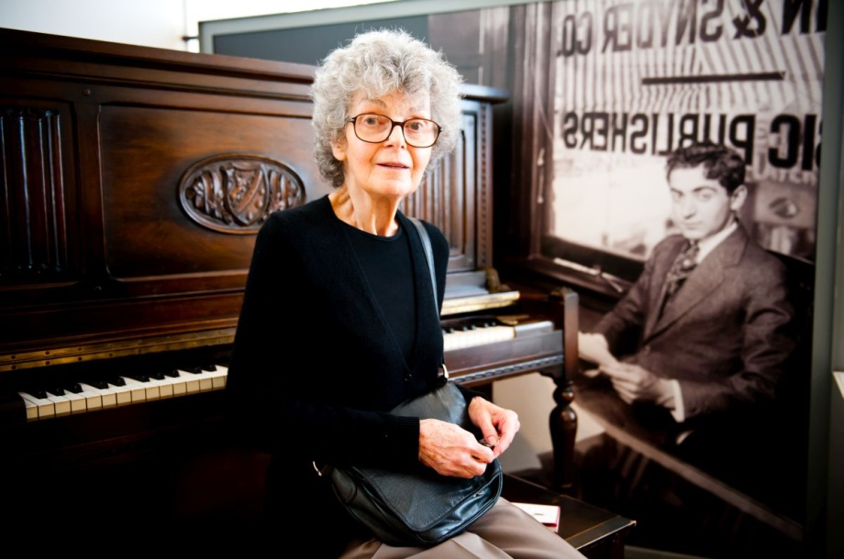

*Linda Emmet at the piano of her father Irving Berlin, Red Star Line Museum, Antwerp © Noortje Palmers*

★ **Architects, scenographer & multimedia designer**

The New York architectural firm Beyer Blinder Belle Architects & Planners LLP designed the exterior and interior of the buildings, as well as the new architectural elements such as the observation tower. The architects also restored the Ellis Island Immigration Museum in New York. As a result, they already had a special bond with the Red Star Line Museum even before starting work on its restoration in Antwerp.

Founded in 1968, Beyer Blinder Belle is an international award-winning architectural design and planning practice of 155 professionals in New York City and Washington, DC, specializing in historic preservation and with a demonstrated commitment to design excellence, social integrity and sustainable practices. The firm has completed landmark revitalization projects including Grand Central Terminal, Ellis Island, Rockefeller Center, the Empire State Building and the U.S. Capitol Building.

The design team for the Red Star Line Museum included founding partner John Belle, who also led the restoration of the American equivalent of the Red Star Line Museum, the Ellis Island National Museum in New York City.

Scenographer Christophe Gaeta acted as the local Belgian partner of Beyer Blinder Belle to work out the scenography of the permanent exhibition. Due to an enthusiastic dialogue between the museum team, the architects and Christophe Gaeta the exhibition succeeds on taking all visitors on an emotional journey through personal stories and the magic of the building itself.

The immersion of the visitor is also achieved by a diverse and elaborated mix of multimedia and audiovisual installations. These installations, that guide the visitor in a subtle and often surprising way, were developed by Tempora, a Belgian firm for exhibition design and production.

**Scenographer & multimedia designer of the exhibition ‘Via Antwerp’**

This travelling exhibition is designed, produced and installed by Tempora, a Belgian company for exhibition production and museum management, in collaboration with Christophe Gaeta, the scenographer of the permanent exhibition of the Red Star Line Museum for Beyer Blinder Belle.

‘Via Antwerp’ is designed with ‘Tempocases’, a state of the art, flexible, all integrated, easy to install travelling exhibition system.

★ **Founder**

The museum’s Founder **CMB** (*Company Maritime Belge*) CMB is the oldest active Antwerp shipping company. CMB is very proud of its partnership with the Red Star Line Museum. The company had various motives for sponsoring the museum. Managing Director Marc Saverys said that the most important motives for lending financial support to the Red Star Line Museum were the role of the Red Star Line Museum as a silent witness of the immense hope that drove millions of people from Eastern Europe, including many Jews, westwards to the New World. He added that the Red Star Line Museum raises awareness of Antwerp’s almost forgotten role in this historic exodus for this generation and for future generations. And finally, the origins of both the Red Star Line and of the CMB are inextricably linked to the history of the city of Antwerp and its port.

1. **Information for the press**

★ **Contact details**

Red Star Line Museum

Montevideostraat 3

2000 Antwerp

E-mail: redstarline@stad.antwerpen.be

www.redstarline.be

[www.redstarline.be/eng](http://www.redstarline.be/eng)

★ Luc Verheyen

Director

E-mail: [luc.verheyen@stad.antwerpen.be](mailto:luc.verheyen@stad.antwerpen.be)

★ Bram Beelaert

Curator  
E-mail: [bram.beelaert@stad.antwerpen.be](mailto:bram.beelaert@stad.antwerpen.be)

★ Karen Vandenberghe

Head of Marketing & Communications

E-mail: karen.vandenberghe@stad.antwerpen.be

★ Philip Heylen, Vice Mayor for Culture, Economy, City Maintenance and Property Management City of Antwerp

★ **Press contact**

★ Nadia De Vree

Press Coordinator Museums and Heritage Antwerp

**Mobile: +32 (0)475 36 71 96**

E-mail: [nadia.devree@stad.antwerpen.be](mailto:nadia.devree@stad.antwerpen.be)

★ Roel Veyt

Spokesman Mr. Philip Heylen

**Tel.: +32 (0)491 96 42 64**

E-mail: [roel.veyt@stad.antwerpen.be](mailto:roel.veyt@stad.antwerpen.be)

You can find the images of the expo *‘Via Antwerp’* and general images of the Rad Star Line Museum here: <http://pers.redstarline.be/media/album/730>