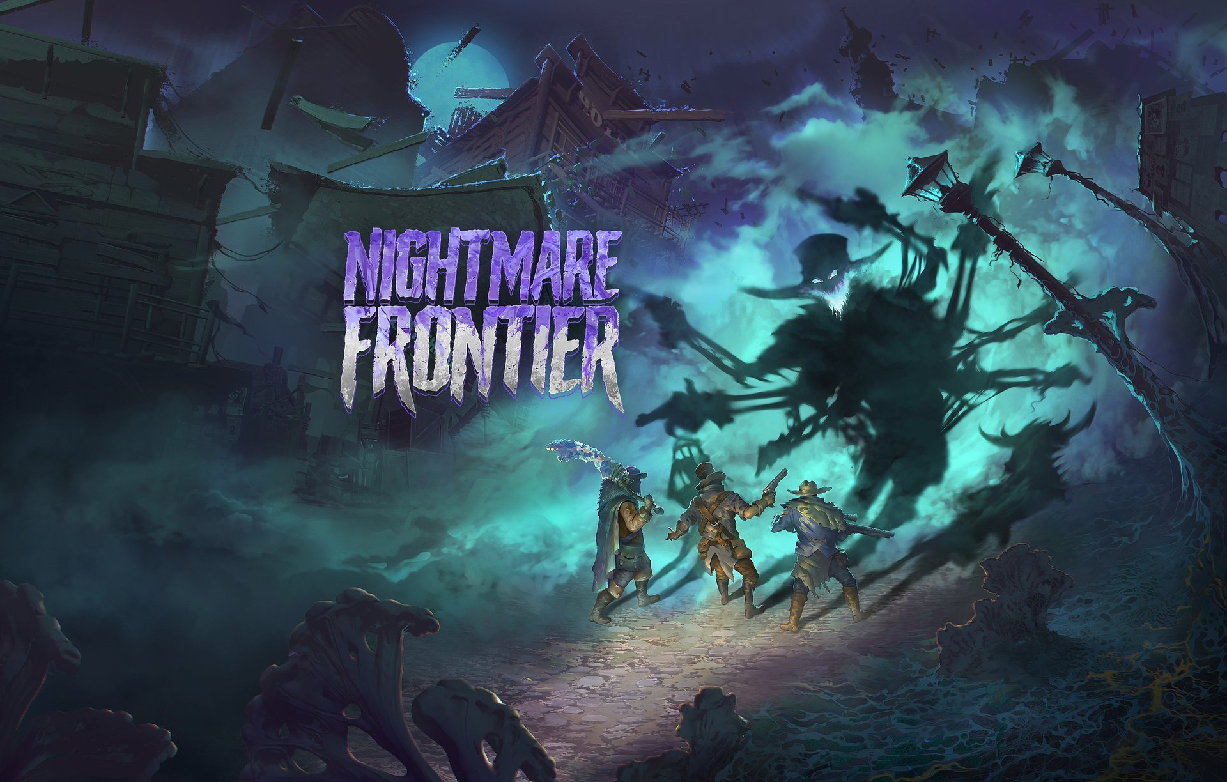

Tactical dread rises from the West Coast! Nightmare Frontier by the creators of Hard West 2 is out now

Today, the nightmare slithers onto the untamed West. Ice Code Games – the team behind Hard West 2 and Rogue Waters – invites players to survive and fight for loot in Nightmare Frontier, an innovative tactical extraction looter. The game is now available in Early Access on Steam.

In the heart of 19th-century America, a mysterious anomaly has altered the course of the entire world, turning the frontier of civilization into a borderland between reality and unknown horrors. The town is engulfed in a Nightmare, where beasts known as Dreadweavers prowl the streets, hunting the few remaining survivors. These terrifying creatures are physical manifestations of humanity’s deepest fears: arachnophobes will face a six-revolver gunslinger spider, while those afraid of fire must prepare to confront the flames and the terrifying creatures that spread them. In Nightmare Frontier, players take on the role of a ringleader fighting to endure and thrive amidst this pervasive horror, seeking not just safety but also a shot at fortune.

Nightmare Frontier – launch trailer

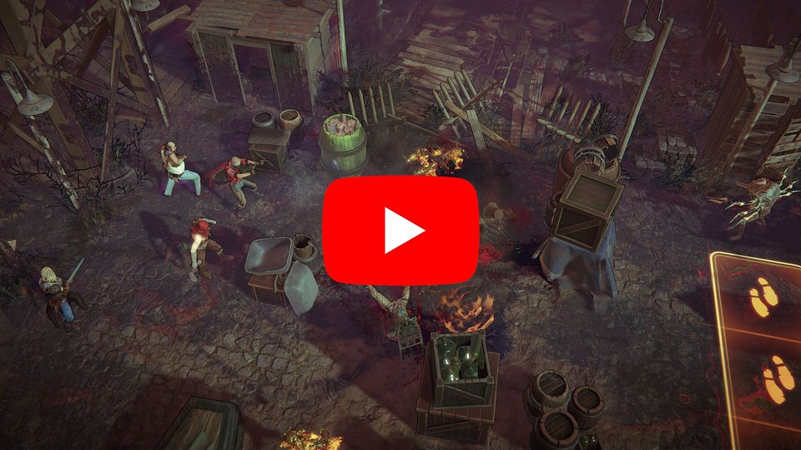
https://youtu.be/1Qc4QZVGiGE

Nightmare Frontier combines tactical turn-based strategy with roguelite elements and focuses heavily on the risk-reward gameplay typical of extraction looters. During gameplay, players are constantly faced with tough decisions: whether to push deeper into the city’s dangerous areas in search of better rewards, or to accept what they’ve already gained. With each turn, the forces of the Nightmare grow stronger, and every move brings increasing danger.

Players who checked out the demo have already gotten a taste of the challenges awaiting in Nightmare Frontier. Early Access introduces significantly more content, including four city districts with the possibility of unlimited raids deep into the Nightmare, where a team of tough individuals will confront 13 terrifying human fears and face matching enemies.

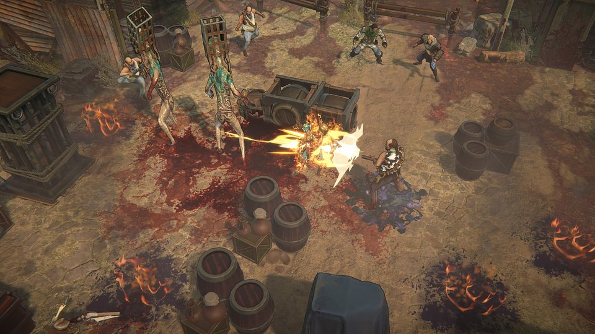

Moreover, there are many more items to gather, including the rarest and most powerful. Players can also upgrade these items to their highest level using Nightmare essence. Early Access offers the chance to dive into a storyline that unravels the nature of the catastrophe that destroyed the city, as well as the terrifying Dreadweavers themselves.

Kicking off today, players will begin to uncover the America we’ve crafted for them in Nightmare Frontier. Thanks to the community’s comments regarding the recent demo, we’re now heading into Early Access with the goal of creating something unique – together with our fans. Our blend of extraction looter gameplay and tactical turn-based strategy with roguelite elements is innovative, so every piece of feedback is extremely valuable – said Mateusz Pilski, CEO. The connection between the attacking monsters and the fears each squad member holds puts the players’ courage to a test. With every step deeper into the Nightmare, the world grows harsher, and the stakes of every battle rise – Pilski added.

See the development roadmap

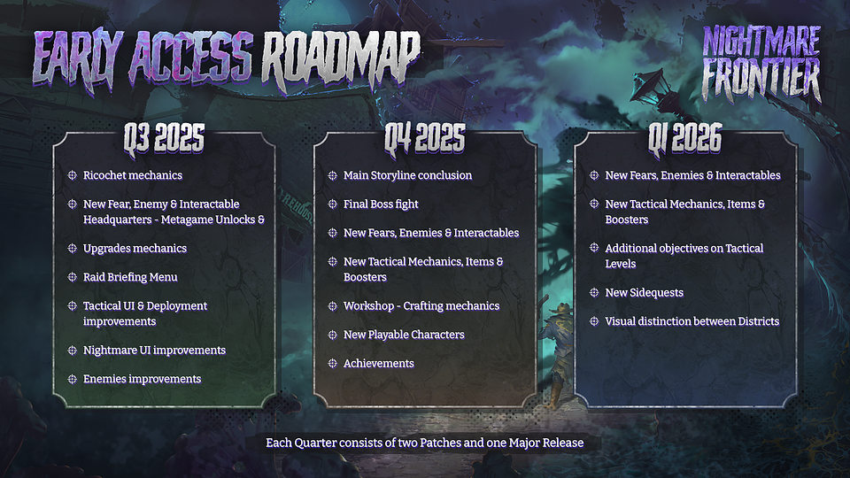

The titular Nightmare is a metaphysical force that warps reality itself as it grows stronger. With every passing turn, the battlefield becomes increasingly hostile, and supernatural phenomena become more frequent and unpredictable. To obtain powerful weapons and special attacks, players must confront deadly nightmarish anomalies that are drawn to each playable character’s deepest fears, preying on their vulnerabilities. For instance, those afraid of spiders will face a terrifying creature standing upright on two legs, with six additional limbs wielding revolvers.

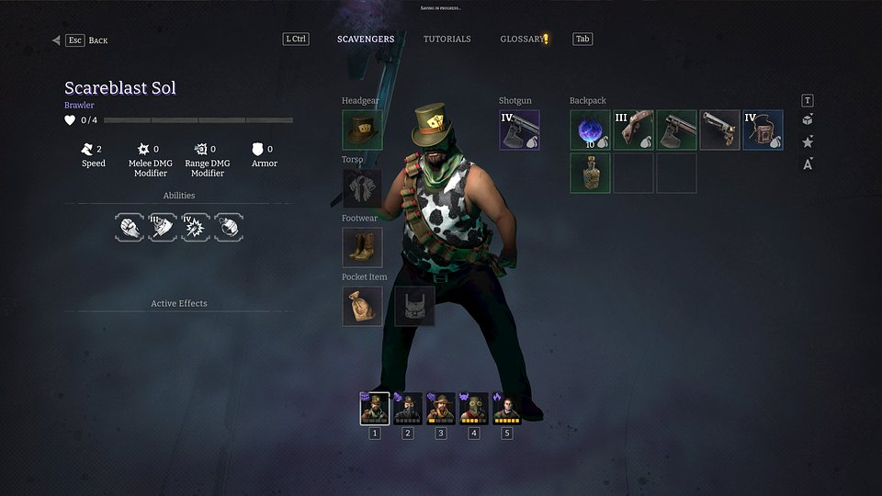

Nightmare Frontier – key features:

● Turn-Based Gun 'n' Slash – a combat system where every detail matters. Nightmare Frontier blends deep tactical gameplay with dynamic combat, using well-known and beloved mechanics from Ice Code Games' previous titles. Push enemies around the battlefield, use the environment to your advantage, chain skills, and get the most out of turn. Showcase your tactical creativity like never before.

● No risk, no reward – in the spirit of extraction looters, players walk the path that leads between risk and opportunity, deciding whether to push deeper into the dark city, risking everything, or retreat to safety and preserve their gains. The greater the risk, the more tempting the rewards – valuable items, resources, and upgrades that can alter the course of the game.

● Otherworldly terror – the titular Nightmare affects all aspects of gameplay – from shaping locations and challenges to the abilities of team members and enemies. Its growing power brings new challenges – every choice and battle is influenced by its increasingly strong presence.

● One more fight – Oversee your team, complete missions, and gather resources to forge powerful weapons. Explore the Nightmare and its dark capabilities by sending your team on dangerous raids into the devastated city, where every step deeper brings you closer to uncovering terrifying secrets.

● Crafted by veterans – Nightmare Frontier builds upon refined and highly praised mechanics known from Hard West 2 (including the famous Bravado), as well as the innovative approach to melee combat showcased in Rogue Waters. Thanks to their previous projects, Ice Code Games has earned a reputation as experts in tactical turn-based games.

Full press kit is available HERE.

Nightmare Frontier is now available in Early Access on Steam for $19.99 / €19.99, with a 25% launch discount. Anyone who wants to see if they can face the Nightmare can also try out the demo. More details about Nightmare Frontier can be found on the official game website and on social media - Facebook, Bluesky and X.

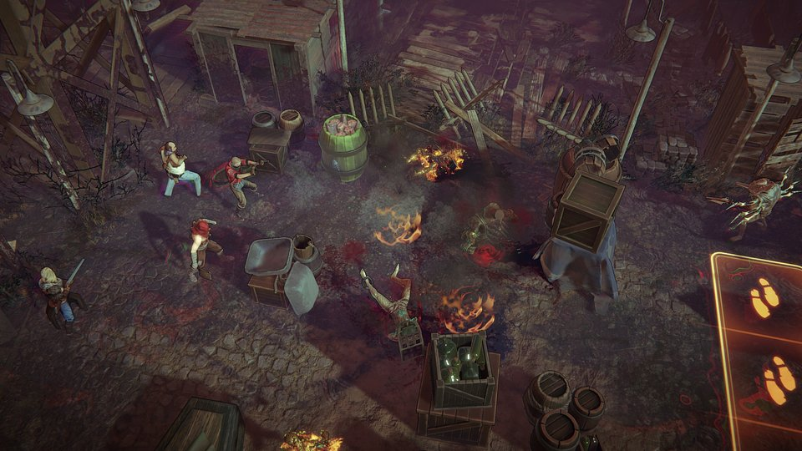

About Ice Code Games:
Ice Code Games is an independent studio based in Warsaw, Poland, best known for the award-winning Hard West 2 and Rogue Waters, released in 2024. The studio specializes in developing strategy, turn-based, and tactical games, and is currently working on a new project titled Nightmare Frontier. Hard West 2 was awarded Best Game and Best Design in the Central &amp; Eastern European Game Awards (CEEGA) in 2023.

