ULTRA PROTECTION AND DESIGN FOR APPLE DEVICES

UNDER EMBARGO UNTIL 06 SEPT 9 AM

Cellularline presents a new special and trendy accessory line for AirPods and iPhone

Cellularline S.p.A., the European leading company in the development and sales of accessories for smartphones and tablets, showcases at IFA 2019 (September 6-11) an accessory line up with a stylish design conceived to ensure maximum protection to AirPods and iPhone.
A variety of products dedicated to those who are always on the move and use their smartphones while working, travelling, training at the gym and during their free time.

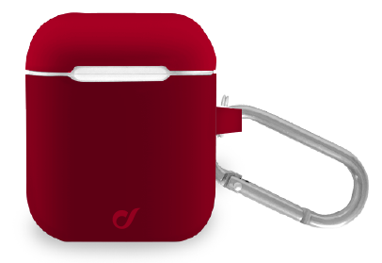
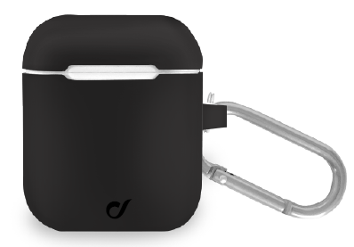
Protection, design, color and innovation: these are the features of Cellularline’s brand new cases designed for AirPods’ users. Pop shades and a stylish touch in three different practical models .

1.BOUNCE
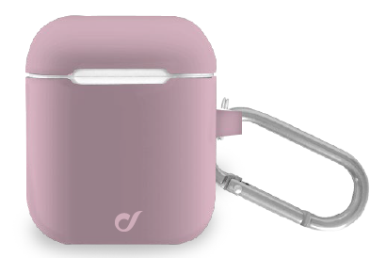
Made of soft-touch silicone and compatible with wireless charge, Bounce protects the AirPods case from any sort of scratch. It is available in four different shades –pink, black, red and white- and presentsa practical hook which can be attached to belts, bags or used to be kept at fingertips in your pockets.
Price: 9,95€

2.DYNAMIC E SPRINT
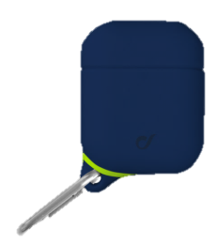
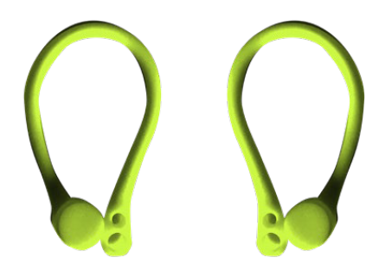
Dynamic and Sprint are practical and handy silicone water-and-dust-resistant cases, designed for those who love doing sport in and outdoor.
DYNAMIC is provided with two rubber headbands in which you can insert the AirPods in order to protect them during the most intensive trainings, and to prevent losing them.
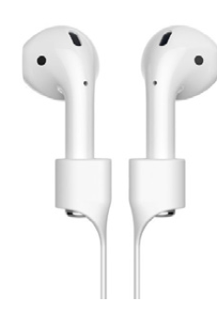
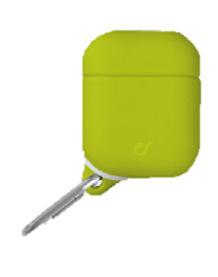
Price: 12,95€

SPRINT is equipped with a light and practical magnetic cord that allows to carry it around the neck. With a simple gesture the AirPods are within earshot and can become the latest accessory to complete your look. Price: 12,95€

UNDER EMBARGO UNTIL 06 SEPT 9 AM
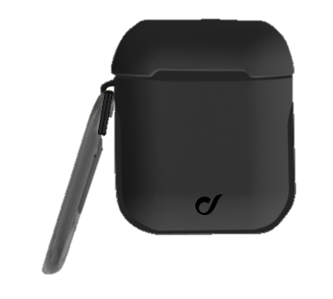
3.DEFENDER
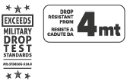
Defender is the ultra protective case certified with Military Drop Test. It can endure up to 4 meters high drops and it’s able to protect the AirPods even from the most reckless usages. Practical and handy, Defender can be carried around thanks to the convenient hook on the side of the case.
Price: 14,95€

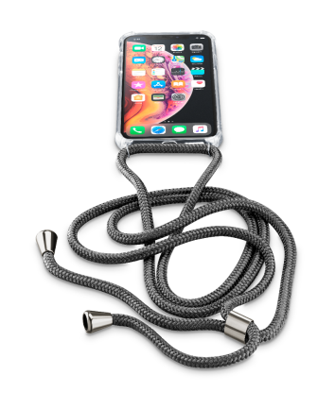
NECK CASE
Your iPhone will become the must-have accessory to show off by carrying it around your shoulder just like a trendy bag, or around your neck like a precious object. Cellularline presents Neck Case for those who want to have their iPhones at hand, ready to shoot selfies, photos or IG stories at any moment. Neck Case is composed by a see-through case with reinforced corners and an adjustable cord, so that you can prevent damages to your smartphones and avoid any risk of loss.
Currently available for iPhone 8/7/6, iPhone Xs/X, iPhone XR, iPhone XI, iPhone XI Max, iPhone XR 2 in pink and black.
Price: 16,95€

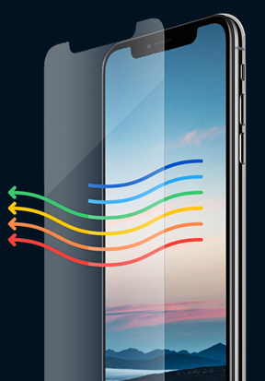
EYE DEFEND
The great amount of time spent in front of smartphones’, tablets’ and PC’s screens can damage our eyes. This applies especially to children as their lens are still being developed. Without the right protection, the blue light shed by these devices can cause several disorders like eyestrain, irritation and headache. Cellularline meets these needs by presenting Eye Defend, the Anti Blue-Light Tempered Glass developed for iPhone screens. A new technology together with a new material designed to prevent color alteration and to maintain the display definition high, assure Eye Defend’s user a protection from blue light 24/7.
Eye Defend’s active protection when combined with night shift mode in the evening hours can power up its effectiveness, without yellowing the iPhone’s display.
Available for iPhone XI, iPhone XI Max, iPhone XR 2, iPhone XR, iPhone Xs/X, iPhone Xs Max, iPhone 8/7
Price: 24,95€

UNDER EMBARGO UNTIL 06 SEPT 9 AM

About Cellularline S.p.A.
Cellularline S.p.A. is the leading company in the accessories’ market for smartphone and tablet. Cellularline brand is the technological and creative landmark concerning the accessories for multimedia devices and aims to offer excellent performances and easy-to-use products for a unique user’s experience. Currently, Cellularline S.p.A. counts about 200 employees and boasts an intercontinental distribution in over 60 countries.

INTERNATIONAL PRESS CONTACTS: SAY WHAT? Srl (Milan, Italy)
Geraldina Soldadino, Senior Account Manager Media Relations: g.soldadino.cons@saywhat.it, Mob. + 39 388 3938334
Letizia Castiello, Junior Account Media Relations: l.castiello@saywhat.it, Tel. +39 02 3191181

PRESS CONTACTS BELGIUM: EVOKE (Etterbeek, Belgium)
Gilles Dujardin, PR Consultant : gilles@evokepr.be, Mob. +32 474 818 999
Ymke Deprez, PR Consultant : ymke@evokepr.be, Mob. +32 479 75 52 32

