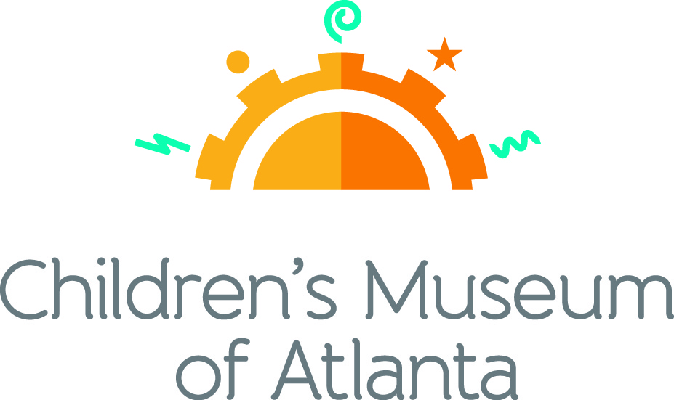

FOR MORE INFORMATION:
Becca Meyer/Jennifer Walker
BRAVE Public Relations, 404.233.3993
bmeyer@bravepublicrelations.com/
jwalker@bravepublicrelations.com

FOR IMMEDIATE RELEASE

Children’s Museum of Atlanta brews up frightful fun with October programming
Programming packed with plentiful tricks, treats and exhibits for local families

ATLANTA (September 18, 2017) – Trick or Treat! Children’s Museum of Atlanta welcomes the city’s favorite season with the annual Trick or Treat at the Museum event, Reading for the Record, cultural holiday celebrations and Sid the Science Kid: The Super-Duper Exhibit! Based on the PBS KIDS television show, Sid’s world is brought to life at the Children’s Museum of Atlanta with a highly interactive exhibit to teach little ones about simple machines, laws of motion and more!

Feature Exhibit: Sid the Science Kid: The Super-Duper Exhibit!
Through January 15, 2018
This thrilling new traveling exhibit brings the award-winning PBS KIDS TV series Sid the Science Kid to life. Children will be able to step into Sid’s world and become “science kids” themselves as they discover and investigate everyday science questions around Sid’s home, at school in the Super Fab Lab and on the playground. Through fun, hands-on activities, kids will use scientific tools to learn about simple machines, the laws of motion, magnetism, air power and the five senses. It’s sure to be a super-duper-ooper-schmooper good time!

Themed daily programming during Sid the Science Kid: The Super-Duper Exhibit! will occur through January 15, 2018. Programming subject to change and may be altered during special events. All programs included with admission unless otherwise noted.

Sid the Science Kid Appearance
Every Monday at 1:30, 2:30 and 3:30 p.m. and Saturday at 11:30 a.m., 12:30 p.m., 1:30 p.m. and 2:30 p.m.
Kids are invited to meet and take photos with Sid the Science Kid on the Children’s Museum of Atlanta stage!

Mini-Musical: Hilarity Academy written by John Jenkins
Weekdays at 11 a.m. and noon; Weekends at noon and 2 p.m.
Congratulations and welcome to Hilarity Academy – a place where science and comedy collide! Children will join Professor Punchline as he teaches Jo King how to incorporate laughter in the world around him.

Story Time
Weekdays at 3 p.m.; Weekends at 1 p.m.
“Sid the Science Kid” books
Little ones can gather around as the Imaginators read all about Sid’s adventures and teach children new science vocabulary.

Music & Movement
Weekdays at 2 p.m.; Saturday at 11 a.m. and 3 p.m.; Sunday at 11 a.m.
Kids can join the Imaginators for some bone-ified fun, featuring a skeleton scavenger hunt and, of course, the Hokey Pokey!

Super Spectacular Science Show
Weekdays at 1 p.m. and Weekends at 4 p.m.
Professor Lab Coat and her assistants will lead a mesmerizing science demonstration for the entire Museum. Throughout October, Professor Labcoat will be sharing spooky science activities! Families can learn about everything from tricky spiders to how spooky sounds are created!
Eat A Georgia Rainbow
Sunday at 3 p.m.
Children will embark on a scavenger hunt and cold cooking activity with the Imaginators to learn more about fruits and veggies harvested in Georgia throughout the year.
Dr. Wondershop: The Science Wondershop with Brian "Dr. Science" Williams
Sundays at 1:30 and 2:30 p.m.
The Science Wondershop offers children the opportunity to explore science through a variety of hands-on activities. The program is designed for adult and child interaction to encourage imagination, curiosity and an interest in our world. Limited space available. A sign-up sheet will be located behind Security and is available on a first come first serve basis for the first 10 children and 10 adults.

Art Studio Projects
Weekdays 10:30 a.m.-3:30 p.m.; Weekends 11 a.m.-4 p.m.
Little ones can discover colors and explore artists from around the world through various crafts like creating 3D teeth models, examining X-Ray pictures, drafting secret messages using invisible ink and making an extra bouncy ball.
Build It Lab
Weekdays, 10:30 a.m.-3:30 p.m.; Weekends 11 a.m.-4 p.m.
Children will put their woodworking and creative tools to the test in this supervised space where they have access to real tools and materials. Encouraging inventions, Build It Lab sparks creativity by allowing young innovators to build items such as an extending grabber using materials such as straws, popsicle sticks and tape.
Science Bar
Weekdays 10:30 a.m.-3:30 p.m.; Weekends 11 a.m.-3:30 p.m.
Science is everywhere, especially on the mezzanine at the Museum! Step Up to Science is the new STEM exhibit area and features interactive exhibits about light, robotics and how the human body works! Families can saddle up to the science bar for a full menu of fun activities, knowledge and have their questions turned into answers by one of the STEM educators. Throughout October, Professor Labcoat is exploring uncanny science! Kids are invited to piece together Bob – the Museum’s model skeleton, create ooey-gooey monster slime and learn what causes things to glow in the dark!

October Special Programming

Celebrate Sukkot
Sunday, October 8
- Special Music and Movement
11 a.m. and 3 p.m.
At 11 a.m., Children are invited to move and groove to traditional Jewish circle dances such as “Hava Nagila” and “Chiri Bim” with Michael Levine of The Learning Groove! "Mr. Michael" Levine is the co-founder of The Learning Groove music and movement classes, as well as the music producer associated with the original New York Times bestselling “Pete the Cat” picture books.
At 3 p.m., Imaginators will teach little ones simple dance steps to traditional Klezmer music.
- Special Performance by Michael Levine
Noon
Families can join Mr. Michael as he shares interactive songs and stories that celebrate the Jewish holiday of Sukkot. Audiences will laugh, sing, dance, shake, wiggle and giggle to the beat of this joyful holiday celebration.
- Special Story Time
1 p.m.
“Sammy Spider’s First Sukkot” by Sylvia Rouss
Little ones can gather around as the Imaginators highlight the Jewish holiday of Sukkot with a special story time. Sukkot appreciates the shelter that homes provide. The original Sukkah was a shelter built by the Jewish people traveling to Egypt. In Sylvia Rouss’ book, Sammy Spider learns first-hand about the festival of Sukkot by watching the Shapiro family build their sukkah.
- Art Studio
11 a.m.-4:30 p.m.
Families are invited to create colorful paper flowers together! During Sukkot, a special Jewish holiday, families come together to create a sukkah, a basic walled structure where everyone enjoys each other's company and eats a delicious feast. The sukkahs are always filled with lots of decorations such as paintings made by children, flowers, fruits and vegetables to hang from the ceiling.
- Build-It -Lab
11 a.m.-4:30 p.m.
Little ones can use real tools and materials to create a miniature sukkah out of wood, branches and cardboard. Under supervision, children will have access to materials needed to spark creativity, nurture curious minds, and ignite the next wave of innovators.

Celebrate Diwali: A Cultural Exploration
Saturday, October 14
- Kahaaniya for Kids Puppet Show
11 a.m. and 1 p.m.
Kahaaniya for Kids will present a Diwali puppet show featuring narrative dance as told from the perspective of an unsung hero. Little ones will learn about perseverance, loyalty, courage and bravery.
- Special Story Time
Noon and 3 p.m.
Kahaaniya for Kids will present a special interpretation of the story of Diwali based on “Amma, Tell Me About Diwali” by Bhakti Mathur.
- Special Music and Movement
2 p.m.
Families are invited to join Kahaaniya for Kids in a traditional Indian dance performance and interactive game.
- Art Studio
11 a.m.-4:30 p.m.
In honor of Diwali, the festival of light, children can craft a compact disc candle holder.
- Build-It-Lab
11 a.m.-4:30 p.m.
Little ones can use real tools and materials to nurture the curious mind. Under supervision, children will have access to woodworking and other popular maker skills.

Read for the Record
Thursday, October 19
This special event is in support of Jumpstart’s Mission: to work toward the day every child in America enters kindergarten prepared to succeed. Families can visit Children’s Museum of Atlanta for an adventurous morning filled with activities.
- Special Story Time
10:30 a.m., 11:30 a.m. and 3 p.m.
“Quackers” by Liz Wong takes little listeners through a day-in-the-life of a cat who thinks he is a duck. “Quackers,” which will be ready by children all across the country on this date, teaches children about standing out, fitting in and building a life with room for everyone!
- Mini Musical
2 p.m.
Grab those dancing shoes and join the Imaginators for a dance off! Families will learn the Stray Cat Strut, Disco Duck and other fun numbers inspired by “Quackers!”
- Art Studio
10:30 a.m.-3:30 p.m. Kids can participate in a special Read for the Record craft to create a personalized puppet!
- Build-It Lab
10:30 a.m.-3:30 p.m.
Little ones can use real tools and materials to nurture the curious mind and learn all about levers! Under supervision, children can build an extending grabber using popsicle sticks, straws and tape.

Halloween
Tuesday, October 31
- Super Spectacular Science Show
1 p.m.
Professor Lab Coat and her assistants will lead a mesmerizing science demonstration for the entire Museum. As a special Halloween treat, Professor Labcoat will be sharing spooky science activities! Families can learn about everything from tricky spiders to how spooky sounds are created!
- Special Music and Movement
2 p.m.
Sid the Science Kid will lead families around the Museum for a spooktacular Halloween parade. Following the parade, little ones can join the Imaginators as they take the stage with a Halloween Soul Train Dance party.
- Special Story Time
3 p.m.
Children can gather around as the Imaginators brew up spellbinding stories in honor of the hair-raising holiday!
- Science Bar
10:30 a.m.-2:30 p.m.
To continue the tricks and treats, Professor Labcoat will explore uncanny science! Kids are invited to piece together Bob – the Museum’s model skeleton, create ooey-gooey monster slime and learn what causes things to glow in the dark!
- Art Studio
10:30 a.m.-3:30 p.m.
Abracadabra! Young artists are invited to make magnificent magician’s hats.
- Build-It-Lab
10:30 a.m.-3:30 p.m.
Time to get festive! Little ones can use real tools and materials to create a spider for Halloween. The spider can be crafted with plenty of imagination, squiggly eyes and furry legs!

October Ticketed Events

Girl Scout Day
Saturday, October 14 from 10:30 a.m. – 4:30 p.m.
Local Girl Scouts can join Children’s Museum of Atlanta’s special guests, Kahaaniya for Kids, to explore Diwali, the Hindu festival of lights, through a variety of activities. One of the most popular festivals of Hinduism, Diwali spiritually signifies the victory of light over darkness, good over evil, knowledge over ignorance and hope over despair. Girl Scouts will learn about the cultural significance of the holiday through interactive performances and stories about the holiday, traditional dance and costumes and special projects in the Art Studio and Build It Lab.

Scouts can explore and earn badges in learning zones on the exhibit floor. Scout badges are not provided by Children’s Museum of Atlanta. Children’s Museum fun badges are available for purchase in the gift shop.

Exclusive discounted tickets are $13.95 per person, plus tax and are available for troops and Girl Scout families. To receive the discount, troops can use code GS2 online or call 404.527.3693 and must wear uniform or sashes the day of the event.

Trick or Treat at the Museum
Saturday, October 21 from 6:30-8:30 p.m.
Calling all ghosts, goblins and boo’tiful princesses! One of Atlanta’s most popular family-friendly trick or treating events is back with Halloween-themed arts and crafts, science experiments, playtime, prizes and surprises. Tickets are $8 (members) and $18 (non-members) and must be purchased in advance. Ticket prices will increase after October 16. Due to high demand, no tickets will be sold at the door.

On-going Monthly Programs

Target Free Second Tuesday
Tuesday, October 11 from 1-6 p.m.
Children’s Museum of Atlanta invites local families to visit the Museum free of charge on the second Tuesday of each month. Registration for Target Free Second Tuesdays will be available exclusively online through the Museum’s website (childrensmuseumatlanta.org) the day prior to each event to create a seamless process for guests. Patrons will be able to choose from two sessions listed below:
- Session 1: 1 p.m. – 3:15 p.m.
- Session 2: 3:45 p.m. – 6 p.m.
Guests who do not register in advance will be admitted on a first come, first serve basis pending availability.

Sewing Thursdays
10:30 a.m.-3:30 p.m.
Children, along with parents and guardians are invited to sew a master creation together! The classes are open studio type, designed to spark imaginative thinking and collaborative work. The fabric, thread, sewing machine and professional instruction is provided. It’s the perfect time to learn something new!

Special Toddler Programs

Tiny Club Monday
10:30 a.m.
Designed for little minds, Tiny Club Monday offers FOODiE Club, SCiENCE Club, ARTiST Club and BUiLDER Club for children ages 2-5 and caregivers to enjoy together. The classes are each 30-minutes and offer hands on activities, professional instruction and the chance to create and learn something new!

Messy Thursdays
10:30 a.m.
Little visitors and guardians are invited to get messy! Messy Thursdays offer slime, finger painting and more! Let the Children’s Museum of Atlanta clean up the mess while the little ones have a blast. There are new, messy activities every week to try, offering endless opportunities.

Toddler Jam Fridays
10:30 a.m.
Rock and roll into the weekend with this high energy, music-filled class guaranteed to shake out the wiggles and foster a love of music. Each week offers new songs, instrument play, circle time activities and, of course, dance breaks.

For more information on the April program offerings or to support Children's Museum of Atlanta, visit childrensmuseumatlanta.org or call 404.659.KIDS [5437].

About Children’s Museum of Atlanta:
Children’s Museum of Atlanta is the only educational venue of its kind in Atlanta, presenting educational programs and exhibits designed for young children ages 0-9. The Museum’s mission is to spark imagination and inspire discovery and learning for all children through the power of play. With six permanent learning zones consisting of bright, creative and hands-on exhibits, the Museum supports inventive play-based exploration and experiential learning focused on the whole child. Core competencies for literacy, math and science are promoted throughout all exhibits and programming in alignment with the state and national Core Performance Standards. The Children’s Museum of Atlanta also offers parties, memberships, field trips, summer camp and private events. For more information or to support Children's Museum of Atlanta, visit childrensmuseumatlanta.org or call 404.659.KIDS [5437].

Major support is provided by the Mayor’s Office of Cultural Affairs. Major funding for this organization is provided by the Fulton County Board of Commissioners.

Museum Admission: General Admission is $15.95 (plus tax) for anyone 1 – 100 years old. Babies and members are admitted for free. All daily programs are included in price of admission. Group rates and military discounts are available. For more information regarding ticket and membership options, visit childrensmuseumatlanta.org/plan-your-visit/faqs/.

Museum Hours: Monday, Tuesday, Thursday and Friday 10:00 a.m. – 4:00 p.m.; Saturday and Sunday 10:00 a.m. – 5:00 p.m.; Closed on Wednesdays. Please check the Museum website to confirm hours of operation.

Facebook: https://www.facebook.com/childrensmuseumatlanta
Twitter: https://twitter.com/ChildMuseumATL
Instagram: https://www.instagram.com/childrensmuseumatlanta
Pinterest: http://pinterest.com/cmatlanta
###

