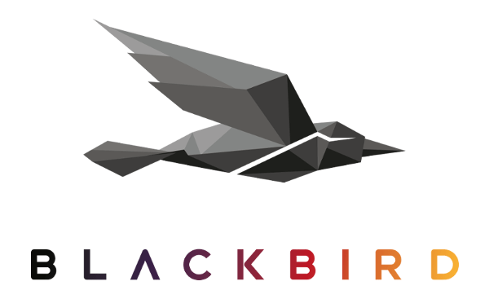

NAB 2019: Xytech Systems, Blackbird Partner to Streamline Asset Management Process for MediaPulse Users

The partnership will bring Blackbird’s leading cloud video platform to Xytech’s best-in-class facilities management software

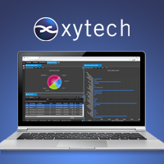
Las Vegas, April 2, 2019 — Xytech [NAB 2019 booth SL4705], leaders in facility management software for the broadcast, media services and video transmission industries, and Blackbird [NAB 2019, booth SL6716], the market-leading cloud video platform, have partnered to offer a frame accurate codec player in the version 9 of Xytech’s MediaPulse facility management software system. This partnership will help streamline the asset management process for users of MediaPulse version 9, announced at NAB 2019, and provide users with a real-time, accurate HTML5 viewer featuring compete access security for all files.

Based in the cloud, the Blackbird player will provide MediaPulse users with an efficient, cost-saving viewer through a streaming proxy codec. By using the integrated player during their workflow, post-production professionals are now able to frame-accurately play, jog and shuttle backwards and forwards through their video content at multiple speeds, all in the cloud on bandwidth as low as 2 MB per second. Since the content is streamed, deleting the source file instantly renders all stream void for an added a layer of security.

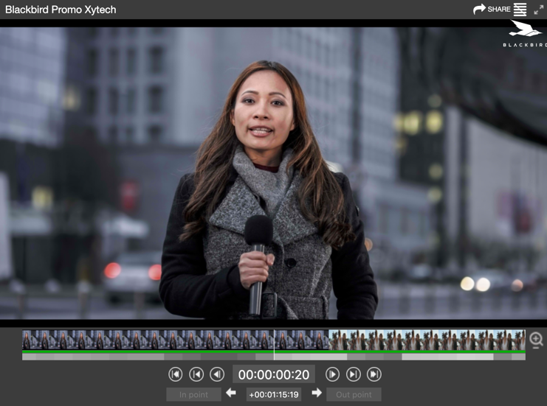
“This strategic partnership with Blackbird brings real-time viewing features to MediaPulse users supporting Asset Management and Promo Workflows,” said Greg Dolan of Xytech. “Post-production professionals will be able to securely and accurately access and view video content using Blackbird and do it all on a nominal connection right from MediaPulse. Blackbird shares our vision of intuitive User Experiences. This partnership is a great fit.”

Ian McDonough, CEO of Blackbird developer Forbidden Technologies, said: “We’re thrilled Xytech has chosen to integrate Blackbird into their market-leading facility management software, MediaPulse. Blackbird’s unique power and agility will enable Xytech’s customers to frame-accurately access and view their video content at speed delivering significant efficiency benefits. Blackbird is increasingly being recognized by companies globally who need lightning-fast access and management of their video content. Our partnership with Xytech is perfectly aligned with our strategic OEM model for Blackbird as we gain further market adoption in the key US market and beyond.”

The Blackbird version 9 player will be available with the 2019 MediaPulse release version 9 due out in June 2019.
Xytech will be exhibiting at the upcoming 2019 NAB Show from April 8-11, 2019. Located at booth SL4705, Xytech will demonstrate the new features of its leading facilities management software MediaPulse, including the Blackbird codec player. Those interested in scheduling an appointment may contact Alexandra Kuipers at akuipers@xytechsystems.com, + 1 (818) 698-4958.

Blackbird will be exhibiting at the 2019 NAB Show from 8 – 11 April on Microsoft’s stand, SL6716.

About Xytech Systems: For 30 years, the world’s premiere media companies have depended on Xytech to run their businesses. MediaPulse is the only end-to-end solution for the complete content lifecycle. MediaPulse provides scheduling, automation, asset management, billing and cost recovery for broadcasters, media services companies and transmission facilities in a scalable platform-independent solution.

For more information, visit xytechsystems.com

About Forbidden Technologies & Blackbird: Forbidden Technologies plc (AIM: FBT, www.forbidden.co.uk) floated in February 2000. Forbidden develops, markets and licenses a powerful cloud video platform using its patented Blackbird technology. The technology underpins multiple applications, which are used by rights holders, broadcasters, sports and news video specialists, eSports live events and content owners, post-production houses, other mass market digital video channels and corporations. The Blackbird technology allows full visibility on multi-location digital content, improves time to market for live content such as video clips and highlights for social media distribution, and results in much more effective monetization. Blackbird® is a registered trademark of Forbidden Technologies plc.

For more information, visit blackbird.video.

Media Contacts:

Katie Kailus
Public Relations
Hummingbird Media
+1 (630) 319-5226
katie@hummingbirdmedia.com

Jeff Touzeau
Public Relations
Hummingbird Media
+1 (914) 602 2913
jeff@hummingbirdmedia.com

