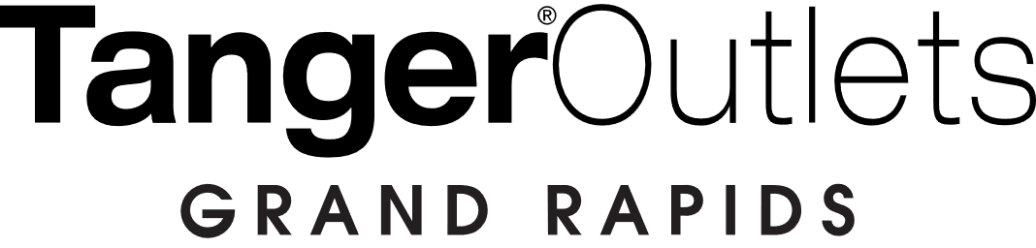

FOR MORE INFORMATION
Britain Bennett
BRAVE Public Relations
404.233.3993
bbennett@emailbrave.com

*MEDIA ADVISORY*
Tanger Outlets brings an explosion of color to Grand Rapids with art festival, June 18-20
West Michigan Chalk Arts Festival returns to Tanger Outlets Grand Rapids

GRAND RAPIDS, Mich. (June 11, 2021) – Tanger Outlets Grand Rapids is hosting the Byron Community Wellness Foundation’s West Michigan Chalk Art Festival sponsored by Serra Honda Grandville from Friday, June 18-Sunday, June 20. The chalk art festival is an imaginative, family-oriented experience allowing artists to express their creativity through sidewalk chalk murals for the chance to earn coveted prizes and share their work with the West Michigan community.

Artists traveling across the country will be inspired by the festival’s theme – wellness – fueling their originality as they compete for dynamic titles, such as People’s Choice, Best 3D and Best Use of Color. Registration will be open until June 19 for entrants of all skill levels to participate., The community is invited to explore the vibrant creations throughout the weekend!

Guests will enjoy free festival favorites, including DJ music, caricature artists and a KidsChalk event for children up to age 11 on Saturday, June 19. Judging will take place from 3 p.m. to 5 p.m. on Saturday.

WHAT: West Michigan Chalk Art Festival
Tanger Outlets to host free, family-oriented art festival to showcase Michigan artists and support the Byron Community Wellness Foundation.

WHEN: Friday, June 18: 10a.m. – 9p.m.
Saturday, June 19: 10a.m. – 9p.m.
Sunday, June 20: 10a.m. – 7p.m.

WHERE: Tanger Outlets Grand Rapids
Byron Center
350 84th St SW
Byron Center, MI 49315

HOW: Artists can register for limited number of spaces at wmcaf.com. The event is free and open to the public for spectators.

For more information on registration and artist participation, please visit wmcaf.com.

To learn more or connect with Tanger Outlets Grand Rapids, please visit tangeroutlets.com/grandrapids.com

###

