Sennheiser and 1 Beyond announce advanced camera tracking solution for TeamConnect Ceiling 2

Sydney, Australia, November 22, 2021 – Audio specialist Sennheiser and 1 Beyond, industry leader in camera tracking solutions, announce the release of a new camera tracking solution that offers voice-activated camera tracking for rooms of any size: classrooms, boardrooms, multi-purpose meeting spaces and more.

Customers are enjoying the integration of the 1 Beyond Automate VX and Sennheiser’s Team Connect Ceiling 2 (TCC2). Integrators have deployed the pair at financial institutions, universities and hospitals since the summer of 2021.

This solution leverages the audio quality and accurate beam position information provided by the TeamConnect Ceiling 2 microphone array combined with 1 Beyond’s advanced camera positioning algorithm to offer close-up shots of people speaking in a room, whether they are seated or standing anywhere in a room.

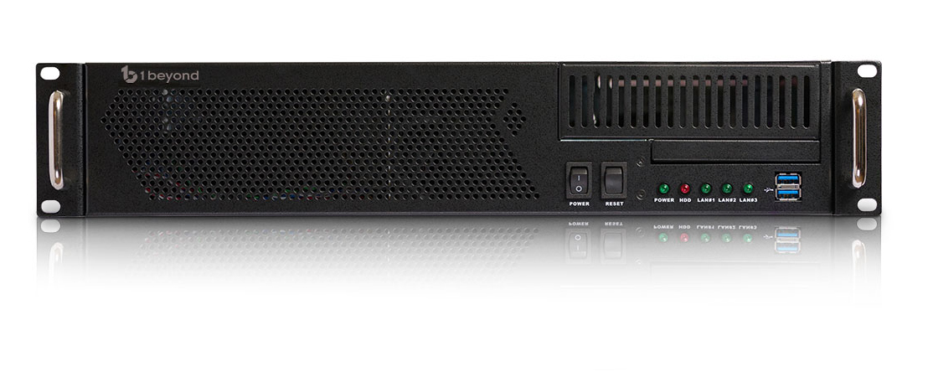 | 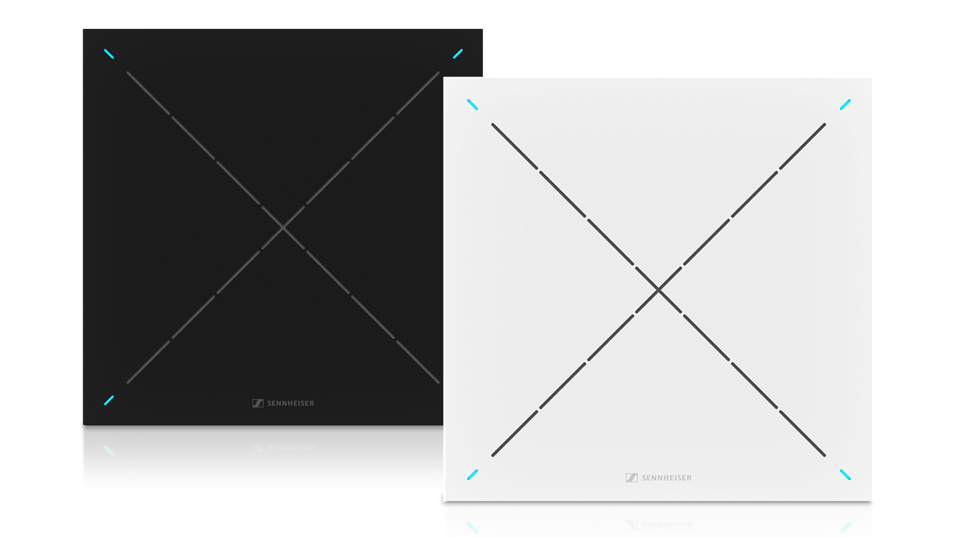
The combination of 1 Beyond Automate VX (left) and the Sennheiser Team Connect Ceiling 2 provides voice-activated camera tracking for classrooms, boardrooms and multi-purpose meeting spaces

Multiple ceiling microphones can be combined to cover larger spaces and up to 12 cameras can be placed anywhere to get the best camera angles regardless of where the speaker is located.

Some of the distinguishing features of this solution include:
- An intelligent switching algorithm: with multiple cameras the remote participants see broadcast style cuts and no camera movement
- Auto-configuration based on a room design: No camera presets need to be set manually
- Customisable shot widths: the installer can select how tight or broad the camera angles should be
- Ability to distinguish between seated and standing participants: uses the microphone’s reported height as well as horizontal position of the talker
- More possible camera angles per microphone: The beam can point to up to 700 unique positions giving more precise audio location information
- Multi-source layouts: show wide shot of room along with active speaker for context
- Discussion mode that shows the two most recent talkers in side-by-side

“1 Beyond offers advanced camera tracking that pairs perfectly with the TCC2 microphone array,” explains Charlie Jones, Global Alliance and Partnership Manager for Sennheiser. “Unlike other products in the market, the TCC2 does not limit the number of zones you can use for camera tracking. This allows the real-time positional information from the microphone to automatically switch the cameras to the optimal view, regardless of where the speaker is located in the room, ensuring a lifelike meeting and classroom experience for remote participants. 1 Beyond has even automated the system setup resulting in a system that is extremely powerful while still easy to deploy.”

“1 Beyond’s Automate VX solution has been on the market for over four years and is a mature product with many advanced features,” says Terry Cullen, CEO/Founder, 1 Beyond. “We’re excited about this partnership. The combination of Sennheiser and 1 Beyond technologies really advances the state of the art for voice-tracking camera solutions”.

See the solution in this short video demo: www.1beyond.com/automate-vx/
Contact sales@1beyond.com for more information or book a TCC2 demo slot with Sennheiser here.

About 1 Beyond, Inc.
1 Beyond, Inc. designs and manufactures automated camera solutions for streaming, recording and video conferencing. Specialising in intelligent tracking cameras and automatic multi-camera switching systems, 1 Beyond provides an enhanced video communications experience for universities, corporations and government organisations without increasing the need for production or IT staff. www.1beyond.com

About Sennheiser
Shaping the future of audio and creating unique sound experiences for customers – this aim unites Sennheiser employees and partners worldwide. The independent family company, which is managed in the third generation by Dr Andreas Sennheiser and Daniel Sennheiser, is today one of the world’s leading manufacturers of headphones, loudspeakers, microphones and wireless transmission systems. In 2020, the Sennheiser Group generated turnover totalling €573.5 million. www.sennheiser.com

Local Press Contacts

Gabby Wallace
gabby.wallace@groundagency.com
+61 431 045 932

Caitlin Todd
caitlin.todd@groundagency.com
+61 410 781 849

Daniella Kohan
daniella.kohan@sennheiser.com
+1 (860) 598 7514

