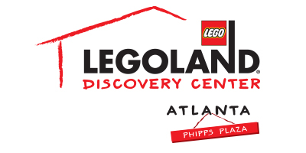
Media Contact:
Katie Clark
BRAVE Public Relations
404.233.3993
kclark@bravepublicrelations.com

**MEDIA ADVISORY**

LEGOLAND® Discovery Center Atlanta to host LEGO® NINJAGO® Adult Night, October 19
Adults invited to channel their inner ninja

ATLANTA (October 5, 2017) – In the spirit of the newly released film, adult fans of LEGO® are invited to discover their inner ninja during LEGO NINJAGO® Adult Night at LEGOLAND® Discovery Center Atlanta on October 19 from 7 – 9 p.m. Guests can enjoy a themed scavenger hunt, a ninja skills challenge, LEGO build activities and so much more!

WHAT: LEGO NINJAGO Adult Night

WHEN: Thursday, October 19 from 7 – 9 p.m.

WHERE: LEGOLAND Discovery Center Atlanta
Phipps Plaza | Buckhead
3500 Peachtree Road NE
Atlanta, GA 30326

HOW: Tickets can be purchased at the door for $19.95 or online ahead of time for $14.95. Purchase online by visiting www.atlanta.legolanddiscoverycenter.com.

For more information, visit www.facebook.com/LDCatlanta
or www.atlanta.legolanddiscoverycenter.com.

