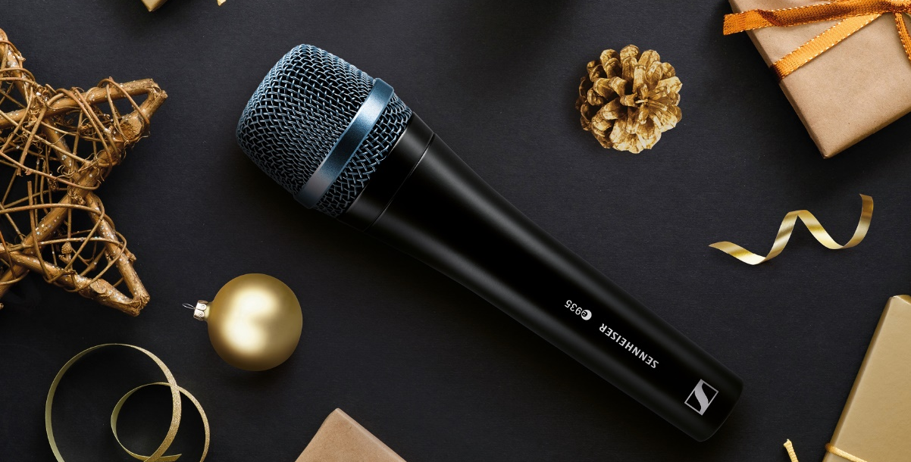
The mic before Christmas: How to capture the perfect festive sound
How the right technique and microphone can help recreate the sound of Christmas

Wedemark, December 3, 2020 – While motorists sing along to “Driving home for Christmas” on the car stereo, others are staying in to enjoy a “Silent Night”. It’s that special time of year when we go misty eyed over a “Last Christmas”’ heartbreak while “All I want for Christmas is You” offers a promise of better things. No matter the emotions – and 2020 has certainly given us all plenty of ups and downs – there’s a definite magical quality in the air when Christmas songs and carols start to play. But maybe there’s more to the Christmas sound than magic? Maybe the secret to capturing Christmas sounds and music lies in the recording, the right microphone and the right technique? Expert sound engineer Carsten Kümmel offers tips for sparkling results.

Sound experiments in your own four walls
Carsten Kümmel knows how this Christmas mood can be created musically with Sennheiser microphones: The well-known sound expert is not just an expert tonmeister and sound engineer with many years of experience, but also teaches as Professor for Public Address and Live Recording at Darmstadt University of Applied Sciences.

Kümmel reveals tips and tricks for perfect recordings: “It does not necessarily always have to be an MKH condenser microphone from the professional class,” explains the audio expert.
“Even simpler dynamic microphones, which don’t require you to dig quite so deeply into one’s pockets, can let you achieve outstanding results. However, it’s vital that the right microphones are used correctly.”

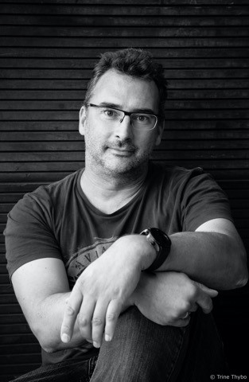 | The well-known sound expert Carsten Kümmel is an expert tonmeister and sound engineer with many years of experience and teaches as Professor for Public Address and Live Recording at Darmstadt University of Applied Sciences  Photo credit: Trine Thybo

According to Carsten Kümmel, you should, whenever possible, ensure that the room is not too small when recording at home, because otherwise the recording will sound “small”, too. This is caused by what is known as “early reflections”. They hit the microphone diaphragm very early and with high intensity in small rooms – a spacious living room is therefore more suitable for a good sounding recording than a cramped little storage room. If a reverberant sound image is required, you can even experiment by using staircases or bathrooms.

In other words, the room in which a recording is made has a significant influence on the sound character of a recording. If you do it skillfully, your own four walls already offer quite a few possibilities.

Capture the sounds of Christmas – Fireplace crackles, cookie crunches and reindeer
Mic technique can also help to capture all those subtle sounds that help make up the ambience of the festive season. For natural sounding recordings, a suitable distance between the microphone(s) and the sound source is important to achieve a balanced spatiality. Obviously with a crackling fireplace fire, it’s sensible to avoid getting too close to the blazing logs with any sort of microphone. The goal, however, is to get the balance right and ensure an optimal relationship between direct sound and the reflections resulting from the surrounding room (“reverberation”).

Of course, when shooting in the forest, you don't have to deal with room reflections - so if you want to record steps in the snow or cracking branches outdoors, you can easily get close to the source of the sound. However, recording reindeer in the wild needs a bit more space and care: Set up the camouflage tent at a safe distance and use a shotgun microphone such as the Sennheiser MKH 70-1 or MKH 8070 to capture the hoarse calls or the characteristic clicking sounds of reindeers’ steps.

What about bringing out those small, yet evocative sounds like nibbling cookies or sipping hot mulled wine? No doubt it’ll be easy to find helpers to enjoy the treats but to make recordings a little more effective the right mic technique can help: With the legendary Sennheiser models MD 441 (ideal for high sound pressure levels and featuring a fast transient response) or MD 421-II, you can position yourself as close as possible to the sound event and experience the results in a suitably festive ASMR video.

As a rule of thumb: the larger the sound source, the greater the distance. But that doesn’t mean driving out to the next village with your mics to record Christmas church bells - a shotgun microphone such as the universally popular Sennheiser MKH 416 can be the tool of choice here. Sometimes, a friendly conversation with the local church can work wonders with regard to finding a perfect recording location. It’s certainly one way to escape the Christmas pop songs, but don’t forget to wear ear protection if you get to climb up the bell tower! Or better still, try that shotgun mic from a sensible distance…

Ding-a-ling with “Jingle Bells”
One of the ultimate Christmas classics is “Jingle Bells”, which surely owes a huge part of its appeal to the imagery it conjures up of a cheerful sleigh ride through a snowy landscape with the rhythmic ting-a-ling of bells.
“The Sennheiser e 914 is ideal for picking up this sort of sound or bells of any kind,” says Carsten Kümmel. “The e 914 is a high-quality, yet affordable condenser microphone with excellent dynamic range. Thanks to its silky high-frequency response, professionals like to use it for miking a hi-hat or as an overhead solution. With a reasonable distance of 80cm or 1 m, the e 914 is perfectly suited for a bell strap. Of course, you can also use a dynamic handheld microphone such as the Sennheiser e 935, if available, but in this case, you would have to choose a slightly smaller distance from the sound source.”

Percussion for the “Little Drummer Boy”
The same applies to the soprano glockenspiel, beloved of children thanks to its colorful steel bars: if you get too close to the glockenspiel, the sound plates located in the immediate vicinity of the microphone capsule will be picked up much louder than the rest of the instrument – so here too, it is advisable to place a Sennheiser e 914 at a suitable distance.

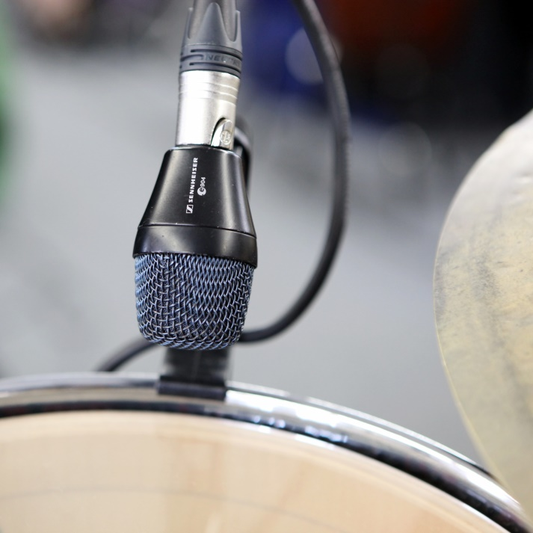 | If the drum sounds too thin, it is recommended to bring the microphone close to the instrument

This approach is also useful for percussive instruments of all kinds: If, for example, the “Little Drummer Boy” (with its irrepressibly catchy, “Pa rum pum pum pum”) is on your Christmas set list, the snare drum may sound unintentionally thin. Carsten Kümmel has a tip: “If additional low-frequency components are required, a microphone such as the universally applicable Sennheiser e 614 with super-cardioid pick-up pattern or the legendary Sennheiser MD 421-II can be brought close to the instrument: The closer you bring the capsule to the sound source, the more the proximity effect becomes apparent. This effect emphasizes low frequencies – so the selected distance can be used to influence the warmth or the low-frequency sound components, which should not be underestimated in terms of their effect on the overall sound.”

Experimenting and simply trying things out also applies here: Kümmel recommends making a test recording, listening to it carefully and then adjusting the microphone position – this way you will find the sound you want faster than you thought.

Kids, Christmas carols and recorders
For many people, kids with recorders aren’t exactly the height of listening pleasure but some things just have to be done. At Christmas, many of us get to sample the pleasures of children playing carols on their recorders – usually with enthusiasm sure to melt the hearts of parents and grandparents. How best to capture this… delightful… sound?

“It would be a mistake to point the microphone at the recorder’s bell,” explains Carsten Kümmel. “To capture a recorder well, a mono recording with one microphone is sufficient. I would position the mic at a distance of about 50 to 60 cm from the instrument, and above the recorder, as the sound only comes out of the bell if all finger-holes are closed.”

As with any recording of acoustic instruments, it is advisable to use your ears to choose the best possible microphone position: Move around the player and listen very carefully to where in the room the sound is most beneficial. Kümmel: “The Sennheiser e 914 is a good choice for an instrument like a recorder. Among the audio specialist’s long-established models, there are also interesting dynamic microphones such as the MD 421-II or the MD 441 which would also be good options for recorders.”

Warming up winter with brass instruments
With brass instruments like trumpets, the positioning of the microphone can be used to direct the sound accurately in a desired direction and influence its nature: “The sound of the trumpet comes from its bell,” Carsten Kümmel points out. “The sound characteristic can be influenced by moving the microphone position from the middle of the bell to the side – the further out you go, the warmer the sound. With a classical Christmas carol, I would like to go clearly out of the middle, and preferably at an angle of well over 45 degrees, because the trumpet then sounds very warm. If, on the other hand, you want a big band sound with a trumpet that tends to sound sharp, you can also experiment with the 0-degree axis.”

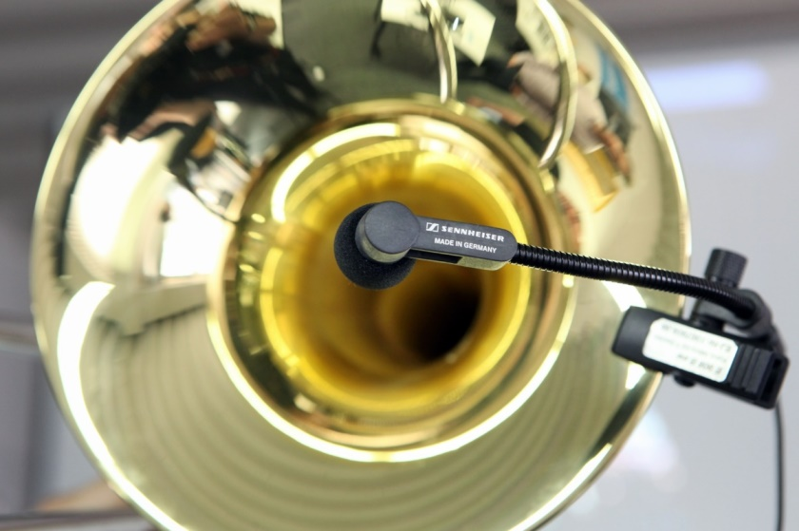 | By positioning the microphone correctly, the sound of the trumpet can be accurately directed in the desired direction

Kümmel offers a few more specific microphone recommendations: “A large-diaphragm microphone like the Sennheiser MK 4 would be a good choice for the trumpet. An alternative would be microphones such as the Sennheiser e 908 B gooseneck, which can be conveniently clipped to the bell where it ensures a consistent sound thanks to its constant distance. In a recording context, however, I would personally prefer a certain degree of ambience – and would rather recommend mounting the microphone directly onto the instrument for live concerts in noisy surroundings. Best suited for the trumpet are long-established Sennheiser models such as the MD 421-II or the popular MD 441, which some people may own already.”

Christmassy violin sounds
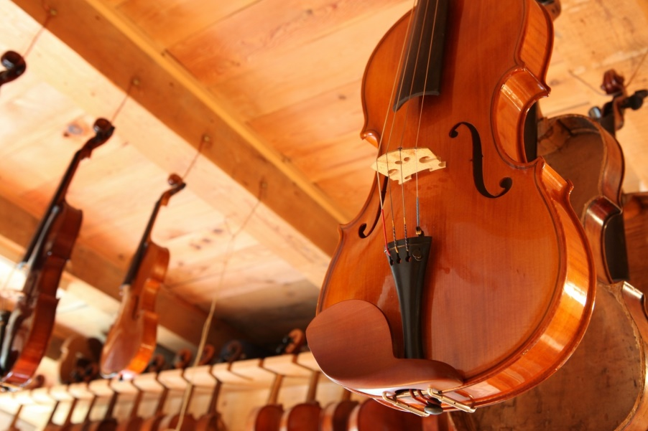 | When recording violins, care should be taken to ensure that the radiated frequencies can mix fairly homogeneously before they hit the microphone

Strings, too, are a mainstay of the Christmas sound – just think of songs like “Silent Night”. According to Carsten Kümmel, it is important when recording a violin that the radiated frequencies can mix fairly homogeneously before they hit the microphone. According to Kümmel, while clip-on microphones are really the only method of choice for violins on loud stages, Sennheiser condenser models such as the e 914 or products from the Sennheiser MKH series are much more suitable for picking up violins. In his judgement as an expert tonmeister, a Sennheiser MK 4 or an MK 8 would also be well suited to the task. The microphone should be positioned at a height of about one meter above the instrument; Carsten Kümmel recommends an angle of 90 degrees to the top of the body. If two violin players are to be recorded, a single microphone can still provide an attractive sound; in this case the mic should point into the area between the two instruments.

Stereo recordings usually bring out the best in violins, two condenser microphones are the best choice. Position two Sennheiser MK 4 or e 914 in an A-B set-up at about 15 to 30 cm from each other. Both microphone signals are recorded at the same level; in the mix, one of the signals is later outputted to the left speaker, while the other is assigned to the right speaker. “The stereo effect can sound absolutely beautiful on violins and is usually more impressive than a mono recording,” emphasizes Kümmel.

An alternative to the A-B technique is X-Y stereo, where the capsules of two directional microphones are brought as close together as possible at an angle of 90 degrees to each other. As Kümmel explains: “An X-Y recording usually sounds less spatial than A-B stereo – however, if the instrumentalists are very active, you will end up with a more constant sound image in the recording.”

“Silent Night” on the guitar
Whether nylon or steel strings: Carsten Kümmel recommends that when recording an acoustic guitar, it’s vital to search with your own ears for the best possible microphone position before starting the recording. “It may well be that the sound near the sound hole is clearly too warm,” he explains. “By the way, you should definitely avoid using the pickups built into some acoustic guitars – such electric pickups are definitely not the right choice for Christmas music!”

As with other instruments, Carsten Kümmel recommends sufficient distance between sound source and microphone for a natural sound character. According to Carsten Kümmel, there is no need to worry about fingering noises: “The noises that arise when you touch the strings are essential for the sound of the instrument,” says the sound expert. “They are simply part of an acoustic guitar.”
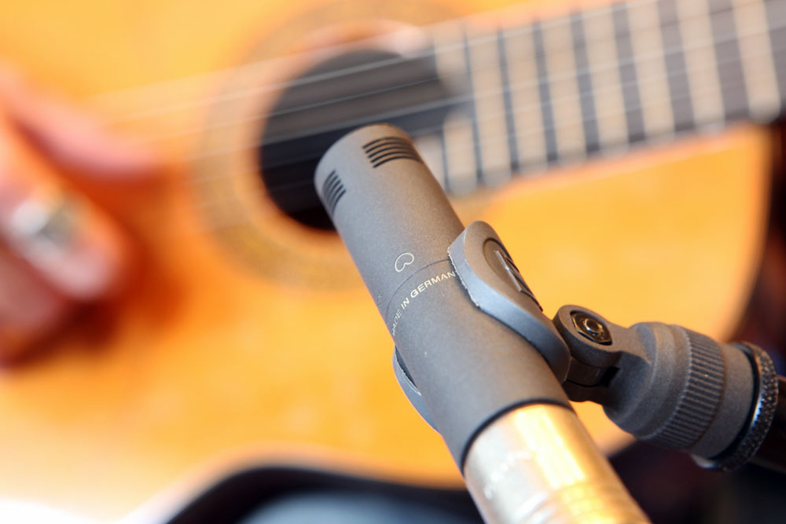 | To find the ideal position for the microphone to record an acoustic guitar, it is worth listening carefully

With two microphones, beautiful stereo effects can be achieved on acoustic guitars – especially when a comparatively wide A-B set-up is chosen. In this context, Carsten Kümmel prefers condenser microphones such as the Sennheiser e 614, which is also affordable for smaller budgets. A good choice would also be “usual suspects” such as the e 914, the MK 4 and the entire Sennheiser MKH series.

Squeezing perfect recordings from the accordion
For many countries, the accordion features frequently on Christmas music. Simply put, the sound production of an accordion is divided into two areas: The left hand controls the bass, while the right hand is responsible for the melody by means of the keyboard / button bar. The two sides are connected by a flexible bellows, which inspired the “squeezebox” nickname.

When the bellows is pulled apart, the distance between the sound source and the microphone capsule changes naturally, which leads to undesired effects during recording. Carsten Kümmel recommends two procedures to get the problem under control: “You can mike the accordion at a distance of about one meter from the front – with such an arrangement, it is relatively irrelevant how far the bellows is finally pulled out, since the basic conditions remain the same.”

Kümmel's recommendation number two: “A clip microphone like the Sennheiser e 908 B can do a good job on an accordion, because such a microphone practically moves with the instrument – the constant distance results in a consistent sound image. In my opinion, however, a stereo pair of Sennheiser condenser microphones, placed at a reasonable distance in front of the instrumentalist, provides a better sound.”

Vocal recording “around the Christmas Tree”
Clearly, there’s a characteristic blend of instruments that is key to the Christmas sound. But the festive season is all about people too: Vocals are an essential ingredient for Yuletide joy. “When it comes to recording a single voice, handheld microphones such as the dynamic Sennheiser e 935, which has a very balanced sound, or the e 965 dual-diaphragm true condenser microphone can be used,” says Carsten Kümmel. “These microphones were developed for close-miking, allowing you to sing into such a microphone from a few centimeters away. With a model designed for greater distances, such as the Sennheiser e 614, the e 914 or the Sennheiser MK 4, this would not work because these microphones are not designed for such short distances. These models, however, will sound pretty great if they are placed at a suitable distance in front of the singer.”

If omni-directional microphones are available, singers can position themselves in a circle around the microphone – perfect for singing a rousing chorus of “Oh Come All Ye Faithful” or “Hark the Herald” together. Suitable microphone models would be the Sennheiser MKH 8020 or the MK 8, set to an omni-directional pick-up pattern. “The beauty of a circular setup is that you have direct eye contact with each other – this is good for performance and undoubtedly contributes to a wonderful recording result,” says Kümmel.

“We Wish You a Merry Christmas and a Happy New Year!”
Have fun singing, making music, experimenting and recording together!

The images accompanying this press release can be downloaded at https://sennheiser-brandzone.com/c/181/aETt8Xsg.

About Sennheiser
Founded in 1945, Sennheiser is celebrating its 75th anniversary this year. Shaping the future of audio and creating unique sound experiences for customers – this aim unites Sennheiser employees and partners worldwide. The independent family company, which is managed in the third generation by Dr. Andreas Sennheiser and Daniel Sennheiser, is today one of the world’s leading manufacturers of headphones, loudspeakers, microphones and wireless transmission systems. In 2019, the Sennheiser Group generated turnover totaling €756.7 million.
www.sennheiser.com

Global Press Contact

Stephanie Schmidt
stephanie.schmidt@sennheiser.com
+49 (5130) 600 – 1275

