Synthax to Present AES@NAMM Sessions on Monitoring, Networking During
the 2019 NAMM Show

Synthax’s Mathias von Heydekampf and Derek Badala will host three sessions covering the hottest topics in audio networking, mixing and monitoring
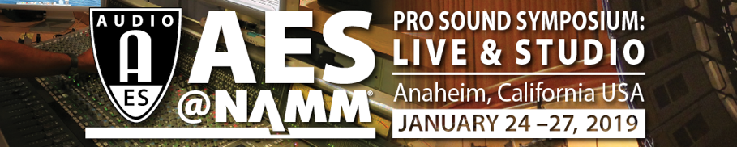
Anaheim, California – December 17, 2018 – Synthax, distributor of best-in-class audio solution manufacturers RME, Ferrofish and myMix, has announced its Managing Director Mathias Von Heydekampf and its Director of Sales, Americas Derek Badala will present three sessions during the second annual AES@NAMM Pro Sound Symposium: Live & Sound educational and training program. Taking place during the 2019 NAMM Show in Anaheim, California, from January 24–27, 2019, the sessions will focus on selecting the right audio interface, overcoming in-ear monitoring issues, and breaking down audio networking options.
Targeted at working professionals in the live sound, recording and performance-audio space, this four-day international symposium features training academies and related technical sessions presented by a team of specialists and experts in the field.
“Every application requires a mastery of audio tools and processes,” Badala said. “Whether you are scoring a film, recording live audio or broadcasting audio, these sessions will help you select the right tools for your application, conquer personal monitoring and master audio networking.”

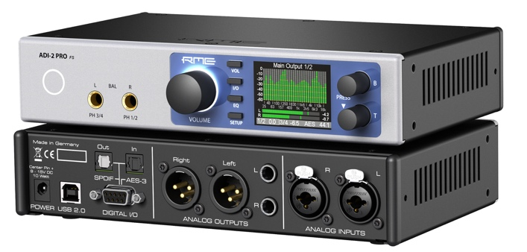
‘Choosing the Right Audio Interface’
On Friday, January 25 at 12 p.m. noon, Synthax’s Badala will walk listeners through what to consider when shopping for their next interface during the session “Choosing the Right Audio Interface.” During the two-hour session, Badala will address how to select the best interface for your needs, break down the differences between USB 2.0 and USB 3.0, and share how to achieve low-latency monitoring. The session will explain how a complete approach to interface design will take all of these aspects into consideration to smooth out the decision process.
‘In-Ear Monitoring Advantages and Personal Monitor Mixing’
Synthax’s Managing Director Mathias Von Heydekampf will present “In Ear Monitoring Advantages and Personal Monitor Mixing” on Friday, January 25 at 2 p.m. The two-hour session will delve into the dynamics of listening with in-ear monitors and how a qualified personal monitoring system can help overcome these issues by creating an individual mix using stereo effects and panning to re-create a three-dimensional and natural sound experience.
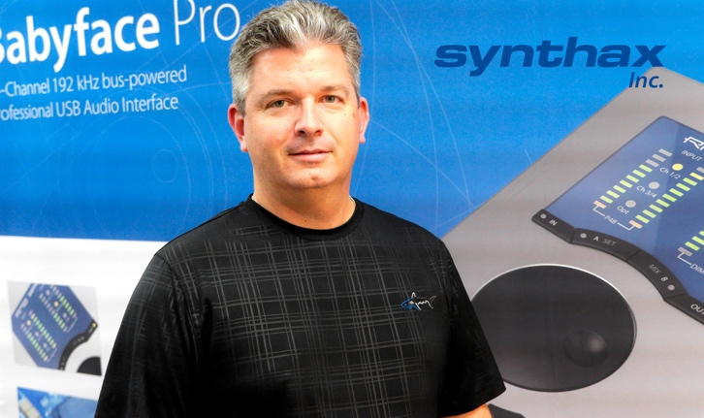
‘Unraveling Audio Networking: An In-depth Look at Dante, AVB and MADI’
Synthax brands RME and Ferrofish have been on the forefront of the audio networking thanks to a variety of interfaces and converters that support MADI, AVB and Dante capability. From their flexibility and ability to adapt according a user’s needs, these systems have proven to be reliable, functional and non-complicated. On Saturday, January 26 at 2 p.m., Synthax’s Badala will host “Unraveling Audio Networking: An In-depth Look at Dante, AVB and MADI” which will break down each system’s advantages and explain how to best employ them in your setup.
For more information, visit the Synthax at booth 14702 during the 2019 NAMM Show.
For more on Synthax, visit http://www.synthax.com.

About Synthax, Incorporated
Synthax Inc. is the exclusive USA distributor for RME digital audio solutions, Ferrofish advanced audio applications, myMix audio products, and ALVA cableware. We supply a nationwide network of dealers with these products for professional audio, broadcast, music industry, commercial audio, theater, military and government applications. For additional information, visit the company online at http://www.synthax.com.
Media Contacts:
Katie Kailus
Public Relations
Hummingbird Media
+1 (630) 319-5226
katie@hummingbirdmedia.com

Jeff Touzeau
Public Relations
Hummingbird Media
+1 (914) 602 2913
jeff@hummingbirdmedia.com

