

Biuro prasowe better. gaming agency
bettergamingagency.prowly.com

[Embargo] The press release and all the materials are under embargo until July 2nd, 2024, 16:00 CEST, 15:00 BST, 07:00 PDT.

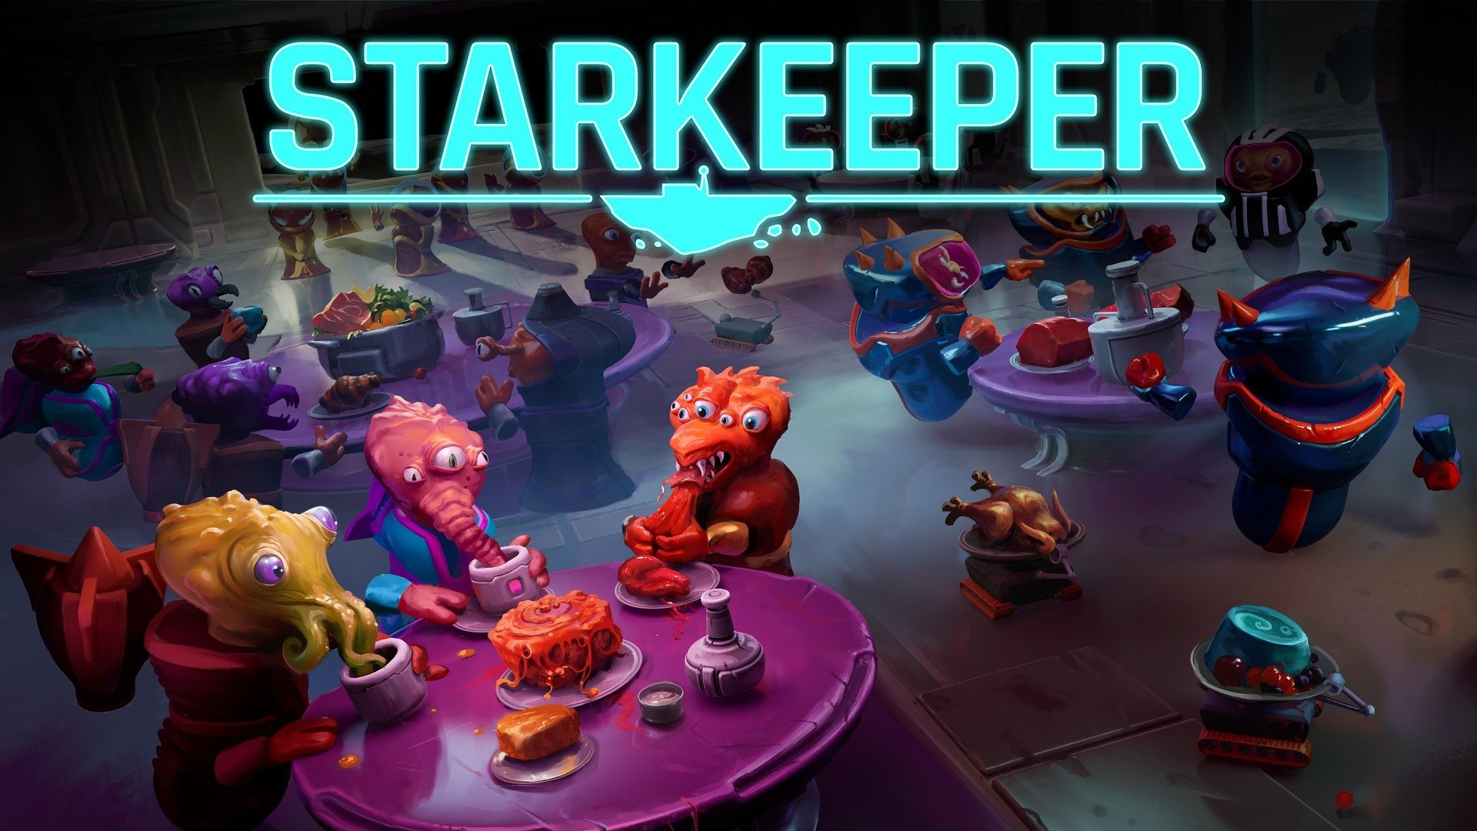

In StarKeeper players will run their own tavern... in space!

This galactic tavern management simulator is being developed for PC, PlayStation 5, Xbox Series S/X, and Nintendo Switch.

StarKeeper is the latest title from Longterm Games. Today, the developers showed the game for the first time, unveiling its announcement trailer. StarKeeper will take players into uncharted corners of the galaxy, where they will manage their own tavern on an asteroid hurtling through space. Gameplay goes beyond just serving drinks and meals to clients from other planets, as players will face challenges based on four pillars: travel, trade, management and relationships.

StarKeeper – announcement trailer

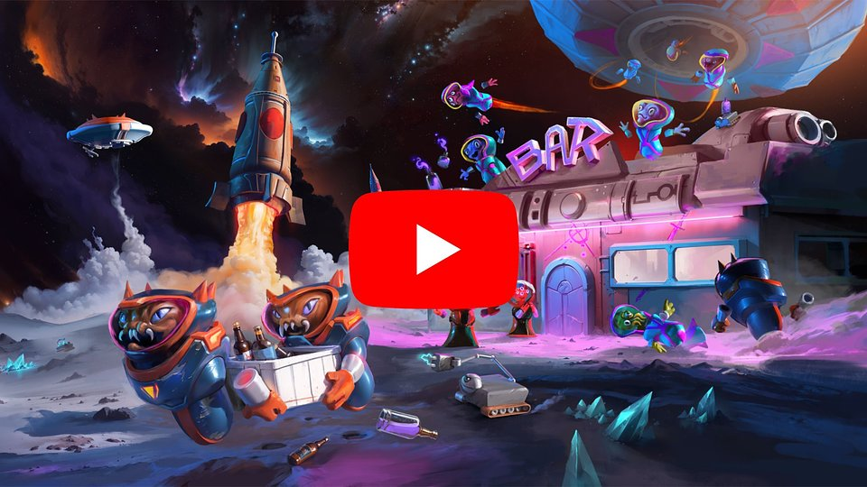
https://www.youtube.com/watch?v=D8L98MGEWL0

Procedurally generated star systems, full of random events and numerous alien species, ensure that every playthrough will be unique. StarKeeper is an isometric 3D game where players will strive to satisfy the needs of diverse guests, aiming to make their tavern the talk of the entire galaxy. They will achieve this by serving the best food, offering clean and comfortable rooms, and providing affordable fuel.

Here's what awaits hosts who aren't afraid to embark on a galactic journey:

🚀 Travel – explore diverse star systems and meet their inhabitants. Visit planets with unique climates, from icy to tropical, each offering special goods for sale. Confront challenging travel hazards like meteor showers, mood-altering nebulae, or galactic conflicts. React to dynamically changing circumstances in procedurally generated regions of space. The places you visit will leave a mark on your asteroid in the form of new residents, cultural elements, or artifacts.

💰 Trade – develop your own trading network to gain access to a rich variety of products. To achieve this, you'll need trade and transport permits in various star systems. Sounds complicated? Smuggling is always an option!

📈 Management – oversee buildings and workshops that provide food, drinks, oxygen, and fuel. Gather a team of robotic workers ready to assist in various tasks, while you enjoy decorating rooms in your tavern. Arrange tables, chairs, and specialized machines, including kitchen equipment that allows experimenting with dishes.

🤝 Relationships – forge connections by satisfying the needs of diverse guests, influenced by their race and faction allegiance. Meat-eaters, vegetarians, pacifists, and warriors - all are welcome within the walls of your tavern, but each group requires specific types of food, rooms, and decor. The most discerning customers may refuse to share space with others. Build friendships with factions or attempt to eliminate them in a political game. The fate of the cosmos will be shaped by your choices, and as the owner of a respected establishment, you can influence agreements and conflicts among cosmic nations.

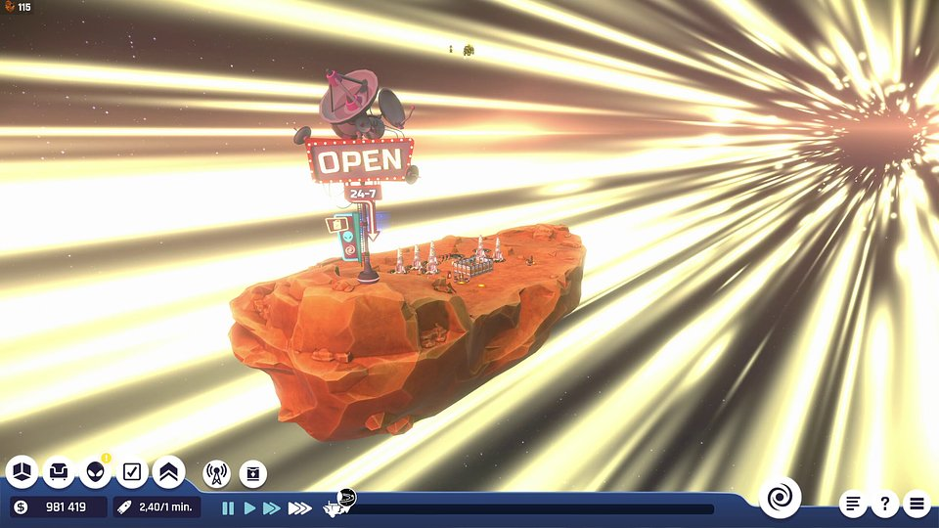

„We don't know what awaits us during the colonization of space, but one thing is sure - we wouldn't want to run out of good drinks! With StarKeeper, we aim to set the standard in tavern management simulators, and setting the game on an asteroid that is speeding through the galaxy allows us to introduce many innovative ideas to this genre. Implementing new, often unconventional mechanics brings us immense joy, and we can't wait to share them with players”

- said Albert Rokicki, CEO of Longterm Games.

The developers at Longterm Games believe that StarKeeper can fill a gap in the market which still lacks solid tavern management simulators. This can be achieved by a unique approach to mechanics characteristic of the genre. Fueled by passion, the team consists of experienced developers for whom game development has always been a satisfying challenge.

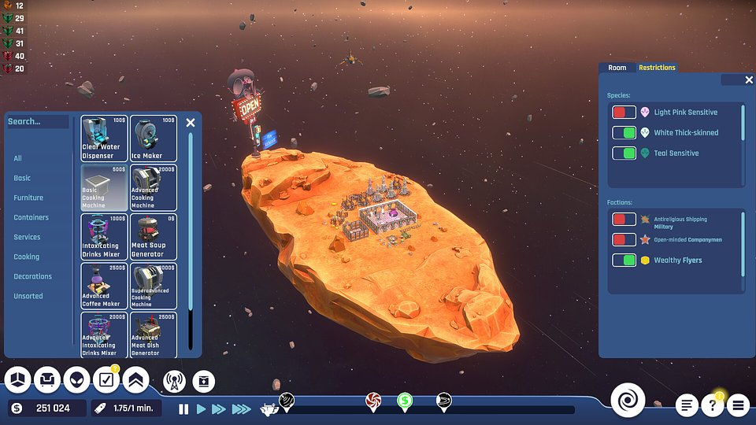

StarKeeper will firstly be released on PC, with versions for PlayStation 5, Xbox Series S/X, and Nintendo Switch coming after the launch. Players intrigued by the possibility of running their own tavern in space can already add the title to their wishlist on Steam. More information about the game can be found on Facebook, X (Twitter), and Instagram.

The press kit is available here.

About Longterm Games:
Longterm Games was founded in 2020 by Albert Rokicki and Robert Ogłodziński. The company specializes in developing and publishing video games that provide players with unique experiences. The studio's business model focuses on developing long-selling titles, generating revenue over many years from sales of base games, DLCs, cooperative packs, season passes, and sequels. Despite its relatively short time in operation, the company collaborates with veterans of the gaming and IT industries, known for their work at CD Projekt RED, Klabater S.A., and Deloitte Poland.

