PRESS RELEASE - JANUARY 2018
ODLO IS DOUBLE ISPO GOLD WINNER
ODLO is proud to be the recipient of two GOLD WINNER Awards for its AEROSKIN RACE SUIT and ACTIVE SPINE concepts. These two awards cement ODLO’s place as one of the world’s leading performance sports brands. “As engineers of active layers since 1946, ODLO has always been innovative. These two awards are a clear acknowledgement that ODLO continues to build on its strengths while managing to stay one step ahead”, commented ODLO’s Brand Director Timo Pape. This year’s double award follows previous wins by ODLO for its iconic EVOLUTION BLACKOMB and EVOLUTION WINDSHIELD products.
Each year an independent jury of over 40 experts from the international Sports Business Network (ISPO) evaluates several hundred entries across different categories. Exceptional products are honoured with the ISPO Gold Award.

AEROSKIN RACE SUIT: ISPO GOLD WINNER, CATEGORY SNOWSPORTS/ OUTERLAYER XC
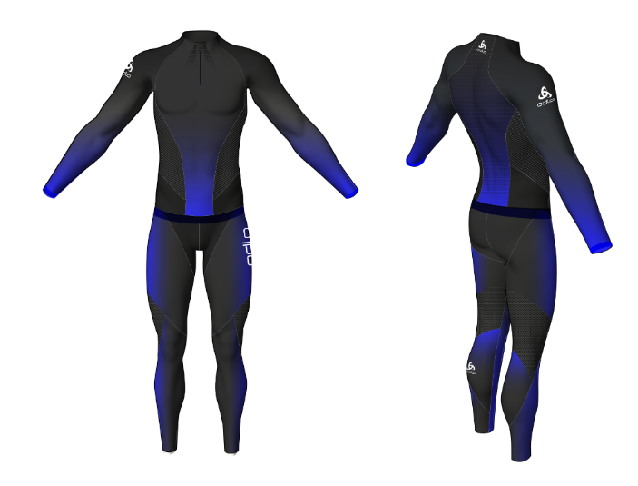
The AEROSKIN RACE SUIT is made for winning! The next generation Nordic race suit is aerodynamically engineered with maximum breathability and perfect freedom of movement for competitive Nordic ski athletes that look for every marginal advantage to win the race. Utilizing organic body mapping, the AEROSKIN RACE SUIT features targeted dual-layer construction zones where wind impact is greatest. The first layer features a golfball-like structured texture with an open mesh fabric to increase air turbulence and reduce drag. The second layer provides the customized graphic application while enhancing the aerodynamic properties of the first layer to deliver the most aerodynamic Nordic race suit on the market today. Thanks to the increased aerodynamic performance, athletes save valuable seconds, which can make the difference between losing or winning.
The AEROSKIN RACE SUIT will be available from July 2018.

ACTIVE SPINE: ISPO GOLD WINNER, CATEGORY HEALTH & FITNESS
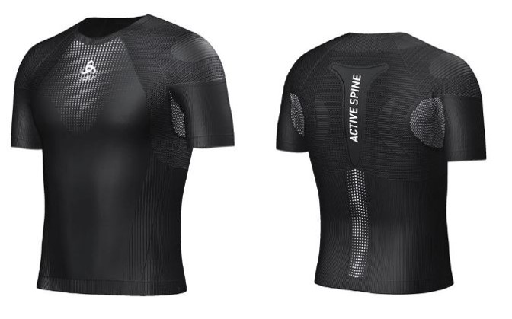
ACTIVE SPINE is an innovative, next-to-skin performance base layer combing advanced biomechanic studies and industry-leading seamless knitting technology to deliver an active posture control system. ODLO's patent pending ACTIVE SPINE technology is inspired by the natural function of the human spine to ensure posture control during and after sports resulting in enhanced athletic performance and recovery.
ACTIVE SPINE will be available in late Fall 2018.

Please do not hesitate to contact us if you have any queries.

Born in Norway and engineered in Switzerland, ODLO offers performance sportswear across 6 categories: functional sport underwear, running, training, cycling, Nordic disciplines and outdoor. With more than 70 years of heritage, ODLO, the inventor of performance sports underwear and the three-layer principle, continues to innovate always making sure that it stays one step ahead and is distributed in over 35 countries. As a full-year performance brand, ODLO also continues to show strong commitment towards social and environmental sustainability, and is proud of its leader status at the Fair Wear Foundation. For further information, please go to: www.odlo.com

