Tune into Zen: Introducing the iFi ZEN DAC 3 for Every Listener
Southport, England— April 15, 2024— iFi Audio, a trailblazer in high-fidelity audio components, proudly introduces its latest innovation: the iFi ZEN DAC 3. Featuring a refreshed design and updated features, this home-based DAC has been designed to electrify gaming, casual listening, and critical audiophile experiences.

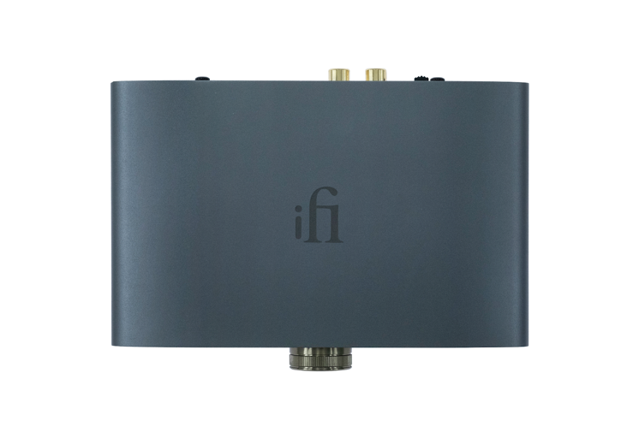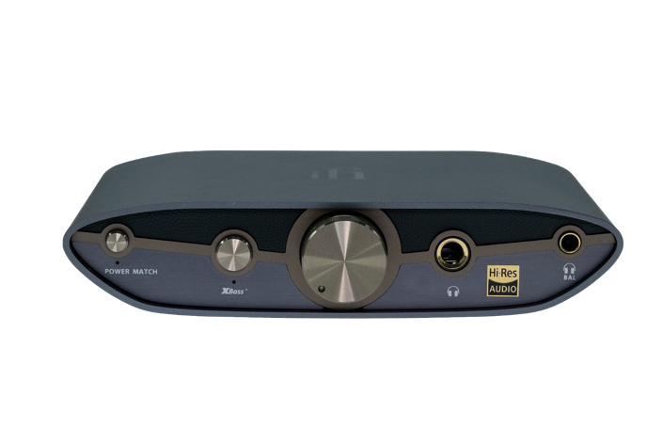

With both fixed and variable output gain options, the ZEN DAC 3 seamlessly connects to headphones, amplifiers, or active speakers, providing unparalleled versatility for any audio setup. Featuring two 4.4mm balanced outputs – one dedicated to headphones and the other to all other Hi-Fi equipment – this innovative design minimizes distortion, crosstalk, and noise, delivering pristine sound quality that truly immerses you in your music.

From PCM 768kHz to DSD 512 and full MQA decoding, it ensures that every nuance of your music is faithfully reproduced with remarkable clarity and detail. Furthermore, enhancements such as improved DC offset and USB-C input overvoltage protection guarantee peace of mind while enjoying your favourite tunes, ensuring reliable and safe operation.

Additional features such as XBass+ and PowerMatch analogue processing modes empowers you to customize your listening experience with precision and finesse.

Digital Stage

The DAC section is based around a Burr-Brown DAC chip that iFi uses extensively, selected for its fluid, highly ‘musical’ sound quality and ‘True Native’ architecture. This, together with the XMOS chip used for input processing, enables iFi to deliver excellent sound quality across all manner of digital audio formats including hi-res PCM, ‘bit-perfect’ DSD and MQA – the hi-res streaming codec, as used by Tidal’s ‘Masters’ tier. Given the diminutive asking price, the ZEN DAC 3’s digital audio credentials are highly impressive.

PCM and DXD audio data is supported up to 24-bit/384kHz, alongside DSD sampling rates from 2.8MHz to 12.4MHz (DSD256). Thanks to the Burr-Brown chip’s True Native design, PCM and DSD take separate pathways – this enables DSD to remain ‘bit-perfect’ in its native form, right through to analogue conversion. Many DACs that claim DSD compatibility accept DSD data but then convert it to PCM; for DSD purists, the ZEN DAC 3 is a fantastic affordable solution.

Another circuit feature that separates this and other DACs made by iFi from competing designs is iFi’s in-house programming of the XMOS chip. While other manufacturers simply use the firmware that comes with the chip off-the-shelf, which is not typically optimized for audiophile-grade sound, iFi programs its own bespoke firmware to boost audio processing power.

iFi’s continuous software development allows features to be added or optimized via firmware updates, enabling the ZEN DAC 3 to be tailored to the user’s playback priorities and ensuring it stays cutting-edge over time. Users can even download and install different versions of iFi firmware to experiment with different digital filters should they so desire. Extensive clock-locking is used throughout the digital stage to eradicate jitter, maintaining the integrity of the digital signal until conversion.

Analogue Stage

The ZEN DAC 3’s analogue stage is a balanced design – highly unusual in a DAC/headphone amp anywhere near this price point. It incorporates a range of high-quality circuit components, carefully selected for their performance in an audio context, including C0G capacitors from TDK and a high quality analogue volume pot.

XBass+ joins PowerMatch

The headphone amp stage has switchable gain, which iFi terms PowerMatch. This matches the level of drive to the load presented by the headphones, by adjusting input sensitivity and thereby signal strength. With high-sensitivity headphone types such as in-ear monitors, leave PowerMatch at its lower setting for ultra-low-noise performance. But if your headphones require more drive – most on/over-ear types, for example – press the PowerMatch button on the front panel to increase gain.

The personalized audio experience is taken a step further with the introduction of the XBass+ analogue processing mode. XBass+ is a proprietary circuit that can be engaged to enhance low frequencies, its sophistication enabling it to do so whilst maintaining bass definition and without muddying the midrange. This is useful with, for example, some open-back headphones that sound bass-light; it ‘corrects’ the bass so that the listener hears low frequencies as the artist intended.

Even better connected

The ZEN DAC 3 sports 4.4mm balanced outputs, both front and back – this is a relatively new interface type, designed to enable balanced signal transfer between compact products that cannot accommodate traditional XLR connections.

The front-mounted 4.4mm output sits alongside a standard, single-ended 6.3mm headphone socket – thus, the benefits of balanced headphone designs are fully utilised, whilst also accommodating every type of headphone, both balanced and single-ended. The 4.4mm output to the rear enables connection to amps and active speakers equipped with a balanced input – either a 4.4mm input, or XLR inputs via a 4.4mm-to-XLR cable. Single-ended RCA outputs are also provided.

These line-level outputs – both balanced and single-ended – can be switched between ‘variable’ and ‘fixed’, enhancing the ZEN DAC 3’s versatility. The variable setting applies volume control to the audio signal, enabling the ZEN DAC 3 to perform as a preamp feeding a power amp or active speakers. The fixed option bypasses the volume control, fixing the output at 4.2V (balanced) or 2.1V (single-ended) for connection to an external preamp or integrated amp.

The ZEN DAC 3 features USB Type C input which benefits from input overvoltage protection. This means less audible clicks while switching functions.

Key features of the iFi ZEN DAC 3 includes:
- Ultra-res audio: PCM 768kHz, DSD 512 and Full MQA Decoding
- Improved DC offset and USB-C input overvoltage protection
- USB-C input for plug-and-play connectivity
- 4.4mm balanced headphone and line outputs
- Fixed or variable output gain for optional preamp functionality
- XBass+ and PowerMatch analogue processing modes
Pricing & Availability
The iFi ZEN DAC 3 is available to purchase from ifi-audio.com and selected retailers for $229.

General Specification

Input |  | USB-C
Formats | PCM  DSD  MQA | 768kHz  512  Full Decoder
DAC |  | Bit-Perfect DSD & DXD DAC by Burr Brown
Headphone Output |  | BAL 4.4mm/UnBAL 6.3mm
Output Power  (RMS) | Balanced  UnBAL | 390mW@32Ω; 7.2V@600Ω  210mW@32Ω; 3.8V@600Ω
Output Impedance |  | <1Ω (BAL/UnBAL)
SNR |  | 109dB(A) (BAL/UnBAL)
DNR |  | 109dB(A) (BAL/UnBAL)
THD + N | Balanced  UnBAL | <0.006% (2.0V @ 600Ω)  <0.006% (1.27V @ 32Ω)
Line Output |  | BAL 4.4mm/UnBAL RCA
Output Power | Balanced  UnBAL | 2V-6.2V max. (variable); 4.2V fixed  1V-3.3V max. (variable); 2.1V fixed
Output Impedance |  | <200Ω BAL; <100Ω UnBAL
Frequency Response |  | 5Hz - 90kHz (+/-3dB)
Power Consumption |  | ~2.5W Max Signal
Dimensions |  | 158x115x35mm (6.2” x 4.6” x 1.4”)
Weight |  | 456g (1.0 lbs)
Warranty period |  | 12 months

About iFi
iFi is the sister-brand of Abbingdon Music Research (AMR) and is headquartered in Southport, UK. The two brands respectively design and manufacture portable, desktop and lifestyle audio products and high-end hi-fi components. Combined in-house hardware and software development teams and a ‘music first’ approach enable iFi and AMR to create advanced audio products that deliver new levels of design, functionality and performance at their respective price points. Since iFi’s formation in 2012, its products have earned many awards around the world, helping it to become one of the fastest-growing brands in its field. For more information, please visit— https://ifi-audio.com/

Media Contacts
Shelby Coppola
Hummingbird Media
+1 (203) 598-8167
shelby@hummingbirdmedia.com

Jeff Touzeau
Hummingbird Media
+1 (914) 602-2913
jeff@hummingbirdmedia.com

