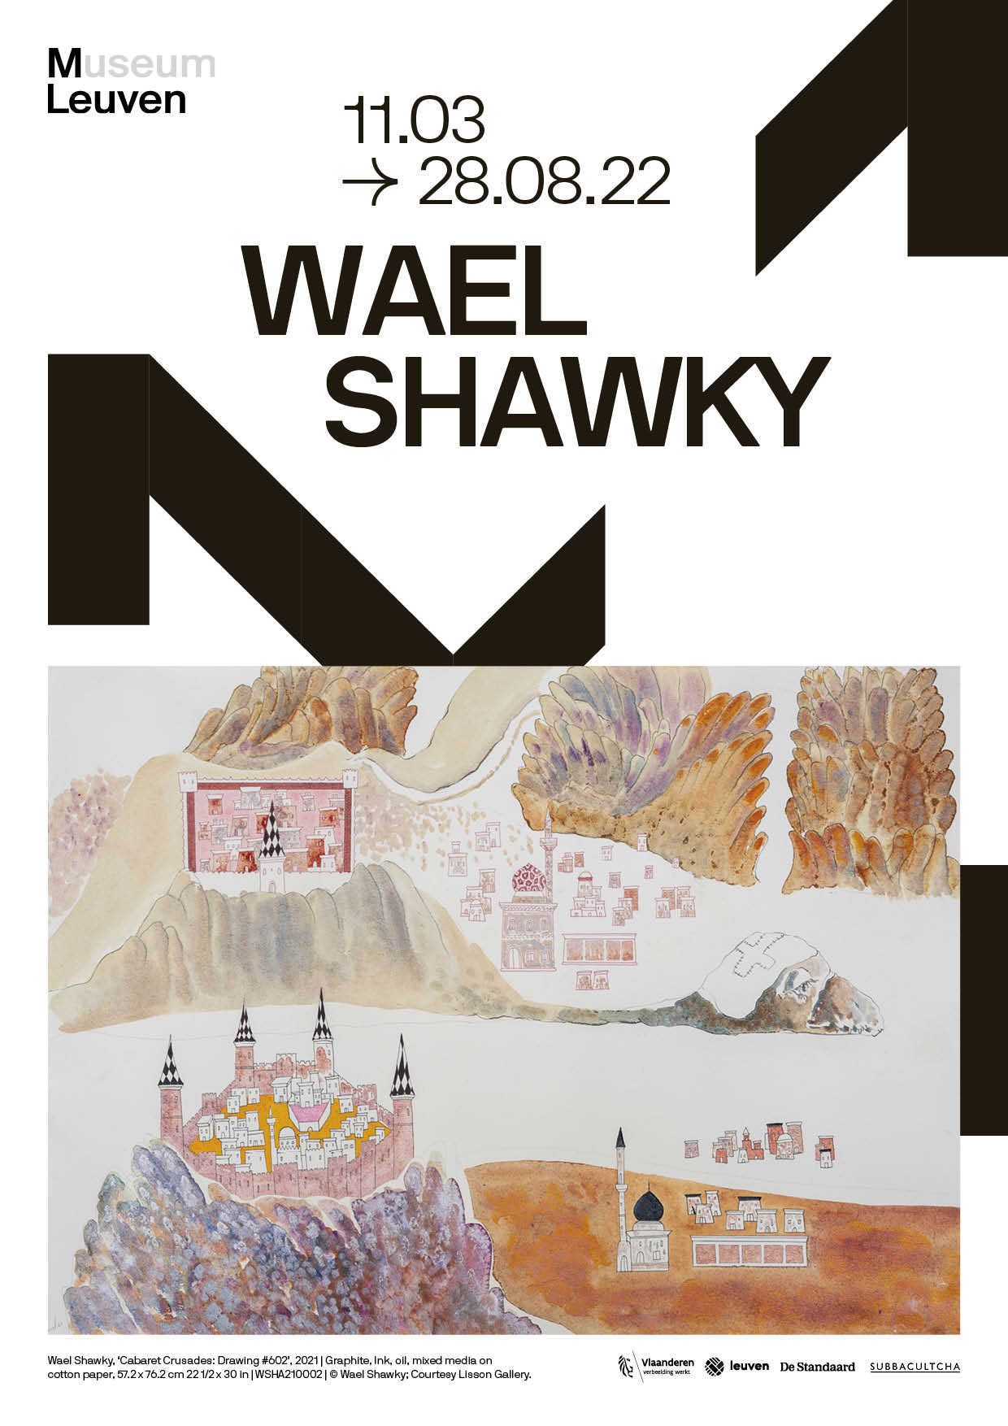M LEUVEN PRESENTS A LARGE SOLO EXHIBITION BY WAEL SHAWKY  
Dry Culture Wet Culture — 11.03– 28.08.2022

M Leuven presents a large solo exhibition of work by Egyptian artist Wael Shawky. The exhibition, entitled *Dry Culture Wet Culture*, brings together works from different series and presents two new in-situ installation works. These are all projects in which Shawky frames contemporary culture from a historical perspective and vice versa.

With the title of the exhibition, *Dry Culture Wet Culture*, Shawky attempts to capture the characteristics and contradictions of these social evolutions in two concepts. In the development of societies, certainly in the Arab world, he sees a constant shift from a so-called *Dry Culture* - a traditional form of existence of wandering Bedouins in the dry desert - to a *Wet Culture* - a sedentary society based on irrigation and agriculture. Shawky's focus is therefore often on the links that may or may not exist between old and new - between *Dry and Wet Culture*.

The exhibition Wael Shawky: *Dry Culture Wet Culture* features, among others: *The Gulf Project Camp* and *Cabaret Crusades*. Both deal with the clash of cultures, the broad theme of migration, and societies in development and change.

Wael Shawky

Wael Shawky (1971) describes his artistic practice as that of an alchemist: a mediator between social ideas and tangible forms. His work deals with themes such as identity, religion, and history, which can be at the heart of a society in transition.

As a child, Shawky lived in Saudi Arabia for a long time, where he witnessed the transition from a nomadic tribal society to a modernised, more Westernised one. This change left a deep impression on him and led to a fascination as an artist with all aspects of cultures and societies. Shawky compiles the multitude of stories that emerge from this process into overarching art projects in which he addresses social and historical issues in a variety of media: from painting and drawing to sculpture, film and even music.

Throughout his work, Shawky confronts us with the boundaries of our own vision of history and the world. To what extent is our thinking coloured by our background and personal past? Is there such a thing as history, and can it be written without prejudice? And what role does our view of the past play in the development of a culture or national identity?

© M Leuven, photo Sanne Delcroix

The Gulf Project Camp

In *The Gulf Project Camp*, Wael Shawky focuses on the history of the Arabian peninsula through drawings, sculptures, wood carvings, installations and an as-yet unreleased film. The project aims to provide an overview of some 400 years of social evolution in the region: from nomadic migrations in the 17th century, through the establishment of American and British oil companies during the Interwar period and the subsequent independence of the Gulf States, to the present.

The installation entitled *The Wall #2* consists of a wall covered in black graphite, on which are stretched canvases that recall the tents of Berber culture. As such, the work engages in a transition between the traditional form of society of the original Arab peoples and the contemporary, industrialised and urbanised society.

CABARET CRUSADES    
  
Cabaret Crusades – film trilogy  
*Cabaret Crusades* is the title of a film trilogy that places the history of the Crusades in a new light by approaching it from an Arab perspective. Despite the tumultuous storylines and violent scenes, the films exude a magical realism and beauty. In *Cabaret Crusades*, Shawky combines seemingly accurate facts with a personal, artistic imagination. This mix of truth and fiction raises questions about the nature of history, and the privileged role of those who write it. Similarities with today's geopolitical context are numerous: the civil war in Syria, the new regime in Afghanistan, or the ongoing Palestinian-Israeli conflict.

WSHA150012_at Den Frie Centre of Contemporary Art, Denmark_2021-22- Photo by David Stjernholm_019

Cabaret Crusades – reliëfs and drawings  
Parallel to the film trilogy *Cabaret Crusades*, Wael Shawky also makes paintings, drawings and wooden reliefs depicting episodes from the history of the Crusades. Painting and drawing are the most obvious and direct media for the artist: they are the disciplines in which he was trained as a student at the Alexandria Academy. For the wooden reliefs, just as for the glass marionettes in the film, Shawky works with experienced craftsmen from the Italian region of Veneto.

Wael Shawky, ‘Cabaret Crusades: Drawing #602’, 2021 | Graphite, Ink, oil, mixed media on cotton paper,   
57.2 x 76.2 cm 22 1/2 x 30 in | WSHA210002 | © Wael Shawky; Courtesy Lisson Gallery.

Wael Shawky, ‘Cabaret Crusades: Drawing #606’, 2021 | Graphite, Ink, oil, mixed media on cotton paper,   
57.2 x 76.2 cm 22 1/2 x 30 in | WSHA210006 | © Wael Shawky; Courtesy Lisson Gallery.

Wael Shawky, ‘Cabaret Crusades: The Capture of Constantinople in 1204’ (after Jacopo Tintoretto, 1580-1605), 2018 | Hand-carved wood, paint, goldleaf | 330 x 400 cm | 129 7/8 x 157 1/2 in | (WSHA180010) | © Wael Shawky; Courtesy Lisson Gallery.  
  
Wael Shawky, ‘Cabaret Crusades: The Capture of Jerusalem by Jacques de Molay in 1299’ (after Claude Jacquand, 1846), 2018 | Hand-carved wood, paint, goldleaf | 250 x 450 cm | 98 3/8 x 177 1/8 in (WSHA180011) |   
© Wael Shawky; Courtesy Lisson Gallery.

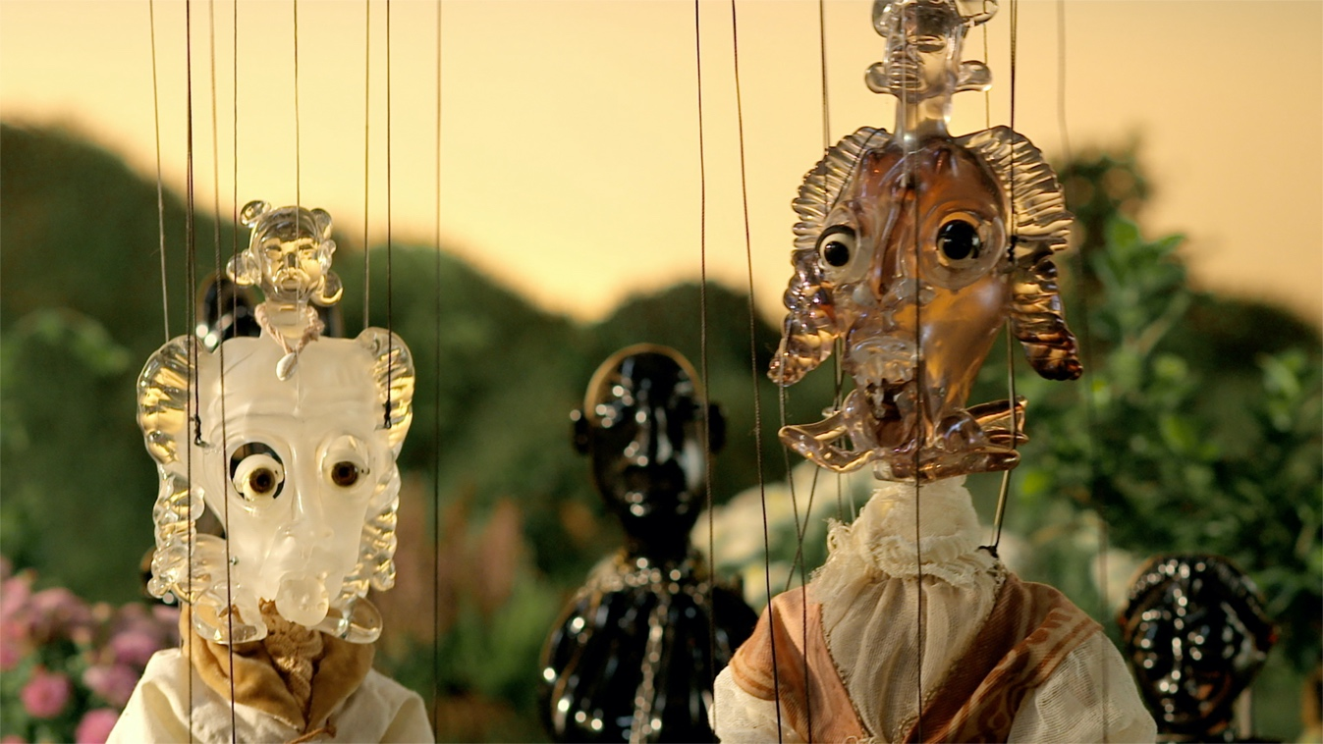

Wael Shawky, ‘Cabaret Crusades III: The Secrets of Karbalaa’, 2015  
HD Film, colour, sound, English subtitles  
120 minutes  
(WSHA150001)  
© Wael Shawky; Courtesy Lisson Gallery.

The Cave

In *The Cave*, Wael Shawky has himself filmed walking through a supermarket and reciting a specific chapter or surah from the Koran by heart: *Surah Al-Kahf*, or the *surah* of The Cave. That surah consists of several stories, but the most essential is that of the 'Companions of the Cave'. In it, a number of men escape from a tyrant by hiding in a cave and sleeping there for 309 years until a better ruler emerges.

Shawky sees the companions' centuries-long sleep and their subsequent awakening as a form of migration: a transition through time and state of mind. The theme of migration appears repeatedly in the surah, which was originally intended to convince the Prophet Muhammad to undertake a journey from Mecca to Medina.

Wael Shawky filmed three versions of *The Cave*, each time in a supermarket in a city where he was staying temporarily: in Istanbul (2004), in Hamburg (2005), and in Amsterdam (2005). This link with Shawky's own biography, as well as the explicit portrayal of the artist himself, makes *The Cave* a kind of self-portrait.

# PRACTICAL

M LEUVEN  
Vanderkelenstraat 28  
3000 Leuven  
+32 (16) 27 29 29  
[info@mleuven.b](mailto:info@mleuven.b)e  
[www.mleuven.be](http://www.mleuven.be)

**Plan your route to the museum**

By bike  
Cyclists are welcome! Parking is easy. Just use the secure underground bicycle parking at Rector de Somerplein. From there, it’s just a two-minute walk to the museum.

Via public transport  
The museum is a ten-minute walk from Leuven Station. Rector de Somerplein is the closest stop if you’re coming by bus. Use Google Maps to plan your route.

By car  
Leuven’s new circulation plan leads you into the city and car parks via a series of rings. Would you prefer to avoid the city’s traffic? Just park your car at one of the car parks on Leuven’s outskirts and catch a free bus to the centre. Prefer to park nearby? The Ladeuze car park is only a two-minute walk from the museum. There are also 18 spaces for disabled passengers (higher clearance: 1.90 m). Click here for more information on the circulation plan and parking options.

# CONTACT

Hanne Grégoire

Head of Press & Communications  
hanne.gregoire@mleuven.be

+32 (0)472 95 52 26

Samantha Fadahunsi  
Press & Communications Officer  
[samantha.fadahunsi@mleuven.be](mailto:samantha.fadahunsi@mleuven.be)  
+32 (0) 491 35 02 95

Webpage links:  
https://www.mleuven.be/en/wael-shawky

Link Prezly:

High-resolution images can be downloaded at the bottom of this press release:  
<http://prez.ly/j7Wb>