BASSBOSS to Host Los Angeles Demo Tour in Early December, Highlighting Latest Loudspeaker Offerings

Attendees will experience how BASSBOSS Powered Loudspeakers give DJs and Mobile Audio Professionals the ability to “Make music physical”.
Los Angeles, CA, November 28, 2017 — Powered loudspeaker manufacturer BASSBOSS will host a Los Angeles demo tour, showcasing their latest product offerings on three separate demo opportunities across the Los Angeles area.
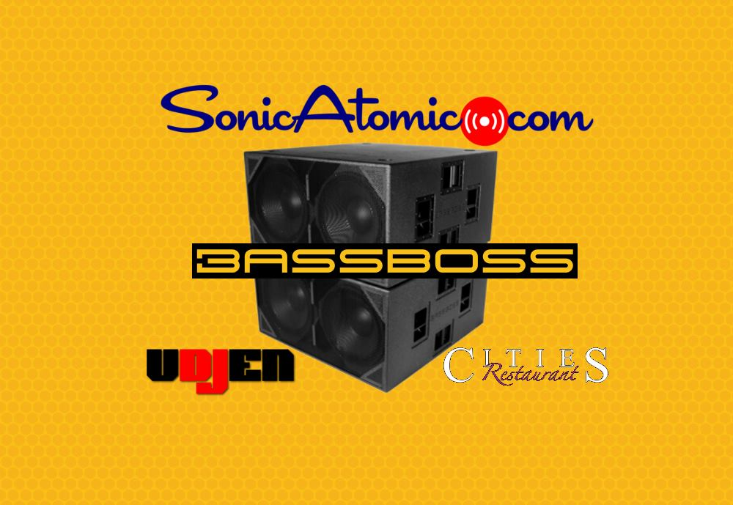
On Friday, December 8th, hosted by BASSOSS Dealer Sonic Atomic (http://sonicatomic.com) an evening demonstration will be held at Cities Restaurant & Lounge [4512 East Cesar E Chavez Avenue, Los Angeles, CA 90022 ]. The demo will run from 8:00 p.m. to 10:00 p.m., and then the resident DJ will spin until the early morning hours through a dedicated BASSBOSS system. There is no charge for the event, which is open to the public.

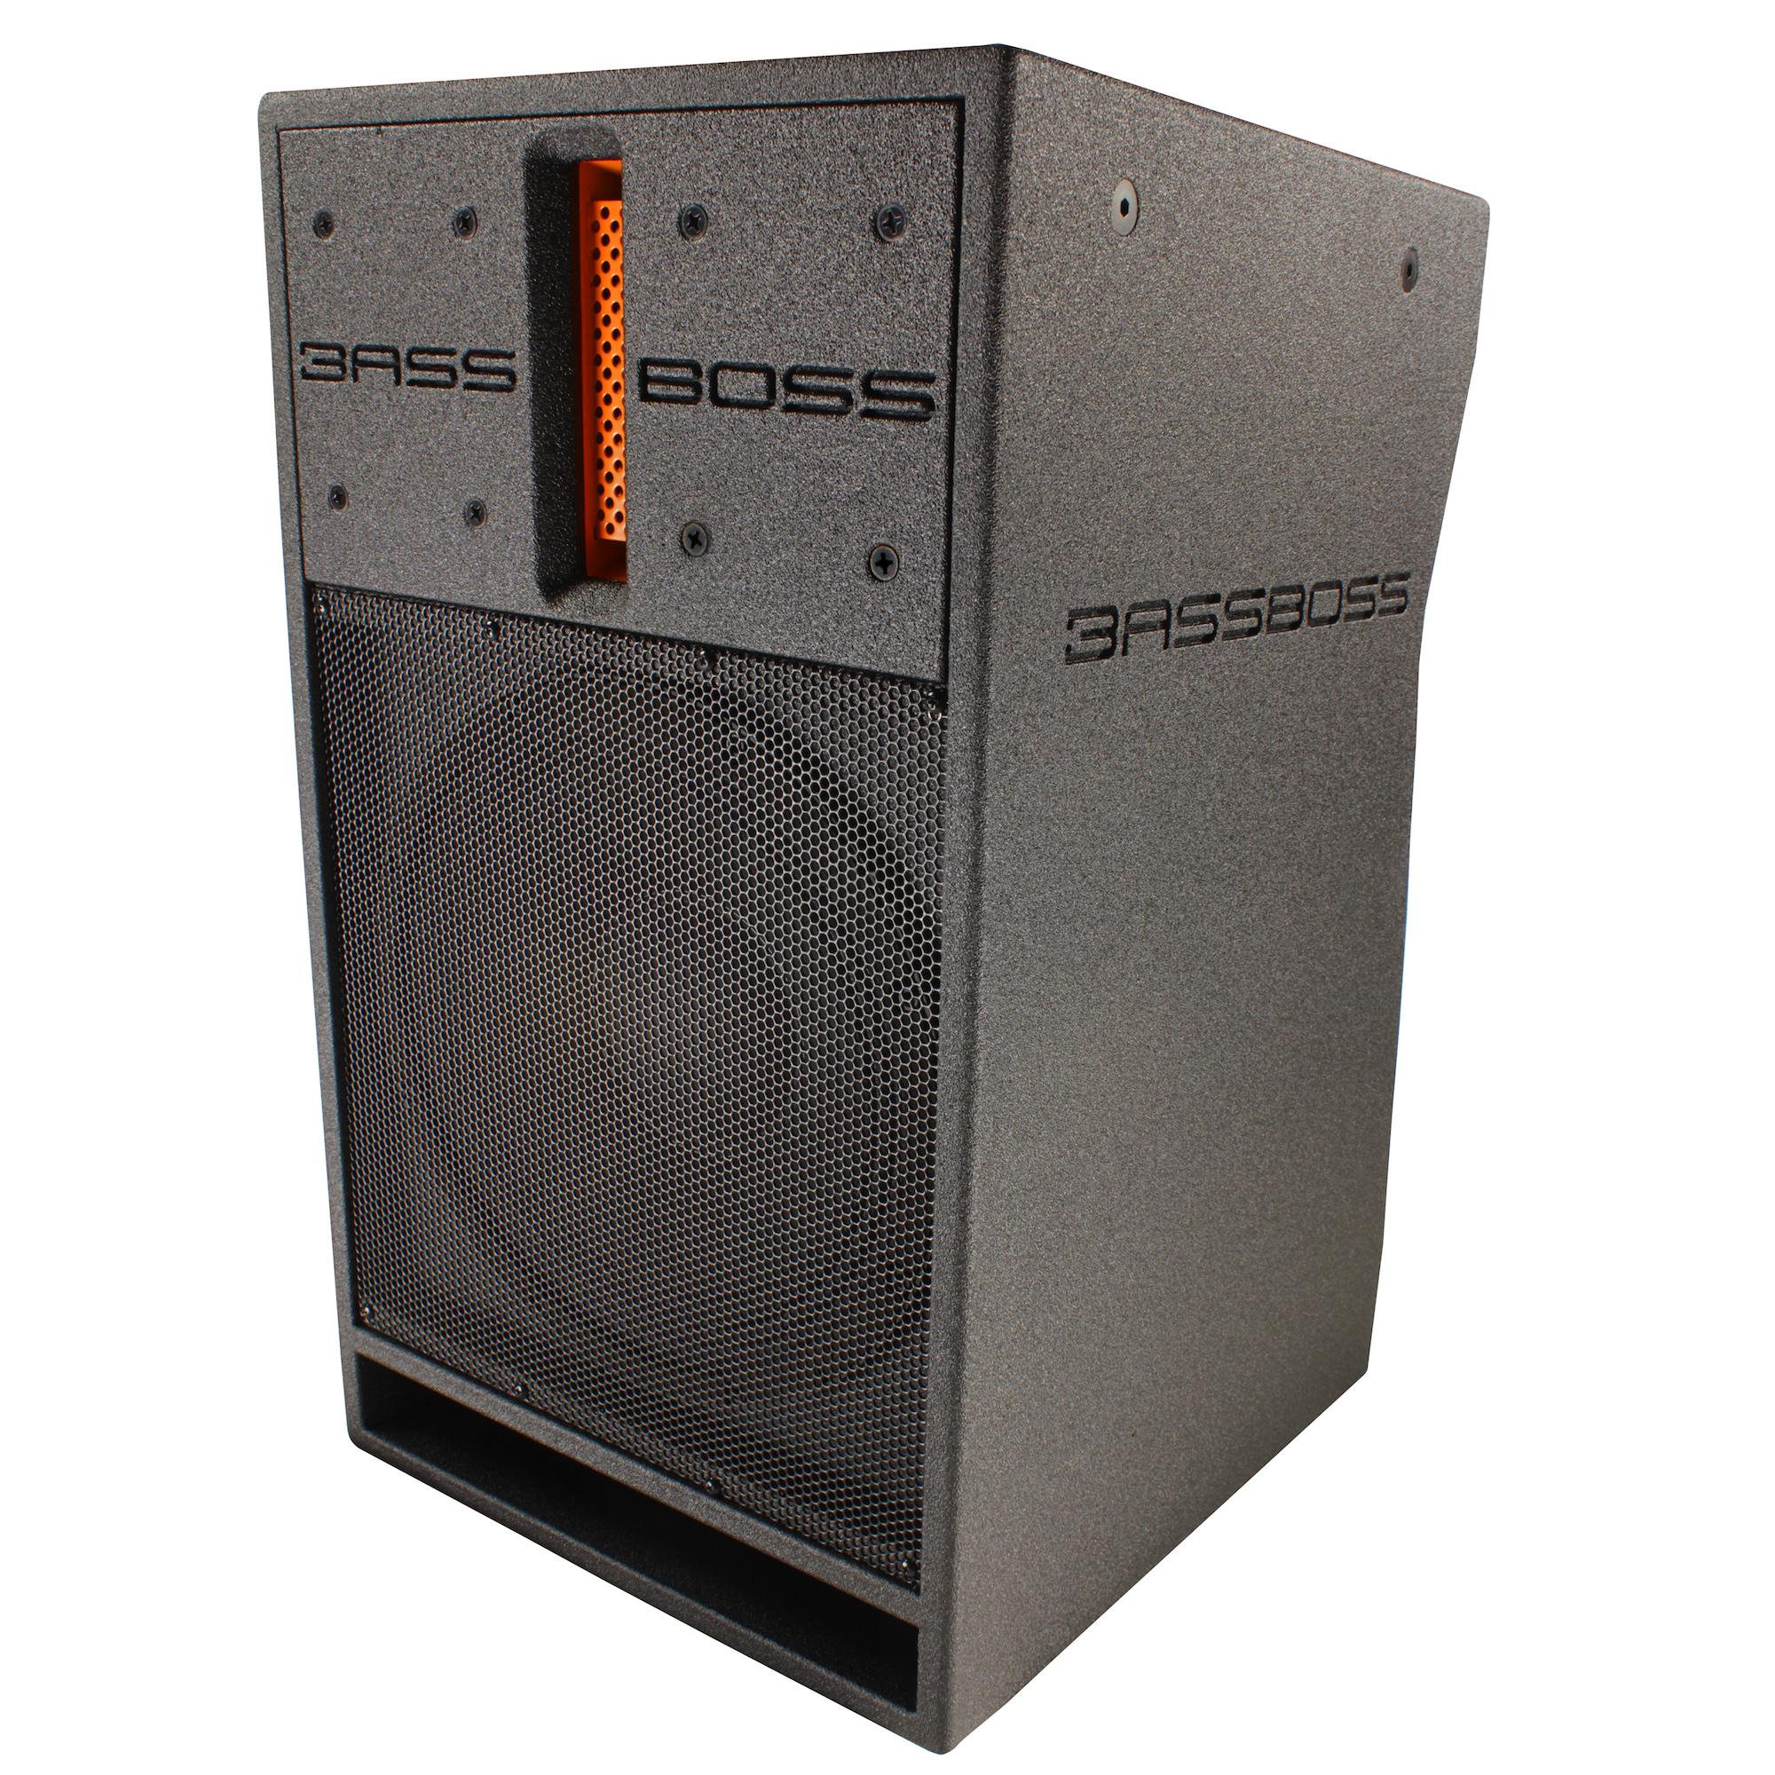
BASSBOSS will be onsite at Dealer Sonido Live [1140 East 11th Street, Los Angeles, CA 90021] on Sunday, December 10th between 3:00 p.m. to 6:00 p.m., and on Monday, Dec. 11th between 2:00 p.m. and 6:00 p.m. Both demos are free and open to the public. Those interested in scheduling time to meet with a BASSBOSS sales representative to discuss their audio needs can register at bassboss.com/la-demo-tour/ for personalized assistance.

The ultimate power - to go
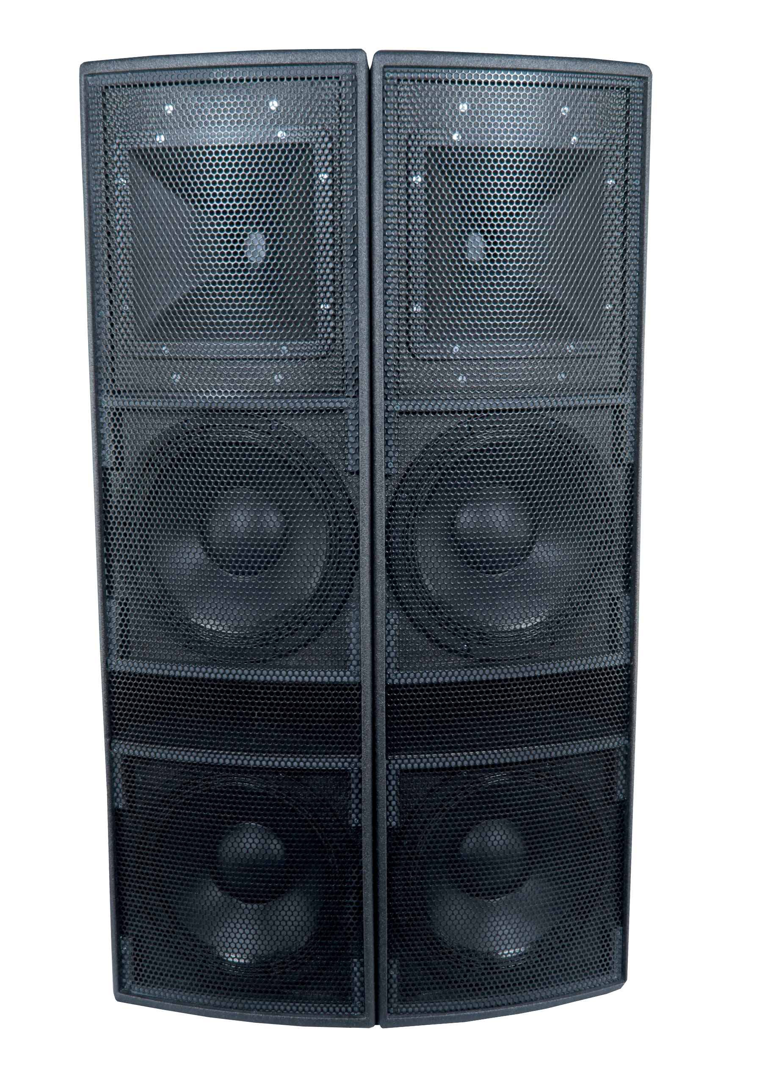
Offering excellent portability and high output, the new DV12 Micromain will be demonstrated in pairs, and arrayed with two per side. A rugged, 2-way active, full-range, direct radiating loudspeaker, the DV12 has 3,000 Watts of Powersoft Amplification in each cabinet, giving it extremely high output and uniform energy dispersion over a very wide and deep sound field. The DV12 provides ultra high-fidelity full-range music reproduction, excellent speech intelligibility, extremely wide dispersion, and even sound projection over distance. In full-range mode, its bass performance beats many systems that include a subwoofer. With a subwoofer, it can cover much larger audiences than conventional 12” loudspeakers.

BASSBOSS will also showcase its AT312 and AT212 Powered Tops. The AT312 Top is a co-axial point-source cabinet for medium to short distance coverage where high output, a small footprint and very high fidelity are needed. The AT212 Attuned Top is a 2-way, self-powered, bi-amplified loudspeaker for short to medium distance coverage. An equally outstanding portable solution, the DiaMon DJ112 is a compact, high-output, self-powered loudspeaker that can be used with up to two double 18-inch subwoofers for each cabinet — making a great DJ monitor while providing a tight, punchy performance that will not distort at high sound pressure levels.

The bosses of bass
During each of the three demos, the sonic clarity and rich bass BASSBOSS is known for will be on full display for all to feel. The company will highlight a wide selection of its subwoofers, including the ZV28 Powered Subwoofer, which delivers bass at the very limits of human hearing and presents notes that other subwoofers simply cannot articulate.

A new offering, the DJ18S, is a single 18” powered subwoofer that pushes the envelope on performance capabilities of a portable cabinet. With a 2400 Watt Continuous RMS Class D Amplifier, it offers deep-bass performance down to 27 Hz at very high volume for its size.

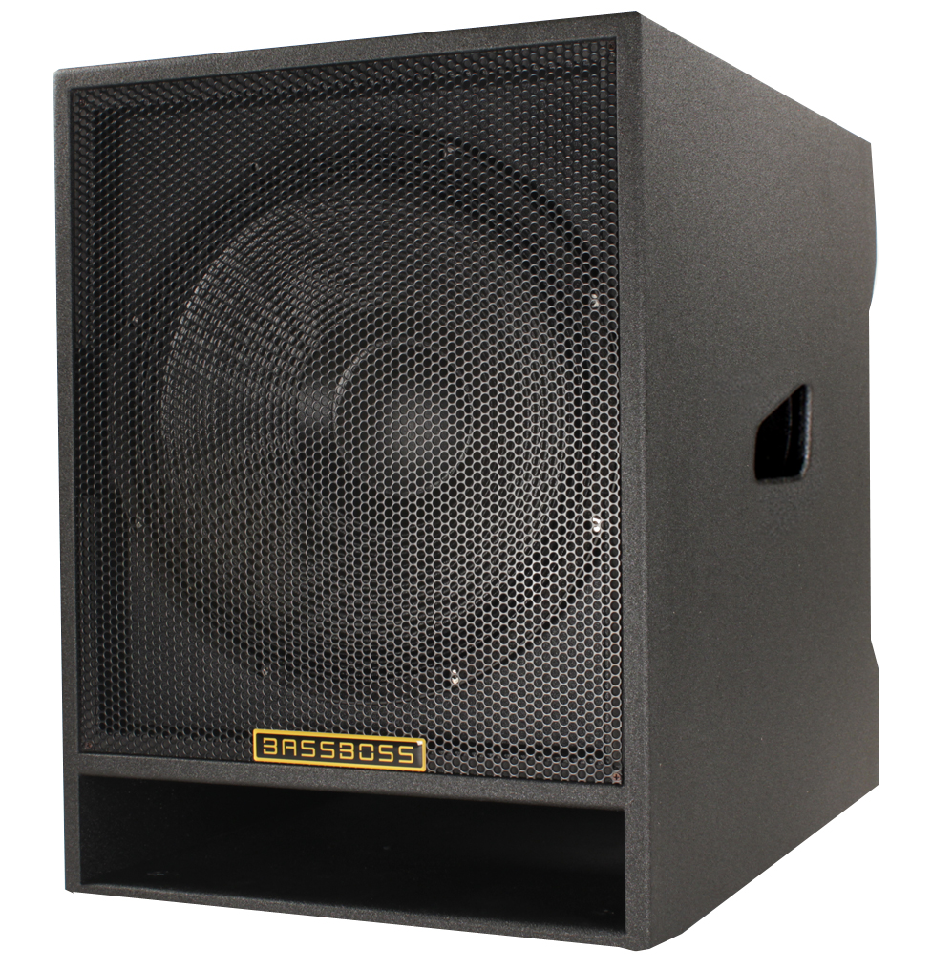
Attendees will also be able to experience the punch and power of the VS21, single 21” Powered Subwoofer. A super-versatile speaker, the VS21 can cover a range of music — from dance to acoustic — making it ideal for DJ gigs cover ing multiple genres. Also highlighted will be the SSP218 Powered Subwoofer, which features a solid, flat response to 30 Hz, powerful bass and makes for a great universal solution for those looking for a huge low end for an affordable price.

To register for one of the LA demos, visit: bassboss.com/la-demo-tour/

To learn more about BASSBOSS, visit www.bassboss.com

About BASSBOSS
BASSBOSS creates premium, ultra high-fidelity sound systems for the professional consumer, live sound and systems integration markets. The company was founded on the design and engineering expertise of David Lee, a pioneer in subwoofer design whose work has transformed the audio systems for hundreds of venues across North America. BASSBOSS systems are easily integrated, compact and power-efficient. Each cabinet is highly optimized with dedicated, comprehensive amplification and processing. For more information on BASSBOSS, please visit www.bassboss.com

Press contact:
Jeff Touzeau
Public Relations
Hummingbird Media, Inc.
(914) 602-2913
jeff@hummingbirdmedia.com

