For immediate distribution

Sweetwater Studios’ Nick D’Virgilio and Big Big Train Win Album of The Year at Prog Awards 2019
Celebrated drummer tracked drums and vocals for “Grand Tour” at Sweetwater Studios
October 28, 2019, London, England – On September 12, 2019, Prog magazine held the eighth installment of its Progressive Music Awards at Underglobe, beneath Shakespeare’s Globe Theatre in London. The event celebrates the best and brightest talents in forward-thinking rock and pop music from the previous twelve months, and has in the past honored members of rock royalty from prog progenitors Pink Floyd and King Crimson to modern artists like Dream Theater and Devin Townsend. This year’s Album of the Year was awarded to Grand Tour, the latest epic from the international prog supergroup Big Big Train, which was also a Top 40 hit in the UK charts. The win was especially meaningful for Big Big Train drummer Nick D’Virgilio, because it affirmed an approach to making music that the Sweetwater Studios’ first-call session drummer/engineer has developed over his time with the group.

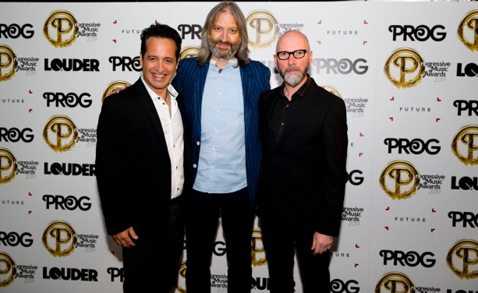
Although much of Grand Tour was tracked at studios across the United Kingdom, where most of his membership call home, D’Virgilio recorded his drum and vocal tracks remotely at Sweetwater Studios in Fort Wayne Indiana with Sweetwater Studios Senior Producer/Engineer and VP of Music Production Mark Hornsby, who also recorded the album’s string sections at Abbey Road Studios. This process has been a part of the band’s artistic chemistry since D’Virgilio first joined, but it has allowed the band to grow and work creatively despite the distance. “This band has been around for a long time and we work really hard to make the music that we want to make,” he said. “It’s a tough process but one we do with great joy.”

D’Virgilio accepted the award alongside bandmates David Longdon and Greg Spawton, where they graciously thanked Prog and and its readership for selecting Grand Tour as album of the year. “It’s truly fantastic to win an award like this and we truly appreciate everyone that voted for us,” he said. “Even being on the list with the other nominees was an honor, so we’re grateful for being appreciated.” In addition to being present as a member of Big Big Train, he and Hornsby also represented Sweetwater Studios, who sponsored the Best International Artist Award which was presented to this year’s winner, Dream Theater.

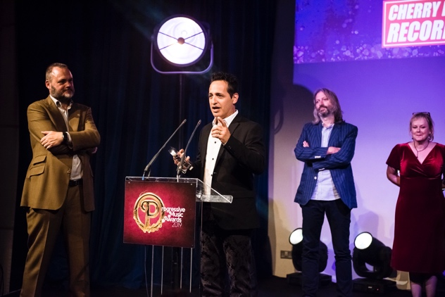
With the Album of the Year award in tow, Big Big Train has planned its biggest tour yet, with six dates in the UK and its first shows in the United States later in the year. They will also be headlining the PROG Stage at the Ramblin Man Festival in Kent in July of 2020. “We’re really excited at how things are ramping up for the band,” D’Virgilio says. “It’s a jumping off point for bigger and better things, and we can’t wait to bring this music to audiences everywhere.”

For tour dates and more information on Big Big Train, please visit: https://www.bigbigtrain.com/

For more information on Sweetwater Studios, please visit: http://www.sweetwaterstudios.com/

About Sweetwater Studios
Sweetwater Studios is a wholly owned subsidiary of Sweetwater Sound, Inc., the largest online music instrument retailer in the country. With three world-class studios designed by Russ Berger and access to a greater diversity of musical equipment and professional audio gear than any other recording studio in the world, Sweetwater Studios is able to accommodate just about any recording, mixing or mastering project, no matter how simple or complex. With renowned staff producer Mark Hornsby at the helm, who has worked on many Grammy-award winning albums, Sweetwater Studios also has an exceptional staff of producers, engineers, session musicians and studio technicians.

Media contacts
Steve Bailey
Public Relations
Hummingbird Media
+1 (508) 596 9321
steve@hummingbirdmedia.com

Jeff Touzeau
Public Relations
Hummingbird Media
+1 (914) 602 2913
jeff@hummingbirdmedia.com

