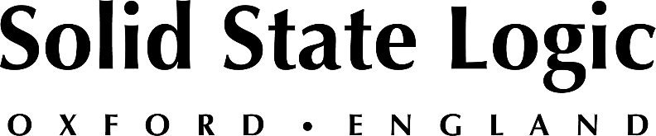

Solid State Logic to Showcase its New SSL Live L650 Console with V5.1 Software, Along with BiG SiX, UF8 and Fusion at InfoComm 2022

SSL will present the latest production tools for AV professionals, delivering intelligent workflows for a next-gen events, installed sound and content creation

Las Vegas, June 3, 2022 — Solid State Logic [Booth W2831] is proud to be exhibiting at InfoComm 2022, which is scheduled to be held at the Las Vegas Convention Center between June 4 and 10. In addition to a selection of the latest hybrid production tools, SSL will be highlighting its new SSL Live L650 — the most powerful SSL Live console to date — along with its L100, Remote Tile and System T Tempest Control Rack flypack system.

Solid State Logic will also have a host of products on hand from its ACP (Audio Creation Products) lineup, including the new BiG SiX SuperAnalogue™ mixing console + USB interface, its UF8 DAW and UC1 Plug-in control surfaces, Fusion and more. SSL’s ACP range is perfect for music, post and content creators wanting to take their workflow to the next level whilst achieve outstanding sonic results.

The new SSL Live 650 console — combined with latest SSL Live V5.1 software — delivers all the power needed for the next generation of installed sound and complex touring productions where multiple live, broadcast, and streamed/OTT mixes are often required. Designed on an advanced AoIP backbone and boasting native 64-bit processing combined with SSL’s legendary processing tools and latest integrated control solutions for L’Acoustics and Meyer Sound immersive loudspeaker systems, the new L650 console and V5.1 software gives experienced operators the tools to get the absolute best from their productions. Meanwhile, the L100 console is a flexible solution for small to mid-scale tours and installations where a superior sonic performance must be achieved.

Also available for demonstration will be SSL's Tempest Control Rack (TCR). TCR, which is contained in a compact 3U rack, delivers advanced AoIP capabilities, next-gen operator workflows and powerful remote production capabilities, providing the full power of a broadcast console in a small flypack solution.

SSL is pleased to be attending InfoComm once again and looks forward to meeting with attendees.
To book an appointment, please visit the events page: https://www.solidstatelogic.com/events/infocomm-2022

Solid State Logic is the world’s leading manufacturer of analogue and digital audio consoles and provider of creative tools for music, broadcast, live and post production professionals. For more information about our award-winning products, please visit: www.solidstatelogic.com.

###
For further information contact:
Jeff Touzeau
+1 (914) 602-2913
jeff@hummingbirdmedia.com

Ross Gilbert
+44 (0) 1865 842300
rossg@solidstatelogic.com

