The Man Behind the Neumann KU 100: An Interview With Stephan Peus

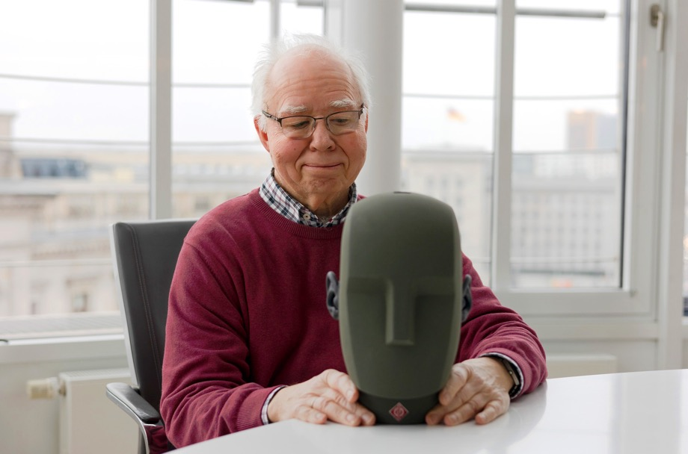

Berlin, June 14, 2023 – This year marks the 50th anniversary of the Neumann dummy head microphone. We spoke with our former President of Development and former General Manager, Stephan Peus, for whom “Fritz”, as the Neumann dummy head is fondly called, was a constant companion. And has remained so to this day! For in retirement, he founded peus-recording to specialize in dummy head recordings.
Dear Mr. Peus, you started at Neumann in 1974, shortly after the first dummy head microphone KU 80 saw the light of day.

That's correct, the KU 80 was introduced at the 1973 IFA trade show. I had already become acquainted with it before that because I was studying communications engineering and acoustics at the Technical University of Berlin. During that time, I met the three inventors of the dummy head, Kürer, Plenge and Wilkens, and took part in the final acoustic tests. My first contact with the finished KU 80 was the recording of a piano concerto by Brahms, which had been recorded in the large auditorium of the SFB (now RBB) on a big studio tape machine. I was thrilled to be entrusted with the editing.

One might think that a dummy head microphone is just a mannequin’s head with two mic capsules in its ears. But it's not as simple as that, is it?

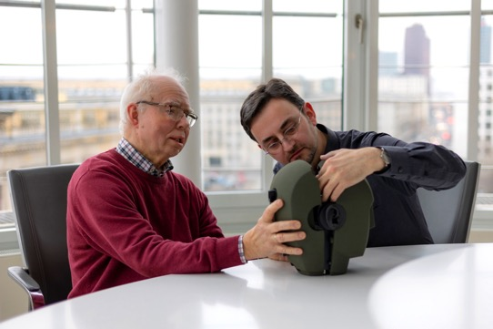
No, because high-quality recordings require a signal-to-noise ratio that cannot be achieved with tiny capsules that would fit in the ear canal. That's why Neumann was approached right away. Here, they could be certain to get the required quality. However, the difference in diameter from the ear canal of about 6 mm to the 21 mm diameter of the small-diaphragm studio microphone
used causes strong coloration. Therefore, acoustic filters had to be installed to combat the resonances and reflections. However, these filters and the reproduction of the entire ear canal were the reason why the first dummy head KU 80 sounded impressive only over headphones. Incidentally, the reference was Sennheiser's HD 414, the first open headphone, which was extremely popular at the time and triggered an initial headphone boom. Over loudspeakers, however, recordings with the KU 80 sounded muffled.
Stephan Peus in conversation with Andreas Hau
The poor loudspeaker compatibility was already fixed in its successor, the KU 81, launched in 1981, wasn’t it?
The impetus came from the Institut für Rundfunktechnik (IRT) in Munich. Some employees of the TU Berlin, who had developed the dummy head, had transferred there. They looked at conventional stereo microphones, especially the Neumann SM 69, and concluded that a dummy head microphone should be diffuse-field equalized. After all, it is usually positioned at some distance from the sound source, i.e., outside the so-called critical distance. At the same time, a diploma thesis brought the realization that the outer ear’s acoustic impact reaches only a few millimeters into the ear canal. So, it was possible to shorten the ear canal in the dummy head considerably, which greatly reduced the attenuation of the upper frequencies. Together with diffuse field equalization, this was a major step forward. However, to facilitate production, I implemented the acoustic filter inside the KU 81 differently than in the IRT design. That was great fun, because I finally got to apply what I had learned in acoustics lectures. Before that, everything I really needed, I had learned at Neumann. Of course, I had the acoustic understanding, but the university didn’t teach you how to build a good-sounding microphone.
Another important innovation in the KU 81 was that new silicone materials made it possible to reproduce the human outer ear in a much more complex and differentiated manner. This has led to a higher resolution.

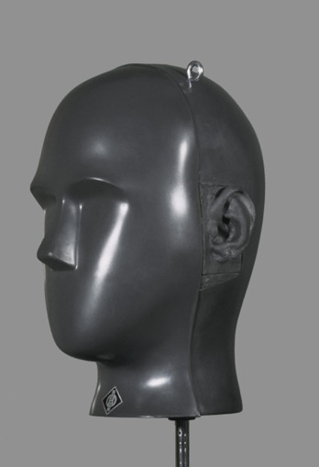
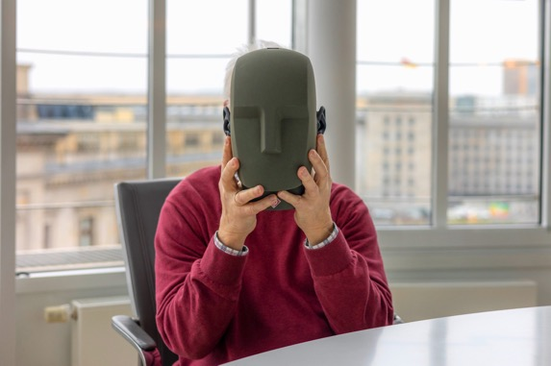
But the Neumann dummy head never had a torso, did it?
The KU 80 was originally sold in a carrying case as wide as our shoulders. So, when you mounted the head on it, you had the upper part of the torso. It was assumed that was important for directional imaging, until one realized that a shoulder section is only relevant for head rotation, when it creates different reflection angles. But with a rigid mount, the torso plays no role in directional perception. That's why we didn't include a shoulder-width case with the KU 81 and KU 100.
After the KU 81 remedied the KU 80's biggest shortcoming by providing good speaker compatibility, what were the motivations for developing the KU 100?
Acoustically, the KU 100 is indeed not all that different from the KU 81, nor were there any major quirks that absolutely had to be fixed. However, we had contact with a very interesting designer who found the KU 81 so ugly that he offered us a design draft – which we liked right away!
The more abstract form actually also corresponds to the current state of research that, for example, very human-like robots tend to appear uncanny, while artificial forms, which clearly identify themselves as something technical, meet with fewer reservations.
There's something to that! At the very beginning, the KU 80 was used in theaters and in the Philharmonie Berlin to allow the director to listen 1:1 into the room. And there were indeed protests from actors and from the audience that a “dead skull” was hanging up there. So they built a cube with black gauze in which the head disappeared.
But the KU 100 does offer some detail improvements over its predecessor?
Yes, one of them being the shape of its ears. In the KU 80 and KU 81, we worked with casts of real ears. In the case of the KU 80, they were the ears of one of its developers: Dr. Henning Wilkens; in the case of the KU 81, they decided to use the ears of an employee of the Ruhr University Bochum, who unfortunately died in a traffic accident a few years later. But his ears live on, so to speak. In principle, the ears of the KU 100 are the same, but since our outer ears (and hence those of the first dummy heads) are never perfectly symmetrical, I had the idea to match the ears of the KU 100. This was to prevent the asymmetries of the KU ears from accidentally overlapping with those of the listener’s ears in such a way that the result could become too right- or left-biased. And because I had no way of measuring and eliminating this asymmetry automatically, I did the alignment by hand. My daughter, who is a dental technician, gave me suitable materials, and so I worked on the ears of the KU 100 from sculpting paste with a spatula and scraper. I took one of the ears as a reference and made the second one as much like a mirror image as possible.
My impression is that the frontal localization is more accurate on the KU 100 than on the KU 81.
This could be in part due to the improved symmetry of the ears. We have also changed the “pitch angle” of the ears somewhat. In listening tests with the KU 81, it had been noticed that sound sources in the horizontal plane usually tended to be perceived slightly upward during reproduction. This is related to a characteristic “dip” in the horizontal frequency response of our outer ears. For every natural ear, that dip is at a slightly different frequency. This does not interfere with natural hearing, because we “adjust” the location of sound sources with the help of our eyes throughout our lives. If we are now given a certain configuration by the dummy head, we cannot correct visually. As it happened, the aforementioned dip in the horizontal frequency response of the KU 81 caused sound events from the front to be perceived as slightly shifted upward. In the KU 100, we therefore adjusted the angles of the ear cups relative to the vertical so that the imaging is now correct horizontally and vertically.
Since your retirement, you have gained a lot of experience in dummy head recordings with "peus-recording". Would you have any tips?
I have been careful to work only in acoustically “nice” and balanced rooms, often in churches. A sound check is essential, of course, to determine a good position for the dummy head. And you should watch out for unwanted background noises. In “normal” recordings, microphones are used that can largely block out sound from irrelevant directions. The dummy head, by its very nature, listens in all directions, and you should be very careful to assess the overall acoustic situation before recording. Nothing remains hidden from a microphone as sensitive as the Neumann dummy head!
Thank you very much for the interview, Mr. Peus!
The interview was conducted by Dr. Andreas Hau (Content Marketing Manager, Neumann)
The KU 80 und KU 81 had a more „human“ appearance.
.

Link: Find out more about the Neumann KU 100
Stay up to date and follow us on: FACEBOOK I INSTAGRAM I YOUTUBE

About Neumann
​Georg Neumann GmbH, known as “Neumann.Berlin”, is one of the world’s leading manufacturers of studio-grade audio equipment and the creator of recording microphone legends such as the U 47, M 49, U 67, and U 87. Founded in 1928, the company has been recognized with numerous international awards for its technological innovations. Since 2010, Neumann.Berlin has expanded its expertise in electro-acoustic transducer design to also include the studio monitor market, mainly targeting TV and radio broadcasting, recording, and audio production. The first Neumann studio headphones were introduced in 2019, and since 2022, the company has increased its focus on reference solutions for live audio. With the introduction of the first audio interface MT 48, and its revolutionary converter technology, Neumann now offers all the necessary technologies needed to capture and deliver sound at the highest level. Georg Neumann GmbH has been part of the Sennheiser Group since 1991 and is represented worldwide by the Sennheiser network of subsidiaries and long-standing trading partners. www.neumann.

Press Contact Neumann:
Andreas Sablotny
andreas.sablotny@neumann.com
T +49 (030) 417724-19

Raphael Tschernuth
raphael.tschernuth@neumann.com
T +49 (030) 417724-67

