A Commitment to the Future:
Mammut releases Achievements in the 2023 Corporate Responsibility Report
©Mammut Sports Group AG

27.06.2024, Seon, Switzerland – Mammut Sports Group AG is pleased to announce the release of its 2023 Responsibility Report. This report marks a significant milestone in Mammut’s ongoing commitment to environmental and social responsibility. The comprehensive report highlights Mammut's achievements, such as a 17% reduction in the CO₂ footprint and a 19% decrease in carbon intensity.
Other key highlights include the launch of the company’s decarbonized trail running collection and the innovative use of polyester waste for insulation materials. The report also details the challenges and future goals, as Mammut aims to set new standards in the outdoor industry.
Key highlights of the 2023 Responsibility Report:
- Decarbonization and climate action: In 2023, Mammut's overall carbon footprint was estimated at 43,963 metric tons of CO₂-eq, reflecting an approximate 17% decrease from 2022. This reduction is primarily attributed to a decrease in upstream Scope 3 emissions. Scope 1 accounts for emissions from facilities and tools Mammut owns or controls, including company cars and technical equipment at its own locations. Scope 2 addresses indirect emissions such as electricity, heating, and cooling consumed by Mammut. Scope 3 is the largest and most challenging category, involving all production and post-sales emissions, ranging from unused materials during manufacturing and employees commuting, to the product treatment at end-of-life. Building more sustainable supply and value chains will significantly impact Scope 3 emissions. This is why Mammut’s climate strategy focuses on upstream and downstream activities.
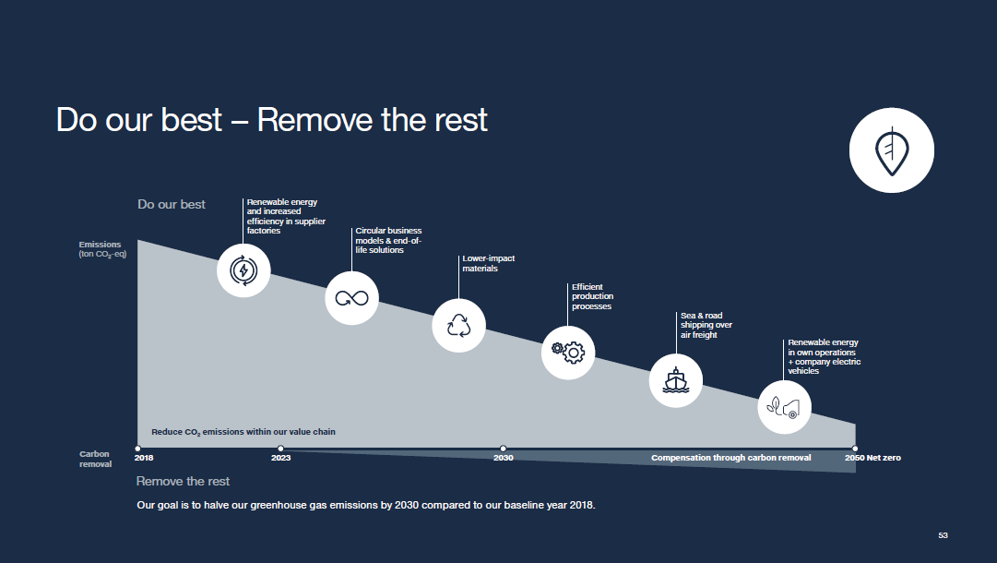
Compared to 2022, Mammut’s carbon intensity relative to its business revenue decreased by 19% in 2023. Carbon intensity is measured by the ratio of emissions to turnover. To prevent Mammut’s growth from automatically leading to increased emissions, it is imperative to continually reduce carbon intensity. This result marks the fifth consecutive year of decreased carbon intensity.

Mammut partnered with carbon removal technology leaders Climeworks and Klimate in 2023. For the launch of its decarbonized trail running collection, Mammut purchased carbon removal credits for all emissions generated during production and transport of the goods.
- Material mix: For the first time, the 2023 Responsibility Report includes a breakdown of the materials used by volume, along with their corresponding CO₂ emissions. This transparency allows stakeholders to understand the environmental impact of each material used in Mammut's production processes.
- Circularity and product longevity: In 2023, over 13,000 Mammut products were repaired worldwide, extending the lifespan of the high-quality outdoor gear. The Loopinsulation project, which converts polyester waste from industrial rope production into insulation material for jackets, is another example of Mammut’s commitment to sustainability and reducing environmental impact through innovative recycling and repair programs.
- Social responsibility and community engagement: Mammut has reinforced its commitment to social responsibility through several key initiatives. The new Responsible Business Conduct policy outlines guidelines for ethical operations and supplier interactions, addressing human rights, anti-corruption, and environmental stewardship. Additionally, the worker well-being booklet aims to enhance employee welfare across the supply chain, focusing on improving working conditions and showcasing best practice examples.
Mammut continued its collaborations with several partners like Protect Our Winters, ClimbAID, and American Mountain Guides Association. Additionally, Mammut signed the International Accord for Health and Safety in the Textile and Garment Industry and joined the Bangladesh Child Sensitive Social Protection (CSSP) program. These partnerships ensure safe working environments and provide social protection to workers and their families in Bangladesh, highlighting Mammut's dedication to fostering ethical and supportive working conditions globally.
- Transparency and accountability: For the first time, Mammut is publishing comparable year-on-year data from 2021, 2022, and 2023, showcasing its commitment to transparency. In alignment with emerging CSRD and ESRS (EU) regulations, Mammut has begun year-on-year data comparisons to progressively meet high standards. This approach enhances transparency and makes data more accessible, and context based.
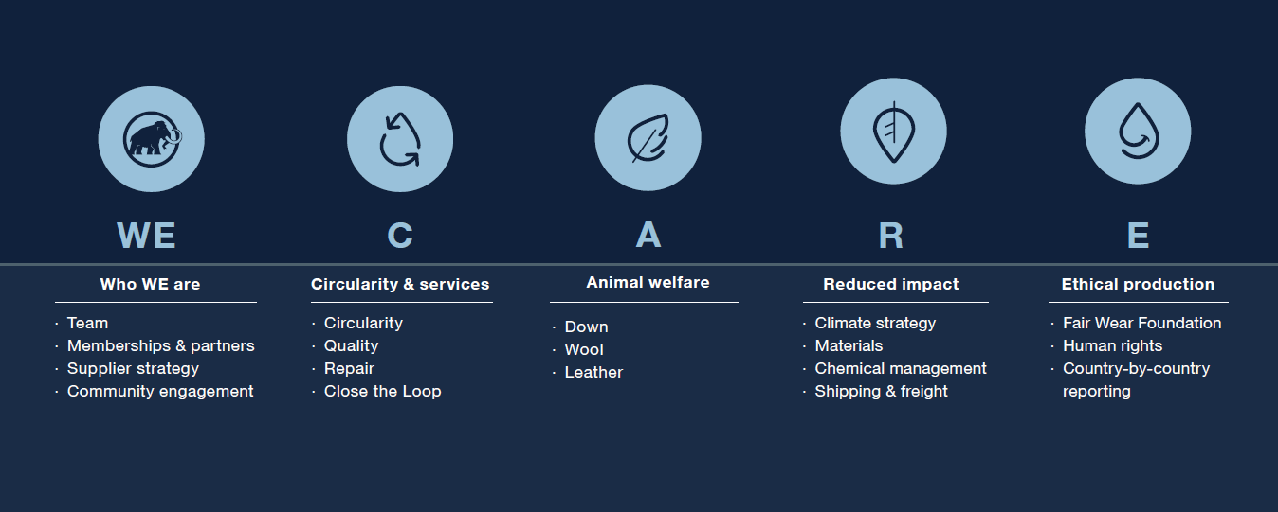
Further areas of progress include improvements in down, wool, and leather sourcing, as well as advancements in bluesign® and PFC-free product initiatives. The report details progress towards the 2025 targets outlined in the WE CARE framework, covering key areas such as circularity, animal welfare, reduced impact, and ethical production.

"This report is a testament to the collective efforts and contributions of our colleagues, partners, and the broader Mammut community," says Heiko Schäfer, Chief Executive Officer of Mammut Sports Group AG. "Since 1862, our relentless focus on product performance, quality, and durability has been the cornerstone of our brand. This report reflects our journey towards becoming a more responsible and transparent company, and we are excited to share our tangible progress and learnings with the world."

Download
Access the full report 2023

About Mammut

Mammut is a Swiss outdoor company founded in 1862 that offers mountain sports enthusiasts worldwide high-quality products and unique brand experiences. For 160 years, the world's leading premium brand has stood for safety and pioneering innovation. Mammut products combine functionality and performance with contemporary design. With its combination of hard goods, footwear, and clothing, Mammut is one of the complete suppliers in the outdoor market. Mammut Sports Group AG is active in around 40 countries and employs approx. 850 people.

mammut.com

