Wijchen, January 2018

MarGe Models introduce Nooteboom 3-axle semi low-loader in scale 1:32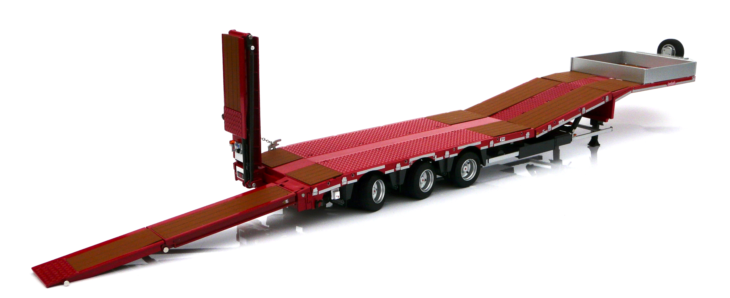
▲Photo caption: Prototype Nooteboom 3-axle semi low-loader scale 1:32, MarGe Models.

At the Spielwarenmesse in Nurnberg - 31 January to 4 February - MarGe Models will introduce their very first Nooteboom scale model in scale 1:32 on their stand C48 in hall 7. It concerns a 3-axle semi low-loader, type MCOS-48-03EB, particularly suitable for the transport of construction equipment and agricultural machinery. The model has plenty of detail and is fitted with steered axles, a height-adjustable load floor and double-folding ramps that can also be adjusted in width.

In Q2 of this year the model will become available to collectors for the extremely low price of EUR 85, incl. BTW. The model comes in two versions: a load floor and ramps with aluminium grid sections or with hardwood floor sections. Exactly like the options that are available for the real thing.
During Q1 these models can be reserved via the Nooteboom Shop at www.nooteboomshop.com.

MarGe Models have also designed new tractors for this trailer. At the Spielwarenmesse they will present prototypes of the Volvo FH16 4x2 and the Volvo 6x2. This is the type of tractor that is often used in combination with a 3-axle semi low-loader. These tractors will become available later in the year.

+++++

Note to the editor (not for publication): Digital photographs in high resolution are attached and free for publication. Photographs in higher resolution are available on request.

For further information:
MarGe Models B.V., Gert Valkema, tel.+31 630743055, email: gvalkema@margemodels.com
Nooteboom Trailers B.V., Denise Janssen, tel. +31 24648806, email: d.janssen@nooteboom.com

