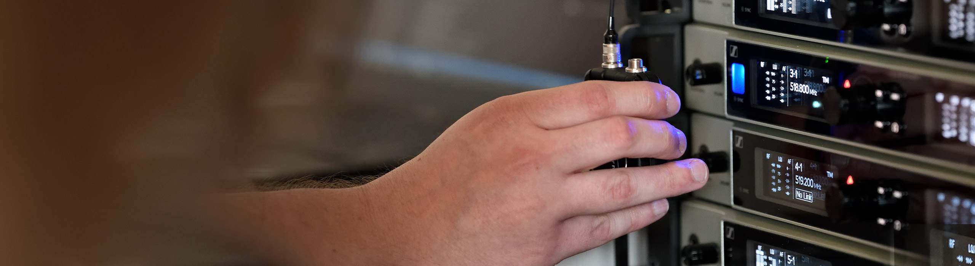

#DontStopTheEducation: Panel on Live Sound at Houses of Worship

Leading sound engineers on how they mix houses of worship for in-person and livestreamed events

Old Lyme, Connecticut, July 30, 2020 – Following the popular House of Worship roundtable in April, the Sennheiser SoundAcademy is pleased to offer a new session on live sound mixing for houses of worship on August 25, 2020.

Panelists include three live sound engineers: Raph Williams of Bethel Productions, Dan Bowater of Church Sound Summit and Paul Mitchell who is Director of Production Technology for Chase Oaks Church. Micah Williams of Eagle Vision Videos will also join to offer insight into video production for houses of worship. The roundtable will be hosted by Sennheiser’s Andy Egerton and Tim Moore, who will lead discussions focused on mixing live audio, as well as how the panelists are adapting to production for livestreamed events and services during COVID-19.

The panelists will also share how they initially become involved in houses of worship, their individual careers and the experiences they have gathered along the way. The roundtable will take questions from the audience.

Please register at https://zoom.us/webinar/register/WN_yT1jDjvtQvClpdTtXbQHWA.

House of Worship Roundtable #2
Tuesday, August 25 at 17:00 Berlin time (15:00 UTC, 11:00 New York time)

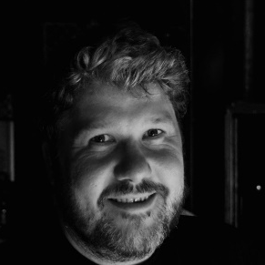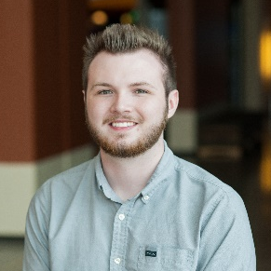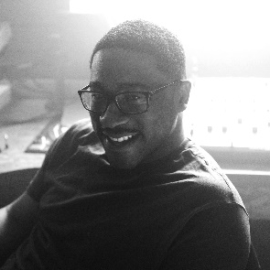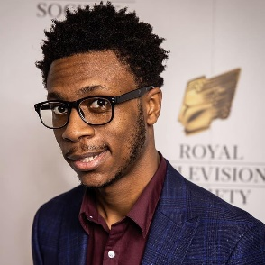

Dan Bowater, Paul Mitchell, Raph Williams and Micah Williams (from left to right) will answer your questions on live sound mixing and production for the House of Worship roundtable on August 25.

About the Panelists

Dan Bowater

Dan Bowater Has been involved in audio since he was a kid travelling with his musician Dad and involved in the local church, creating demos for friends and family.

After university Dan went freelance before setting up dB Studios using equipment and experiences he had gained from working with artists like Delirious on their King of Fools Album.

Between 1996 and 2014 Dan managed the studio while also freelancing for large Christian Gatherings (FOH, monitors, broadcast and live recording). He has engineered at almost all the Christian festivals in the UK and worked with many of the leading worship leaders and bands in the country.

In 2014 he moved with his family to work for International’s House of Prayer in Kansas City where he was to head up their sound department, consisting of 30+ engineers and venues around the city. After 2 years including their yearly One Thing event it was time to return to UK.

Since then, Dan has diversified and worked on many events as well as rock and pop gigs and large-scale theatre shows, plus working with several classical shows including Russell Watson, Queen Symphonic and Orchestral Madness. He’s also found that the corporate event market is similar in many ways to running a church event and has worked on many large (and small) corporate events around the country. In 2019, Dan premiered a new event for church tech teams www.thechurchsoundsummit.com with the aim to help train churches and engineers by creating a network of like-minded people. This year he is hoping to run a livestreamed event to continue the momentum started in 2019.

Post Covid-19 he has managed to pick up a number of jobs going back to studio life and has mixed livestreams, recorded and edited podcasts as well as mixed for future releases.

He currently lives in Lincoln with Jennifer and their 3 kids.

Raph Williams

Raph Williams has never forgotten his roots and foundation of the church setting where he started his life as a Sound Engineer. His work life reflects that. Becoming a world-renowned sound engineer that has worked on some of the biggest stages, with global artists in the music industry such as Stormzy, his values of integrity, professionalism and excellence have made him one of the most sought-after engineers in the field.

During lockdown Raph has returned to roots and been involved in church community projects to continue reaching people.

Micah Williams

Micah Williams recently graduated with a first class honors degree studying BSc Media Technology while being a Royal Television Society Bursary Recipient.

He purchased his own camera through profits made by selling sweets as a 12-year old. Before starting university, he developed his own video production team (Eagle Vision TV), which captured many church conferences, weddings and funerals for livestream and private viewing. They have installed live streaming systems for churches all around the UK.

Micah is from a social group that is underrepresented in the industry (black, male graduates) and would like to challenge this statistic. He is keen to teach young people about the industry and to inspire them to pursue a career in broadcasting.

Paul Mitchell

Paul Mitchell is currently the Production Technology Director for Chase Oaks Church, a multisite church in the Dallas-Fort Worth area. He oversees all production related technologies at all campuses of the church. Paul has spent his time in Dallas-Fort Worth consulting and designing AVL systems for integrators, Chase Oaks Church, and surrounding churches.

About Sennheiser
Founded in 1945, Sennheiser is celebrating its 75th anniversary this year. Shaping the future of audio and creating unique sound experiences for customers – this aim unites Sennheiser employees and partners worldwide. The independent family company, which is managed in the third generation by Dr. Andreas Sennheiser and Daniel Sennheiser, is today of the world’s leading manufacturers of headphones, loudspeakers, microphones and wireless transmission systems. In 2019, the Sennheiser Group generated turnover totaling €756.7 million. www.sennheiser.com

Local press contact Global press contact

Daniella Kohan Stephanie Schmidt
daniella.kohan@sennheiser.com Stephanie.schmidt@sennheiser.com
+1 (860) 222 – 4226 +49 (5130) 600 – 1275

