Supplementary Material for

Dahdouh-Guebas, F., G.N. Ajonina, A. Aldrie Amir, D.A. Andradi-Brown, I. Aziz, T. Balke, E.B. Barbier, S. Cannicci, S.M. Cragg, M. Cunha Lignon, D.J. Curnick, C.M. Duarte, N.C. Duke, C. Endsor, S. Fratini, I.C. Feller, F. Fromard, J. Hugé, M. Huxham, J.G. Kairo, T. Kajita, K. Kathiresan, N. Koedam, S.Y. Lee, H.-J. Lin, J.R. Mackenzie, M.M. Mangora, C. Marchand, T. Meziane, T.E. Minchinton, N. Pettorelli, J. Polanía, G. Polgar, M. Poti, J. Primavera, A. Quarto, S.M. Rog, B. Satyanarayana, Y. Schaeffer-Novelli, M. Spalding, T. Van der Stocken, D. Wodehouse, J.W.H. Yong, M. Zimmer & D.A. Friess, 2020. Public perceptions of mangrove forests matter for their conservation. Frontiers in Marine Science 7:603651. (https://www.frontiersin.org/articles/10.3389/fmars.2020.603651/full).

Supplementary images: separate images used in the collage in Figure 1

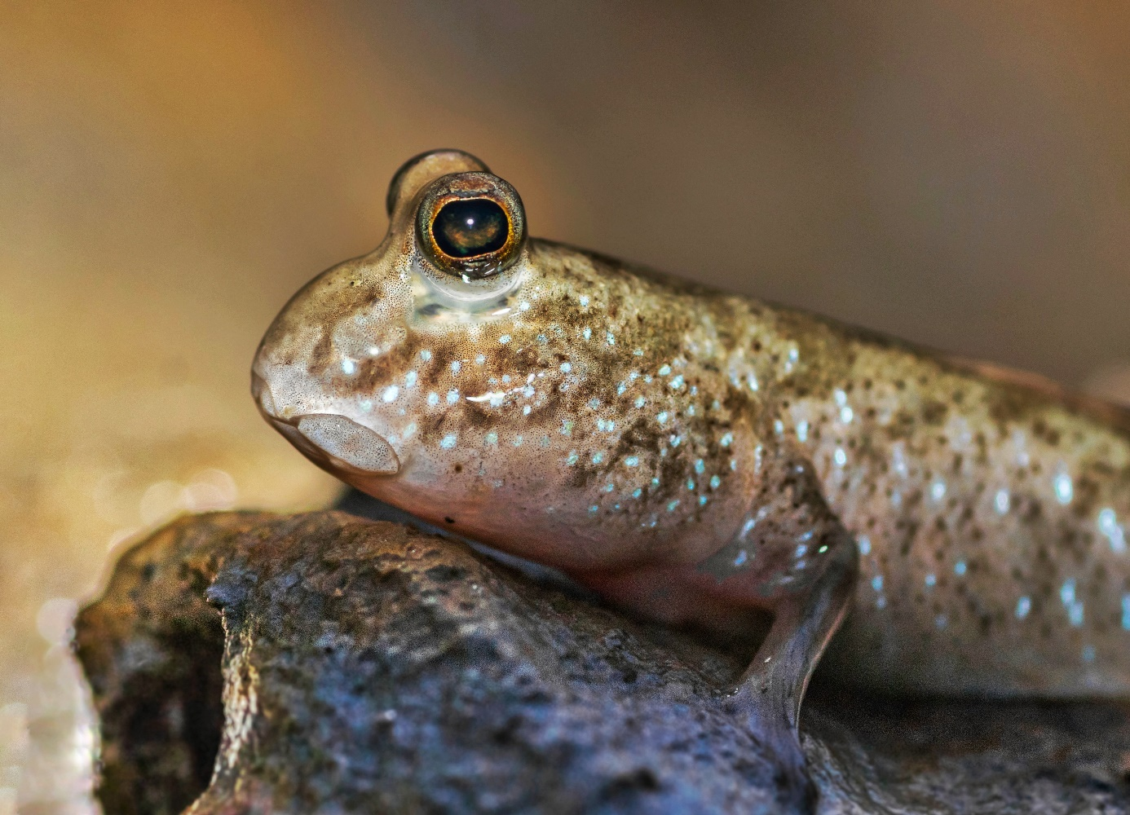
Figure S1. Mudskippers, unlike other fishes, are able to survive on land with ease. India (Photograph by Arghyadeep Das).

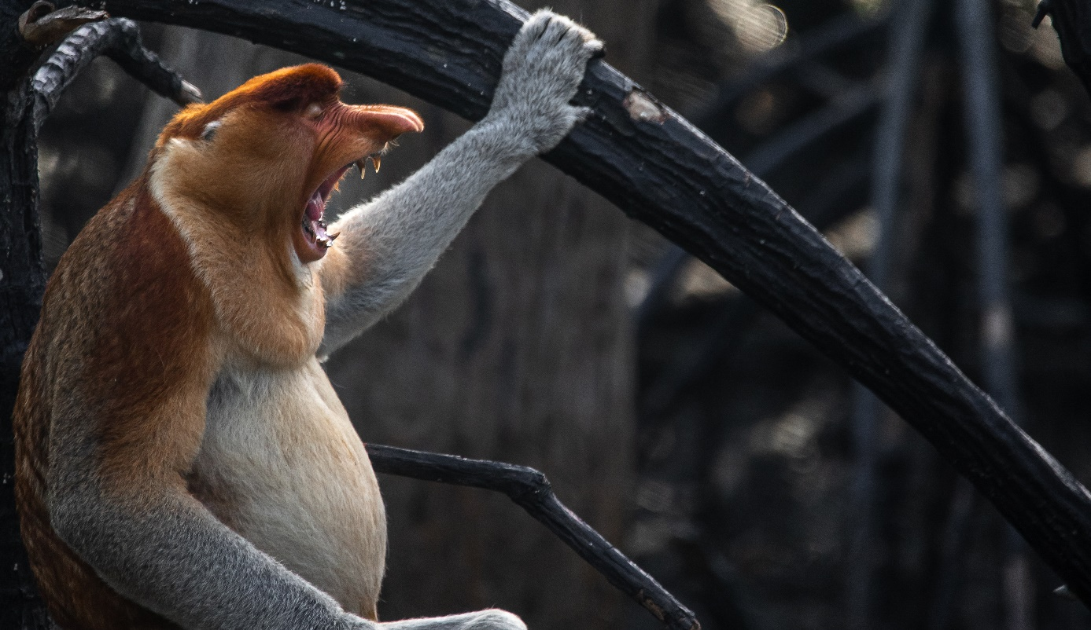
Figure S2. The proboscis monkey (Nasalis larvatus) or long-nosed monkey, known as the bekantan in Indonesia, is an arboreal Old-World monkey with an unusually large nose, a reddish-brown skin colour and a long tail. It is endemic to the southeast Asian island of Borneo and is found mostly in mangrove forests and on the coastal areas of the island. Mangrove forests are the main habitat for this charismatic monkeys and protecting mangroves is therefore essential for its conservation. Borneo, Indonesia (Photograph by Anil T. Prabhakar).
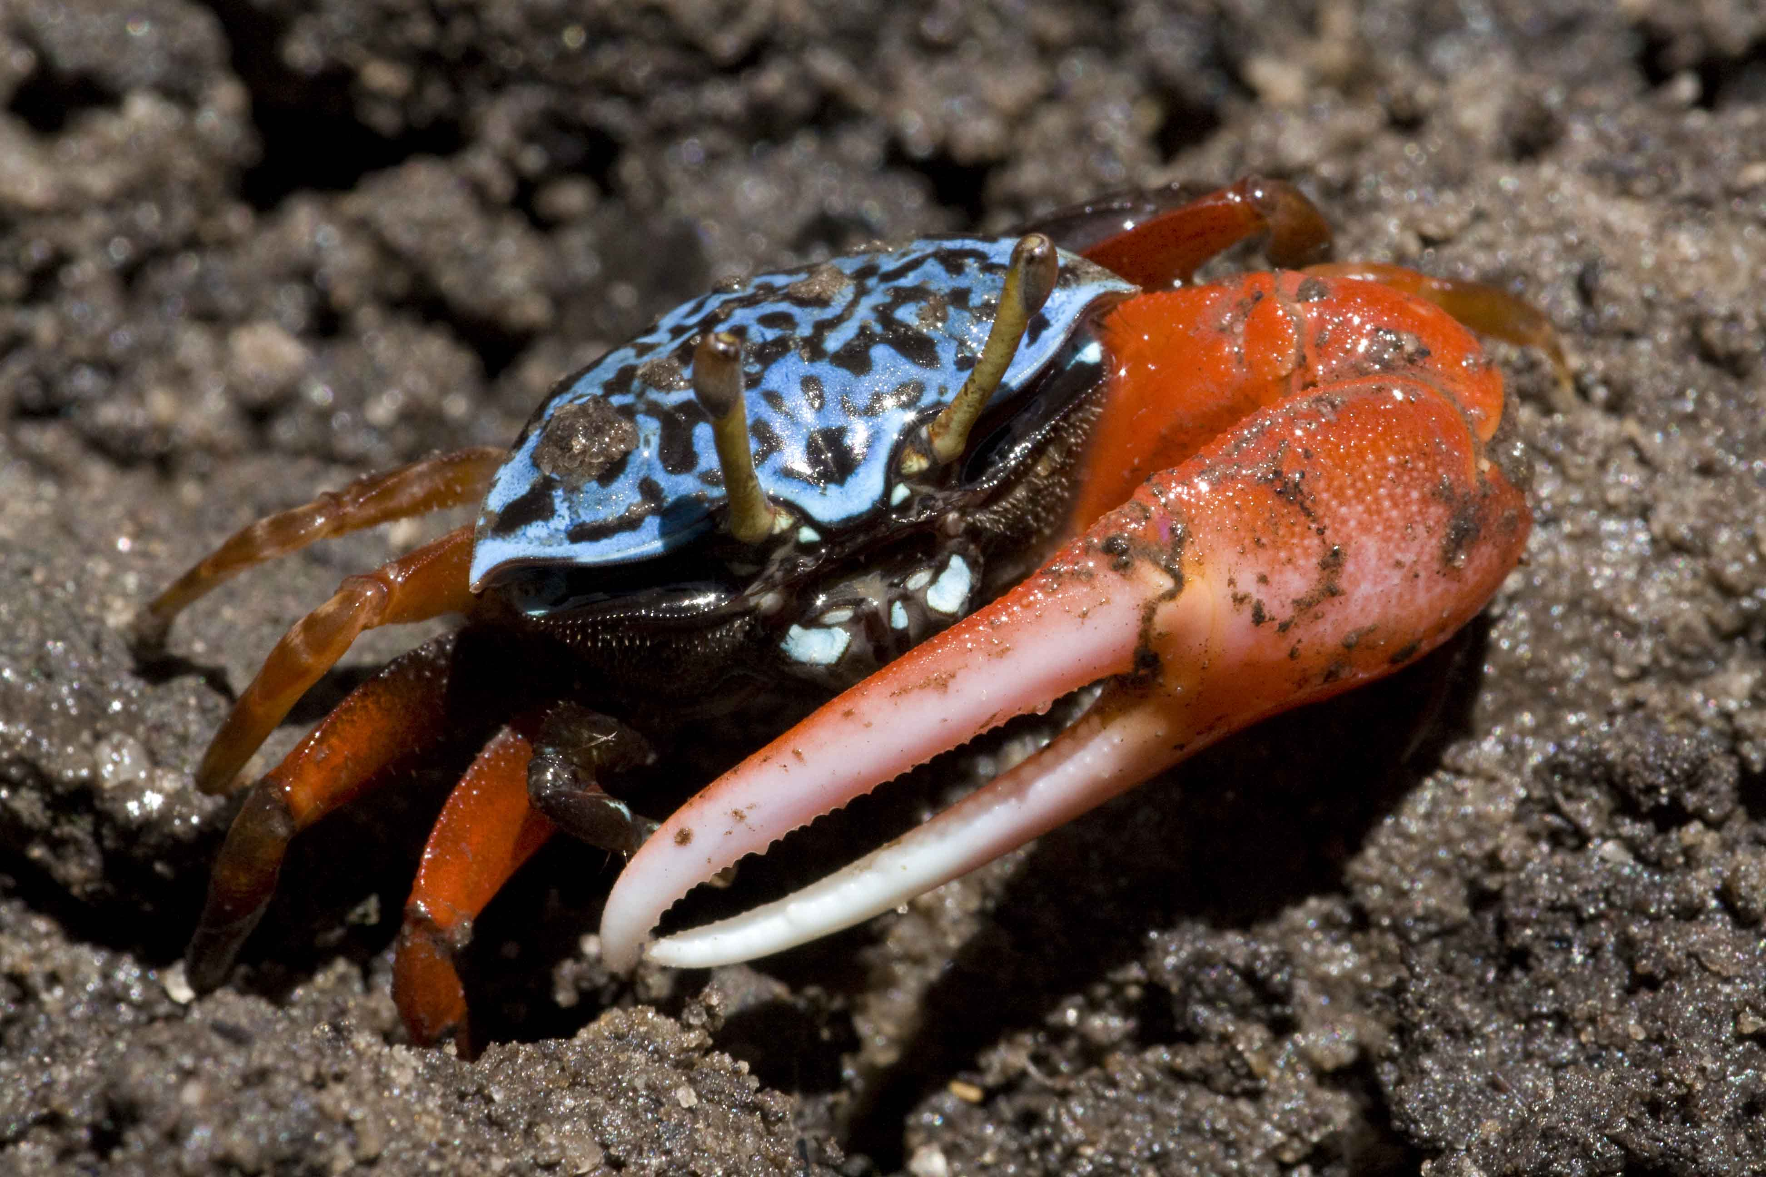
Figure S3. Crustaceans, molluscs and other invertebrates such as this fiddler crab Paraleptuca chlorophthalmus from Gazi Bay (Kenya) are part of a unique biodiversity in the intertidal zone where mangroves thrive and often they function as ecosystem engineers through their bioturbation activities (Photograph by Stefano Cannicci).
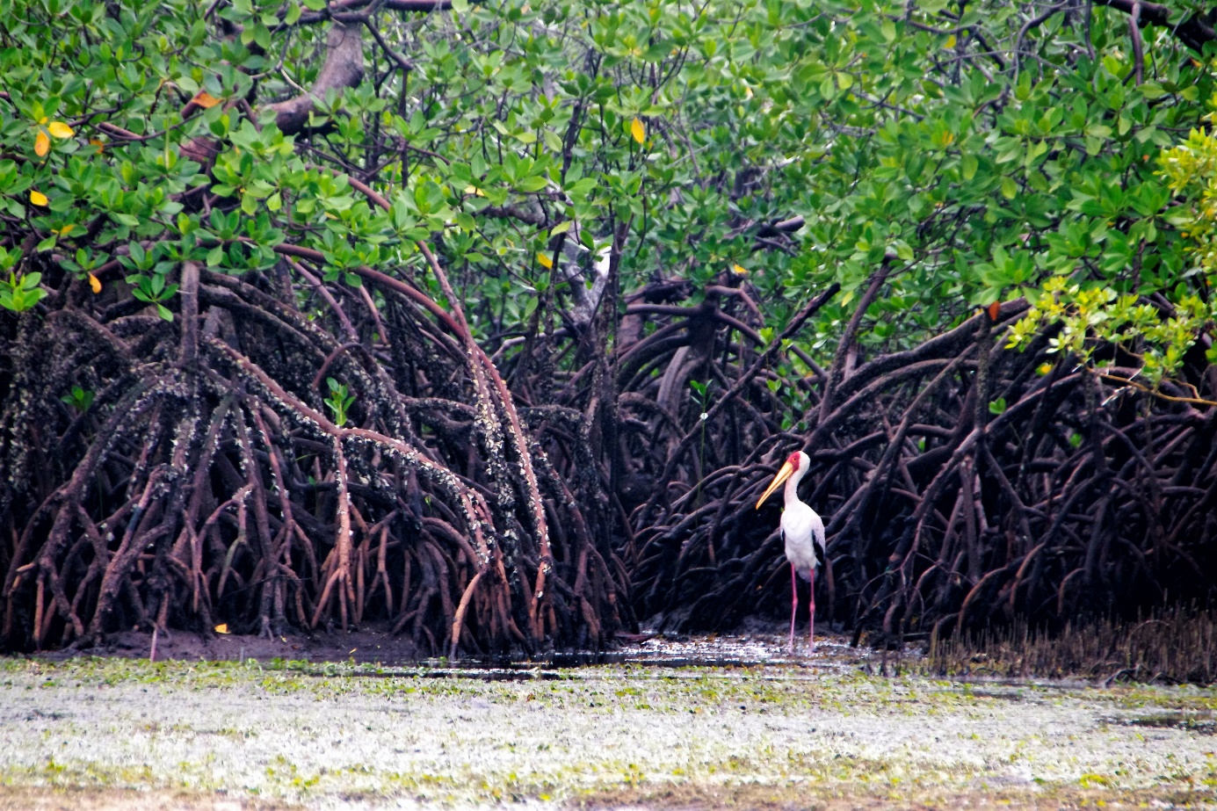
Figure S4. Yellow billed stork wading in the mud around a Rhizophora mucronata stand in Gazi Bay, Kenya (Photograph by Dominic Wodehouse).

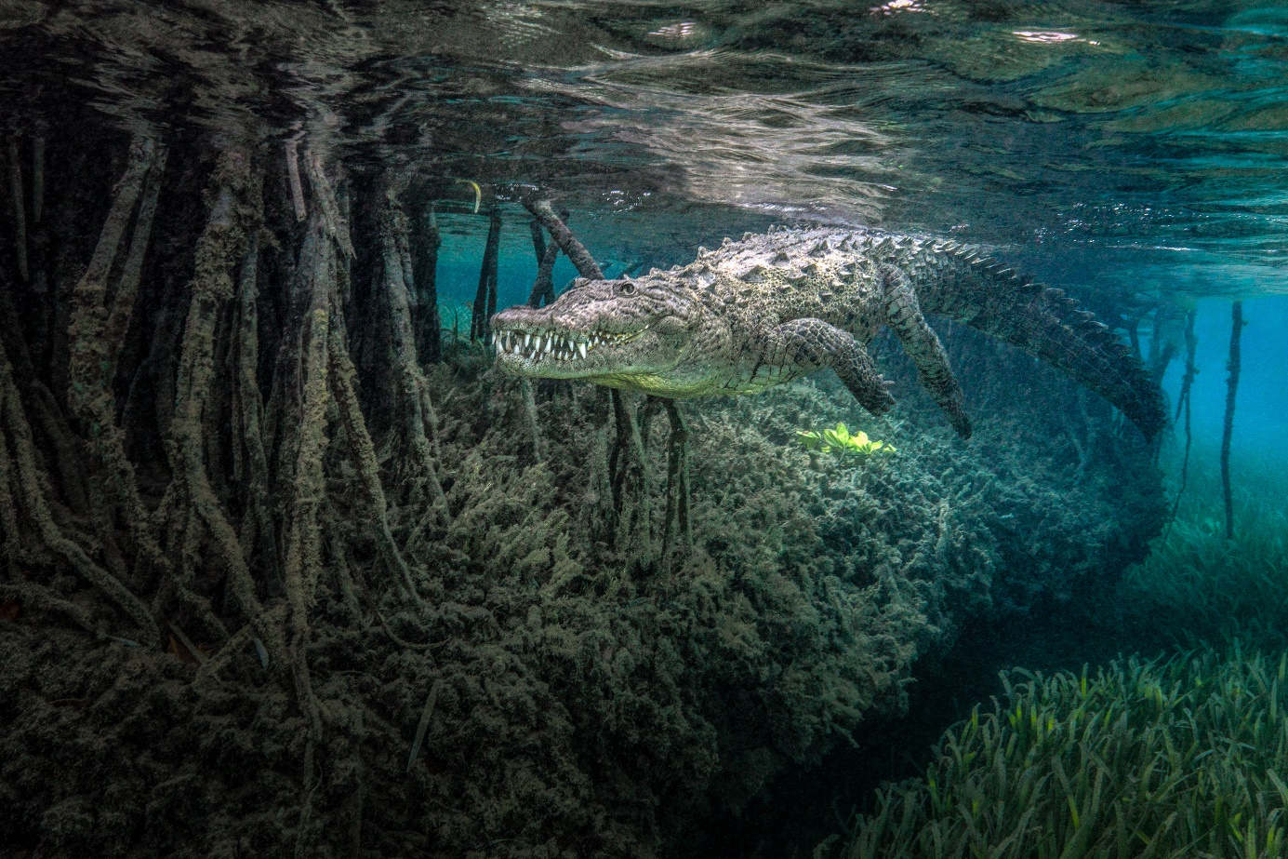
Figure S5. The beautiful and powerful animal in its home environment, the mangroves of Jardines de la Reina, Cuba (Photograph by Jenny Stock).

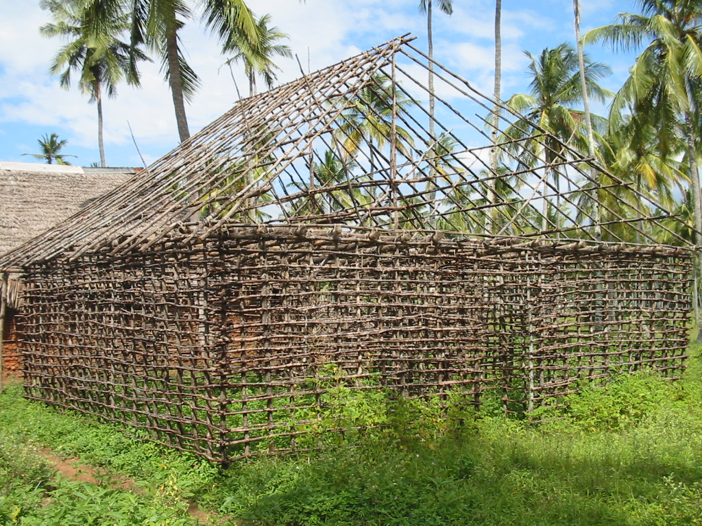
Figure S6. Typical Swahili house in Gazi Bay (Kenya) composed of poles from different mangrove species depending on their position in the construction. The Red mangrove Rhizophora mucronata is used for supporting pillars, the Yellow mangrove Ceriops tagal for the horizontal interweaving network and the Orange mangrove Bruguiera gymnorrhiza for ceiling beams (Photograph by Griet Neukermans).

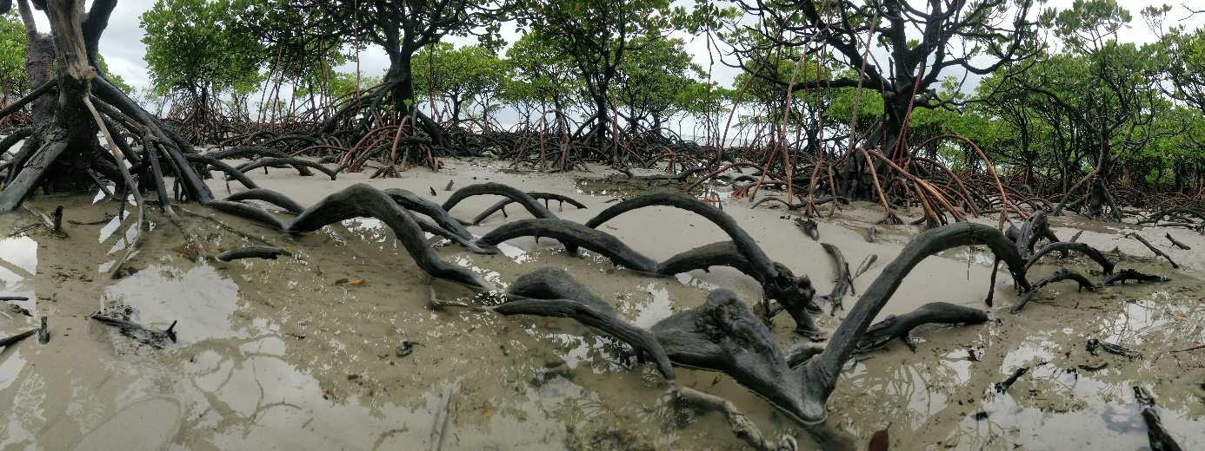
Figure S7. Spreading your roots to stand stronger and taller against the storm. Cape Tribulation, Queensland, Australia (Photograph by Mohammed Hisham Shaikh).
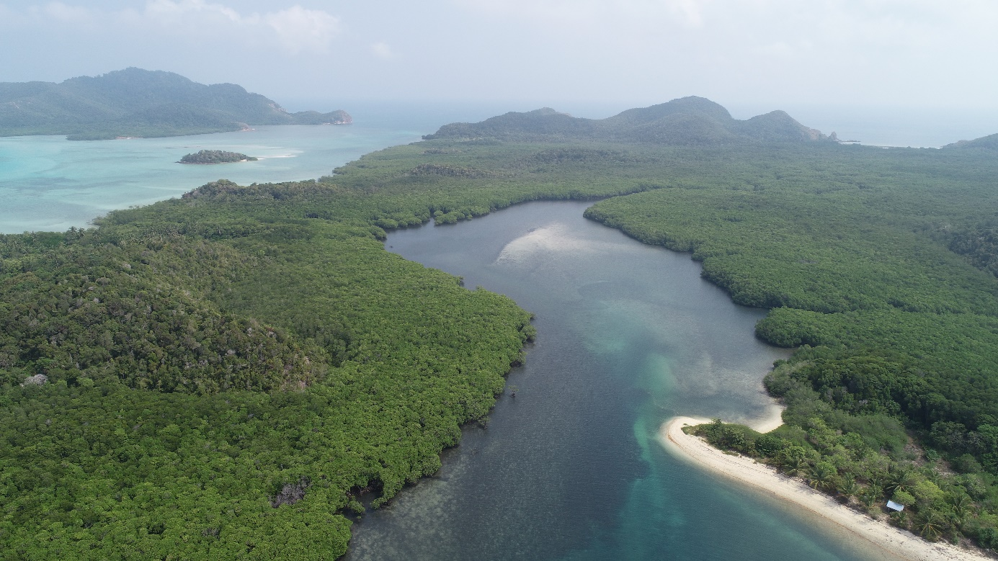
Figure S8. Scenic view of mangrove creeks in Pulau Seri Buat, Pahang, Malaysia (Photograph by Ahmad Aldrie Amir).

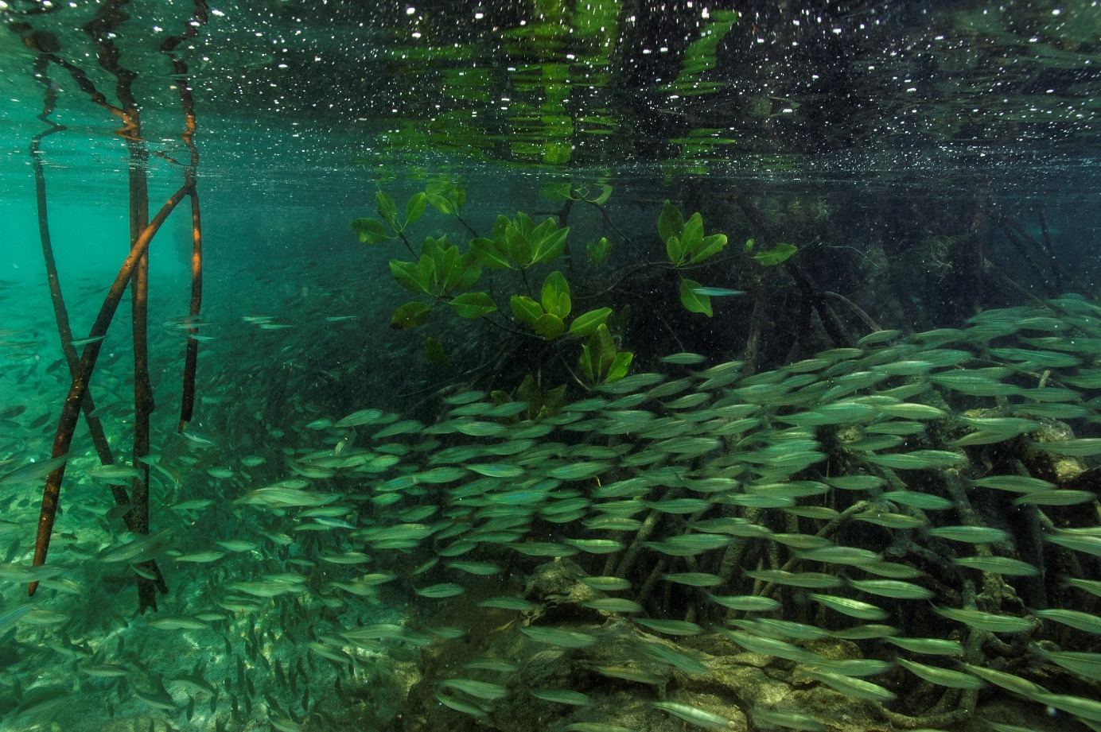
Figure S9. The mangrove root complex serves as breeding, spawning, hatching and nursing habitat for fish and other organisms and as refuge against predators such as shown in Figure S5. South Button, Andaman Archipelago, India (Photograph by Umeed Mistry).

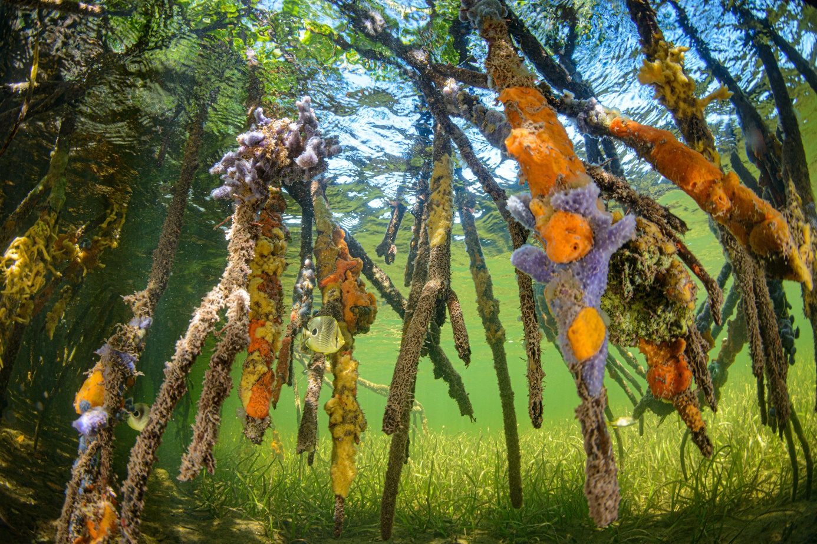
Figure S10. Four-eyed Butterfly fish among sponge encrusted roots of mangroves in Grand Cayman Island. These sheltered areas provide foraging grounds and protection for all kinds of juvenile reef fish. Grand Cayman, Cayman Islands (Photograph by Eiko Jones).

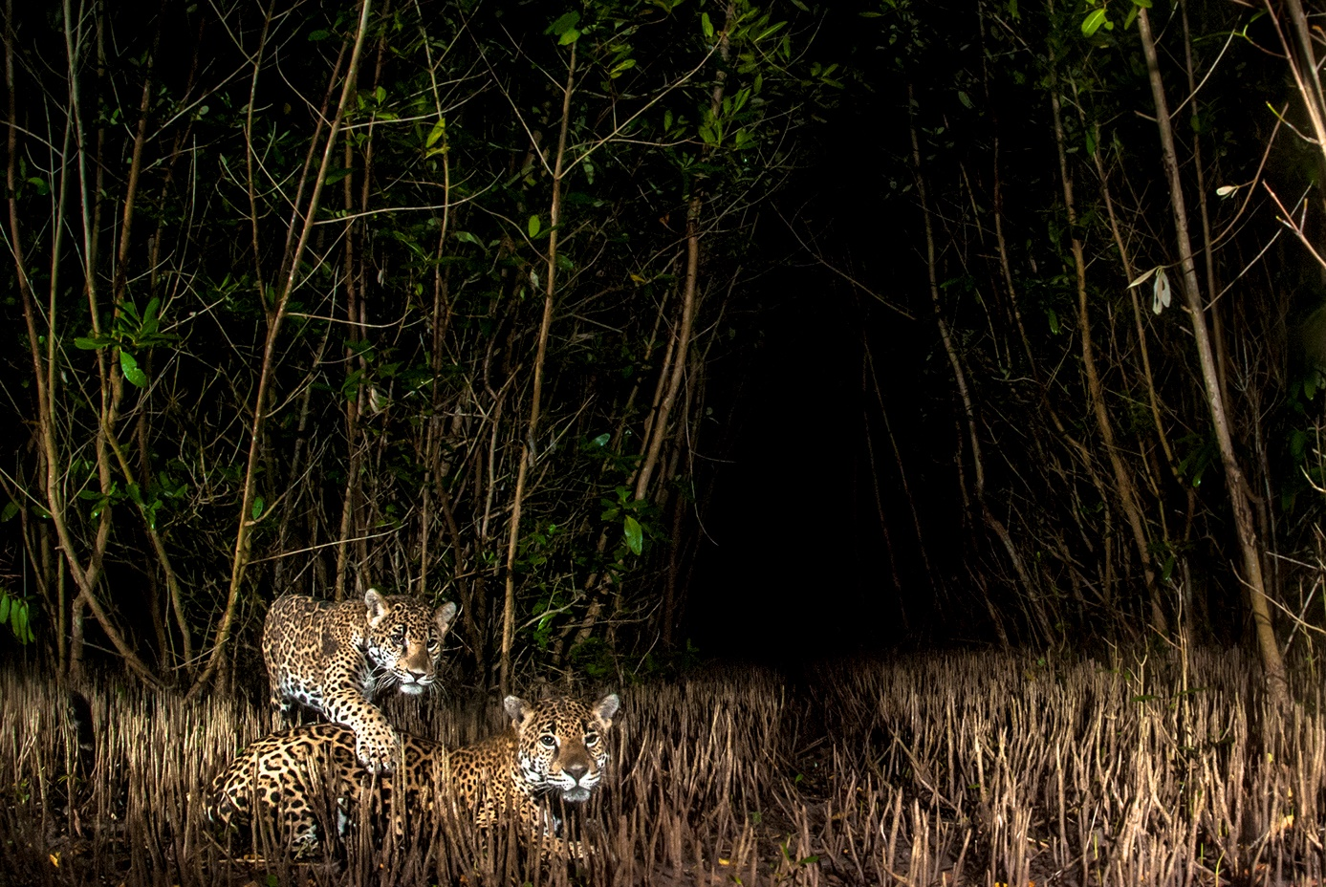
Figure S11. Jaguars (Panthera onca) in the ADVC La Papalota, Nayarit, western Mexico. This female named “Janis” is a resident and has reproduced at least three times (Photograph by Victor H. Luja Molina).
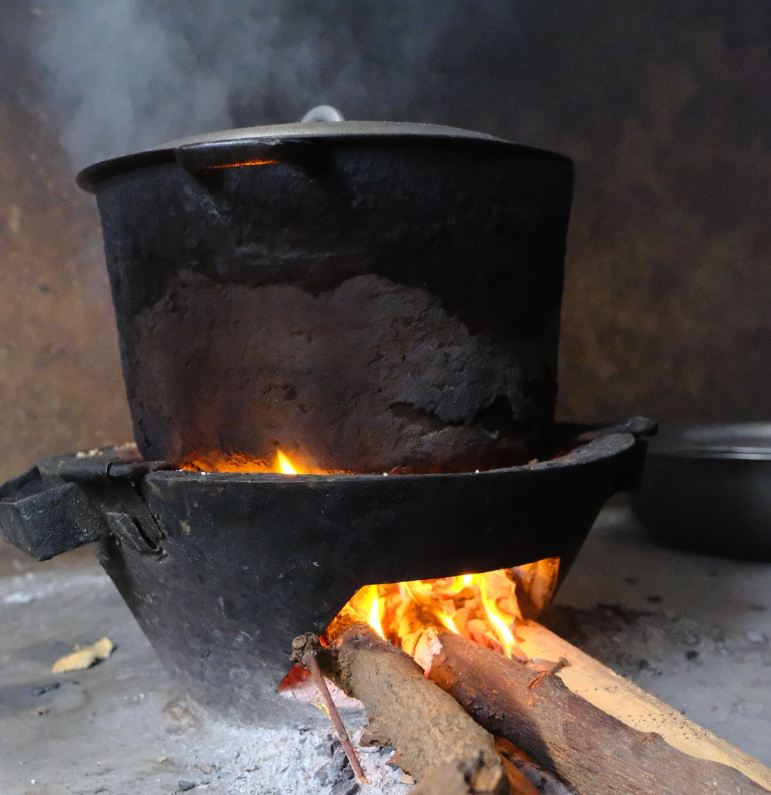
Figure S12. Millions of coastal populations world-wide collect firewood from mangroves every day to cook their food. Toubacouta, Sine Saloum, Senegal (Photograph by Dominic Wodehouse).

Supplementary images: separate images used in the collage in Figure 1

Dahdouh-Guebas, F., G.N. Ajonina, A. Aldrie Amir, D.A. Andradi-Brown, I. Aziz, T. Balke, E.B. Barbier, S. Cannicci, S.M. Cragg, M. Cunha Lignon, D.J. Curnick, C.M. Duarte, N.C. Duke, C. Endsor, S. Fratini, I.C. Feller, F. Fromard, J. Hugé, M. Huxham, J.G. Kairo, T. Kajita, K. Kathiresan, N. Koedam, S.Y. Lee, H.-J. Lin, J.R. Mackenzie, M.M. Mangora, C. Marchand, T. Meziane, T.E. Minchinton, N. Pettorelli, J. Polanía, G. Polgar, M. Poti, J. Primavera, A. Quarto, S.M. Rog, B. Satyanarayana, Y. Schaeffer-Novelli, M. Spalding, T. Van der Stocken, D. Wodehouse, J.W.H. Yong, M. Zimmer & D.A. Friess, 2020. Public perceptions of mangrove forests matter for their conservation. Frontiers in Marine Science 7:603651. (https://www.frontiersin.org/articles/10.3389/fmars.2020.603651/full).

