

Biuro prasowe better. gaming agency
bettergamingagency.prowly.com

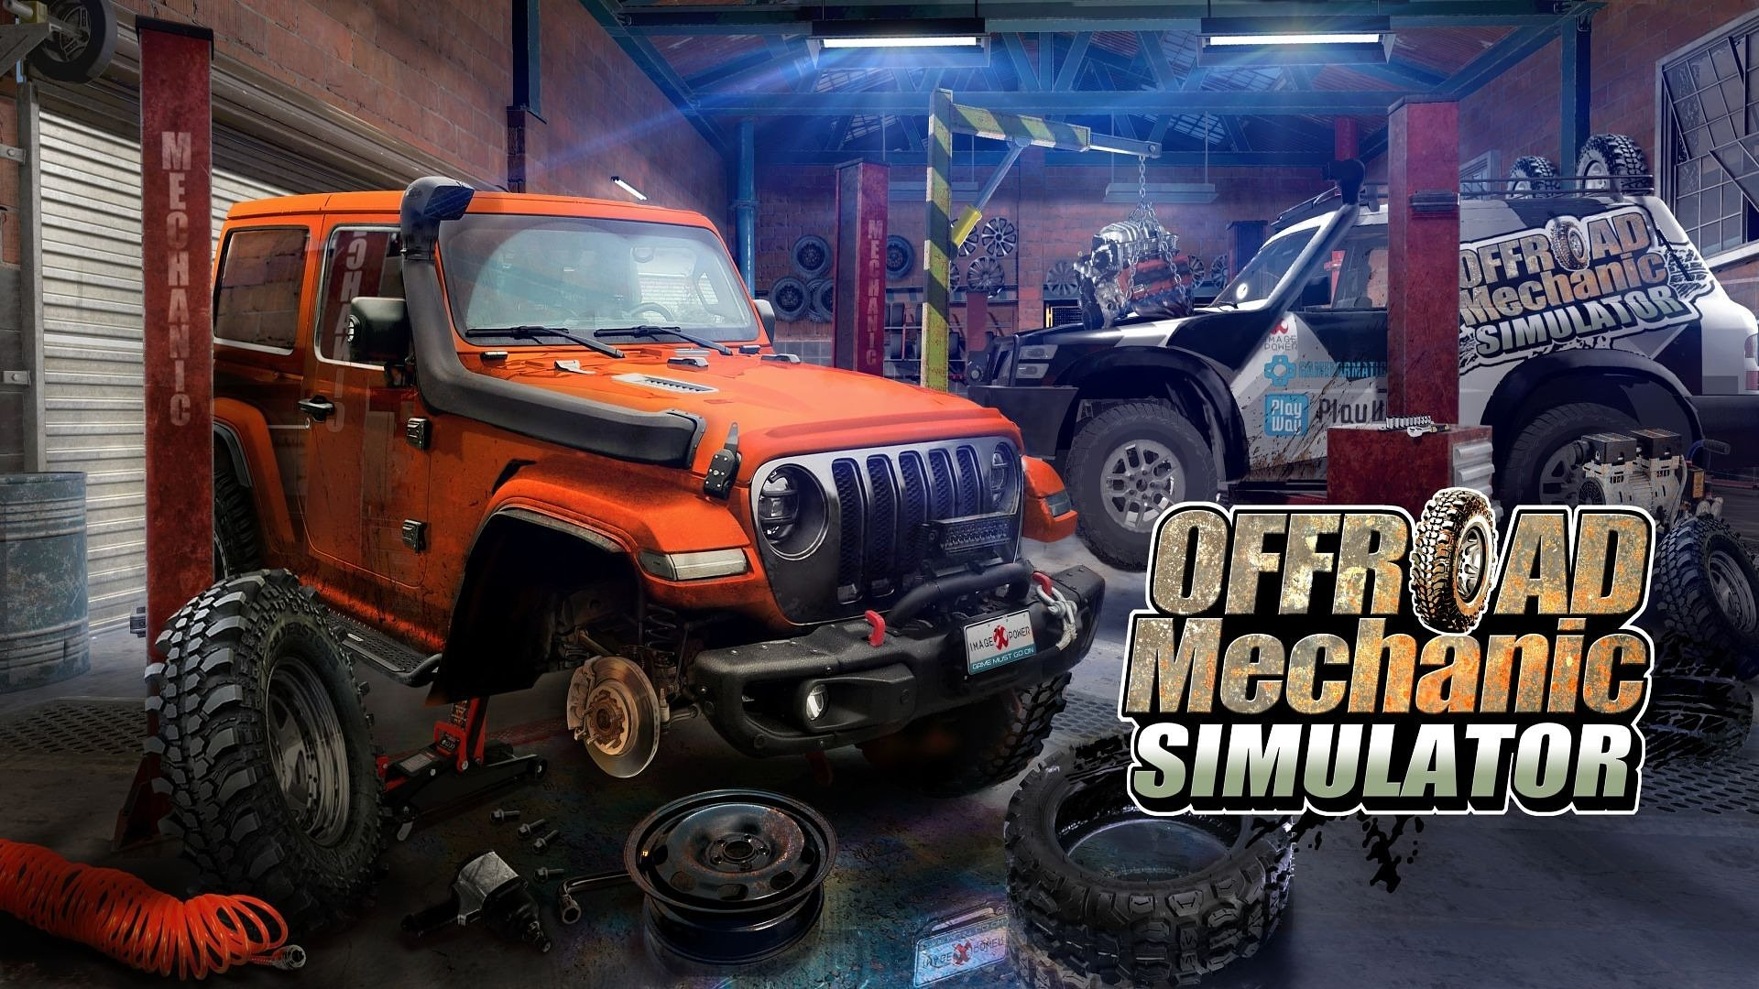

Unpaved roads, adrenaline, and hard work in the garage. Offroad Mechanic Simulator is coming to Steam!

Dust, grease, and mud will splash on your screens today! Offroad Mechanic Simulator, developed and published by Image Power in cooperation with GameFormatic, is coming to Steam. Embark on a journey filled with adrenaline through challenging off-road tracks, where you can count only on yourself.

Offroad Mechanic Simulator is a simulator that allows players to experience the excitement of driving powerful off-road vehicles without the need to leave cozy rooms. During the adventure, players will come face to face with iconic off-road vehicles, repairing, modifying, and upgrading them to ensure that those beasts can withstand rigorous field tests. Deadly races and challenges await daredevils who are not afraid to drive in extreme conditions.

Offroad Mechanic Simulator – trailer

https://www.youtube.com/watch?v=wk_TPY41mxk

In Offroad Mechanic Simulator, you take the job that all car enthusiasts dream about. Your mission is to transform off-road vehicles into powerful beasts capable of conquering the toughest challenges. While playing the role of a mechanic, your responsibilities go way beyond ordinary tasks. As the owner of a workshop, you will receive orders that require something extra. By equipping the vehicles with top-quality parts, you can significantly enhance their performance. You will also have to personally ensure that the vehicles are ready to tackle the most demanding conditions and meet the expectations of your customers. However, this will not be an easy task, as each project must be accomplished within a fixed budget.

Push the boundaries of safety as you boldly venture into treacherous terrains, fearlessly climbing rocky cliffs, and bravely crossing muddy rivers. With each completed challenge, enjoy the rewarding and breathtaking views of the scenic landscapes. Just remember to thoroughly clean the vehicle before returning it to the customer, making sure it shines like never before!

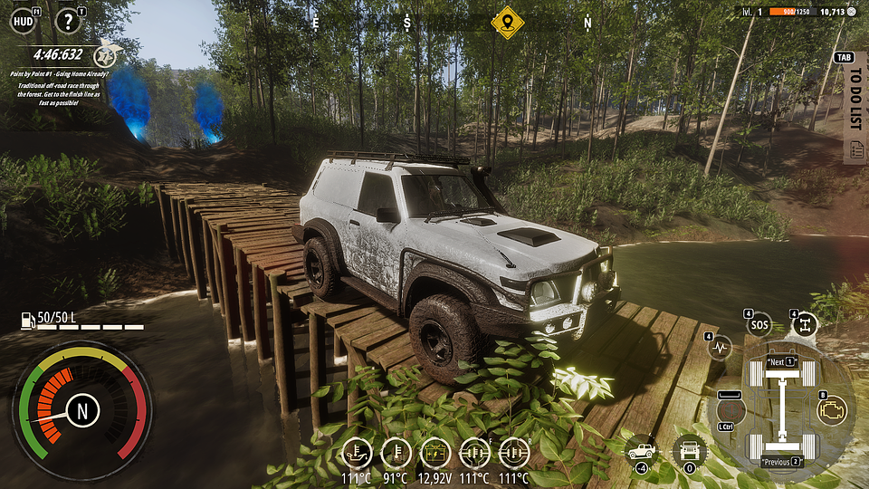

Offroad Mechanic Simulator – key features:

🚙What a beast! – repair, modify, and upgrade powerful machines that you will then personally take on demanding tests.

🚙 Become a master – career mode with story missions will challenge you to demonstrate your expertise and skills like no one else.

🚙 The kingdom of wrenches and grease – in your workshop you will have everything a mechanic could dream of. The availability of professional equipment makes the work even more enjoyable.

🚙 Grit in your teeth – a realistic driving model that embraces the true challenges of off-road style driving. The whole experience is accompanied by beautiful forest and desert landscapes, where there are plenty of obstacles to overcome.

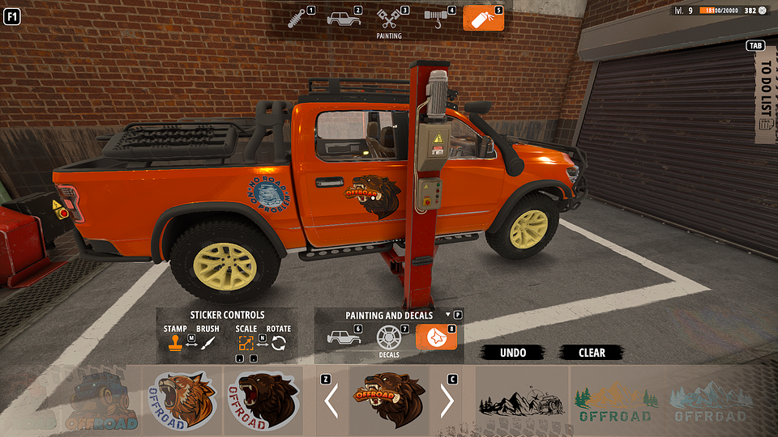

Offroad Mechanic Simulator is available on Steam from July 24th. The game is priced at $19.99, but you can currently purchase it with a special 15% launch discount.

The full presskit is available here.

About Image Power:The history of Image Power reaches back to 2012 and the establishment of the first concept art and digital painting school in Poland of the same name. In 2019, after becoming a public company, Image Power extended the scope of its business to game production and publishing. In April 2021 the Company successfully debuted on the NewConnect market of the Warsaw Stock Exchange.The strategy of the Company assumes working on low-budget productions, including simulators and similar genres, as well as gradually engaging in projects of higher production and marketing scope, including the premium category. Image Power creates the games with the use of internal developer teams, as well as external studios. The strategy of the Company is to publish 3-4 titles per year for PC, PlayStation and Xbox family consoles, and Nintendo Switch.



Jakub Smolak
PR Specialist at better. gaming agency
jakub.smolak@bettergaming.pro
Twitter

