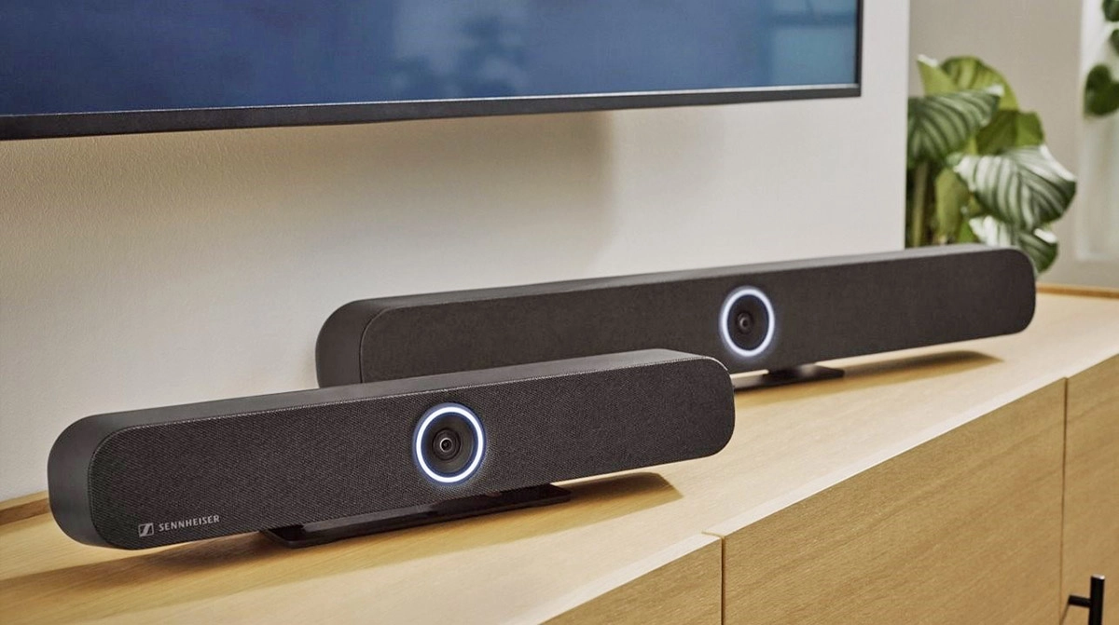

**Sennheiser Offers TeamConnect Bar Rebate Promotion for US Customers**

*New program provides up to $300 back to customers who purchase a TC Bar S or TC Bar M*

***Old Lyme, Conn. – Aug. 19, 2025 –*** [**Sennheiser**](http://www.sennheiser.com)**, the first choice for advanced audio technology that makes collaboration and learning easier, today announced a limited time rebate program that will offer a $150 rebate after the purchase of a TeamConnect Bar S and a $300 rebate following the purchase of a TeamConnect Bar M by a US customer.**

The Sennheiser TeamConnect (TC) Bar Solutions are scalable, all-in-one conferencing devices, designed to meet modern meeting demands with a built-in camera, microphones and speakers. Available in two models — TC Bar S (with four microphones and two speakers) and TC Bar M (with six microphones and four speakers) — they ensure successful conferencing experiences across rooms of any size.

Eligible participants must make a US-based purchase of a TC Bar between August 1st and October 31st, 2025. Following the purchase, customers must complete a rebate form and then send the completed form with a copy of a dated sales receipt to [tania.pampena@sennheiser.com](mailto:tania.pampena@sennheiser.com) by November 30, 2025.

“With our new rebate program, our US customers can upgrade their meeting rooms with the dynamic sound and enhanced AI features of our TC Bars, while realizing exclusive savings,” stated Simon Holley, Vice President, Sales, Business Communication, Sennheiser. “Our cash-back incentive is a limited time offer, so we encourage customers to quickly engage with their usual purchasing channels to get the TC Bars that work best for their meeting space.”

Sennheiser TC Bars offer a combination of 4K Ultra HD video and Sennheiser Trusted Audio Quality. Designed for seamless scalability, TC Bars support small to large rooms, and even campus-wide installations, thanks to Dante I/O and control integration. The flexibility of the TC Bars is unmatched, allowing users to expand with table mics, Sennheiser TeamConnect Ceiling microphones, or even a second external USB camera. The integrated DSP, PoE support, and single cable mode reduce setup complexity and eliminate clutter.

For more information about the Sennheiser TC Bar US Rebate Program and to access the rebate form, visit <https://www.sennheiser.com/en-us/teamconnect-bar-rebate>.

###

**About the Sennheiser Brand – 80 Years of Building the Future of Audio**

We live and breathe audio. We are driven by the passion to create audio solutions that make a difference. This passion has taken us from the world’s greatest stages to the quietest listening rooms – and made Sennheiser the name behind audio that doesn’t just sound good: It feels true. In 2025, the Sennheiser brand celebrates its 80th anniversary. Since 1945, we stand for building the future of audio and bringing remarkable sound experiences to our customers.

While professional audio solutions such as microphones, meeting solutions, streaming technologies and monitoring systems are part of the business of Sennheiser electronic SE & Co. KG, the business with consumer devices such as headphones, soundbars and speech-enhanced hearables is operated by Sonova Holding AG under the license of Sennheiser.

[www.sennheiser.com](http://www.sennheiser.com)

[www.sennheiser-hearing.com](http://www.sennheiser-hearing.com)

**Global Press Contact**

Jeffrey Horan

Global PR/Media Manager Business Communication

jeffrey.horan@sennheiser.com

+1 860-598-7539