**Xytech Launches *Dash* Facilities Management Solution for**

**Any Size Media and Broadcast Company**

*Cloud-based, subscription model takes three days to implement and delivers robust workflow management capabilities, making facility operations more efficient*

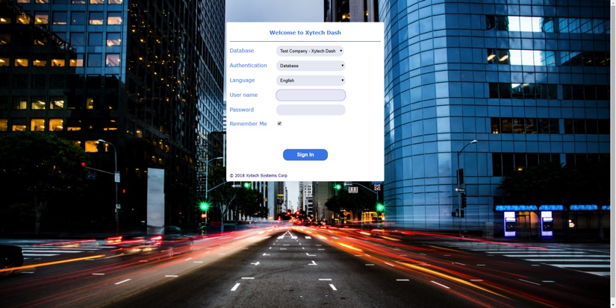**Los Angeles, February 27, 2018** — [Xytech](https://www.xytechsystems.com/), the leader in facility management software for the broadcast, production, media services and video transmission industries, has launched Dash, a new cloud-based software built to manage the operational needs of smaller facilities. The subscription-based software takes just three days to install and enables smaller video departments and post-production operations the ability to leverage Xytech's world-class workflow capabilities. Further, *Dash* offers no-compromise security as part of Microsoft Azure Managed Cloud.

“Dash offers complete facility management in the cloud in a preconfigured way for the smaller facility,” explains Greg Dolan of Xytech. “This allows us to address a truly exciting and underserved market and provide an entirely new set of customers with plug-and-play facility management capabilities."

The new Dash offering allows Xytech to seamlessly manage the end-to-end business cycle for customers in the small-to-medium size range. These customers range from large universities with sophisticated media departments, to corporate communication departments and boutique post facilities.

**End-to-End Efficiency in the Cloud**

Xytech's monthly subscription model for Dash offers access to all the innovative dashboards, graphs and charts. Customers can manage resources, handle scheduling tasks, cost forecasting, invoicing and reporting all on one system. Dash also offers the option of a built-in library management program and the option of a bidding module, enabling users to bid on a project and have it accepted on the spot.

The brand new web interface allows users easy access to the Dash applications from any supported web browser. “We listened to our clients and adapted our software into a series of directed workflows allowing users to schedule, raise a bid and generate an invoice," Dolan says. “Additionally, we’ve made installation support fast and seamless on Dash, so our team can easily teach our clients and get them up and running in just a few days.”

**Pricing**

In the coming weeks, Xytech will be hosting Dash webinars on its website, xytechsystems.com. The software has a low per user price and is available on a monthly subscription basis. The company is offering early adopters of Dash an early-bird discount, to be announced shortly.

**About Xytech Systems:** For 30 years, the world’s premiere media companies have depended on Xytech to run their businesses. MediaPulse is the only end-to-end solution for the complete content lifecycle. MediaPulse provides scheduling, automation, asset management, billing and cost recovery for broadcasters, media services companies and transmission facilities in a scalable platform-independent solution.

For more information, visit xytechsystems.com.

**Media Contacts:**

Katie Kailus

Public Relations

Hummingbird Media

+1 (630) 319-5226

[katie@hummingbirdmedia.com](mailto:lipoff.alexis@gmail.com)

Jeff Touzeau

Public Relations

Hummingbird Media

+1 (914) 602 2913

[jeff@hummingbirdmedia.com](mailto:lipoff.alexis@gmail.com)