THE SENNHEISER GROUP AT A GLANCE

Creating the future of the audio world and creating unique sound experiences for customers - this is the aspiration that unites the employees and partners of the Sennheiser Group worldwide. The independent family-owned company Sennheiser was founded in 1945 and is today one of the leading suppliers in the field of professional audio technology. Since 2013, Daniel Sennheiser and Dr. Andreas Sennheiser have been the third generation of the Sennheiser family to manage the company. The headquarters of the Sennheiser Group is located in Wennebostel in Wedemark near Hanover.

Product portfolio
- Wireless microphone and monitor systems
- Wired microphones
- Conference and information technology
- Headphones for professional use
- Streaming technologies
- 3D audio technologies and software

The Sennheiser Group includes
► Sennheiser electronic GmbH & Co. KG, Wedemark (Germany)
Microphone and monitor systems, conference and information technology, headphones for professional use, streaming and 3D audio technologies.
► Georg Neumann GmbH, Berlin (Germany).
Microphones and monitor speakers, headphones for professional use.
► Sennheiser Streaming Technologies, Wedemark (Germany)
Development of innovative streaming solutions
► Dear Reality, Düsseldorf (Germany)
3D audio software for VR/AR applications and multi-channel mixing
► Sennheiser Entwicklungs GmbH, Wedemark (Germany)
Development of pro audio products

With 21 of its own sales subsidiaries and long-standing trading partners, the Sennheiser Group is active in over 50 countries worldwide. In addition, Sennheiser has a total of four development centers worldwide; three in Germany (Wennebostel. Berlin, Duisburg) and one in Switzerland (Zurich).

Production sites
The Sennheiser Group has its own production at three different locations::
- Wennebostel (Germany)
- Albuquerque (USA)
- Braşov (Romania)

Employees
Worldwide, 1.971 employees work for the Sennheiser Group*. Of these, 80 percent are employed in Europe, 8 percent in the Americas region and 11 percent in the APAC region. In Germany, there are 1.263 employees*, 1.085 of which are based at the headquarters in Wennebostel. Overall, 41 percent of the workforce is made up of women and 59 percent of men.

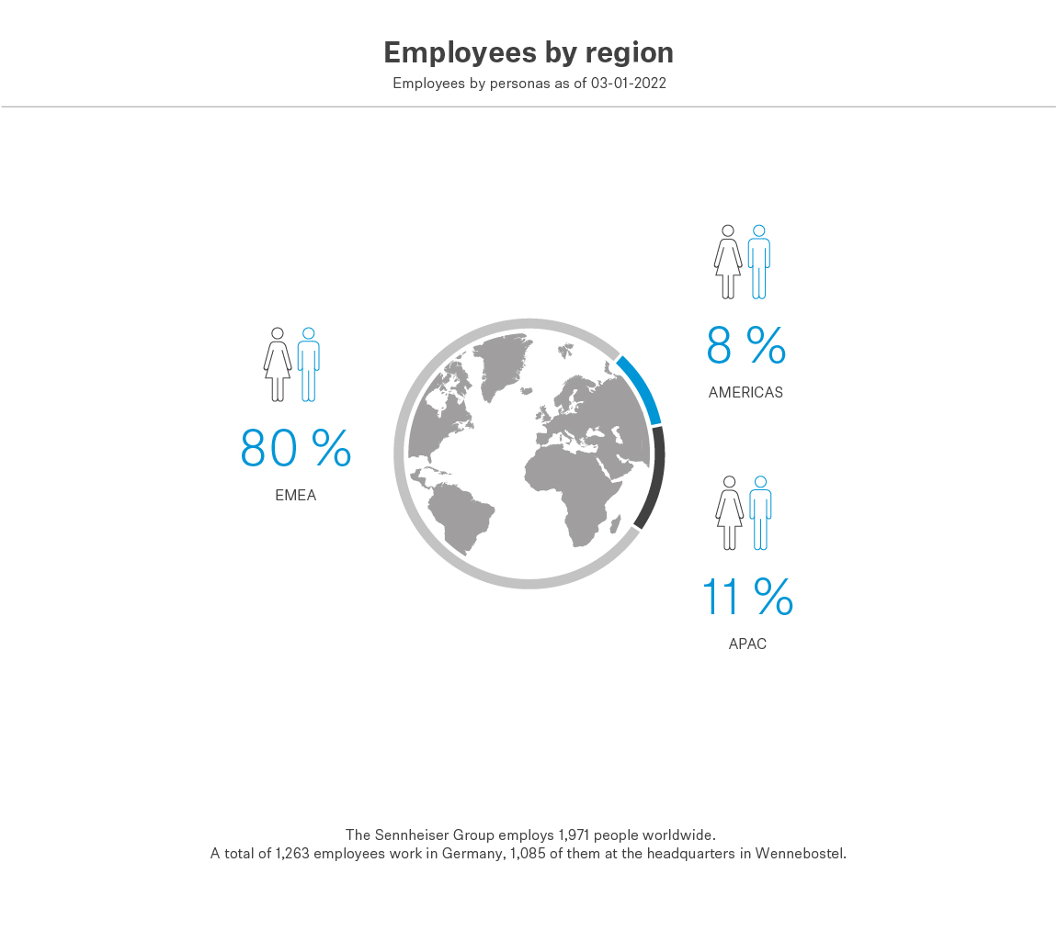

*As of March 1, 2022
Sales of the Sennheiser Group
In 2019, the Sennheiser Group generated sales of 573.5 million euros. 307.9 million euros of total sales were attributable to the professional business and 241.9 million euros to the consumer electronics business.

In the financial year 2021, the Group was able to achieve their sales targets for the year 2021 in all business areas and in some cases even close above plan. In 2022, following the takeover of the consumer business by Sonova Holding AG, Sennheiser will again focus exclusively on the professional business for the first time in over 50 years.

Brands of the Sennheiser Group
The Sennheiser Group brands include Sennheiser, Neumann.Berlin and Dear Reality. In addition, Sennheiser has strong technology brands such as AMBEO or NoiseGard. Following the sale of the consumer business to Sonova Holding AG, a permanent cooperation with Sonova is planned under the joint Sennheiser brand umbrella. A license agreement on future brand use has been agreed.

Executive Management Board
- Dr. sc. techn. Andreas Sennheiser
Chief Executive Officer
- Daniel Sennheiser
Chief Executive Officer
- Peter Claussen
Chief Operating Officer Professional Division
- Steffen Heise
Chief Financial Officer
- Thomas Weinzierl
Chief Operating Officer Supply Chain

Supervisory Board
The Supervisory Board of the Sennheiser Group includes:

- Andreas Dornbracht (Chairman)
- Stephan Plenz
- Iris Epple Righi
- Prof. Dr. Jörg Sennheiser
- Johann Soder

