EFFORTLESSLY DETAILED AUDIOPHILE SOUND EVERYWHERE
The new Sennheiser IE 200 – an ideal choice for audiophiles looking for clarity, detail, and impact at home or on the go.

Sydney, Australia, 6 January, 2023 – The Sennheiser IE range continues its history of excellence with the all-new IE 200. The newest member of the IE family shares considerable DNA with its renowned siblings but seeks to bring pure listening pleasure to a broader audience. With exceptional detail, clarity, and impact, users can now expect quality and features that are usually reserved for top-of-the-line devices.

"The Sennheiser IE 200 represents an open invitation for everyone to enjoy high-end sound,” says Jermo Koehnke, Sennheiser Audiophile Product Manager. “With balanced, true-to-life audio reproduction, users will be able to hear the details that they’ve been missing in ordinary headphones."
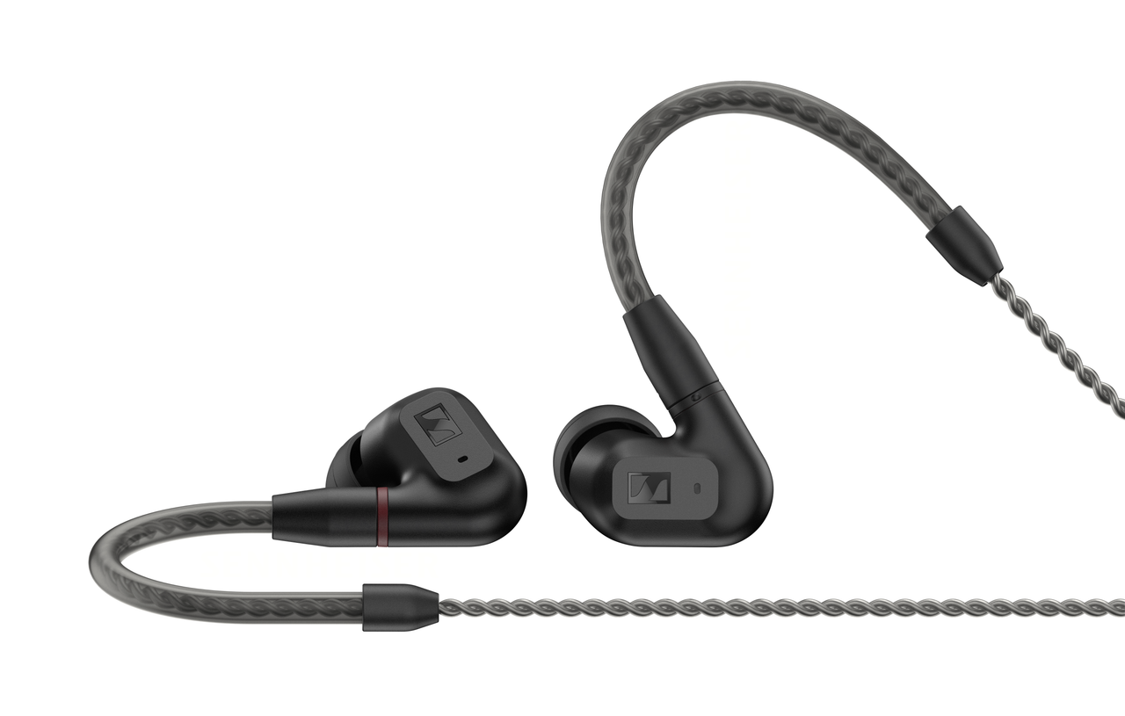
Quality fit for audiophiles
The IE 200 enables seasoned hi-fi enthusiasts and newcomers alike to experience new dimensions of sound quality. Based on 15 years of Sennheiser TrueResponse Transducer technology, the IE 200 features a 7-millimeter extra-wide band transducer for exceptional quality. A hallmark of the IE family, the latest addition to the in-ear lineup continues to bring superbly balanced and realistic audio to an ultra-compact form factor.

With IE 200, nothing stands between the user and discovering new sonic landscapes. Harmonic distortion is almost non-existent, with a natural frequency response curve typically found in earphones costing significantly more. Furthermore, the IE 200 can appeal to a variety of listening preferences thanks to its unique dual-tuning feature. Audiophiles can mount the included ear tips in one of two positions, giving them control over the balance of their audio experience – from deep and emotional bass response to texture-rich treble presence.
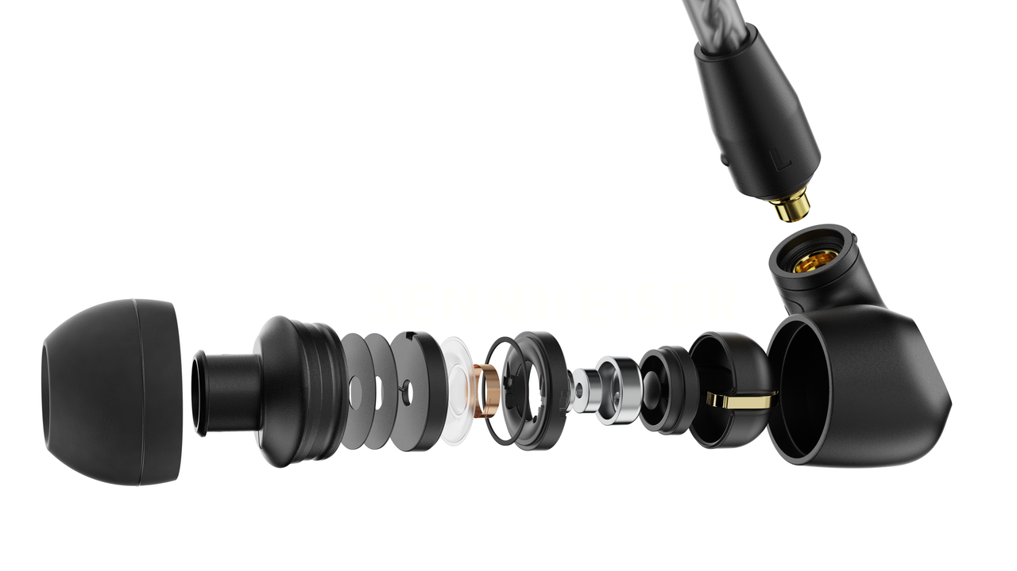
Comfortably Connected
With an exceptionally comfortable fit, IE 200 is made for uninterrupted listening sessions. Able to accommodate ears of all sizes, their inconspicuous design boasts a proven ergonomic design that promotes a secure seal and lasting comfort. Viscoelastic foam and silicone ear adapters in multiple sizes block ambient distractions while maximising low-end response. A revised, braided cable reduces handling noise, and terminates to widely a 3.5mm stereo plug and MMCX connectors for connection to countless audiophile devices.

Pricing and availability
The Sennheiser IE 200 will be available from the end of January 2023 for $239.95 AUD / $254.95 NZD.

About the Sennheiser brand
We live and breathe audio. We are driven by the passion to create audio solutions that make a difference. Building the future of audio and bringing remarkable sound experiences to our customers – this is what the Sennheiser brand has represented for more than 75 years. While professional audio solutions such as microphones, meeting solutions, streaming technologies and monitoring systems are part of the business of Sennheiser electronic GmbH & Co. KG, the business with consumer devices such as headphones, soundbars and speech-enhanced hearables is operated by Sonova Holding AG under the license of Sennheiser.
www.sennheiser.com
http://www.sennheiser-hearing.com/

Local press contacts
Caitlin Todd
caitlin.todd@groundagency.com

Gabby Wallace
gabby.wallace@groundagency.com

