Social distancing survival guide

5 tips on how to make the most of your time at home

Wedemark, Germany, May 6, 2020 – Whether you are staying in with family and kids, a partner, roommates or alone – social distancing with plenty of time at home is a completely new situation for most of us. While it can be extremely challenging, it’s also an opportunity for spending quality time with your loved ones, exploring new music or dedicating yourself to a long-neglected hobby. Here are five tips for turning this new normal into something positive and productive.

- Push pause
With 24/7 news on tap, it’s really important to occasionally take a break from the current situation and put aside the worries. Meditation and mindfulness are ideal ways to focus on yourself, your thoughts, your feelings and experience the present. While you’re self-isolating, this can help you reduce stress, while increasing resilience and positivity. Even just a few minutes every day can make a big difference. Whether meditating in total silence, accompanied by music or by listening to a guided meditation app, noise cancelling headphones like Sennheiser’s MOMENTUM True Wireless 2 (MSRP: 299 EUR) can enhance your meditation experience with beautiful sound or peaceful quiet. Designed to anticipate your needs and put your mind at ease, they feature customizable touch controls and offer a Smart Pause feature that immediately pauses playback when you remove the earbuds and smoothly resumes as you place them back in your ear – so you can relax and stay in the zone.
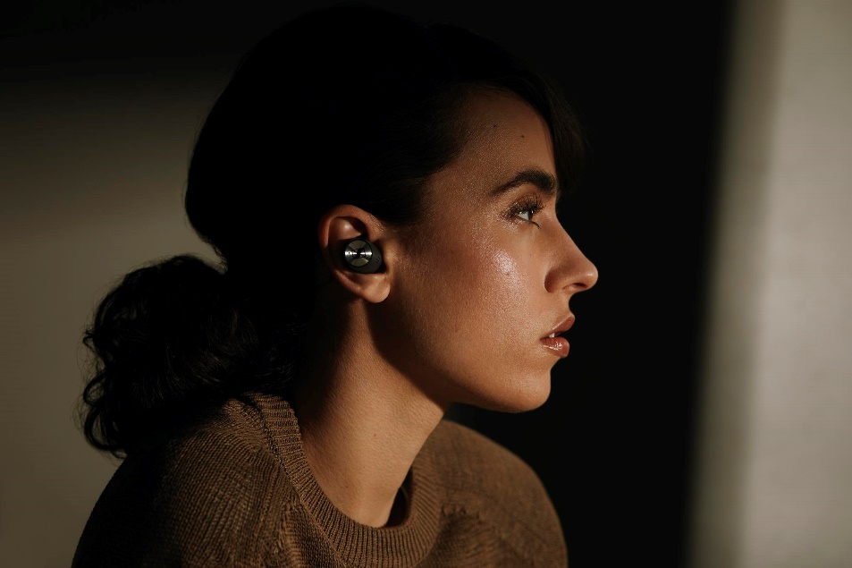

Noise cancelling headphones like Sennheiser’s MOMENTUM True Wireless 2 can enhance your meditation experience with beautiful sound or peaceful quiet.

- Stay in shape
For practising yoga or working out at home you don’t need to have an elaborate equipment set-up. Plenty of blogs, training apps or fitness influencers like Kayla Itsines, Joe Wicks or Pamela Reif are offering brilliant videos for home exercises or live sport sessions. A daily dose of exercise can help you relax and stay fit and healthy, which is especially important during these times. Additionally, daily workouts can contribute to structuring your day and establishing a regular routine.

A daily dose of exercise can help you relax and stay fit and healthy.

- Immerse yourself in music

There’s no denying music’s power to stir our emotions. Whether firing us up or chilling us out, music is a powerful way to escape our worries, pick up our mood, and can even inspire a sense of community and solidarity in uncertain times. So, put on your headphones or turn up your speaker, choose a playlist to suit your mood and let the music carry you away. For those seeking an audio escape like no other, Sennheiser’s HD 820 audiophile headphones (MSRP: 2,399 EUR) are a true game-changer. The closed-back dynamic stereo headphones feature a unique glass transducer cover that minimizes resonances – an innovation that ensures an incredibly realistic and natural sound field. For the ultimate acoustic experience, pair them with the HDV 820 digital amplifier for dynamic headphones (MSRP: 2,399 EUR). In honor of the audio specialist’s 75th anniversary, Sennheiser currently offers a special bundle of this legendary combination at 25% off for 3,598 EUR.
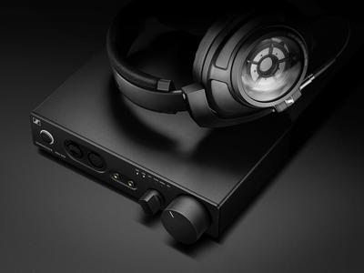

In honor of the audio specialist’s 75th anniversary, Sennheiser offers a special bundle of the HD 820 headphones and the HDV 820 amplifier.

To help keep the music playing at a time where many artists have cancelled or postponed their live tours, Sennheiser is hosting #DontStopTheMusic, a series of exclusive streaming concerts via IGTV on the company’s Instagram account. Check out the Sennheiser website for announcements of dates, videos with immersive recordings from jazz clubs, electro sets in a living room atmosphere as well as live recordings from studios.

- Meet up virtually
Social distancing doesn’t mean being anti-social: Even if you can’t see friends and loved ones in person, you can always hang out with them virtually. Game nights, dance parties, joint cooking sessions or just catching up with each other over hours – all of these activities can be shifted into the virtual world so you don’t have to miss out on a thing. It couldn’t be easier: Just set a date and time and arrange a meet up using services like Zoom, Skype or WhatsApp. Seeing your loved ones is a great way to brighten your day and it ensures distant relatives can still be a part of your life. Whether you choose to dress up in style or go low key in your pyjamas is up to you!

- Stream on
Tiger King, The Mandalorian, Ozark, The Marvelous Mrs. Maisel, or Trolls World Tour… Whatever you’re into, streaming platforms like Netflix, Amazon Prime, Disney+ or Hulu are serving up thousands of hours of home entertainment, including vast archives of classic content as well as brand new series and movies to help while away the hours. A perfect match for the serious movie marathon is Sennheiser’s AMBEO Soundbar (MSRP: 2,499 EUR). It is designed to create an immersive 3D sound experience with just one device and transforms the living room into your very own cinema.

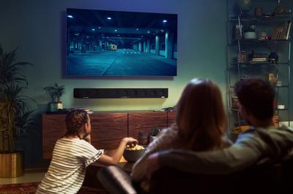

Sennheiser’s AMBEO Soundbar is designed to create an immersive 3D sound experience with just one device and transforms the living room into your very own cinema.

And for those seeking a personalized TV listening experience, the audio specialist’s Flex 5000 (MSRP: 199 EUR) is a great choice: In combination with wired headphones, this smart listening solution intensifies TV sound and lets users binge watch their favorite series, while others in the same room can still pursue other activities without getting distracted.

For even more ideas on how to make the most of your time at home, visit sennheiser.com/
stay-connected, a website dedicated to audio solutions that can help us create, relax, learn or be entertained and to navigate this new normal.

About Sennheiser
Founded in 1945, Sennheiser is celebrating its 75th anniversary this year. Shaping the future of audio and creating unique sound experiences for customers – this aim unites Sennheiser employees and partners worldwide. The independent family company, which is managed in the third generation by Dr. Andreas Sennheiser and Daniel Sennheiser, is today one of the world’s leading manufacturers of headphones, loudspeakers, microphones and wireless transmission systems. In 2018, the Sennheiser Group generated turnover totaling €710.7 million. www.sennheiser.com

Global Contact
Jacqueline Gusmag
jacqueline.gusmag@sennheiser.com
T +49 5130 600 1540

