MEDIA ALERT: Xytech to Demonstrate Streamlined Staff Management in Upcoming MediaPulse Personnel Webinar
Feb. 26th webinar highlights how MediaPulse can manage all aspects of an organization’s personnel scheduling needs

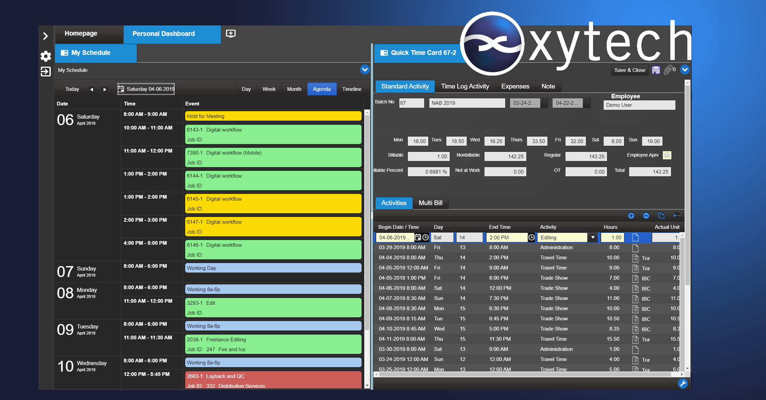
LOS ANGELES, February 20, 2020 — Xytech, the leader in facility management software for the broadcast and media industries, will showcase its MediaPulse Personnel Management solution during a webinar titled, “MediaPulse Personnel Management,” with Greg Dolan and Sales Engineer Darrel Gardner on Feb. 26, 2020, at 1 p.m. ET/10 a.m. PT.

The webinar will demonstrate how MediaPulse’s intuitive tools can manage all personnel scheduling needs, from setting rosters, to assigning tasks, to communicating schedules and recording actualized time with just a few clicks. Additionally, it will show how MediaPulse’s payroll rule engine computes in real-time any potential payroll violations and shares cost implications while offering alternative staff for each position on an organization’s roster. To register, visit: https://xytechsystems.zoom.us/webinar/register/8215807666499/WN_sQLamhx4QiSEu8zsdb48hQ

“MediaPulse is designed to manage the entire workforce of staff or freelancers,” said Gardner. “Configurable Counters, Dashboards and Mobile views show scheduling staff what happened in the past and what is scheduled into the future. Rules are defined providing warnings at the booking stage and calculations for payroll after work is complete. As a result, this webinar is ideal for anyone managing people and will provide insight into how MediaPulse can help manage their facility and ensure their most important resources stay happy.”

These features are available for both Xytech’s web and mobile clients and work on any browser on any device. This webinar is ideal for anyone who manages staff.

To register, for the Feb. 26th webinar, please visit: https://xytechsystems.zoom.us/webinar/register/8215807666499/WN_sQLamhx4QiSEu8zsdb48hQ

About Xytech
For more than 30 years, the world’s premiere media companies have depended on Xytech to run their businesses. MediaPulse is the only end-to-end solution for the complete content lifecycle. MediaPulse provides scheduling, automation, asset management, billing and cost recovery for broadcasters, media services companies and transmission facilities in a scalable platform-independent solution. For more information, visit xytechsystems.com.

Media Contacts:

Katie Kailus
Public Relations
Hummingbird Media
+1 (630) 319-5226
katie@hummingbirdmedia.com

Alexis Lipoff
Public Relations - EMEA
Hummingbird Media
alexis@hummingbirdmedia.com

Jeff Touzeau
Public Relations
Hummingbird Media
+1 (914) 602 2913
jeff@hummingbirdmedia.com

