

Biuro prasowe better. gaming agency
bettergamingagency.prowly.com

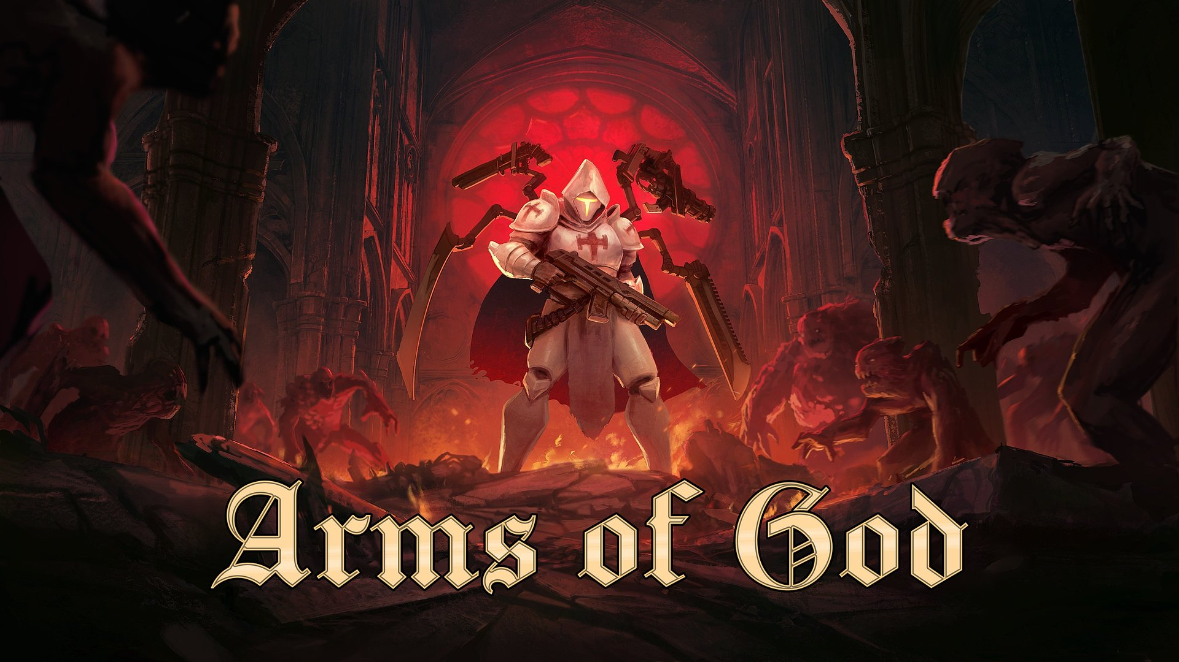

Annihilation of hellish hordes at your fingertips. The creators of Arms of God invite to open playtests

Before Arms of God comes to Steam for good, the developers from Dark Jay Studio are inviting players to check out their ambitious roguelite auto-shooter during open playtests. Anyone ready to face the demonic forces can join them via Steam until April 20. A special trailer has also been released, offering a glimpse into the challenges awaiting the last member of an ancient order.

The Cathedral – the stronghold of the legendary Templar Order – has been overrun and seized by demonic, merciless forces. As the last remaining member of the brotherhood, the player must begin a bloody crusade to reclaim it from the invaders. This will be a truly hellish challenge, but with the help of five powerful weapons, which can be wielded simultaneously, victory is within reach. Arms of God is a roguelite autoshooter where each enemy type presents a unique challenge thanks to their distinct skills, attack patterns, and behaviors, making every battle a test of strategy and skill.

Arms of God – the latest gameplay trailer

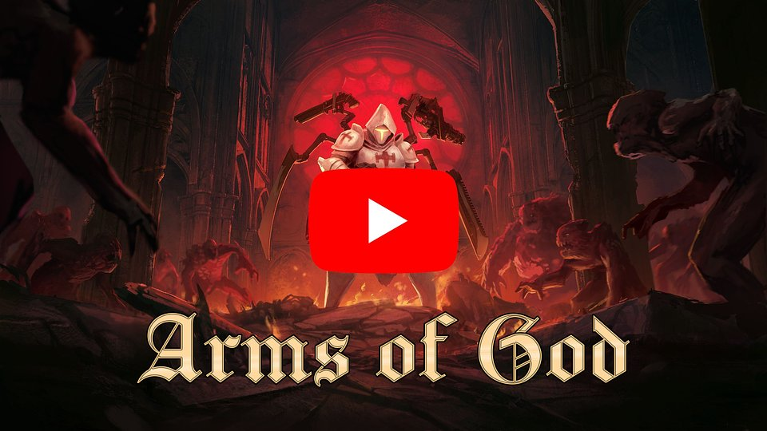
https://www.youtube.com/watch?v=pv4WxQZzRQ4&ab_channel=darkjaystudio

Let’s get straight to the point – we need heroes! Demonic hordes will soon flood the world of Arms of God, and we’re looking for brave souls whose valuable feedback will help us in further development of the game. We invite all those seeking satisfying gameplay and roguelite challenges to join the ongoing playtests and share their thoughts. After all, we’ve seen countless times that no one knows more about slaying demons than gamers!

- Dominik Sójka - the lead developer of Arms of God.

Thanks to additional mechanical arms, which serve as both weapons and tools of divine justice, players can wield up to five weapons simultaneously, each with its own unique significance and power. The available arsenal is even broader, as every weapon can be upgraded and modified to create the deadliest build. In the full version of the game, players will have access to 10 different characters, each having individual traits and abilities, allowing players to tailor the gameplay to their preferred style.

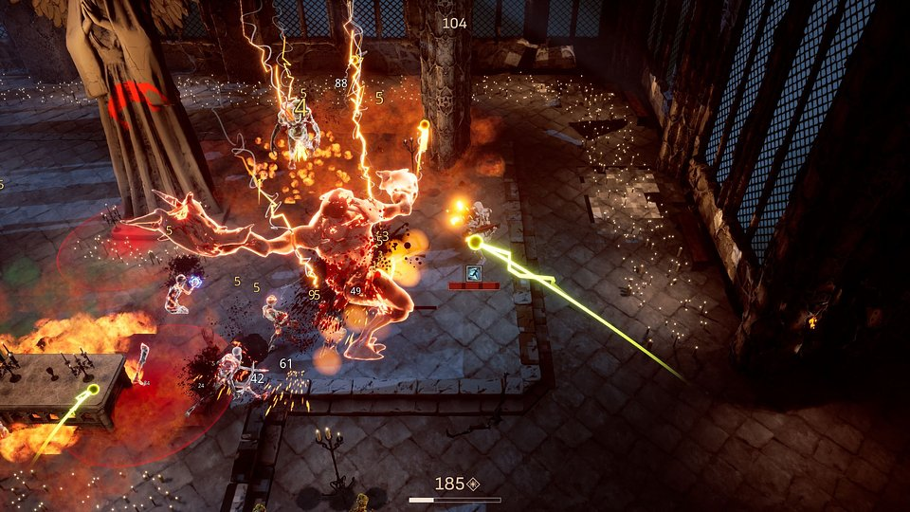

Taking back the Cathedral from the enemy’s clutches is only the first step in the holy crusade. Once liberated, it will serve as a strategic base through meta-progression. This is where players will be able to enhance meta-stats and skills in the Training Grounds, forge mighty weapons in the Armory, boost their in-game abilities in the Alchemy Chamber, and summon new valiant heroes from the Bell Tower. All of this is to carve a path to the deepest abysses of hell and face the ultimate force of the inferno.

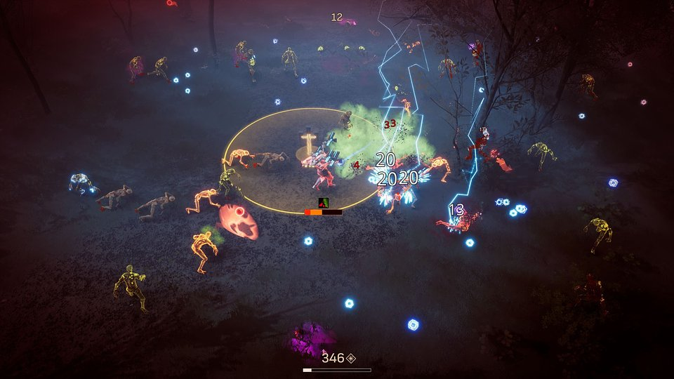

Arms of God – key features:

🔥 You cannot have too much of a good thing – As the last member of the legendary Templar Order, you will use mechanical arms that allow you to wield up to 5 weapons simultaneously, for both close combat and ranged annihilation.

🔥 Tactical autoshooter – In Arms of God, enemies are more than just cannon fodder. The key to success lies in understanding the weaknesses and strengths of your foes, as well as the possibilities offered by combining weapons and upgrades. That's the way to create the ultimate build.

🔥 The journey continues – Reclaiming the Cathedral from the demons is just the beginning. The path forward is shaped by an advanced meta-progression system, which goes hand in hand with the storyline and achievement system.

🔥 A crusade with many faces – The full version will feature 10 different characters, each with their own unique active ability and dedicated skill tree.

🔥 The dead pile up – Enemies will charge in hordes, and defeating them will be pure pleasure. This is all thanks to the satisfying gore system, handcrafted, painted, and animated characters, and fully 3D environments powered by Unreal Engine 5.

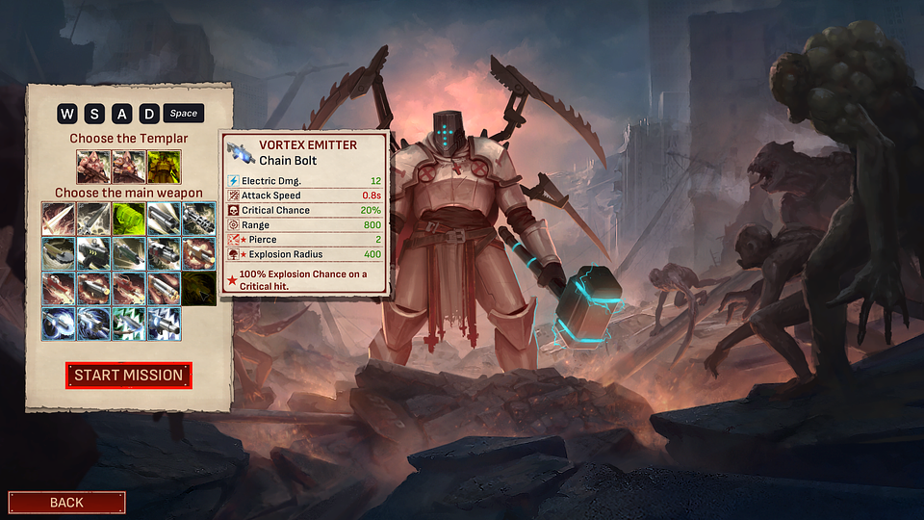

The open playtests for Arms of God have already begun and will run until April 20, with access available on Steam. The release is scheduled for Q1 2026. We encourage all brave souls to add the game to their wishlists. More information about the project can be found on the official website, social media profiles (Instagram, X, Bluesky), as well as on YouTube and Discord.

The full press kit is available here.

About Dark Jay Studio:
Arms of God is a solo-developed project, but Dark Jay Studio is a husband-and-wife duo – he is responsible for the creative and technical aspects of the game, while she handles its presentation and reaching out to the gaming community. Dominik Sójka has over 20 years of experience in game development, gained through working on numerous projects, including The Beast Inside. He has also worked as a Technical Artist on Medium, Senior Technical Artist on Spectre: Divide, and contributed to many smaller titles, including VR and 3D movies.

