SpeechLine Digital Wireless enables campus-wide connectivity at the University of Quebec at Montreal

With Sennheiser Control Cockpit software, UQAM facility technicians can now remotely monitor wireless devices installed throughout the vast campus

Montreal, Quebec, February 11, 2020 – Located in the heart of downtown Montreal, the University of Quebec at Montreal (UQAM) is the largest constituent in the University of Quebec system, offering over 300 programs of study to nearly 40,000 students enrolled in undergraduate, masters and doctoral programs across 40 departments and schools.

Last year, the university began a full-scale upgrade of the wireless microphone systems used in 342 classrooms, meeting rooms and studio rooms housed throughout roughly two dozen separate buildings on campus — including two university buildings located outside the central campus — aiming to provide UQAM faculty and technical staff with easy-to-use, reliable functionality and the maximum speech intelligibility available, as well as network connectivity. So UQAM hired Sennheiser to help implement a campus-wide wireless system upgrade featuring SpeechLine Digital Wireless devices, which lets UQAM facility technicians monitor a variety of individual wireless devices simultaneously from a remote, central location using the Sennheiser Control Cockpit software.

University of Quebec at Montreal – located in downtown Montreal in the heart of the city’s Latin Quarter – now features Sennheiser SpeechLine Digital Wireless systems, providing campus-wide wireless connectivity throughout more than 20 university buildings

“We chose Sennheiser not only for the quality of service we knew they would provide us after the sale,” said UQAM Operational Director Dominic Besner, “but also for the solidity and build-quality of Sennheiser’s product lines, the relative value added across a variety of products at different price points — and, of course, for enabling connectivity of all the newly installed SpeechLine Digital Wireless systems throughout campus using Sennheiser’s Control Cockpit software.”

Connecting the entire campus
Sennheiser's SpeechLine Digital Wireless system is the first digital microphone solution designed exclusively for speech applications. From a presentation using two microphone links, to a meeting room with multiple microphones, to a campus-wide installation like UQAM with hundreds of links – no matter the size of the installation, SpeechLine Digital Wireless systems ensure the ideal microphone solution for any application.

Featuring advanced system automatics and preconfigured sound profiles, SpeechLine Digital Wireless offers flexible solutions tailored to a wide variety of education applications, including hands-free presentations, letting speakers choose between a wireless table stand, handheld or bodypack transmitter for use with the lavalier or headmic, depending on their preference.

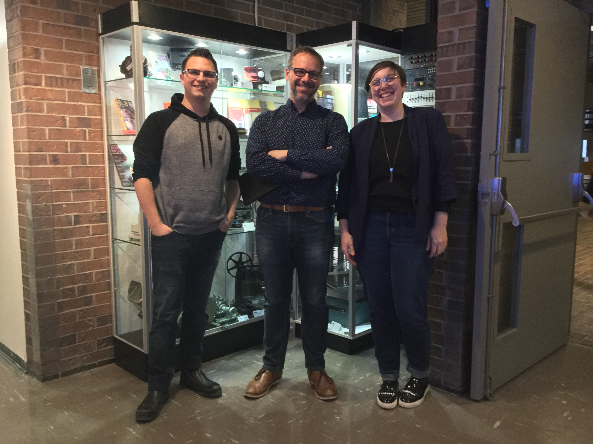 | UQAM staff, from left:  Jean-Francois Plante, A/V Technician; Dominic Besner, Operational Director; Sandra Lachance, A/V Specialist

Remote monitoring with Sennheiser Control Cockpit
Now, with the campus-wide connectivity enabled by the newly installed SpeechLine Digital Wireless systems, all buildings on the UQAM campus can now be centrally monitored from a remote location with the Sennheiser Control Cockpit software.

Accessible on any platform through a web browser, Sennheiser Control Cockpit facilitates easy handling, control and maintenance of the entire SpeechLine Digital Wireless system, offering a continuous, global dashboard overview of all network-enabled SpeechLine Digital Wireless devices, showing status information at a glance. Now, with the ability to monitor all SpeechLine Digital Wireless devices within the network, UQAM technical staff can use Sennheiser Control Cockpit to adjust the settings on a particular device, to monitor global system dashboard and statistics, and to set up workflows for individual devices.

The images to this press release can be downloaded at: https://sennheiser-brandzone.com/c/181/Rh3STygV.

About Sennheiser
Shaping the future of audio and creating unique sound experiences for customers – this aim unites Sennheiser employees and partners worldwide. Founded in 1945, Sennheiser is one of the world’s leading manufacturers of headphones, loudspeakers, microphones and wireless transmission systems. Since 2013, Sennheiser has been managed by Daniel Sennheiser and Dr. Andreas Sennheiser, the third generation of the family to run the company. In 2018, the Sennheiser Group generated turnover totaling €710.7 million. www.sennheiser.com

Local Press Contacts

Sarah James Maik Robbe
sarahj@gasolinemedia.com maik.robbe@sennheiser.com
+44 (0) 1483 223333 +44 (0) 7393 462484

