

Biuro prasowe better. gaming agency
bettergamingagency.prowly.com

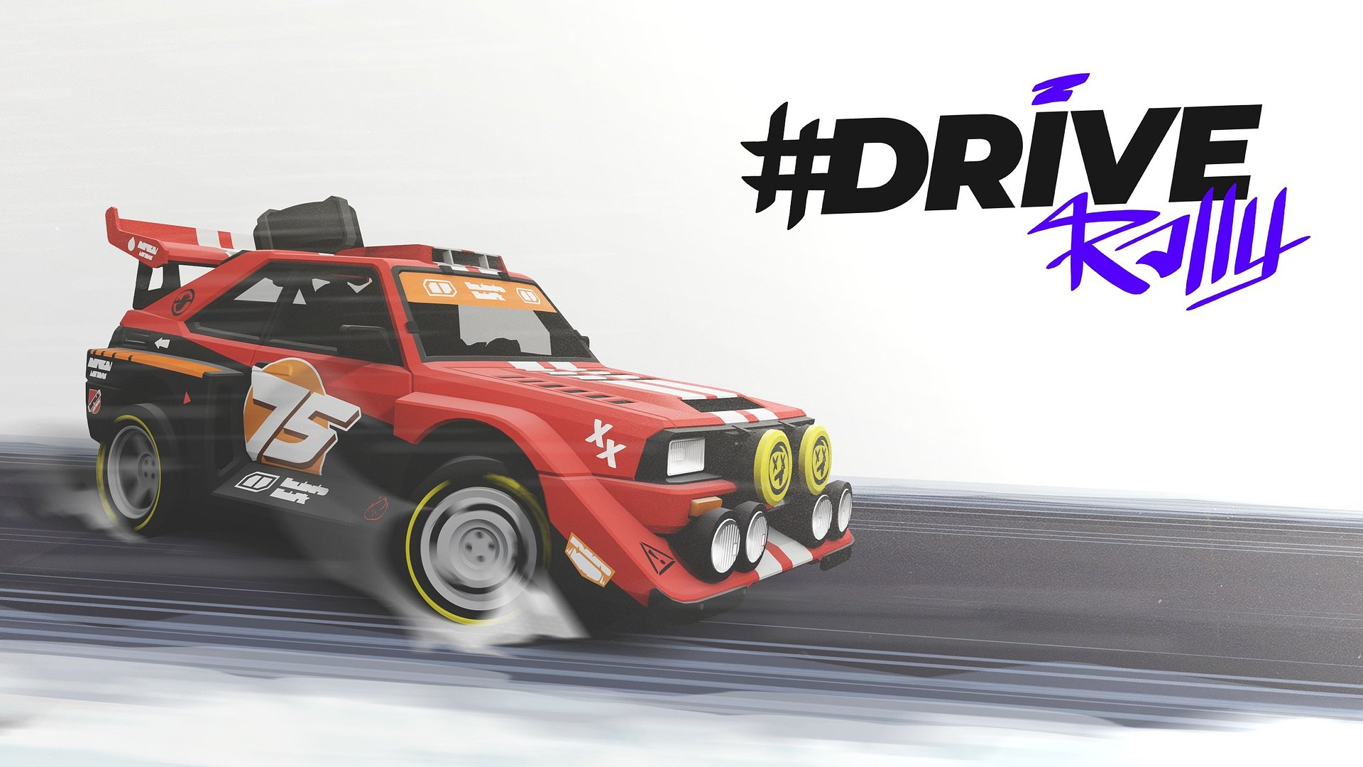

3, 2, 1 GO! #DRIVE Rally leaves Early Access and is available in version 1.0

It’s time to fully experience the rally vibes of the ’90s! #DRIVE Rally has left Early Access today, launching on PC in version 1.0. The game is now available on Steam, GOG, and Epic Games Store. Want to know what awaits players competing for championship trophies? Check out the official launch trailer. The console version is set to arrive later this year.

With the launch of the full version, #DRIVE Rally is packed with fresh content. The developers at Pixel Perfect Dude have prepared over 600 km of tracks across 6 unique locations, as well as 22 cars — each available in 3 different rally classes. A big part of the fun lies in vehicle customization, allowing players to not only create mechanical beasts but also showcase their unique style. Version 1.0 of #DRIVE Rally also introduces new gameplay modes, such as free roam with collectibles and a party mode that lets up to 12 players compete locally for rally glory.

#DRIVE Rally – launch Trailer

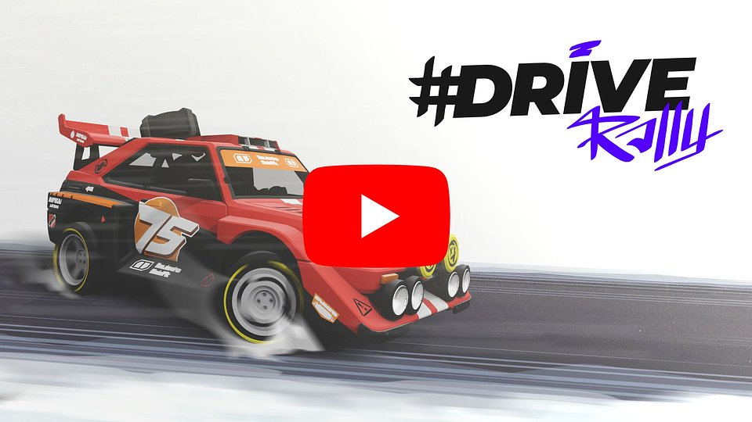
https://youtu.be/s9xK8RjQxC8

Another special stage in the development of #DRIVE Rally is behind us. Now is definitely the perfect moment to pop the champagne. However, this doesn't mean we're going to slow down! We hope that with the launch of the full version, more players will join our community and the number of gamers who love classic rally racing as much as we do will grow. As a team, we wish you an adrenaline-fueled, thrilling experience, and we're excited to hear from you about your impressions, so we can continue fine-tuning the game post-launch. We are also still working on console versions, which we hope to release later this year.

- Dariusz Pietrala, Game Director w Pixel Perfect Dude.

The gameplay model in #DRIVE Rally is intuitive for beginners, while challenging for those who want to master every turn. Everything — from cars, rally stages, and maps — has been designed from scratch with the support of an engaged community, offering a fresh perspective on the rally experience. Throughout the race, the bond with the co-driver is essential, fueled by teamwork and mutual emotion. In the battle for trophies, perfect synchronization can prove more valuable than raw engine power.

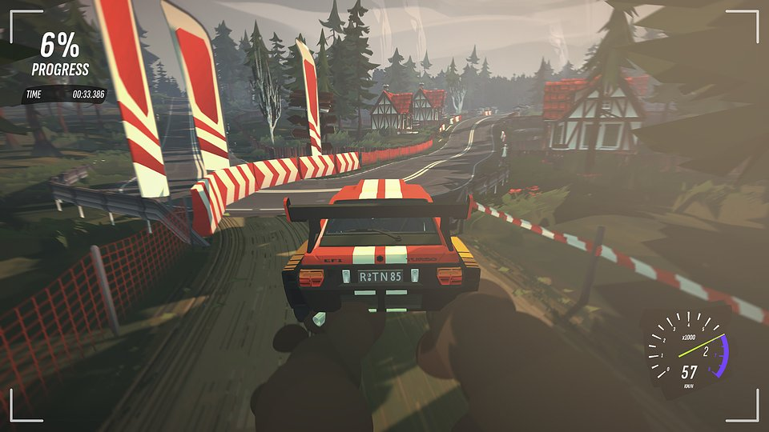

#DRIVE Rally – key features:

● Easy to learn, hard to master – a simple and intuitive driving model that beginners will handle with ease. However, challenging trials await those who know well the sound of gravel under their tires. It's a system designed to highlight the best aspects of racing games.

● Drive your way – classic championships, free roam, or party mode allowing for up to 12 players to compete? #DRIVE Rally offers a variety of ways to enjoy the journey ahead.

● New horizons, new challenges! – over 600 km of rally stages across 6 diverse locations, all to be explored and challenged in 22 unique cars with full controller and wheel support, as well as compatibility with Steam Deck.

● Left three, right one, keep it steady! – the co-driver can be the most loyal fan or the sternest judge. Enjoy victories together, but be prepared for criticism after losses.

● Win with style – take the wheel of cars like Das Holzwagen, The Doggo, or The Bobond, inspired by legendary rally machines, and then customize them to perfectly match your driving style. #DRIVE Rally combines 90s nostalgia with modern tuning options.

● Postcards from rallies – compete in a racing game world like never before. Get creative and capture your best moments in #DRIVE Rally with the special photo mode.

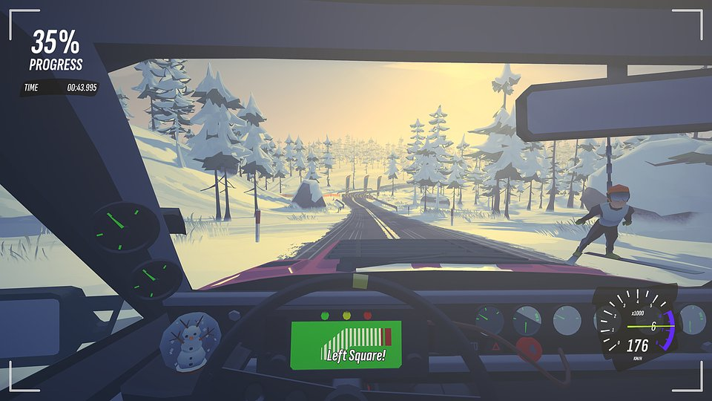

#DRIVE Rally has left Early Access today and is now available on Steam, GOG, and Epic Games Store. The release of the console versions is scheduled for later this year. To get the latest news, we encourage you to follow the game's social media channels (TikTok, X, Facebook) and join the rally fan community on Discord.

The full press kit is available here.

About Pixel Perfect Dude:
Pixel Perfect Dude is a small yet successful independent studio from Poland. The team has created and supported titles such as #DRIVE and Ski Jump. The studio's games boast 30 million players, numerous nominations, and awards, including the title of "Game of the Year." Pixel Perfect Dude always strives to deliver high-quality titles for all platforms. More details about the studio's activities can be found at pixelperfectdude.com

