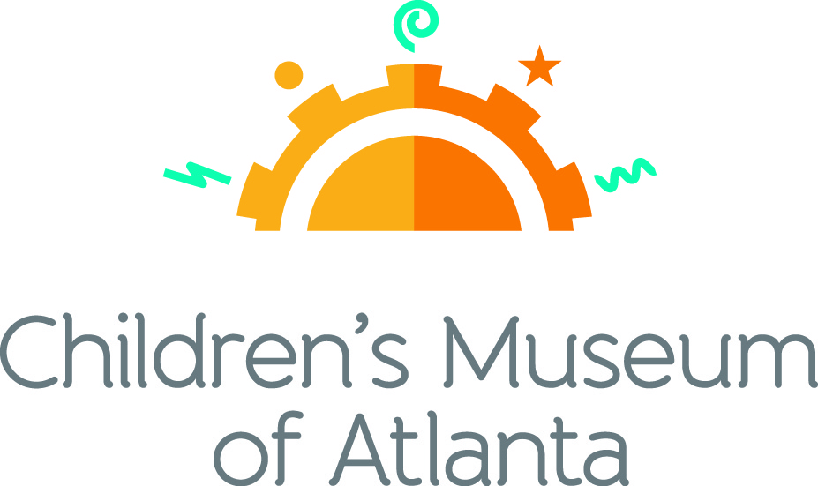

FOR MORE INFORMATION:
Becca Meyer/Jennifer Walker
BRAVE Public Relations, 404.233.3993
bmeyer@bravepublicrelations.com/
jwalker@bravepublicrelations.com

FOR IMMEDIATE RELEASE

Family-friendly fun blossoms at Children’s Museum of Atlanta this May
Special programming and daily “From Here to There” exhibit activities offer something for all kids this month

ATLANTA (April 17, 2017) – April showers bring May flowers! Families are invited to explore the budding activities at the Children’s Museum of Atlanta this May. Children will have the chance to discover the history of Cinco de Mayo, take a memorable picture with mom, dance the day away at the disco, enjoy worry-free storytime and more!

Feature Exhibit: “From Here to There”
Through May 29, 2017
How are objects transported across land, sea and air? Families are invited to find out during Children’s Museum of Atlanta’s newest feature exhibit “From Here to There,” parked in Atlanta now through May 29! Developed by the Sciencenter in New York, this traveling educational exhibit showcases 12 interactive stations and teaches children about gravity, friction, the laws of motions and more physics-filled fun.

Themed daily programming during “From Here to There” exhibit will occur through May 29, 2017. Programming subject to change and may be altered during special events. All programs included with admission unless otherwise noted.

Mini-Musical: Let’s Go!
Weekdays at 11 a.m. and 12 p.m.; Saturday at 11 a.m. and 3 p.m.; Sunday at 11 a.m. and 1 p.m.
Written by Marc Farley
Children will join professors Zip and Dash on an exploration of how people get from here to there. By way of cars, bikes and even boats, the professors will teach young visitors about the science behind different methods of transportation.

Story Time
Weekdays at 1 p.m.; Saturday at 12 p.m.; Sunday at 2 p.m.
- “Motion: Push and Pull, Fast and Slow” by Darlene R. Stille
This interactive story time will explore the concepts of motion by teaching children about movement, speed, force and inertia in an easy-to-learn way!
- “Rosie Revere Engineer” by Andrea Beaty
Where some people see rubbish, Rosie Revere sees inspiration. This special story time will follow shy Rosie, as she creates great inventions –like hot dog dispensers, helium pants and python-repelling cheese hats– from odds and ends.
- “There’s No Place Like Space: All About Our Solar System (Cat in the Hat’s Learning Library)” by Tish Rabe
A reading adventure that’s out of this world! Astronomers are launched on a wild trip to visit the eight planets in the solar system, along with Cat in the Hat, Thing One, Thing Two, Dick and Sally.

Music & Movement
Weekdays and Saturday at 2 p.m.; Sunday at 3 p.m.
Children can join the Imaginators for a highly energetic music and movement, where they will pretend to be a human jetliner and “fly” around the stage, interpret how planets would dance (if they had legs!) and take a trip through time, while acting out ways people get from here to there.

Super Spectacular Science Show
Weekdays at 3 p.m. and weekends at 4 p.m.
Professor Lab Coat and his assistants will lead a mesmerizing science demonstration put on for the entire Museum.
Eat A Georgia Rainbow
Sunday at 12 p.m.
Children will embark on a scavenger hunt and cold cooking activity with the Imaginators to learn more about fruits and veggies harvested in Georgia throughout the year.
Art Studio Projects
Weekdays 10:30 a.m. –3:30 p.m.; Weekends 11 a.m. –4 p.m.
Little ones can discover colors and explore artists from around the world through various crafts like making and decorating a hot air balloon, a floating boat or designing a toy parachute.
Build It Lab
Weekdays, 10:30 a.m. –3:30 p.m.; Weekends 11 a.m. –4 p.m.
Children will put their woodworking and creative tools to the test in this supervised space where they have access to real tools and materials. Encouraging inventions, this Build It Lab will spark creativity by allowing young innovators to design and construct a sling shot car.
Science Bar
Weekdays 10:30 a.m. –2:30 p.m.; Weekends 11 a.m. –3:30 p.m.
Science is everywhere, especially on the mezzanine at the Museum! Step Up to Science is the new STEM exhibit area and features interactive exhibits about light, robotics and how the human body works! Families can saddle up to the science bar for a full menu of fun activities, knowledge and have their questions turned into answers by one of the STEM educators.
May Special Programming

Cinco de Mayo
Saturday, May 6 and Sunday, May 7
Families will enjoy music, special dance presentations and the history behind this Mexican Holiday with
the Museum’s special Cinco de Mayo weekend events.
- 11 a.m. and 1 p.m. Saturday and Sunday: Alma Mexicana
Alma Mexicana, which translates to Mexican Soul, will perform traditional Mexican dances during the Cinco de Mayo celebration.
- 12 p.m. and 2 p.m. Saturday; 2 p.m. Sunday: Special Story Time
Little ones will go on a journey with Marco as he learns the significance behind the food, parades and mariachi music he enjoys during the holiday. Explore the bravery that Marco’s ancestors exemplified during the first Cinco de Mayo in “Marco’s Cinco de Mayo” by Lisa Bullard.
- 3 p.m. Saturday and Sunday: Special Music and Movement
Grab a maraca and join the Imaginators as they dance the Mexican hat dance to help celebrate Cinco de Mayo!

Safety Circus
Tuesday, May 9 from 3 – 6 p.m.
As part of Target Free Second Tuesday programming, families can learn about home, fire, car and water safety by visiting interactive stations throughout the Museum. Kids will have the opportunity to participate in a safety scavenger hunt to win a fun goody bag full of surprises!

Mother’s Day
Saturday, May 13 and Sunday, May 14
Children are invited to a special celebration to honor their amazing mom, grandma or favorite aunt! On Sunday, May 14, moms can receive FREE admission when they stop by the visitor’s services desk and say, “I’m a proud mom!”
- 11 a.m. – 2 p.m. Saturday: Mother’s Day Photo Booth
After capturing a memorable picture for mom, children will have the chance to create their own hand-crafted picture frame for a special Mother’s Day gift!
- 12 p.m. and 2 p.m. Saturday; 2 p.m. Sunday: Special Story Time
“The Night Before Mother’s Day,” written by Natasha Wing, illustrations by Amy Wummer shares a family’s determination to make Mother’s Day one mom will never forget.
- 3 p.m. Saturday and Sunday: Special Music and Movement
Families can grab their bell-bottoms and platform shoes to dance the day away with their groovy moms at the special Mother’s Day Disco Dance Party!

Guest Author Story Time
Saturday, May 20 at 12 p.m.
With its beautiful illustrations and important life-lessons, children will have the chance to listen along as author and illustrator Angelique Monet reads her newest book, “The Bravest Worrier.”

For more information on the April program offerings or to support Children's Museum of Atlanta, visit childrensmuseumatlanta.org or call 404.659.KIDS [5437].

About Children’s Museum of Atlanta:
Children’s Museum of Atlanta is the only educational venue of its kind in Atlanta, presenting educational programs and exhibits designed for young children ages 0-8. The Museum’s mission is to spark imagination and inspire discovery and learning for all children through the power of play. With six permanent learning zones consisting of bright, creative and hands-on exhibits, the Museum supports inventive play-based exploration and experiential learning focused on the whole child. Core competencies for literacy, math and science are promoted throughout all exhibits and programming in alignment with the state and national Core Performance Standards. The Children’s Museum of Atlanta also offers parties, memberships, field trips, summer camp and private events. For more information or to support Children's Museum of Atlanta, visit childrensmuseumatlanta.org or call 404.659.KIDS [5437].

Museum Admission: General Admission is $14.95 (plus tax) for anyone 1 – 100 years old. Babies and members are admitted for free. All daily programs are included in price of admission. Group rates and military discounts are available. For more information regarding ticket and membership options, visit childrensmuseumatlanta.org/plan-your-visit/faqs/.

Museum Hours: Monday, Tuesday, Thursday and Friday 10:00 a.m. – 4:00 p.m.; Saturday and Sunday 10:00 a.m. – 5:00 p.m.; Closed on Wednesdays. Please check the Museum website to confirm hours of operation.

Facebook: https://www.facebook.com/childrensmuseumatlanta
Twitter: https://twitter.com/ChildMuseumATL
Instagram: https://www.instagram.com/childrensmuseumatlanta
Pinterest: http://pinterest.com/cmatlanta
###

