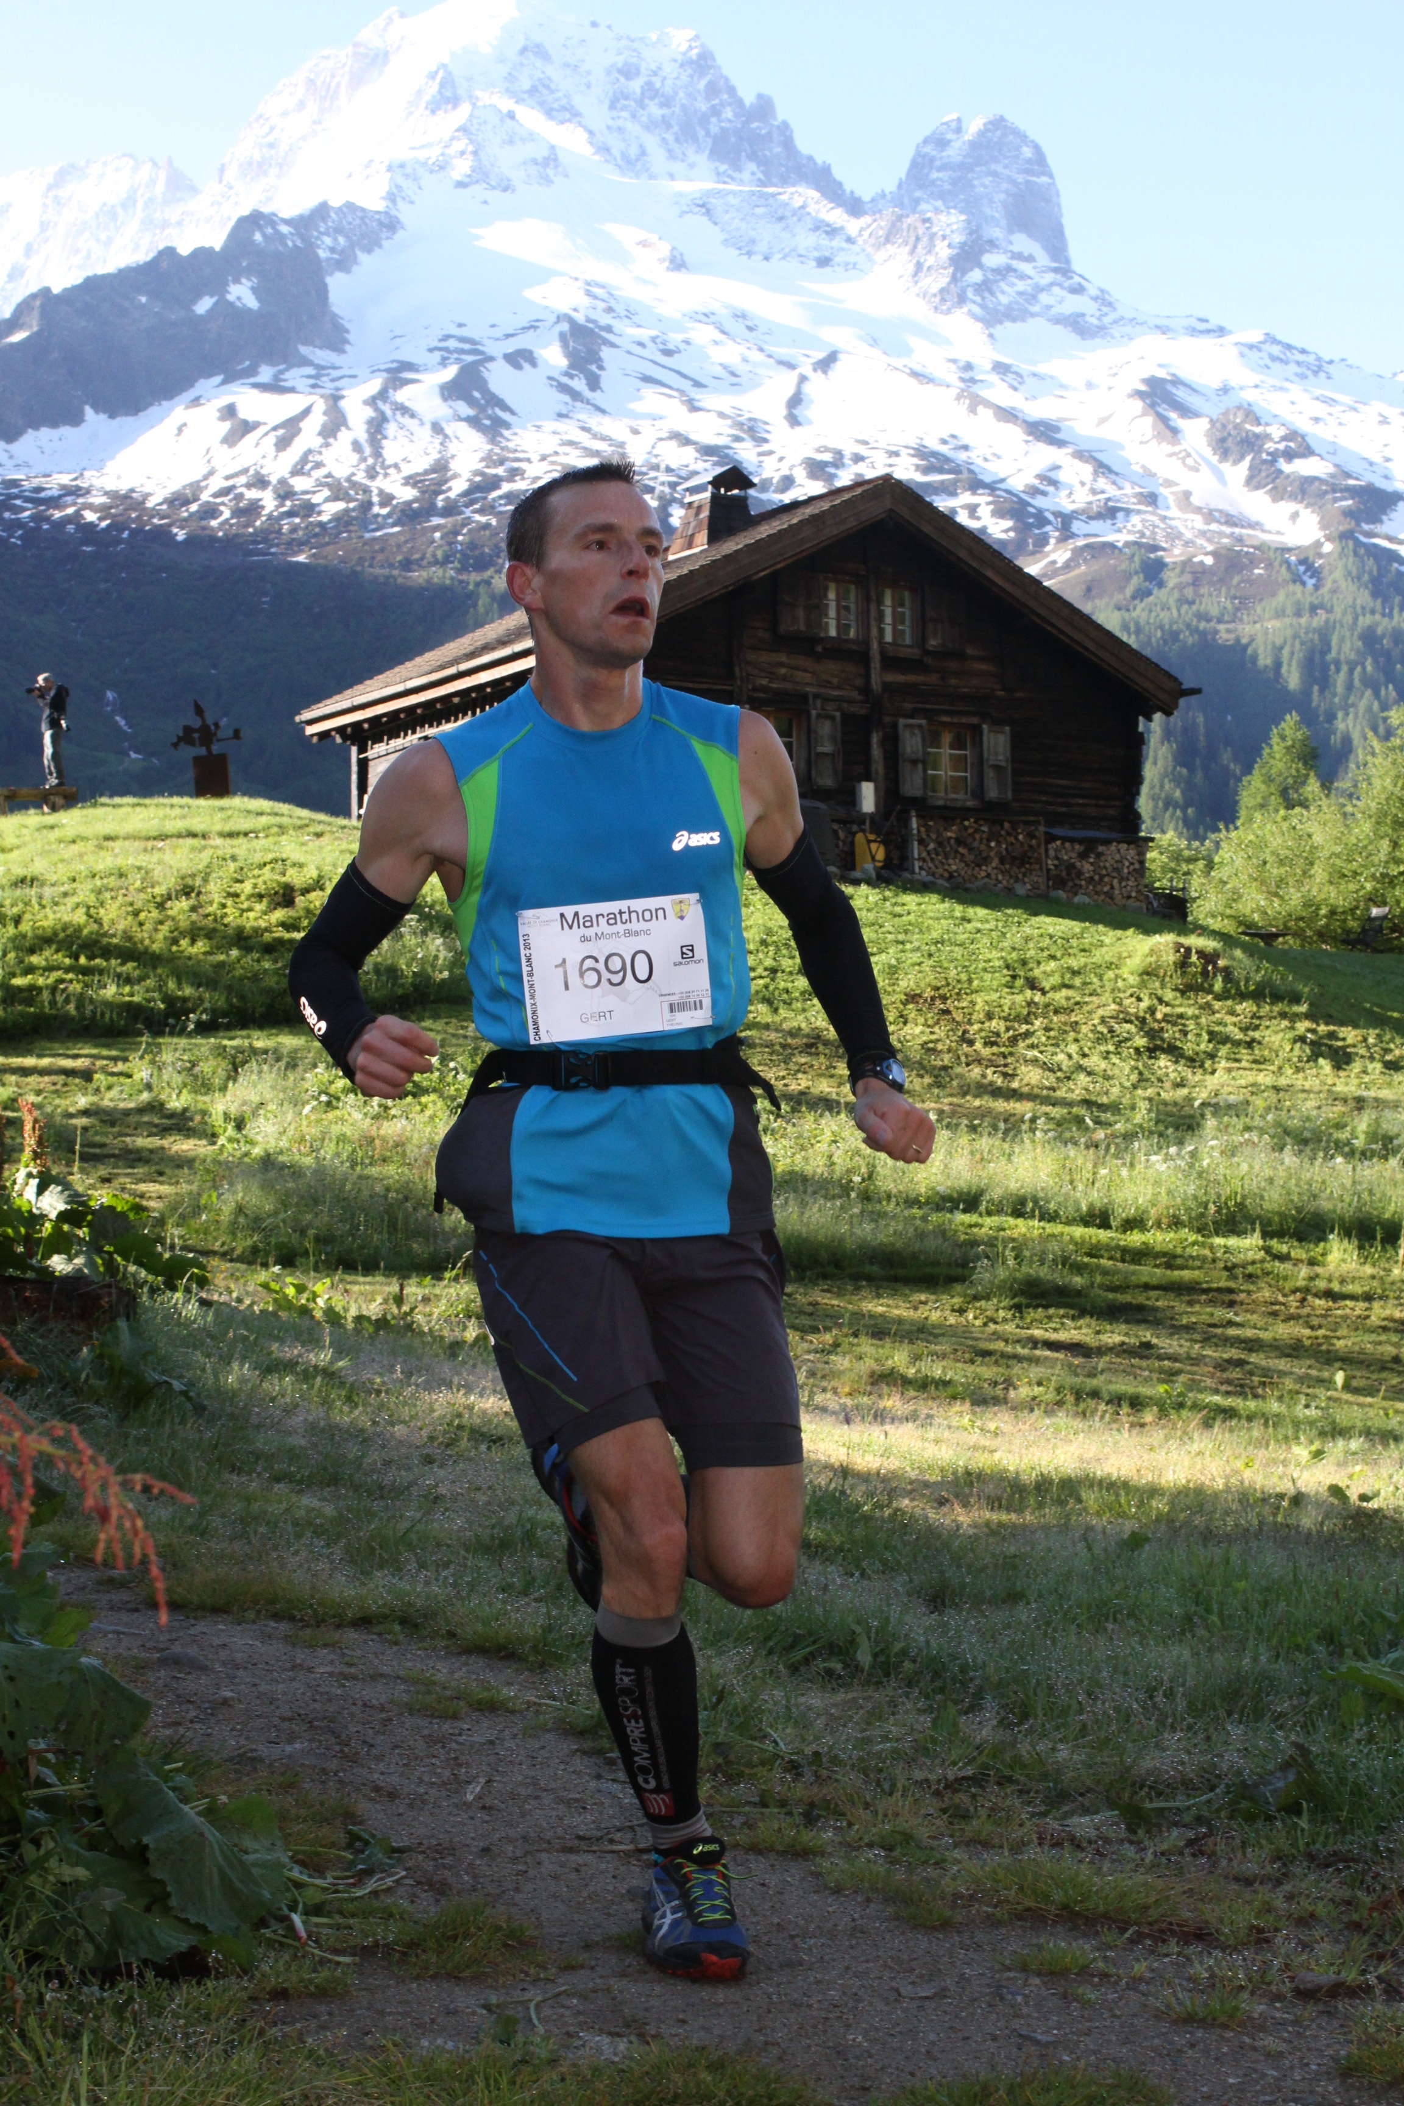

Name: Gert Theunis

DOB: 28/01/1975

Birthplace: Tienen, Belgium

Discipline: Long Distance Running

Outrun the Sum team: Team 2 (ASICS to confirm team name)

About Me:

Belgian Gert Theunis is currently in his sixth year of working as a Technical Representative for ASICS Benelux. He is fairly new to the marathon scene but has shown his natural talent in the discipline - racing in marathons across the globe – and achieving a personal best in the 2012 Amsterdam Marathon with a time of 2:27:52. He recently went on to race the Paris Marathon and achieved a time of 2:30:20 earlier this year.

Gert has been passionate about running from a young age and regularly runs up to five or six times a week. He has always had a passion for the outdoors and nature, and would go out walking to discover new places and settings. It is no surprise that this love of nature has led him to trail running.

He says: “Trail Running is a completely different approach. You will find it’s very different to road or track racing – as there you are focused on time. In trail running you'll be much more relaxed at the start and you will just want to enjoy the scenery, be more connected with your body, how it reacts to the hills.”

Gert currently lives in Hannut, Belgium, with his wife and two children and sees trails as a great way to unwind and relax. Gert has close friends in his neighbourhood who he goes out running with around his local nature reserves. Gert thinks of himself to be very lucky to have hills and countryside so close to his house to help him train.

Q & A:

Why did you get involved in your speciality discipline?
I started trail running around three years ago when it became really popular in Europe. From an early age, I grew up competing in various disciplines, making my way from short to long distance races and finally moving into marathon running at the age of 36. Once I had conquered that marathon running I felt that trail running was the next logical step to challenge me.

What does it mean to you?
Trail running means everything to me. It’s different to running a marathon or taking part in a city run because you have a chance to simply escape and enjoy the nature and beautiful landscape around you.

What do you feel it adds to your life?
Running plays a huge part in my life and I find it a great way to relax, unwind and clear my head.

What can people learn and take from what you do?
Always follow your passion and if possible try and combine it with your family life. I have two children who are eight and ten years old and I have encouraged them to take part in their local athletics club.

What continues to motivate you?
I have been running in various disciplines for 30 years now but each time I run it always feels fresh and new to me. This is because I have always pushed myself to reach new heights, new challenges and compete in disciplines I never thought I would. Trail running brings a new approach towards the way you run, it is not like any other style of running which is really exciting.

How important is the element of nature to you in trail running?
I run every day because I love being at one with nature. Nature has the ability to put me in a good mood!

Career Highlights:

2013 Winner of the 33km 4 Peaks of Herve challenge in Herve, Belgium

29th place in The Marathon du Mont-Blanc, which is 42km coupled with a positive vertical gain of 2511m

2012 Winner of The Eco-Trail 25K in Brussels which is a nature trail with 5 different routes, which can be ran in a group or solo

Completed the Amsterdam Marathon in a time of 2 hours and 27 minutes

