PSB Announces the M4U 9 and M4U TWM Headphones
  - New in-ear and over-ear wireless headphones take personalized listening seriously
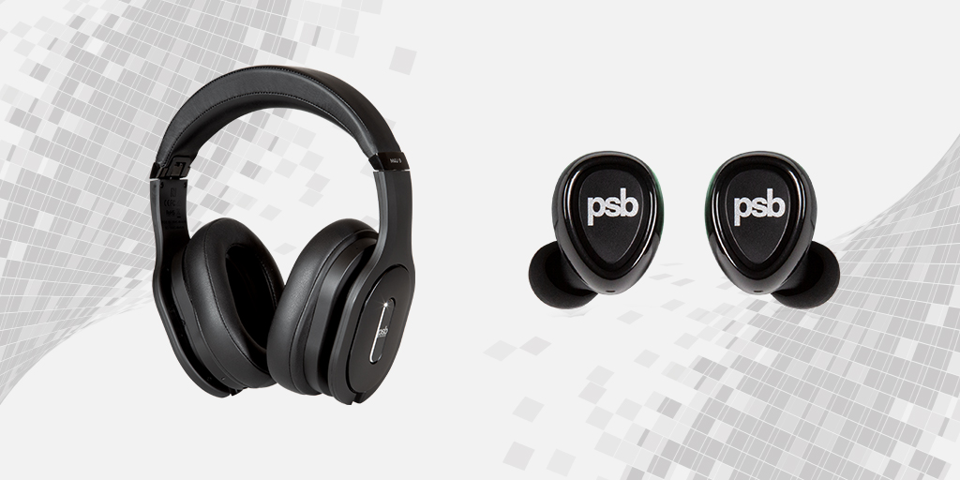
The new wireless PSB M4U 9 (L) and M4U TWM (R) headphones
Axpona AUDIO EXPO NORTH AMERICA, SChaumburg, Illinois, APRIL 5, 2023 – PSB Speakers, one of the first premium hi-fi loudspeaker brands to enter the headphone market over 10 years ago, announces all-new additions to their high-performance M4U line, the M4U 9 and M4U TWM, on the heels of releasing a new espresso brown finish of the M4U 8 MKIIs earlier this year. The headphones implement sound personalization options through a partnership with Audiodo Personal Sound™ along with PSB’s proprietary RoomFeel™ technology. The next-generation M4U 9 and M4U TWM designs feature improved engineering, better componentry and overall stunning presentation of musical detail. The new wireless over-ear and in-ear headphones will be available for demo at the AXPONA Audio Expo from April 14-16, 2023, with retail availability across PSB sales channels starting June 2023 with the following MSRP: (M4U 9) US$499 / CA$699 / €549 / £449 and (M4U TWM) US$199 / CA$299 / €229 / £199.

M4U 9 – Premium Wireless ANC Headphones
Improving on three generations of award-winning headphone design, the M4U 9 is crafted with premium materials, adaptive audio technologies and intelligent features, bringing the ultimate in mobile luxe listening. The wireless active noise cancelling over-ear headphones implement new graphene-infused drivers which improve on damping, stiffness and efficiency to reveal PSB’s “true-to-nature” sonic signature, more crisp and powerful than ever before. aptX™ Adaptive Bluetooth technology enables fast and easy pairing with any device, with support for up to 24-bit high-definition audio. The M4U 9 features all-digital active noise cancelling (ANC) capabilities utilizing 4 digital MEMS microphones to decrease audio conversion errors in audio processing for pure noise-free listening, while two additional mics for cVc™ (clear voice capture) technology deliver crystal clear call quality. A three-position mode switch on the M4U 9 allows users to choose between ANC with RoomFeel, Active with RoomFeel or a Passive mode. Gyro-suspended, fabric and leatherette earpads tilted at 15 degrees provide excellent seal and ergonomic comfort for an extended listening time of up to 25 hours in Active Mode.

M4U TWM – True Wireless Micro Planar Earphones
The M4U TWM earbuds leverage powerful Magneto-Static technology in a Hybrid Planar dual driver design, utilizing the same technology found in high-end magneto loudspeakers and fitting them into remarkably compact earbuds. Dedicated transducers, one for high frequencies and one for low frequencies work together to make the in-ear listening experience truly pristine, reproducing sound with crisp highs, natural midrange and deep lush bass. Enhanced aptX™ Adaptive Bluetooth technology keeps everything in sync from movies to games with dynamic low latency and an adaptive bit rate. Convenient features like hard click buttons on both earphones make music control and voice calls hands-free and intuitive, while a smart USB-C charging case delivers a maximum of 32 hours of extended play time (8 hours out of the case and 3 additional charge cycles in the case).

Sound Optimization with Audiodo Personal Sound™
An integration with Audiodo Personal Sound™ technology is one of the most unique features offered in both wireless headphones. The breakthrough technology uses a non-replicable set of algorithms which allows listeners to calibrate their headphones in a way that accommodates for the listening qualities of their left and right ears independently. After completing a quick and easy hearing assessment accessed through the PSB Headphones app, Audiodo Personal Sound™ maps out a precise and thorough understanding of the listener’s hearing, calculates what changes need to be made based on personal sound perception, and formulates a compensation curve for the listener that can be applied to the overall headphone sound.

Natural RoomFeel™ Tuning
Created to deliver rich and natural sound through headphones, the next generation of PSB’s proprietary RoomFeel technology mimics the experience of listening to a pair of high-quality, full-range speakers properly set up in a good room. Carefully developed using research and expertise around ‘Room Gain’ – the energy and warmth that room boundaries add to the response curve of a flat-measuring loudspeaker, RoomFeel makes the music feel less ‘in the head’ by recreating an open and natural in-room listening experience through the M4U headphones.

PSB Headphones App
All headphone settings, including Audiodo Personal Sound™ tests and Transparency modes are accessed centrally through the PSB Headphones app, a full-featured app that allows users to adjust settings, check battery levels and regularly keep the headphones up-to-date with the latest firmware updates and codes.

Image showing front and profile view of the M4U 9 headphones

Key Features of the M4U 9
- Bluetooth HD wireless connection with Qualcomm® aptX™ Adaptive and cVc™ technology
- Graphene-infused, 40mm drivers
- Separate Active Noise Cancelling (ANC), Active and Passive Modes
- All-digital ANC with digital MEMS microphones decreases audio conversion error
- PSB’s latest RoomFeel™ technology for greater detail and better imaging
- Personal Sound by Audiodo™ through the PSB Headphones app
- NFC pairing for supported devices
- Over-ear, amplified, closed back design
- Physical controls for volume, playback and mode selection
- Unique dual 3.5mm input connections (left or right side)
- Tangle-free, braided cords for analogue wired and USB-C connection
- ¼” stereo and dual-input flight adapters
- Runs on included rechargeable battery power
- Up to 25 hrs battery playtime in Active Mode
- Gyro-suspended ear pads
- Carry case and easy folding for travel and storage

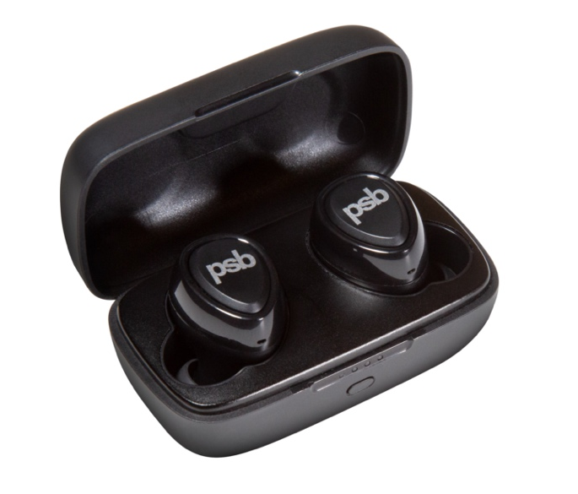
Image showing M4U TWM earbuds inside smart charging case

Key Features of the M4U TWM
- Wireless auto-pairing with any Bluetooth™ enabled device
- Magneto-Static, Hybrid Planar dual driver design
- Lightweight, secure fit suits any active lifestyle
- Activate voice assistants or use hard click buttons for hands-free calling and music control
- Rechargeable with 8 hours of playback and 24 hours in the smart charging case for 32 hours of total extended play time
- IP65 rated for protection against sweat, dust and weather
- RoomFeel™, Audiodo™ and cVc™ (clear voice capture) technologies built-in

About PSB Speakers
Since 1972, Founder and Chief Designer, Paul Barton, has been cementing his legacy as an expert in designing and building high-fidelity speakers that incorporate scientific principles in psychoacoustics. More than 50 years later and now a strategic part of Lenbrook International’s global portfolio, PSB Speakers’ products are sold in more than 70 markets where the brand sets the standard for “True to Nature” sound and is critically acclaimed for its value-driven and non-fatiguing speaker design. With an expansive suite of products that include audiophile speakers, ANC headphones, powerful and musical subwoofers, and a family of installed speaker solutions, PSB Speakers is designed and built to bring life to recorded music at world class levels.

Contacts

Corporate Contact
June Ip
Marketing
media@psbspeakers.com

US Media Relations
Jeff Touzeau (OLEX Communications – US/Canada)
914-602-2913
jeff@olexcommunications.us

UK Media Relations
Steve Dalton (OLEX Communications – UK)
+44 (0) 7748-117-864
steve@olexcommunications.co.uk

Links
Website: https://psbspeakers.com
Images: https://brandlibrary.lenbrook.com/portals/psbspeakers
Facebook: https://facebook.com/psbspeakers
Twitter: https://twitter.com/psbspeakers
Instagram: https://instagram.com/psbspeakers

# # #

