A Broadcaster’s Time-Saver: Digigram Introduces IQOYA X/LINK-MP IP Codec, Centralizing Signals Studio Side

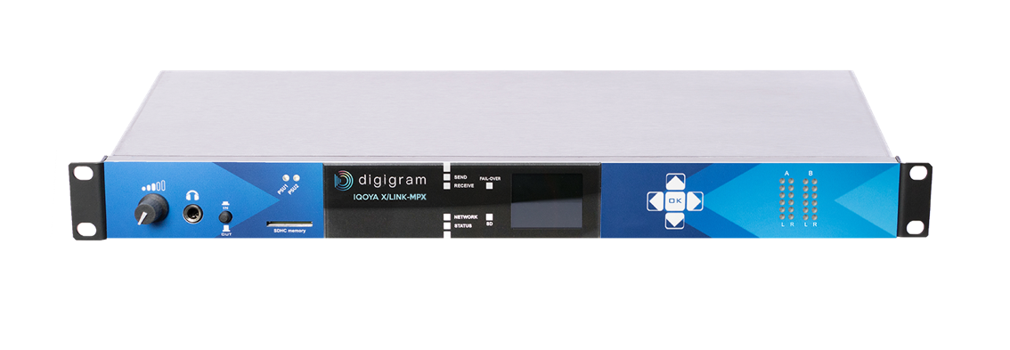
By streaming the composite MPX signal from a station’s FM tower, the new codec helps radio broadcasters and tower companies save both time and money
Fort Lauderdale, Florida, July 13, 2021 — Digigram, leading manufacturer of critical solutions designed for the production and distribution of audio content, has announced the IQOYA X/LINK-MPX IP audio codec. Designed with radio broadcasters and tower companies in mind, the MPX is a 1U rack codec designed for transporting an FM/MPX composite signal over IP networks, saving broadcasters both time and money.
“The new MPX version of the IQOYA X/LINK codec is a game-changer for radio broadcasters and tower companies that are using multiple pieces of equipment on each transmitter site to create an MPX signal,” said Derek Badala, director of sales at Synthax, US distributor of Digigram. “It’s a costly and time-consuming process when it comes to the constant maintenance it requires to sustain this equipment. The IQOYA X/LINK-MPX is a powerful tool because it streamlines broadcasters’ processes by centralizing the MPX signal studio side and saves money on MPX equipment at each transmitter site.”
A Feature-Packed Codec
With input signals that can be analog, digital or RAVENNA, and output signals that can be either analog and/or digital, the IQOYA X/LINK-MPX includes a rich feature set that enables reliable transmission of the MPX signal over managed or unmanaged networks. This also ensures uninterrupted audio service on transmitter sites thanks to two backup levels. The codec is fan-less and features an energy-efficient platform that runs on the highly acclaimed Digigram Fluid IP streaming technology. As a result, the new IQOYA X/LINK-MPX is designed with radio broadcasters in mind for 24/7/365 operation.
The new IQOYA X/LINK-MPX also allows for easy status monitoring thanks to status LEDs and an LCD display and keypad. Two internal redundant PSUs ensure secure operations while the unit also features two analog I/Os and one AES/EBU audio I/O, plus 10 mHz/1 PPS synchronization inputs. The MPX codec also includes 1 digital MPX input and 1 digital MPX output, 1 analog MPX input and 1 analog MPX output, and 4 GPIO/s for tunneling of physical status.
For more information on Synthax, visit: https://www.synthax.com/
For more information on Digigram, visit: https://www.digigram.com/

About Synthax, Incorporated
Synthax Inc. is the exclusive USA distributor for RME digital audio solutions, Digigram broadcast audio systems, Appsys digital audio tools, Ferrofish advanced audio applications, myMix personal monitoring systems and ALVA cableware. We supply a nationwide network of dealers with these products for professional audio, broadcast, music industry, commercial audio, theater, military and government applications. For additional information, visit the company online at http://www.synthax.com.
About Digigram
For over 30 years, Digigram has developed innovative digital systems that make modern broadcasters rapidly evolving operations more efficient, more reliable and more effective. Used by thousands of journalists, broadcasters and industrial users all over the world, Digigram’s sound cards, audio processing software and pioneering IP audio technologies are designed with a consistent attention to quality and reliability. Digigram (DIG) is publicly listed on the NYSE Euronext Paris stock exchange. More information is available at http://www.digigram.com/.

Media Contacts:
Katie Kailus
Public Relations
Hummingbird Media
+1 (630) 319-5226
katie@hummingbirdmedia.com

Jeff Touzeau
Public Relations
Hummingbird Media
+1 (914) 602 2913
jeff@hummingbirdmedia.com

