BJOOKS ANNOUNCES ‘INSPIRE THE MUSIC: 50 YEARS OF ROLAND HISTORY’ TO CELEBRATE THE BRAND’S 50TH ANNIVERSARY

A 400-page journey through Roland’s 50 years of inspiration, innovation and insight is coming this summer

APRIL 18, 2022 — COPENHAGEN, DENMARK — Bjooks, a preeminent publisher of musical instrument book titles including PUSH TURN MOVE, PATCH & TWEAK, PEDAL CRUSH, and SYNTH GEMS I, has announced its forthcoming title INSPIRE THE MUSIC: 50 YEARS OF ROLAND HISTORY in conjunction with the brand’s 50th anniversary. The 400-page, beautifully photographed hardcover book celebrates the culture, people and technology of Roland.

Readers will enjoy more than 70 colorful interviews with world-renowned artists and Roland designers, discussing their relationships with the instruments and making music. The book offers deep insights into the worldwide Roland culture, and a timeline traces Roland’s history from its humble beginnings under founder Ikutaro Kakehashi to its current place as a worldwide leader in music technology.

In addition to the people, INSPIRE THE MUSIC showcases the gear that inspired them. Gear fanatics and curious newcomers alike will enjoy illustrated stories about product lines, popular machines, quirky products and more.

INSPIRE THE MUSIC is a fun, engaging, and informative tour through evolution and revolution in beat making, keyboards, pianos, synthesizers, guitar and bass products, drums and percussion, music production, and more. Not only does this book open up the world of Roland to every music enthusiast, it explores the history of music technology and how it inspired the music itself over the past 50 years.

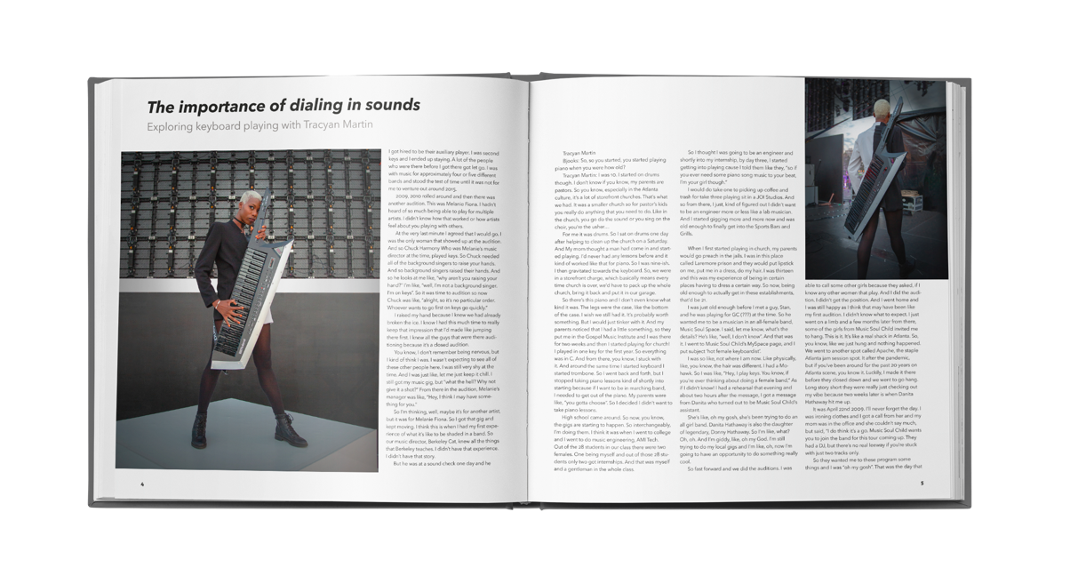

More Than 70 Interviews with Music Makers
INSPIRE THE MUSIC gets up close and personal with world-famous artists and their relationship with Roland products, production and performing. The book shows the tools in the hands of the creators — tools that have been created by visionary product designers and engineers who’ve sought to design the future.

In this celebration of innovation and creativity, readers are introduced to a world of artists, DJs and producers through insightful stories and interviews, including: Thomas Dolby, Jimmy Jam & Terry Lewis, Ali Stone, Omar Hakim, Sister Bliss, Howard Jones, Orbital, Richie Hawtin, Peaches, Culture Club producer Steve Levine, Guy Fletcher of Dire Straits, Clive Deamer of Radiohead, Gingger Shankar, Swizz Beatz, Rachel Z, Nick Rhodes and Roger Taylor of Duran Duran, Nita Strauss, DJ Jazzy Jeff, Steve Stevens, Johnny Marr of The Smiths, Buffy Sainte-Marie, electronic music pioneer Jean-Michel Jarre, Yana Reznik, Jeff “Skunk” Baxter of the Doobie Brothers, Rance Dopson, Bonnie McIntosh, Egyptian Lover and many more.

Insights, Instruments & Innovators
Going beyond just products alone, INSPIRE THE MUSIC is a visual story of the Roland brand and the world it created, with exciting new insights on every page, including a rare glimpse into the world of the innovators who helped design the gear that made Roland what it is today.

Multiple chapters examine the evolving world in which Roland products came to be, and how their inventive and innovative approach to the art and craft of music led to machines that the world often didn’t know they needed until they had them. INSPIRE THE MUSIC tells the story of how Roland gear helped inspire entire musical genres, from 1980s New Wave to today’s EDM and hip-hop scenes.

Beyond the obvious icons — such as the Jupiter-8 that helped redefine pop music, the TR-808 and TB-303 that became the rhythmic voice of everything from rap to acid house, and the BOSS Compact Pedals that forever changed the sound of electric guitar — readers will get to know the context and history of uncommon yet influential technologies. They’ll be introduced to guitar synthesizers and electronic percussion like the V-Drums. They’ll learn how the Octapad became a mainstay of modern music in India and be introduced to the Grooveboxes that added new dimensions to beat making.

“We’re extremely excited to launch INSPIRE THE MUSIC this summer, with the blessing and enthusiastic cooperation of Roland itself,” said Kim Bjørn, founder and CEO of Bjooks. “We’ve been privileged to gain access to the company’s vast archive of interviews and technical information, interview the quiet geniuses that design the musical future, and connect with the worldwide Roland community. Dozens of enthusiastic creators have helped put together this monument of music tech history, documenting decades of tech innovation and artistry, told by the people who used the instruments and the engineers who made them come alive.”

“Roland is thrilled to collaborate with acclaimed music tech publisher Bjooks to create a special book that honors the culture, people, and technology of Roland as we celebrate our 50th anniversary this year. It is exciting to see such a diverse group of artists share their experiences with our products,” said Gordon Raison, CEO and representative director of Roland Corporation.

INSPIRE THE MUSIC will be available through authorized resellers, and at bjooks.com this summer.

Bjooks is an environmentally responsible publisher with all of its books – including INSPIRE THE MUSIC — printed on high-quality, environmentally friendly paper from responsible sources.
Cover and spread image examples are available in the INSPIRE THE MUSIC press kit here.
For more information on Bjooks portfolio, please visit http://www.bjooks.com.

About Bjooks:
Bjooks is the boutique publishing company started and run by author, designer and musician Kim Bjørn. Bjooks first book, PUSH TURN MOVE, was published in 2017. This was followed by PATCH & TWEAK in 2018, which has since been referred to as the 'Bible of Modular Synthesis’; PEDAL CRUSH - Stompbox Effects for Creative Music Making in 2019; and PATCH & TWEAK with Moog in 2020 and SYNTH GEMS I in 2021. The mission of Bjooks is to create exciting titles about music technology, artists and makers, in order to document, inspire, and explore the world of music creation.

About Roland Corporation:
For 50 years, Roland’s innovative electronic musical instruments and multimedia products have fueled inspiration in artists and creators around the world. Embraced by hobbyists and professionals alike, the company’s trendsetting gear spans multiple categories, from pianos, synthesizers, guitar products, and electronic percussion to DJ controllers, audio/video solutions, livestreaming products, and more. As technology evolves, Roland continues to lead the way for gigging musicians, producers, and beatmakers, providing modern software-based solutions and seamless creative workflows between hardware products, computers, and mobile devices. For more information, visit Roland.com or see your local Roland dealer.

Press Contacts:
Katie Kailus
Hummingbird Media
katie@hummingbirdmedia.com
www.hummingbirdmedia.com

Jeff Touzeau
Hummingbird Media
jeff@hummingbirdmedia.com
www.hummingbirdmedia.com

