Give the gift of superior sound this Christmas with Sennheiser
Sennheiser compiles the ultimate Christmas gift guide

Marlow/UK, July 16, 2020 – Turn up the holiday spirit this season and gift an unforgettable Christmas with the latest from Sennheiser. From earbuds to over-ear cans, there’s something for everyone on your Christmas list!

For the on-the-go audiophile
MOMENTUM True Wireless (£279 RRP)
Unwrap the gift of best-in-class audio this Christmas with Sennheiser’s latest wireless earbuds, the MOMENTUM True Wireless 2. Features include:
- Active noise cancellation, perfect for tuning out the outside world so you can rock around the Christmas tree
- Long-lasting 28 hours of battery life, ideal for binge-watching Christmas film favourites
- Available in white or black and designed for all-day wear comfort - look and feel good over the festive period, and beyond.
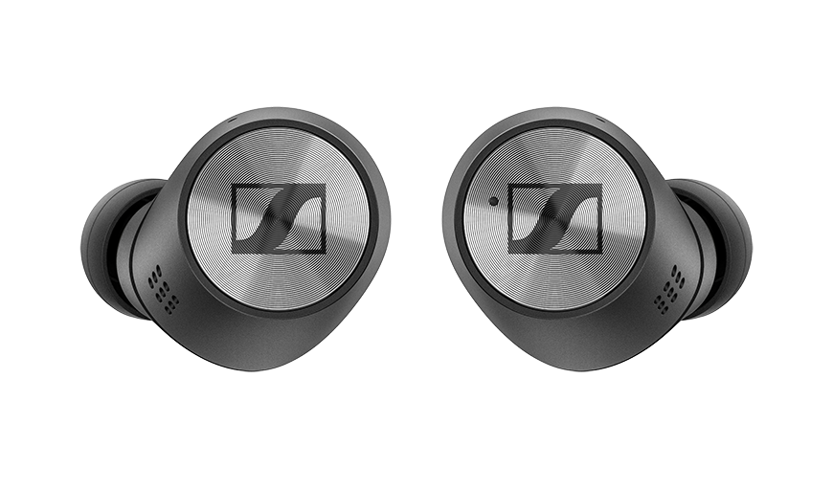

For the new kid on the headphone block
HD 450BT (£159.99 RRP)
Give the youthful ones on your list this Christmas the wireless HD 450BT headphones - a perfect fit for those after their first, nice pair of over-ear headphones. Features include:
- 30 hours of battery life and active noise cancellation
- Great wireless sound - enjoy deep dynamic bass and tailor the sounds of the season via Sennheiser’s Smart Control App
- A designated voice assistant button - so you can call Google Assistant and Siri at the touch of the button.
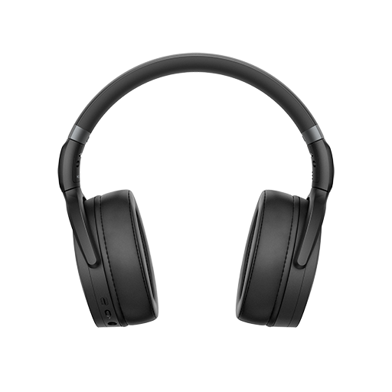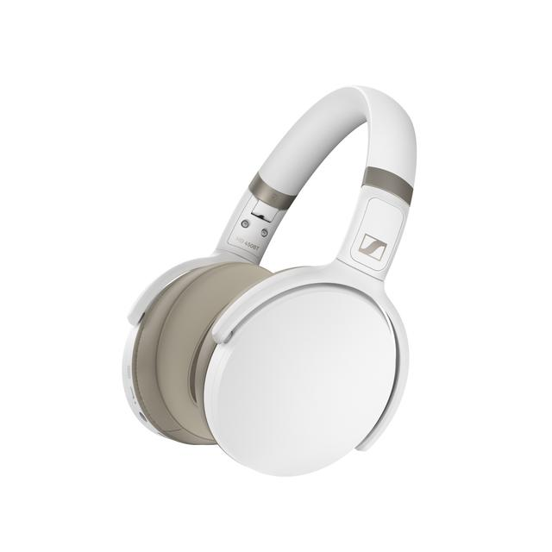
For the fashionable music lover
MOMENTUM Wireless (£349 RRP)
Celebrate the most wonderful time of the year in style with Sennheiser’s iconic MOMENTUM Wireless headphones. Features include:
- Intuitive controls - smart pause and auto on/off features
- Studio-quality sound to dial up the Christmas cheer
- Style and function to sleigh this Christmas thanks to the ergonomic design, leather ear cups and stainless steel matte sliders.

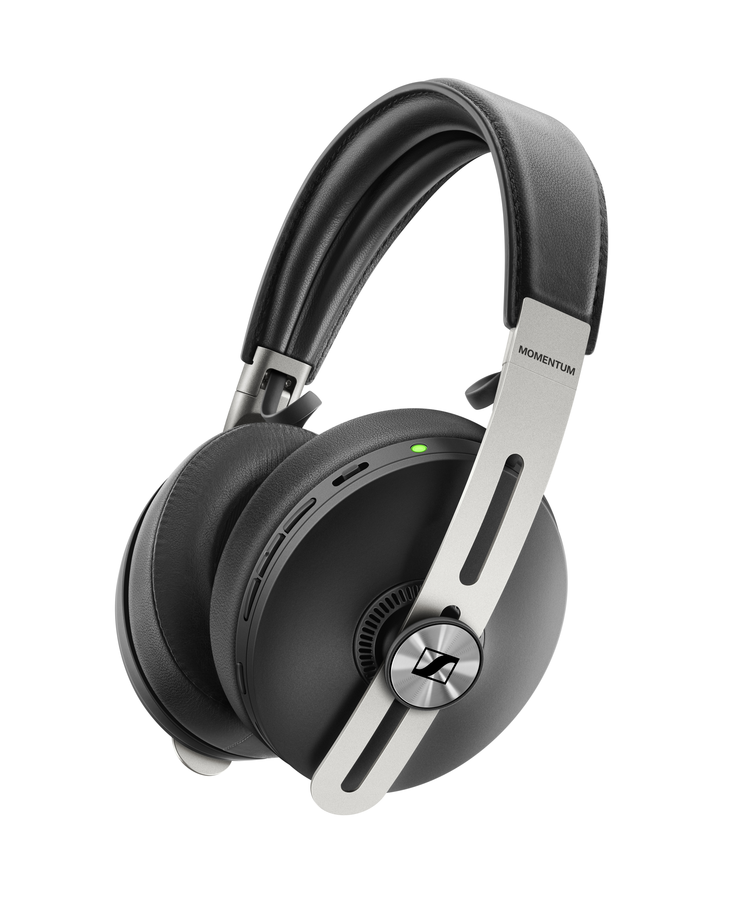

For those wanting great sound on-the-go
CX 350BT (£89.99 RRP)
You’ve made a list and checked it twice - Sennheiser’s CX 350BT delivers on both style and price. Features include:
- Tailored sound via Sennheiser’s Smart Control App. Experience Sennheiser’s podcast mode - designed to bring out the best podcast listening experience
- Seamless connectivity powered by Bluetooth 5.0, allowing you to connect the headphones to two devices at the same time
- Superior sound in a compact package - all they’re missing is a bow! Earbuds are available in black or white.

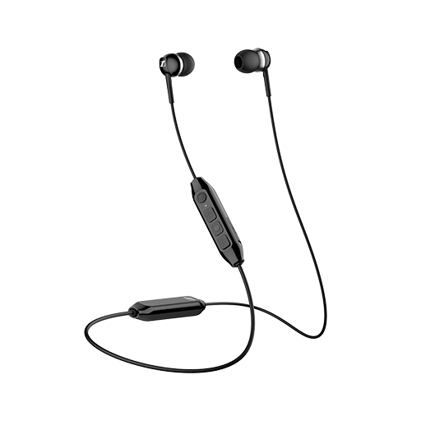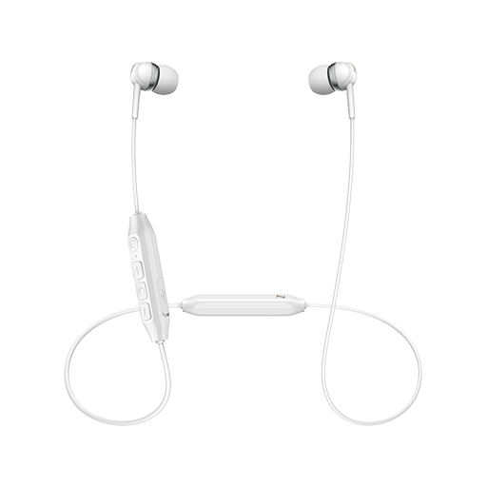

About Sennheiser
Founded in 1945, Sennheiser is celebrating its 75th anniversary this year. Shaping the future of audio and creating unique sound experiences for customers – this aim unites Sennheiser employees and partners worldwide. The independent family company, which is managed in the third generation by Dr. Andreas Sennheiser and Daniel Sennheiser, is today one of the world’s leading manufacturers of headphones, loudspeakers, microphones and wireless transmission systems. In 2019, the Sennheiser Group generated turnover totaling €756.7 million. www.sennheiser.com

Local Press Contacts

Maik Robbe
maik.robbe@sennheiser.com
+44 (0) 7393 462484

