October 20, 2017
Toyota Motor Corporation
GAZOO Racing Company

Rally GB: Preview
TOYOTA GAZOO Racing ready to attack the Welsh forests

The TOYOTA GAZOO Racing World Rally Team takes on one of the most famous rounds of the FIA World Rally Championship with Rally GB from October 26-29. Drivers Jari-Matti Latvala, Juho Hänninen and Esapekka Lappi will head into the forests of Wales for the penultimate round of the season, looking to add to the strong potential displayed by the Yaris WRC during its debut campaign.
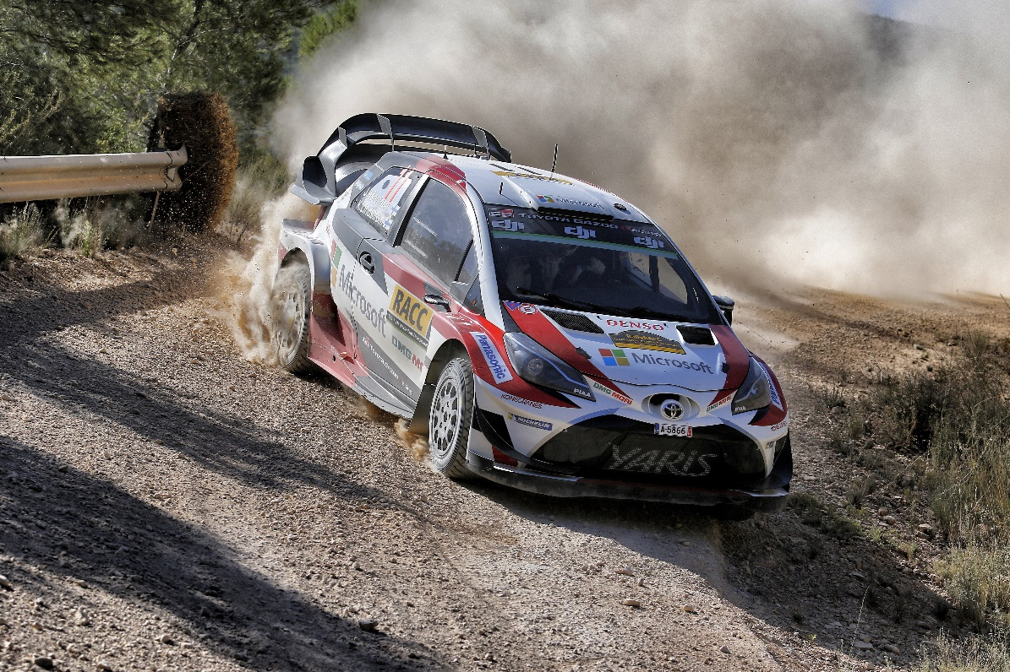

Car11(Juho Hänninen, Kaj Lindström)

Rally GB takes place over forest tracks through mid and north Wales. In dry conditions these stages can be driven at fairly high speeds, but in the Welsh autumn the pace is tempered by mud, which can make the surfaces treacherously slippery. Fog and even ice can add to the challenge, particularly early in the morning or late in the evening.

The rally begins on Thursday night with a new spectator stage at the Tir Prince trotting track on the north Welsh coast, east of the service park in Deeside. Friday consists of the classic Myherin, Sweet Lamb and Hafren stages, run twice with only a tyre fitting zone in between the two loops. A marathon Saturday features nine stages and ends in darkness. Five more stages conclude the action on Sunday, ending with the Brenig Power Stage.

Quotes:
Tommi Mäkinen (Team Principal)
“In 2003 I was fighting for the podium with Colin McRae on my last world championship rally, so personally I have really nice memories of Rally GB. It’s the sort of place where you need a lot of confidence with the car, as often there is actually more grip than there appears to be. Then you have the fog and the rain, which is a big challenge. After Spain, we identified some things that we could do a bit differently, so it will be interesting to see the effect of these changes now. Conditions in our pre-event test were warmer than usual, but that should not affect us too much: in the end it is a question of dialling the car into the nature of the roads, and that doesn’t really change. I think we’re well-prepared.”

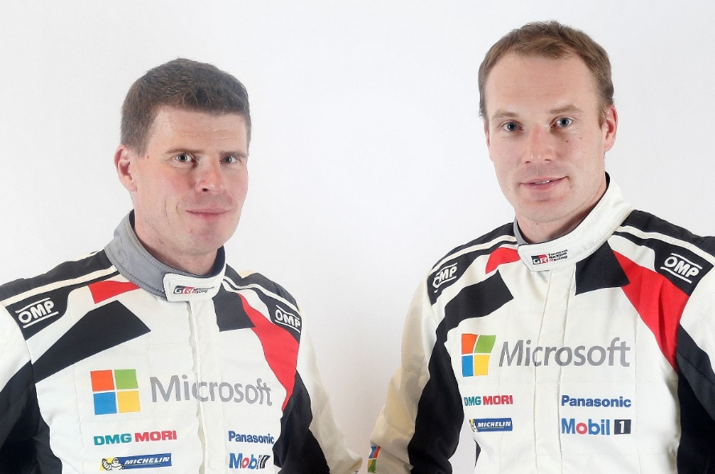
Jari-Matti Latvala (Driver car 10)
“Britain is a bit like my second home as it’s where I started my career and it was also my first world championship rally. There are some fantastic stages like Myherin and Dyfnant, which I’m looking forward to going back to. We obviously had a few technical issues in some of the recent rallies, but I feel confident that the team has got completely on top of those now and I just want to have two strong events to finish this incredible season. The first few rallies were challenging but maybe less demanding on the car than these events now at the end of the year, so we are learning more all the time as it is still only our first season as a team.”
Miikka Anttila and Jari-Matti Latvala

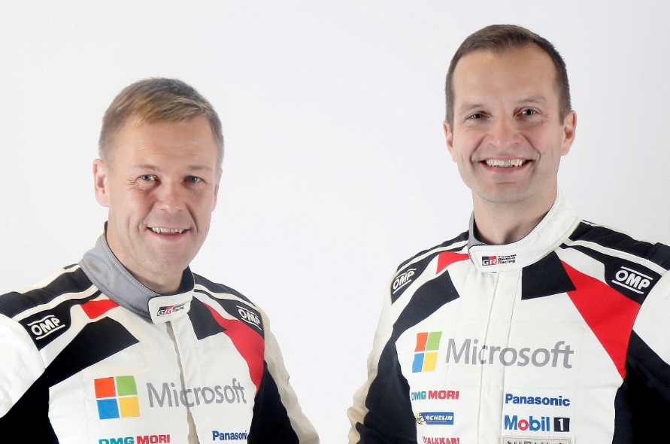
Juho Hänninen (Driver car 11)
“I’m happy with what we managed to do in Spain, so we go into Rally GB with a lot of confidence. This will be my last rally of the year, so most of all I just want to enjoy it. I’ve not actually competed there since 2014, but luckily most of the stages are still quite the same. Even though I don’t have a huge amount of experience in Wales I’ve always liked it, so I want to make sure that this rally is a nice one for us. We don’t have a particular plan: we just want to take it stage by stage and build on our pace. It’s a strategy that has worked well before.”
Kaj Lindström and Juho Hänninen

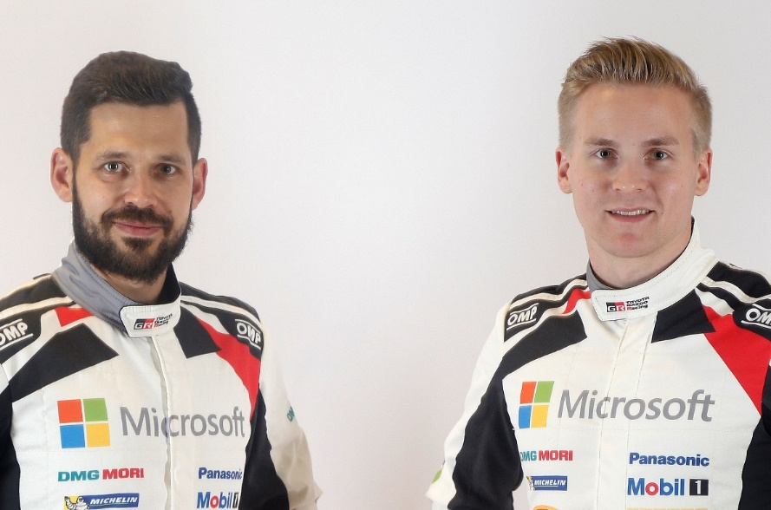
Esapekka Lappi (Driver car 12)
“Our pre-event test was good but it was very strange weather: I brought my winter jacket and my hat, but when I stepped out of the hotel it was 22 degrees! Still, I think what we worked on can still be useful if it’s wet and muddy, which is normally what happens on Rally GB. I just hope that there’s not too much fog, as that can be really difficult. We changed some suspension settings and there are a few other lessons that we learned from Spain that I was able to improve on, so we made a lot of progress during the test. Normally I have a good feeling with Rally GB, so now I’m looking forward to getting out on the stages and hopefully we can have a good result at the end.”
Janne Ferm and Esapekka Lappi

The statistics (Rally GB):
Year | Jari-Matti Latvala | Juho Hänninen | Esapekka Lappi
2016 | 7 | - | 11
2015 | 50 | - | -
2014 | 8 | 30 | -
2013 | 2 | - | -
2012 | 1 | - | -
2011 | 1 | - | -

2017 FIA World Rally Championship for drivers after round 11:

1 Sebastien Ogier 198
2 Ott Tänak 161
3 Thierry Neuville 160

4 Jari-Matti Latvala 123

5 Dani Sordo 94
6 Elfyn Evans 93

7 Juho Hänninen 71
8 Craig Breen 64

9 Kris Meeke 60

10 Hayden Paddon 55

11 Esapekka Lappi 49

2017 FIA World Rally Championship for manufacturers after round 11:

1 M-Sport World Rally Team 358
2 Hyundai Motorsport 275

3 TOYOTA GAZOO Racing WRT 225

4 Citroen Total Abu Dhabi World Rally Team 198

Team Media Hour – Rally GB

Wednesday 25 October at the TOYOTA GAZOO Racing World Rally Team hospitality in the service park, with drivers and management present, from 18:00-18:45. All media are welcome.

Press release
URL: http://toyotagazooracing.com/release/2017/wrc/rd12-preview.html

Pictures will be uploaded here during the event
URL: https://www.tgrwrt.com/ ( ID and Password needed)

Follow us!
Follow TOYOTA GAZOO Racing WRT:
∇Facebook: https://www.facebook.com/TOYOTAGAZOORacingWRC
∇Twitter: https://www.twitter.com/TGR_WRC (@TGR_WRC)
∇Instagram: https://www.instagram.com/tgr_wrc/ (@TGR_WRC)
∇YouTube: https://www.youtube.com/channel/UCCtALHup92q5xIFb7n9UXVg

<Contact>

TOYOTA GAZOO Racing PR Office
Email: tgr_pr @rights-apartment.com

TOYOTA GAZOO Racing Official website
http://toyotagazooracing.com/

TOYOTA GAZOO Racing World Rally Team is supported by the following partners:

