PRESS INFORMATION

The CYBEX YEMA: Embrace Individuality!

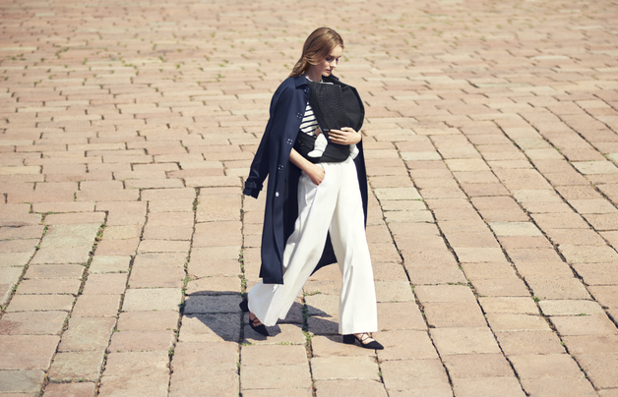

CYBEX introduces the YEMA baby carrier to their Platinum Range, creating new fashion statements as well as an indispensable accessory for parents, highlighting the expression of their individual style.

It’s a new era in which parents set the trends and baby carriers are real eye-catchers. Inspired and designed by the artistic drapery of international runways – we have come to appreciate that understatement is just so yesterday! You spend careful and considerate time selecting your exceptional wardrobe. The YEMA is no different than another extraordinary handbag, but it carries your most important item – your child! Sleek lines, bold prints, luxurious fabric in leather-look and daring design statements are some of the highlights that make this baby carrier your fashion declaration to the rest of the world.

The YEMA’s design offers many features that make it comfortable to carry your child and enhance the comfort for both parent and baby. The YEMA has a 100% cotton lining ensuring correct back support for your child. The width adjustable seat that grows with your child supports the best ergonomic position for your baby, promoting the spread-squat position and helping support premium joint development.

As your child grows and develops the carrier can adjust to three carrying positions. The front carrying position is ideal for a baby’s first months. Older children up to two years of age can also be carried in the hip and back carrying position. Allowing you the unique time to bond with your child and stimulate their cognitive development as you carry on with life.

Straps, belts, and concealed features are all designed to fit you and your child safely, while at the same time respecting the creative and original design that CYBEX is known for. The YEMA is wearable elegance in its most distinct form. Each function of the carrier is easy to use so attention is not diverted from its contemporary design.

As Gabriele Strehle once said: “A handbag must trigger an intense feeling in a woman as a favorite toy in a child.” Your bold style is what makes you the most distinct woman on the street, the YEMA by CYBEX is truly a new era in babywearing; highlighting what makes you unique as a parent - the ability to continue to be yourself.

About CYBEX
Established in 2005, CYBEX has been globally renowned for their iconic design, innovative technology, easy functionality, and superior safety features on all of their products for stylish adults embarking on parenthood. In early 2014, the German company CYBEX fused with Goodbaby International Holding Limited. The group is one of the world’s leading enterprises for the development and production of child and teen goods, headquartered in China. The CEOs of CYBEX are Johannes Schlamminger and Raoul Bader. For more information, visit www.cybex-online.com/de.

CYBEX-press contact:
Raf Caramin
Media Mania
Kipdorp 23
2000 Antwerpen
+32 (0)3 213 07 45
www.mediamania.be

