RME Fireface UFX+ Serves as Centerpiece in Podcasting Giant Crooked Media’s
Los Angeles Studios
Paired with RME’s TotalMix FX software, the Fireface UFX+ allows for complex monitoring and routing while eliminating the need for larger consoles

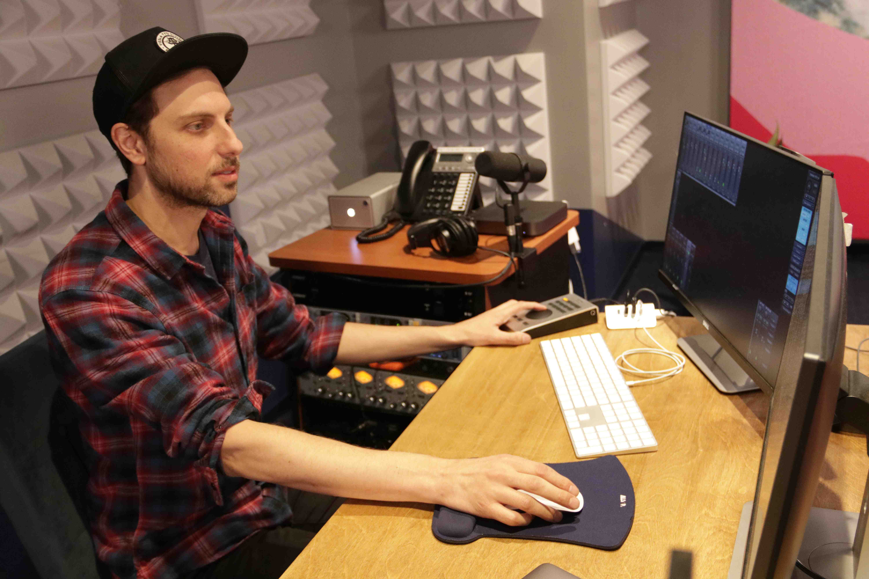
Los Angeles, January 29, 2020 – When Kyle Seglin became the lead audio engineer and studio manager at politics and culture podcast-giant Crooked Media last January, he started by updating the audio equipment in the company’s two Los Angeles studios. Now, all podcasts produced in-house — including the popular “Pod Save America” — are recorded using a single piece of hardware he calls the “centerpiece” of each studio: RME’s Fireface UFX+ interface.
Photo Credit: Narineh Melkonian
Seglin chose RME not only due to the brand’s reputation for providing high-quality conversion and audio, but also because, when used in combination with RME’s TotalMix FX software, he can do all of the complex monitoring and routing required for any of Crooked Media podcasts, without the need for a console.
“When I came to Crooked Media, I upgraded our equipment to feature the two RME units as a core component of both studios,” Seglin said. “I went with RME largely because of TotalMix FX, because it allowed me to do everything that I would do with a large-format console, but without the physical routing connections and massive physical footprint.”
Seglin said he used a variety of other interfaces in other applications before joining Crooked Media, but RME’s TotalMix FX, which is included with all RME’s interfaces, was a huge selling point.
“A lot of the interfaces have high-quality pre-amps and conversion, and I found RME to be right up there with other high-end competitors, but it was the TotalMix FX Software that pushed the Fireface UFX+ over the edge, for me,” he added.
Complex Monitoring & Routing for Any Configuration
Since its founding in 2016, Crooked Media has experienced especially rapid growth in the booming podcasting industry. Starting with its flagship podcast, “Pod Save America,” the media production company has since added a slew of chart-topping podcasts to its list of titles, including “Lovett or Leave It,” “Pod Save the World,” “Keep It,” “The Wilderness” and the new daily podcast “What A Day.”
With both of Crooked Media’s LA studios now outfitted with an RME Fireface UFX+, Seglin’s current setup includes four desk/host mics, which he sends to a separate four-channel mic preamp before feeding it into the Fireface UFX+ via the unit’s ADAT input.
Of the four Fireface UFX+ preamps, Seglin plugs a talkback mic into one and a room microphone into another.
“The other two RME preamps are open for whatever needs might arise,” he added. “In addition to the microphones, I have two phone lines coming line-in to the Fireface via a Telos unit, as well as a Skype feed, first using the virtual inputs in TotalMix to run directly off my main computer, then using TotalMix to route that signal wherever I need it to go. I also have a Bluetooth audio receiving unit and an auxiliary input coming into the Fireface through line inputs. All of these things are connected at all times.”
“The outputs I use largely to send mix-minus feeds back to phone lines and VoIP lines. I love that the Fireface UFX+ used alongside TotalMix FX gives me the ability to have independent submixes for each and every output. Essentially, I can have my studio set up and ready to go with everything in place — and with no need to re-patch anything, due to the flexible, plentiful I/O.”
Replacing More Than Just the Console
In addition to eliminating the need for a large format console, RME’s Fireface UFX+ and TotalMix FX software also allowed Seglin to streamline the audio production.
“Another huge selling point was the direct USB recording (DURec), because that eliminated the backup recorder that I used to use in my rack, which was only capable of taping a two-track recording,” Seglin explained. “With the direct USB recording in the Fireface UFX+, being able to record, multi-track, as a backup, independent of what I’m recording into Pro Tools, that’s huge. With the Fireface UFX+, I have all that within one rack space.”
Finally, taking Crooked Media’s recording process one step further with RME, Seglin now also sends the audio from the media production company’s flagship podcast along to other members of the staff using TotalMix FX.
“With TotalMix FX, I can also send a mix to the video team, who use the TotalMix FX iPad app to make an independent mix for the video feed that gets streamed live for Pod Save America.”
For more on RME, visit rme-usa.com

About Synthax, Incorporated
Synthax Inc. is the exclusive USA distributor for RME digital audio solutions, Digigram broadcast audio systems, Appsys digital audio tools, Ferrofish advanced audio applications, myMix personal monitoring systems and ALVA cableware. We supply a nationwide network of dealers with these products for professional audio, broadcast, music industry, commercial audio, theater, military and government applications. For additional information, visit the company online at http://www.synthax.com.

Media Contacts:
Katie Kailus
Public Relations
Hummingbird Media
+1 (630) 319-5226
katie@hummingbirdmedia.com

Jeff Touzeau
Public Relations
Hummingbird Media
+1 (914) 602 2913
jeff@hummingbirdmedia.com

