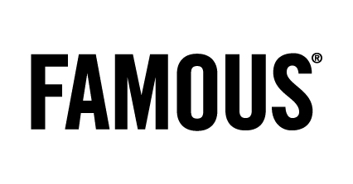

Radio - Neckermann
Last-minutes 2012

Credits
Client: Neckermann
Client contacts: Alexander Schmitt, Tim Tavernier
Agency: FAMOUS
Creative Director: Tim Driesen
Creative Team: Pieter Claeys & Luc Shih
Radio producer : Sandy Leemans
Productiehuis: Het Geluidshuis
Account: Mieke Van de Gehuchte

