For immediate distribution
PK Sound Delivers Loudspeaker Solutions at Second Annual BREAKOUT Festival
Trinity advanced robotic line array technology eliminated unwanted noise in nearby communities
Vancouver, British Columbia, August 27, 2019 — PK Sound, the Calgary-based loudspeaker manufacturing company, partnered with Timbre Concerts and CRESCENDO1 to present the second annual outdoor BREAKOUT Festival on June 15-16 at the PNE Amphitheatre in Vancouver, BC. The two-day, all ages festival featured a lineup of high-caliber Canadian hip-hop and R&B artists, like Lil Berete, Yung Tory, and NinetyFour, alongside some of the hottest acts from the U.S., including A$AP Rocky, Rae Sremmurd, YBN Cordae and Saweetie.
Following two successful BREAKOUT events in 2018 — the inaugural outdoor festival and Winter BREAKOUT —Timbre Concerts and CRESCENDO1 were looking for a way to reduce the potential for noise complaints at the PNE Amphitheatre while providing an uncompromised, full-volume festival experience for attendees. PK Sound was brought on board in 2019 to ensure the sound levels provided a high-volume/low-distortion experience for hip-hop and R&B fans at the festival using Trinity Advanced Robotic Line Arrays. The company used the opportunity to further its relationship with the PNE Amphitheatre as well as expose a new set of fans to PK Sound loudspeakers.

Grassroots growth across all genres
Since founding the company in 2005, PK Sound CEO Jeremy Bridge has been building the brand's reputation throughout Canada and the United States through word-of-mouth, whether at festivals like the Shambhala Music Festival, highly-anticipated EDM events with Bassnectar and Excision, or on tour with top country acts like Dierks Bentley.
Photo Credit: MVSCHAMP

"We've always been a grassroots company," said Arlen Cormack, Senior Vice President of Touring and Production at PK Sound, "and we've had a lot of success with organic growth through our partnerships with Canadian artists and other North American artists. As they've grown, we've grown — so we've found some good synergies by developing solid relationships with artist in younger days and growing with them."
Creating venue longevity
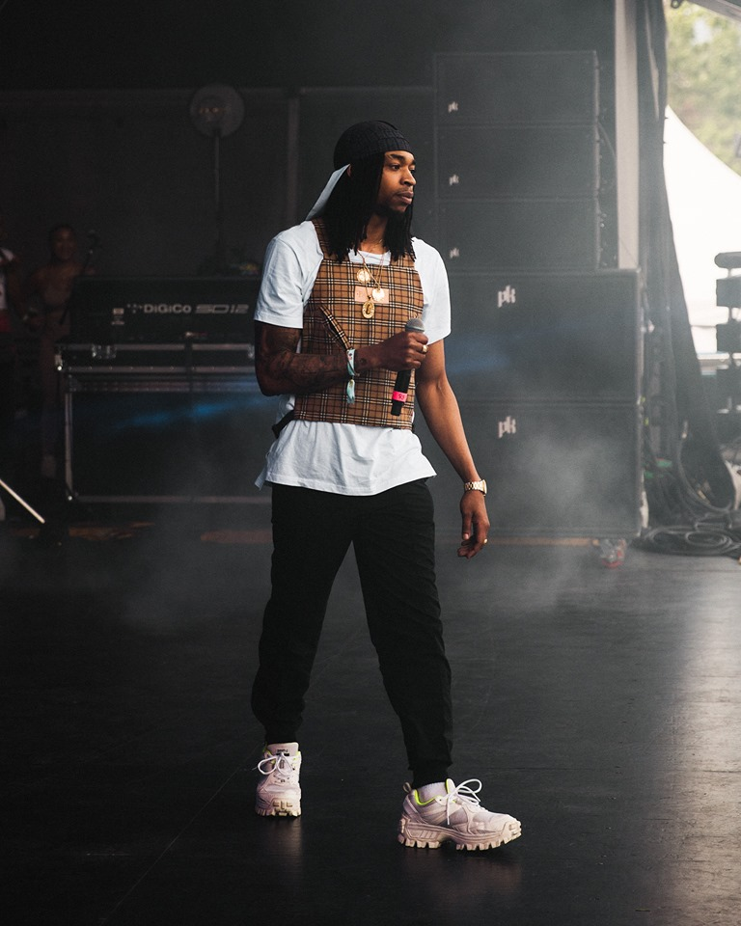
Considering the noise restrictions necessary for an outdoor venue like the PNE Amphitheatre, coupled with the high-volume/low-distortion expectations of hip-hop music fans at the festival, PK Sound’s successes with other outdoor festivals — like the Escapade Music Festival in Ottawa, in which Cormack's system designs lowered the number of noise complaints from over 100 to less than a 10 —gave the Vancouver venue confidence that the second annual BREAKOUT Festival would be an all-around success with PK Sound.
"We spend a lot of time designing our PA to be transparent for all genres — whether its country, hip-hop, pop or electronic," Cormack said. "What we're trying to do is create sound systems that can adapt to the venue, and that's where we're going to keep the noise floor down, keep the distortion down, and increase intelligibility. It's about treating the venue and then allowing the music to speak for itself.
Photo Credit: ryanmax94
"By helping to keep the venue more usable, we're creating longevity, while still keeping the overall show volumes pretty high, relatively," he continued. "From the fan perspective, we're perceived to be louder than other sound systems because there is less distortion, so it's cleaner. Even when we're not pushing it to be ultra-loud, we're providing sound quality and intelligibility, which translate to the music directly."

Angled for success
As soon as Cormack walked in to the PNE Amphitheatre to set up the PK Sound system for this year's BREAKOUT Festival, he knew where not to direct the sound that would be coming from his PA. "At the top of the risers at the back of the amphitheater there's a big, long wall," Cormack said. "And I could see there was a community on the stage left side, but way offstage, probably about a kilometer and a half away from the wall. With a typical PA, if you want to cover the back of the amphitheater with vocals, you will also be hitting that wall.”
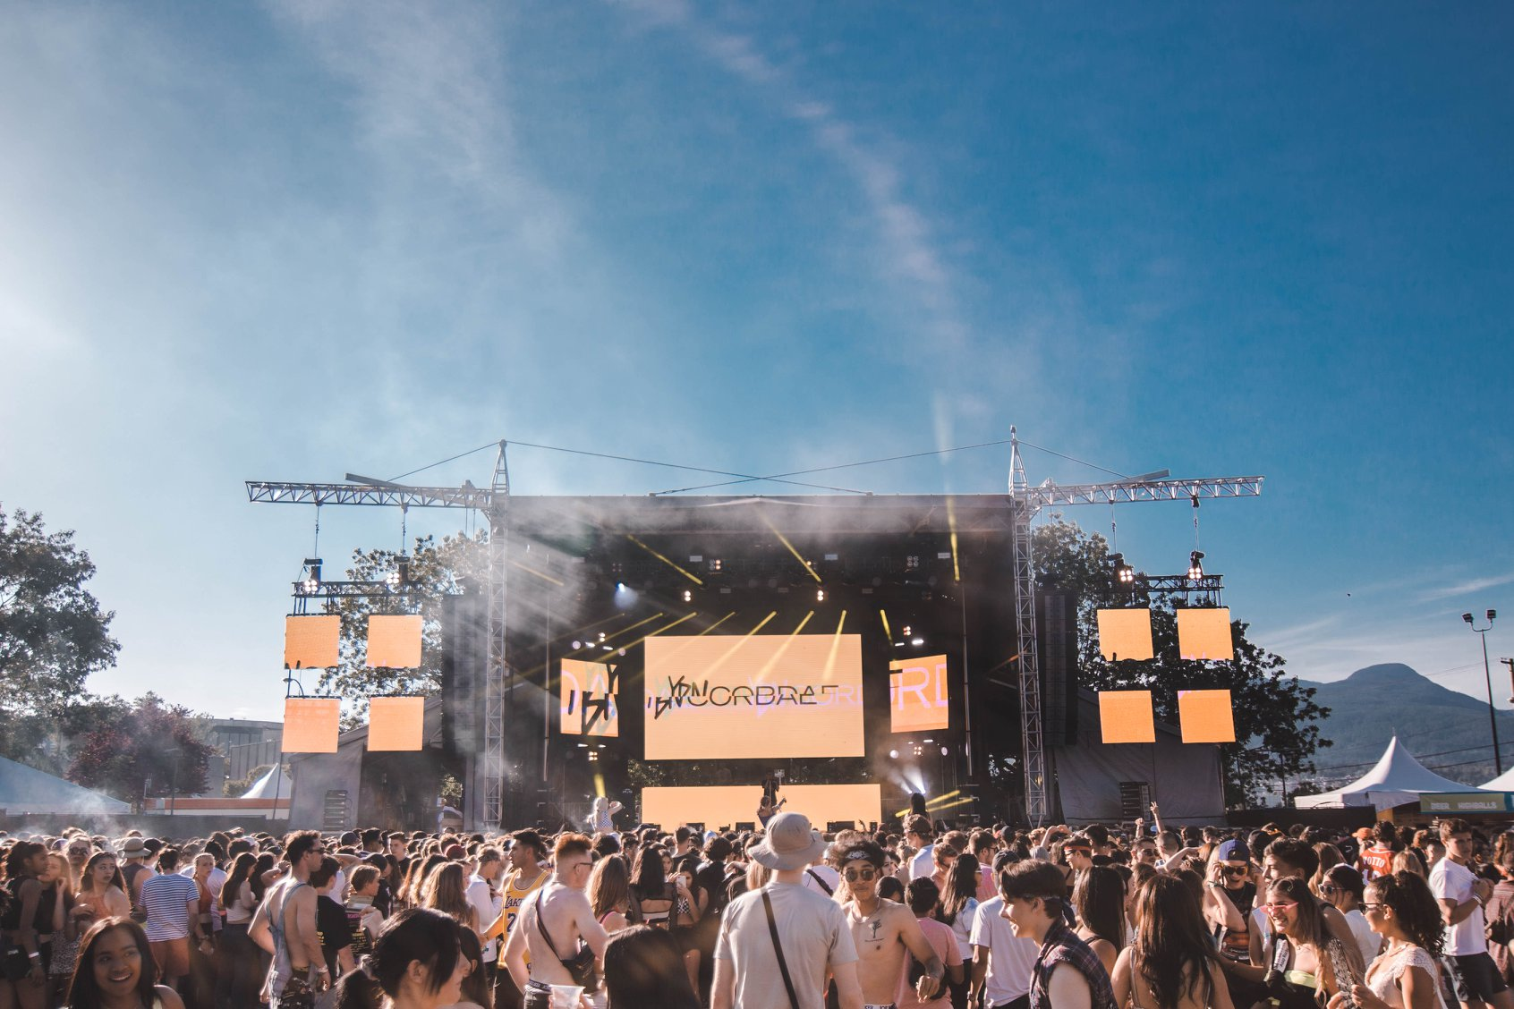
But, using 12 Trinity Robotic Line Arrays for the main hangs on either side of the stage, as well as four ground-stacked Trinity 10 boxes on either side as out fills, Cormack mechanically contoured the vocals away from the reflective back wall, sparing the nearby community, who otherwise would have been bombarded with unwanted reflections from the PNE Amphitheatre.
Photo Credit: MVSCHAMP

"We were able to focus the vocals away from the wall, so that we weren't shoot those vocals a kilometer and a half into a kind of obscure offstage direction," Cormack said. "I went over to the community and did multiple listens, and you couldn't hear anything over there. So, we completely deadened one entire community of complaints just by looking at the obvious and being able to steer away from that. It was really about contouring the sound field right to where the listener was, and nowhere else."
For more information, please visit PK Sound’s website at: https://www.pksound.ca/
About PK Sound
At PK Sound we are passionate about providing a powerful connection between artist and fan. We believe that every audio experience should be exceptional. Our loudspeakers are well known for their transparent, full bodied, powerful sound; a result of new technologies created by people who love music, focusing on the evolving demands of artists, engineers and fans.

Media contacts

Steve Bailey
Public Relations
Hummingbird Media
+1 (508) 596-9321
steve@hummingbirdmedia.com

Jeff Touzeau
Public Relations
Hummingbird Media
+1 (914) 602 2913
jeff@hummingbirdmedia.com

