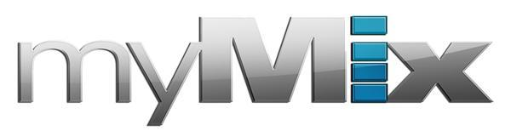
myMix’s Versatility Makes Both Rehearsals and Worship Services a ‘Breeze’ at SoCal Christian Church
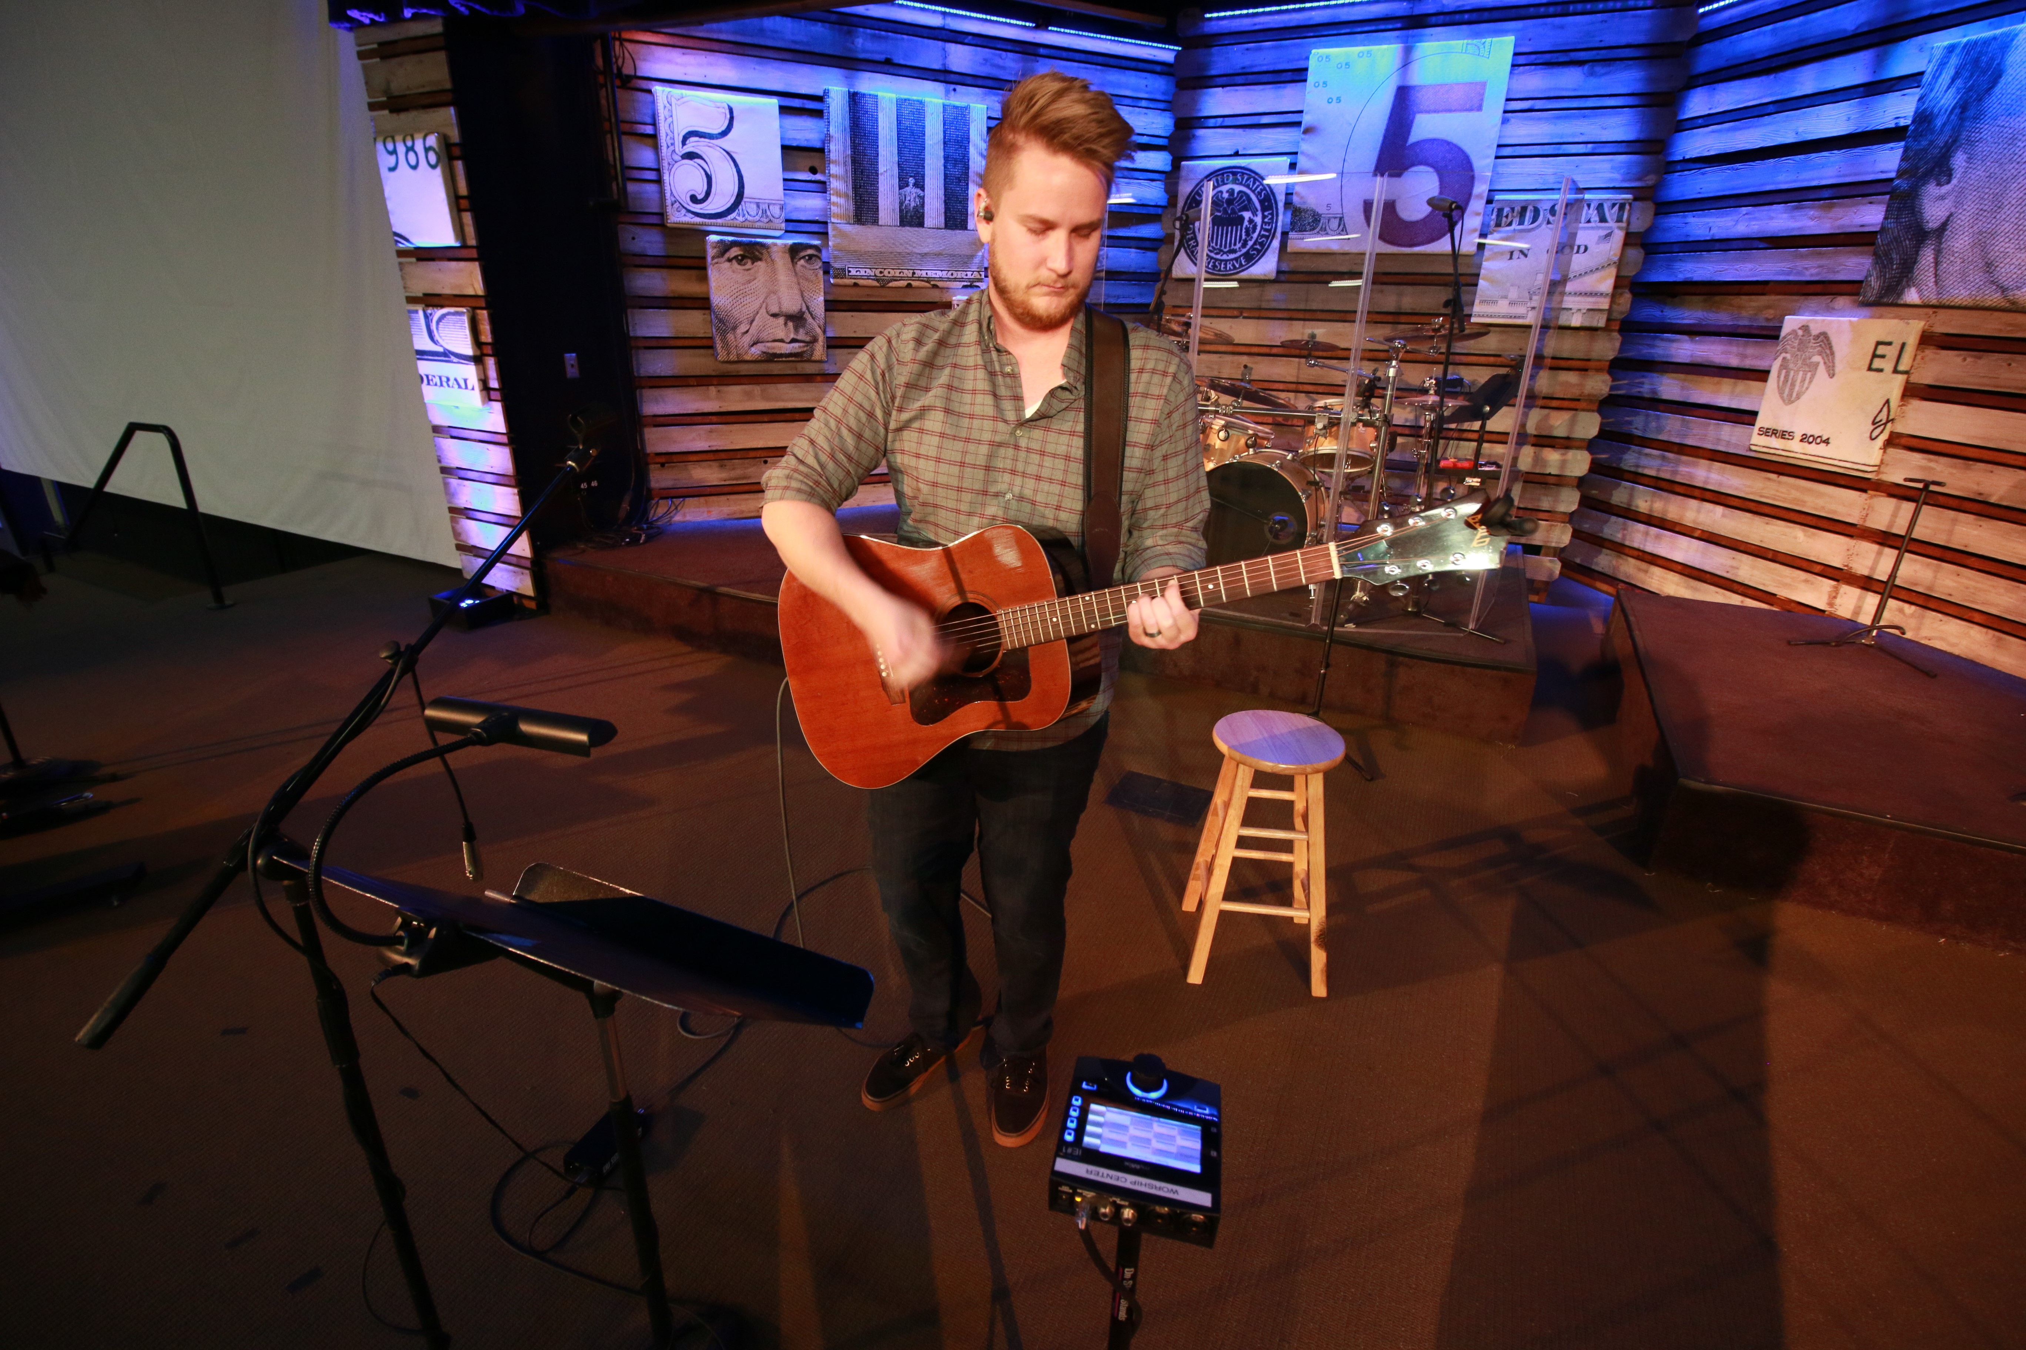
The easy-to-operate personal monitoring system helps both rehearsal and worship services run smoothly and efficiently at Seabreeze Church
Huntington Beach, California, March XX, 2018 — When Seabreeze Church in Huntington Beach, California, needed a personal monitoring solution to power its contemporary worship band, Worship Director Lance Unrau turned to the myMix personal monitor mixing and recording system for not only for quality audio and easy operation during its three Sunday morning worship services, but also for its ability to make rehearsals simpler.

Unrau and his fellow band mates play on average five Christian Rock-style songs during each of the services that see in total of 750 attendees each week. As a result, Unrau and his team find rehearsals to be integral part of their band’s sound.

“The myMix saves us so much time during our rehearsals,” Unrau said. “There’s less coordinating with the AV booth and us, and we can even rehearse without even having to turn the house speakers on. We just power up the myMixes and practice through them. It’s been so helpful for us to not have to rely on the booth for rehearsing, and that has increased our productivity overall.”

Crystal Clear Playback
Also aiding in rehearsals is myMix’s pristine audio output, something that Unrau said as a vocalist has helped improve not only his own sound, but also the entire sound of the band.

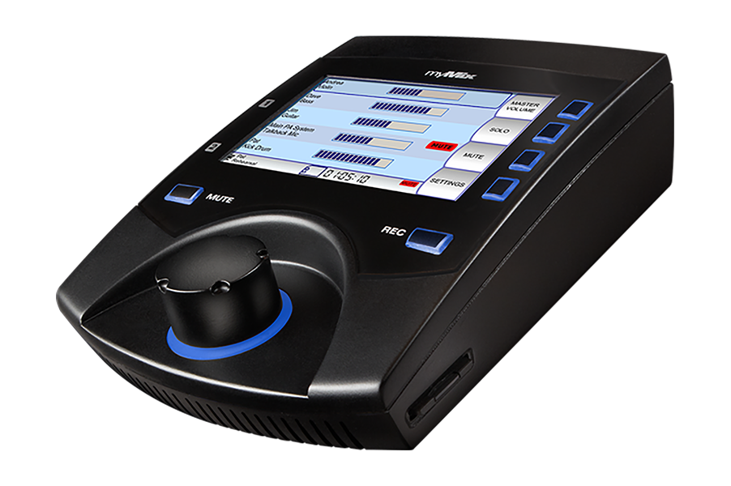
“The myMix is very unforgiving — which is a very good and helpful thing,” he said. “As you are singing the sound is literally right in front of you. As a result of this, I think it’s improved my vocals personally and has helped the whole band blend together. Using the myMix, we are better able to focus on our individual parts because we can hear our parts more clearly.”

Additionally, Unrau said the myMix’s clear audio playback has given the Church’s sound engineers a stronger control of the audio, improving the overall sound in Seabreeze Church’s auditorium.

“If you are running a bunch of floor monitors that really takes control, especially in the first few rows of the auditorium,” Unrau said. “With the myMix, our sound guys now have better control which has really improved the complete sound experience in the auditorium.”

Easy-Breezy Setup
As a worship band made up of mostly volunteers, Unrau finds the myMix’s intuitiveness helpful when instructing a new player on the system.

“I don’t think anyone in our band has ever had much experience with monitoring, but it was pretty easy to get everyone on board and up and running because it’s so easy,” Unrau said. “Even the backend features such as adding effects are intuitive. I usually only have to show someone once or twice, and they are good to go.”

For more information, visit mymixaudio.com.

About myMix
Part of the Synthax family, the North American distributor for RME, myMix is a personal monitor mixing and recording system featuring local network inputs and can operate either self-contained or integrated with any analog or digital mixing consoles. Thanks to its ease of use, the myMix is ideal for on-stage performances, studio monitoring as well as installed applications such as houses of worship.

Media Contacts:
Katie Kailus
Public Relations
Hummingbird Media
+1 (630) 319-5226
katie@hummingbirdmedia.com

Jeff Touzeau
Public Relations
Hummingbird Media
+1 (914) 602 2913
jeff@hummingbirdmedia.com

